Suir Road Davitt Road Junction Upgrade

Kilmainham to Thomas Street

Walking and Cycling Route

Information Leaflet

Public Consultation

Information Evening - Thursday 20th June 4-7pm

What’s In This Leaflet?
Project Overview
Benefits of the Scheme
Key Features
How to Contact Us

Project Overview
Dublin City Council (DCC) will deliver the Active Travel Network through a series of infrastructural projects over the next eight years. The Active Travel Network will grow from its existing 10km to a connected network of 310km across the city. This will offer a safer, inclusive and connected Active Travel Network that is sustainable.

Dublin City Council (DCC), with the support of the National Transport Authority, propose to upgrade the junction of Suir Road, Davitt Road, Dolphin Road and Slievenamon Road where they intersect at the Grand Canal. The LUAS Red Line also runs through the junction. The proposal introduces measures to cater for all transport users passing through the junction, improving the layout and facilitating bus and cyclist movements.

The project is a section of the Kilmainham to Thomas Street Active Travel Project which is part of the DCC core Active Travel Network. It will provide 2.6km of high quality walking and cycling facilities from Kilmainham Gaol to Thomas Street. It will extend from the South Circular Road/Kilmainham Lane junction along South Circular Road, Suir Road, Grand Canal View, St James Linear Park, James Walk, Forbes Lane, Marrowbone Lane and Thomas Court to the junction with Thomas
Street.
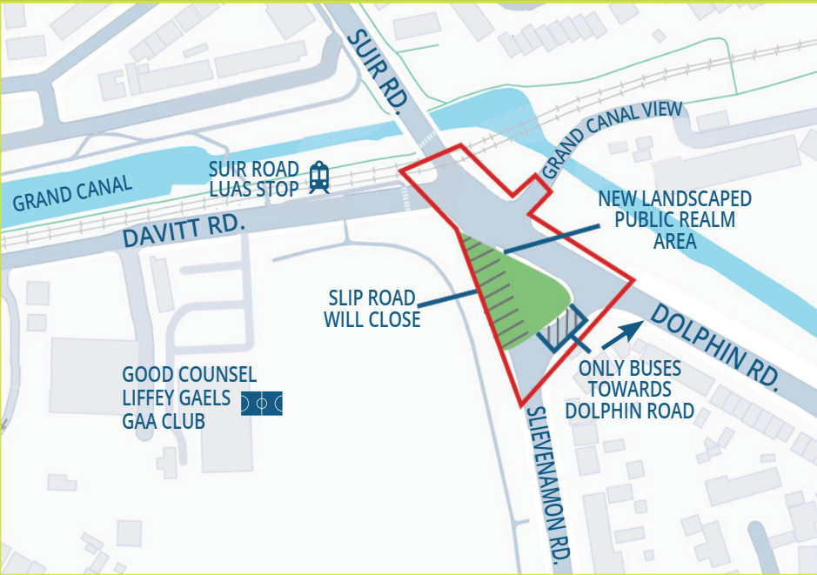

Scheme Extent Map
The map illustrates the scheme with the junction as described in section 1 of this leaflet outlined in red. The map labels the closure of Slievenamon Road, the new landscaped public realm area created and the bus only vehicle movement to be implemented where Slievenamon Road meets Dolphin Road

What Are The Benefits Of The Scheme?

Improve safety for cyclists and pedestrians by providing more direct and signalised crossings
Enhance amenity with an extended, refurbished and accessible landscaped area
Improve safety of LUAS travelling through the junction
Encourage increased levels of physical activity through the provision of a safe route and connectivity to the other walking and cycling routes

Key Features

Closure of Slievenamon slip road
Provide a bus gate for northbound Buses through Slievenamon Road/ Dolphin Road junction
Extended public realm and landscaped area
Reduce rat running through local roads via Slievenamon Road
Optimise traffic signal phasing to facilitate cyclists and pedestrians through the junction
Provide enhanced and more direct pedestrian crossing facilities
Maintain LUAS and bus priority through the junction
Providing new footpaths and road surface for the full junction
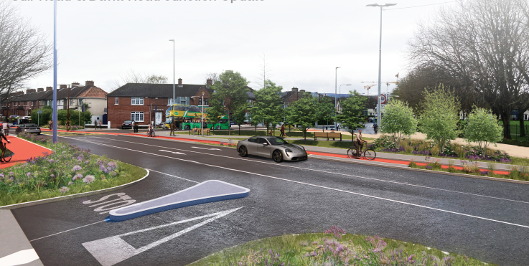

Image 1
The image is a photomontage of the completed scheme looking south west across Davitt Road from Grand Canal View. The image shows the proposed new cycle track on the opposite side of the road. The cycle track is separated from vehicle traffic by a constructed kerb buffer with some planting. Beyond the cycle track in the image is the new public space created by closure of Slievenamon Road. The public space contains seating, small and mid-sized trees with low level planting. In the foreground there is new planting on either side of the mouth of the Grand Canal View junction.
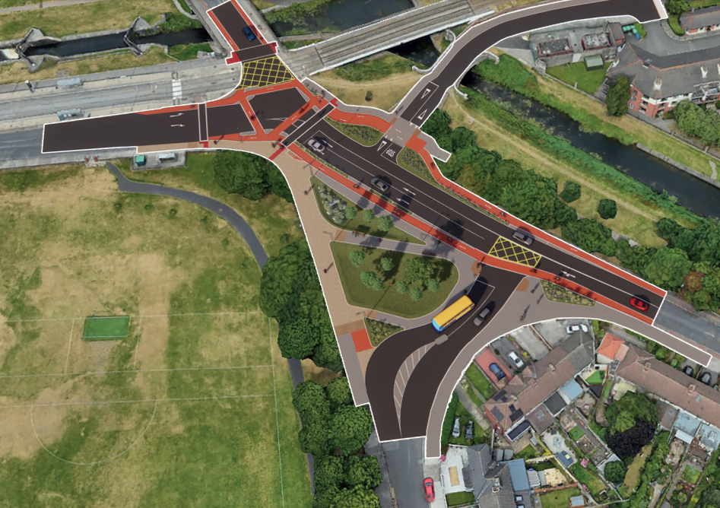

Image 2
The image is a photomontage an artist’s impression of an overhead aerial view of the proposed upgraded junction. It depicts all of the features described in section 3 of this leaflet and how they fit in to the surrounding environment.

