Dublin City Council COVID-19 Mobility Response

Strand Road Trial Rapid Deployment Cycle Route

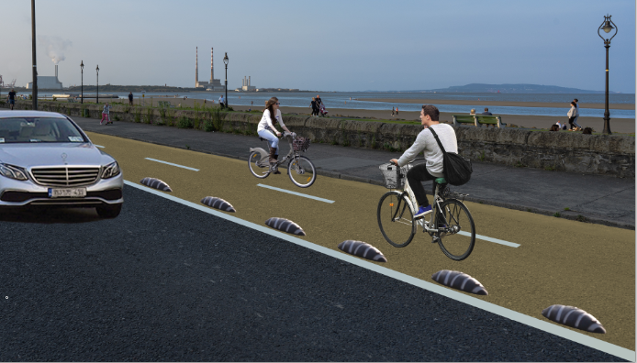

Overview

Dublin City Council in conjunction with the NTA is proposing to improve cycle facilities along the Strand Road in order to offer an alternative transport option as people return to work and school.

It is proposed to undertake a six month trial of a 2 way separated cycle track from Merrion Gates to Sean Moore Rd. In order to install this safe continuous and protected cycle track the inbound traffic lane will be removed between Merrion Gates and Marine Drive and the road converted to a two way cycle track on the sea side with outbound general traffic in one direction on the building side. Access to all properties will be maintained and the vast majority of informal parking along Strand Road will remain as is. The scheme will involve minimal civil works and will be installed in such a way as to allow for localised alterations and to minimise any alterations to existing road surface or kerbs.

Protection will be provided by bollards and orcas in the first instance, which are easily adjusted. More permanent protection will be installed if the trial is successful. The emphasis will be on ensuring that the level of protection is adequate to safely delineate the cycle route from the vehicle running lanes.

Rationale

The Covid-19 pandemic has affected all our lives and has had an enormous impact on our transport system. Public transport capacity is likely to be restricted for some time to come. Private car volumes are currently at 74% of pre-COVID numbers with little extra capacity for people to transfer from public transport to using private cars.

Active Mobility is being encouraged including walking or cycling for those capable who are within 5km of their destination and cycling for those capable who are within 10km of their destination, thereby leaving the capacity on public transport and on the road network for those who have no alternative. It is within this context that the scheme is proposed to provide a safe alternative for those cycling to work and school as well as providing an attractive recreational facility.

Previous schemes have examined the provision of improved cycle facilities in this location while also maintaining 2 way traffic. Doing this in an environmentally sensitive location is extremely challenging.

The beach area along Strand Road and Beach Road is an important natural heritage site with the following designations:

- Special Area of Conservation (South Dublin Bay SAC ref. 000210) designated under the EU Habitats Directive (1992),

- Special Protection Area (Sandymount Strand/Tolka Estuary SPA ref. 004024) designated under the EU Birds Directive (1979) and

- The entirety of Dublin Bay was designated as a UNESCO Biosphere in 2015.

Schemes which try to maintain two way traffic have required some or all of the following:

- removal of all on street parking,

- construction of a new pedestrian & cycle DART crossing/bridge and possible compulsory purchase of land at Merrion Gates and

- a reduction in the amount of footpath space available for pedestrians.

These schemes will also take many years before construction can commence.

This six month trial allows for a full evaluation of the proposed option, its benefits and any adverse impacts. Changing the use of the sea side lane to a two way cycle track means almost no changes are proposed on the property side along Strand Road and the vast majority of informal parking can remain as before. It will considerably reduce traffic levels on Strand Road. The City Council will carefully monitor the impact of the scheme on the wider area.

This temporary scheme can be in place by end October and will run initially for a six month trial period, during which time data and feedback will be gathered and assessed.
Outline of Proposed Trial Scheme

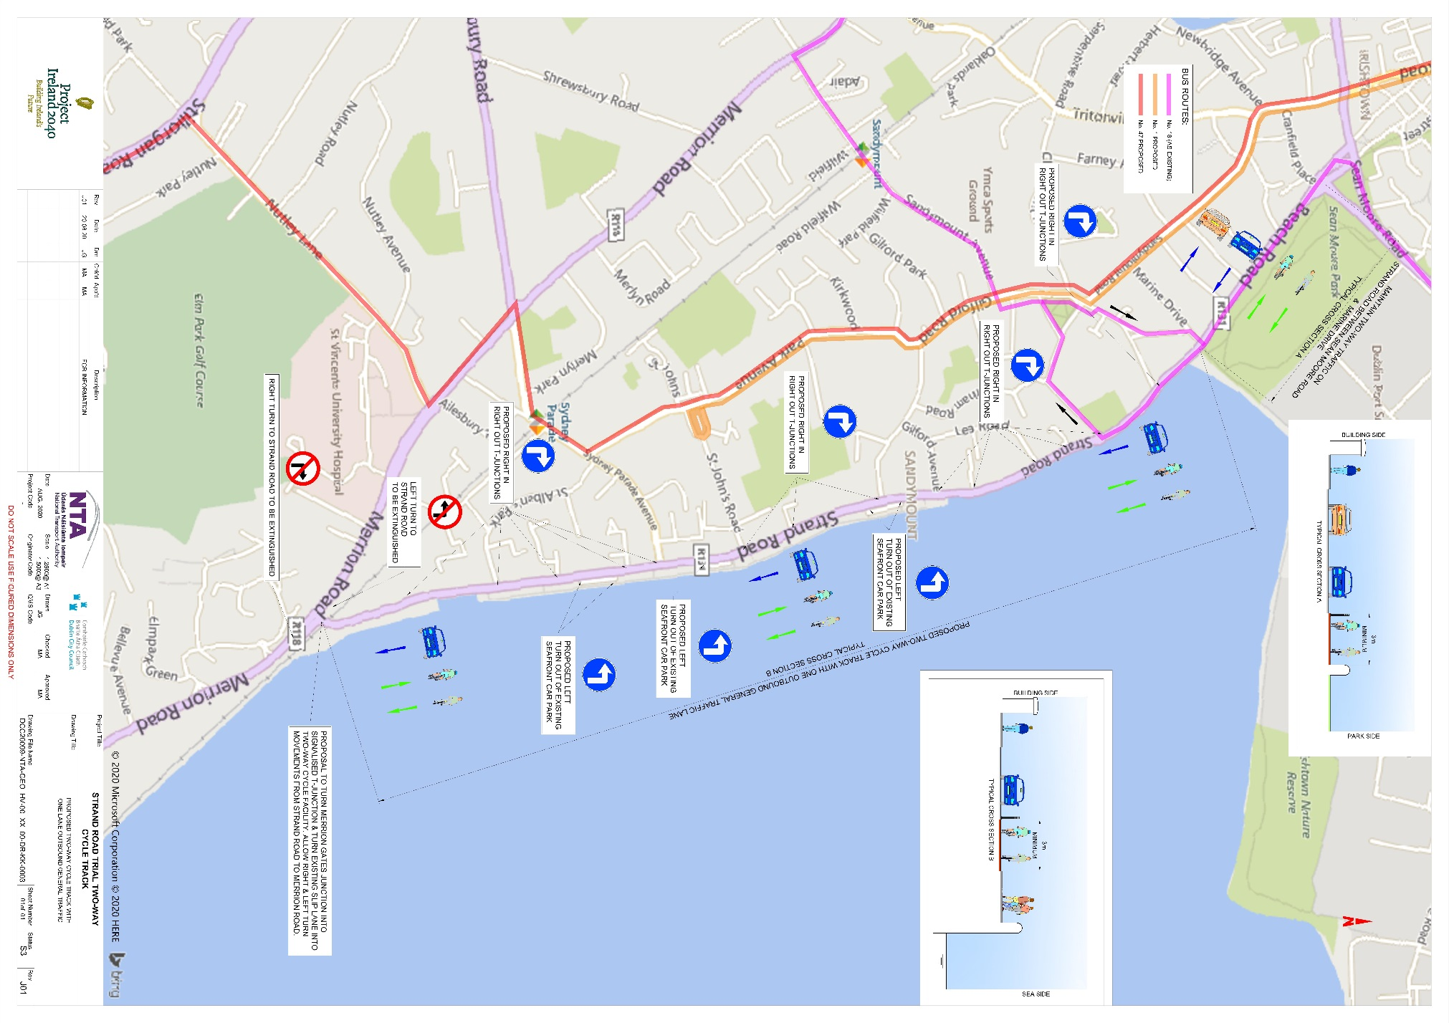

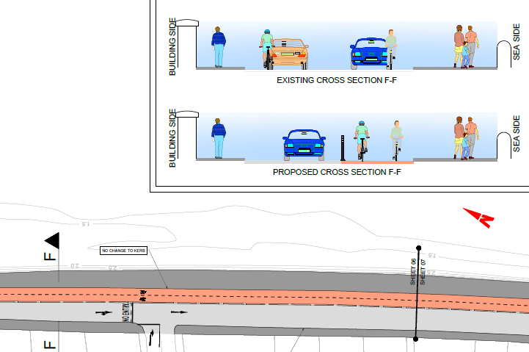

Typical section detail showing one way traffic and two way cycle track

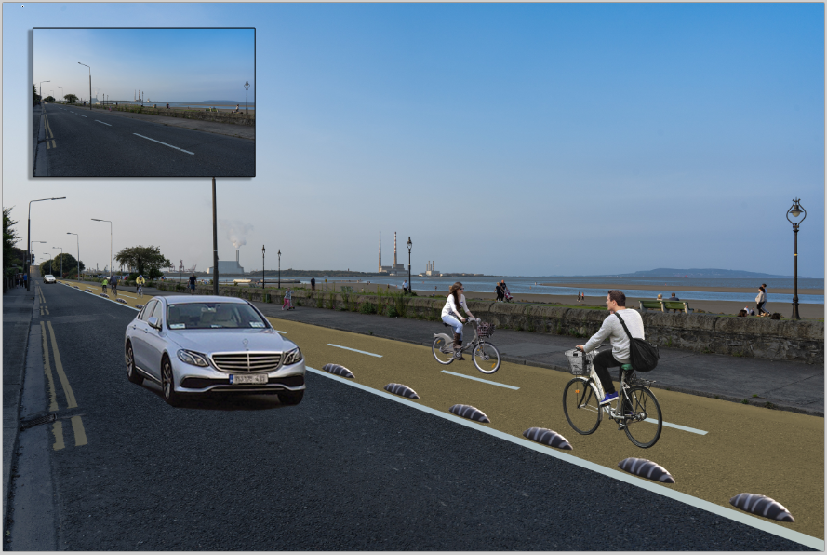

Typical section visualisation showing two way cycling and one way outbound traffic lane

Key Points

- This scheme will substantially reduce traffic volumes on the Strand Road for the duration of the trial. Only 10% of traffic on Strand Road is locally generated and so a substantial amount of through traffic will be removed as well as HGV and LGV traffic.

- 2.6 km of 2 way continuous protected cycle route will be provided between Merrion Gates and Sean Moore Road. Linkages to the routes towards the DLRCC cycle routes and into the city centre will also be advanced if the trial goes ahead.

- 2 way traffic will remain between Sean Moore Rd and Marine Drive to allow the number 18 bus route to remain as is.

- Between Marine Drive and Merrion Gates there will be one outbound lane of traffic. The traffic lane will use what is currently the inbound lane with the cycle route on the coast side.

- The No 1 and No 47 bus routes will use Gilford Road.

- The existing sea front car parks will remain as is.

- A right turn from Merrion Gates onto the Merrion Road will be put in place to facilitate access towards the city.

- No changes on the Merrion Road are proposed. The existing turn bans etc. on Merrion Road remain in place.

- The Bus only right turn inbound remains in place at the Merrion Road/Ailesbury Road junction.

Sean Moore Park Section

Alongside Sean Moore Park the scheme will use the footpath on the Park side for the cycle route. A temporary build out of the footpath will be used to provide space. While this is not ideal it allows for the existing No. 18 bus service to remain as is.

Pedestrians have a footpath inside the park as well as signalised crossings either side of this section of cycle track so they can cross the road at this point if required.

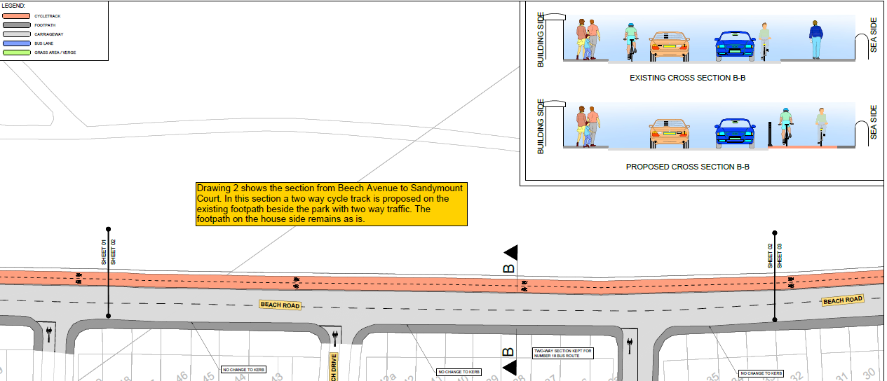

Detail showing two way cycle track on park side using a widened existing footpath

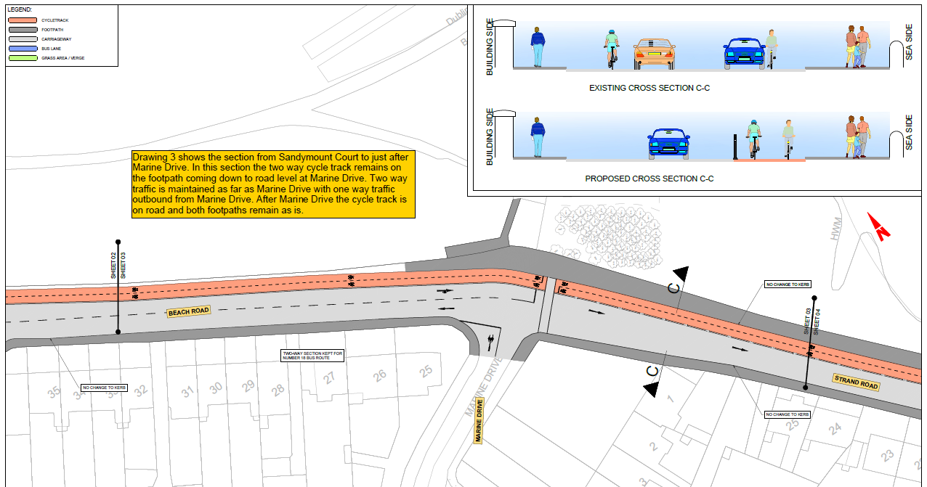

Scheme then transitions into the one way section past Marine Drive

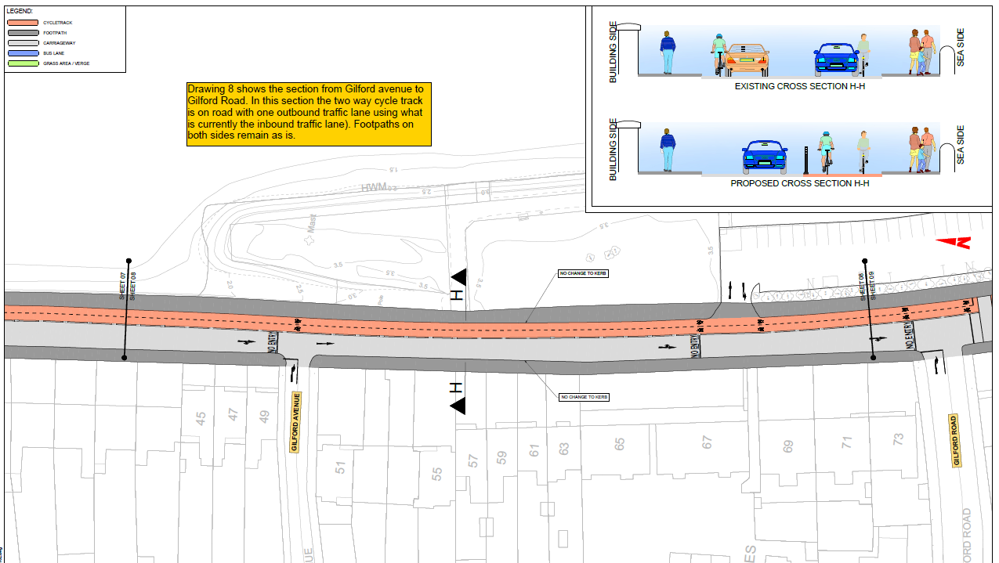

Detail showing one traffic lane converted to a two way cycle track on the road with no alterations to any existing footpaths or informal parking

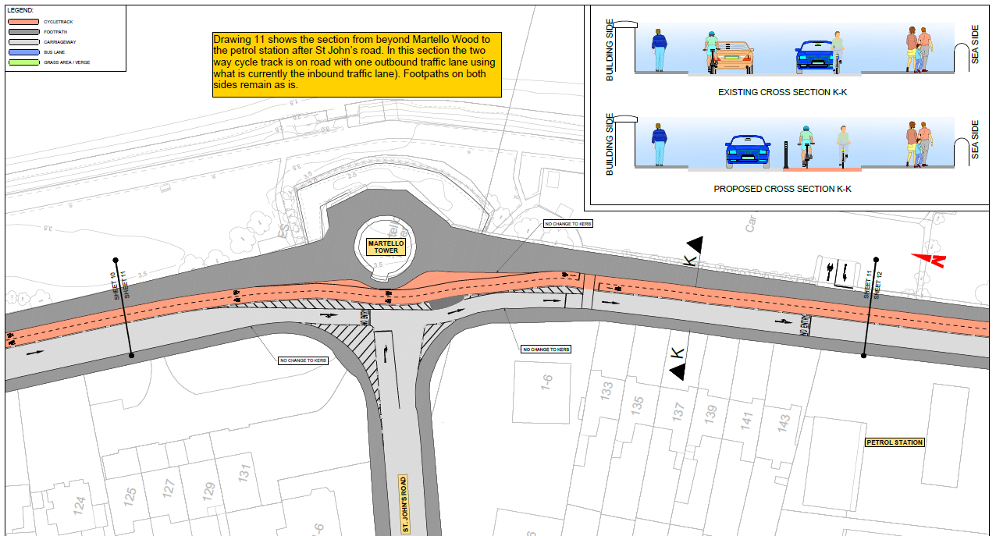

Details showing two way cycle track and one lane road outbound at the Martello Tower

Details showing two way cycle track and one lane road outbound at the Martello Tower

Where the existing road has mini roundabouts these will be altered to allow for traffic and cyclists running as shown above. These alterations will mostly be minor and be capable of being fully restored at a later stage.

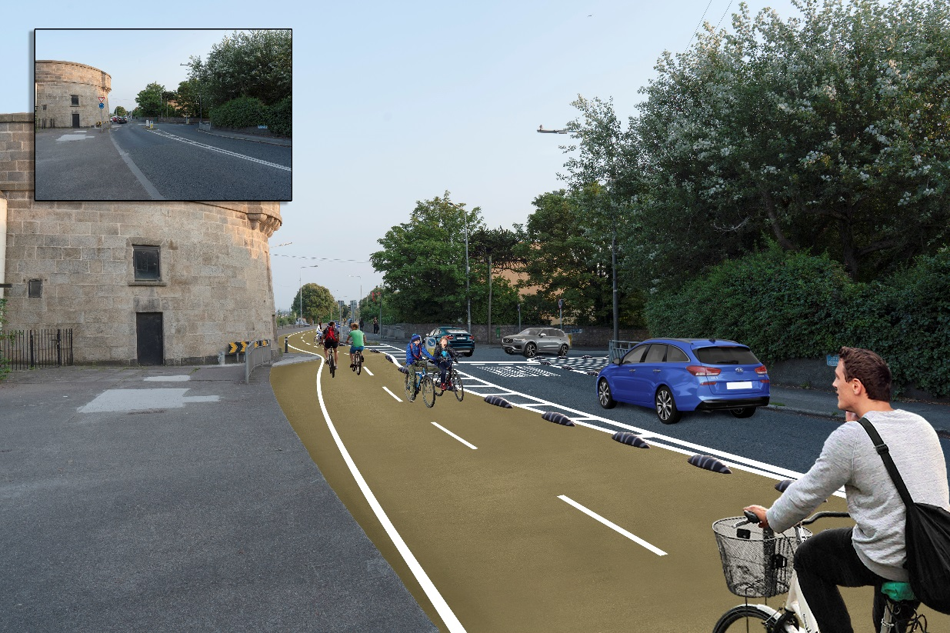

Visualisation showing two way cycle track at the Martello Tower

Merrion Gates

At Merrion Gates the existing right turn inbound and left turn outbound from Merrion Road will be removed. This will then allow a reconfiguration of the junction so that the slip lane will now be a two way cycle track. This will allow the two way protected cycle track to be aligned with a yet to be designed link to the DLRCC coastal route. Outbound traffic will have a separate signalised exit.
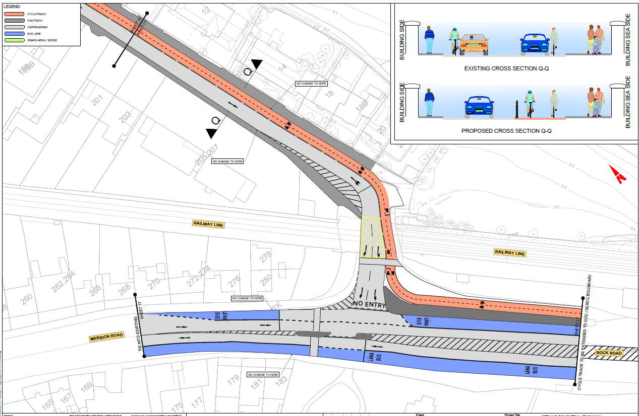

Detail showing proposed alterations to Merrion Gates Junc. which allows a right turn to city

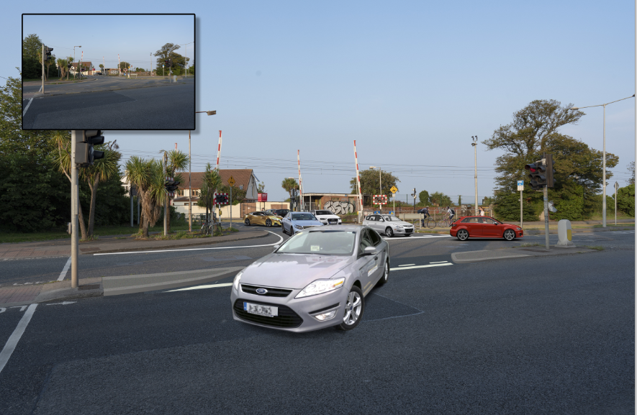

Visualisation of Merrion Gates showing new right turn movement

Bus Route Changes

There are currently three routes serving this area the numbers 1, 18 and 47. Number 18 stays as is. The 1 and the 47 are now proposed to run on Gilford Road and Park Avenue to the existing terminus in the case of the No 1 and the existing Sydney Parade service in the case of the No 47.
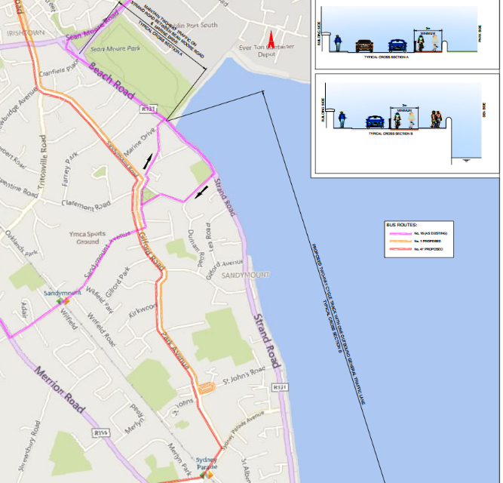
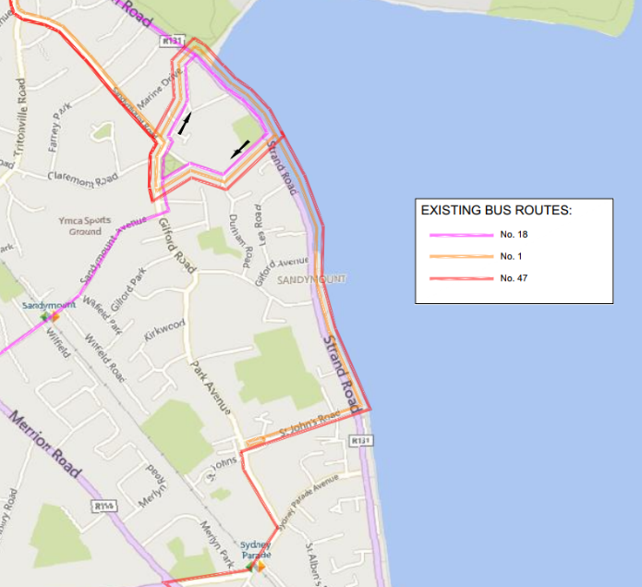

Existing Bus Routes Proposed Bus Routes

Conclusions

There is now a unique opportunity to undertake a six month trial of a 2.6 km continuous protected cycle route which can be put in place using rapid deployment methods and with minimal alterations to existing road or kerbs. This will allow us to determine the use of this facility as a commuting route, as a route to school and as a leisure cycle route. It will form an important link and will allow us to look to also provide rapid deployment protected cycling to the DLRCC boundary and also along Sean Moore Road and towards the city centre.

Feedback

Dublin City Council would like to gather feedback to find out:

- If there are specific concerns in relation to any aspects of the proposals.

- If there are any suggestions for improvements.

- If there are any complementary measures that should be introduced in tandem with this scheme.

The link to our consultation hub is https://consultation.dublincity.ie/and all documentation will be available there to download and consider. We hope to get all responses back by 14 September. Any correspondence received on this scheme will be considered.

FAQs

Why implement this scheme?
What is proposed is a rapid deployment six month trial of a two way fully protected continuous cycle route between Merrion Gates and Sean Moore Road. This is different to anything that has been proposed before as it does not involve major civil works, it is reversible and it is being done at a time when normal traffic volumes and behaviours have been completely changed due to COVID-19.

Why is it important to do it now?
If it is agreed to trial this route it will allow the City Council to immediately start work on linking to the Dun Laoghaire coastal cycle route and from Sean Moore Road to the city centre. Without this link it is difficult to provide a high quality cycling route in the area. It is necessary to ensure that safe protected cycling is provided as a means of transport for work, schools and leisure especially given the impacts of Covid-19.

Why does the cycle track have to be on the road? Why can’t you use the footpath or the green space?
We are using a small section of footpath at Sean Moore Park to allow two way traffic in this section to accommodate the number 18 bus route. Using all the footpath on the sea side for a cycle route would require us to extend the footpath over the entire length, narrow the carriageway to 6m and remove all informal parking along the entire length of Strand Road. Even if this was implemented there is still 300m on the approach to Merrion Gates where it is not possible to provide any cycle protection without the removal of a traffic lane.

Regarding using the green areas for a cycle route, 40% of the route between Merrion Gates and Sean Moore Road does not have green space available to use and we would still not end up with a safe, continuous, protected route.

How will the cycle lane be protected?
Initially a combination of bollards and orcas will be used, buff coloured surfacing will be put on the cycle track to highlight its presence and some other minor changes will take place. All of the measures are reversible and do not interfere with the structure of the road or the existing kerbs except at Sean Moore Park. If the cycle track is to remain for longer than 6 months then a more permanent design will be put in place.

Why is the outbound traffic chosen to be kept rather than the inbound traffic?
Outbound traffic has a higher volume than inbound traffic. Also, the inbound traffic that currently uses the Merrion Gates has multiple options to reach its destinations, depending on its origin some will divert via the M50, others via the Stillorgan Road and Merrion Road. If we made Strand Road one way inbound, then the outbound traffic could not use Strand Road and would have no alternative but to use Sandymount Village or Irishtown in order to reach its destination.

Will I lose the parking outside my house?
At present there is no pay and display or permit parking along Strand Road, however there is some informal parking. Mostly this will be retained as we are only removing one lane of traffic.

Why is the cycle track on the sea side?
To minimize the impact on driveways and the informal parking that exists at the moment.

What changes are being made to the bus routes?
The No.18 route will stay the same. The No.1 and No.47 will use Gilford Avenue and Park Avenue instead of using the Strand Road.

Will there be a large increase in traffic in Sandymount village and other residential streets?
The scheme will reduce the total volume of traffic on Strand Rd by approximately 40%, bearing in mind only around 10% of traffic on Strand Rd is locally generated. This will have a substantial benefit in this area. Regarding the traffic that can no longer travel inbound along Strand Rd, depending on its origin there are multiple alternative routes that can be taken. Traffic volumes are at present substantially reduced and it is not proposed to remove any banned turns along the Merrion Road. During the trial the City Council will monitor traffic volumes throughout the area and make adjustments if required.

There are plans for 3 additional pedestrian crossings in Sandymount and these will be advanced in line with this trial.

Can the scheme be modelled?
The scheme is currently being modelled by the NTA and more information from the modelling will be made available as it comes to hand. Please note that the modelling work is based on census data, traffic patterns and volume data collected pre COVID and can only give a result based on pre COVID levels of traffic and not the current situation. It is useful to determine the origin of traffic using Strand Road pre COVID and shows that only 10% of the Traffic on Strand Road is locally generated. However, it cannot show the current situation which is why a carefully monitored trial with a lot of data collection will provide us with a far more accurate picture of the benefits and impacts of this scheme.

Why has it been so difficult to come up with a design for a cycle route on Strand Rd?
The roadway is too narrow to allow for a protected cycle route and two way traffic. The footpath is too narrow to allow for it to be reduced to provide a cycle lane on the road or to use as a two way cycle track. The section of Strand Rd approaching Merrion Gates is a real pinch point with properties on both sides, narrow carriageways and narrow footpaths.

The beach area along Strand Road and Beach Road is an important natural heritage site

- Special Area of Conservation (South Dublin Bay SAC ref. 000210) designated under the EU Habitats Directive (1992).
- Special Protection Area (Sandymount Strand/Tolka Estuary SPA ref. 004024) designated under the EU Birds Directive (1979).

- The entirety of Dublin Bay was designated as a UNESCO Biosphere in 2015.

Schemes to provide an alternative bridge over the DART line and to provide a boardwalk around the properties on the sea side have been proposed. They all present significant environmental and construction difficulties, willstruggle to get approval and take many years to implement.

The reduction in traffic due to Covid-19, the alteration of commuting patterns due to working at home and the increased desire to ensure there is safe continuous protected cycle routes means that there is an opportunity now to undertake a 6 month trial of the rapid deployment cycle way.

Why a 6 Month Trial?
Six months will allow time for the scheme to settle in, for new patterns of movement to be established and for movement data to be gathered.

Will other traffic calming or public realm measure be considered in the area by DCC?
As part of the consultation process we are inviting people to submit suggestions for complementary measures, which people feel should be implemented along with the trial.

How will the trial affect schools in the area?
The city Council will, as part of this consultation make contact with all schools in the area to ensure that we are aware of any concerns or issues that may arise due to the trial.

How will this trial be funded?
If it is decided to proceed with this trial, funding of up to €250,000 has been provided for this scheme in the Governments Stimulus package and will be allocated to the City Council by the NTA.

