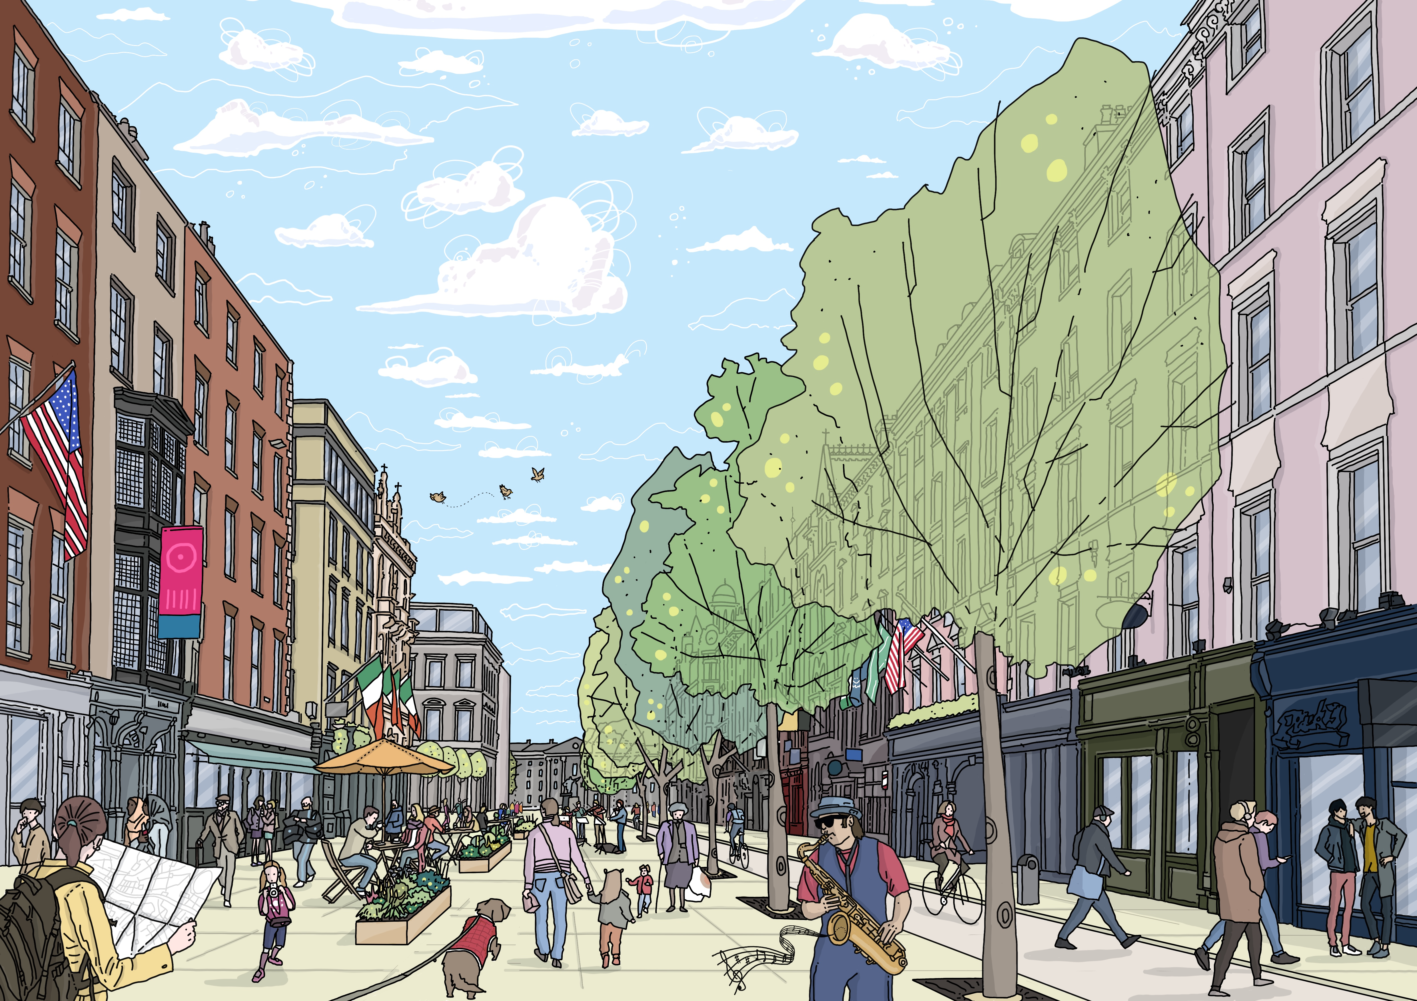

Vehicular deliveries and access from Dame Street: between South Great George’s Street and Anglesea Street area from 6am to 11am, and traffic-free after 11am (MCA Option 4). Concept illustration of space in use, looking east along Dame Street towards Trinity College


