Revised Options for College Green Plaza: Draft Multi-Criteria Appraisal Report

October 2020

Quality information
Prepared by |  | Checked by |  | Verified by |  | Approved by
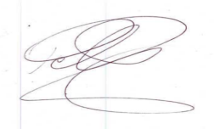 |  | 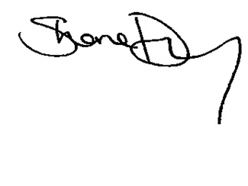
Keith Dalton  Senior Consultant |  | Shane Dunny  Regional Director |  | Elaine Brick  Regional Director |  | Derval Cummins  Director
Peter Foley
Principal Consultant

Prepared for:
Dublin City Council

Prepared by:
‌AECOM Ireland Limited
24 Lower Hatch Street
Dublin 2 D02 TY88
Ireland
T: +353 1 676 3671
aecom.com

© 2020 AECOM Design Build Ireland Limited. All Rights Reserved.
This document has been prepared by AECOM Design Build Ireland Limited (“AECOM”) for sole use of our client (the “Client”) in accordance with generally accepted consultancy principles, the budget for fees and the terms of reference agreed between AECOM and the Client. Any information provided by third parties and referred to herein has not been checked or verified by AECOM, unless otherwise expressly stated in the document. No third party may rely upon this document without the prior and express written agreement of AECOM.

Table of Contents
1. Introduction 4
2. Policy Context 6
3. Approach to Multi-Criteria Appraisal (MCA) 7
4. Original Proposal for College Green Plaza 13
5. Bus Connects Proposals for City Centre 22
6. College Green Trials 25
7. Revised Scheme Options for College Green 28
8. MCA Results 33
9. Conclusion & Next Steps 43
Appendix A Policy Context 44
Appendix B Drawing of Options 1 to 5 52

Introduction
Dublin City Council (DCC) has commissioned AECOM to undertake a Multi-Criteria Appraisal (MCA) of the five options it has identified for the creation of a civic plaza at College Green (the Scheme), Dublin 2. A previous application by DCC for the Scheme was refused permission by An Bord Pleanála in September 2018 (Ref JA0039). DCC has subsequently developed a number of alternative options for the creation of a civic plaza while allowing for movement of all transport modes in the space considering:

- The original application and subsequent Inspector’s report;
- The lessons learnt from trial closures of the space to vehicular traffic during the summer of 2019; and
- The bus network redesign proposed as part of BusConnects Network Redesign which has changed the requirements for providing for bus movements in the area.
The purpose of the MCA is to comparatively assess the five options to facilitate transport movements within the space between the South Great George’s Street / Dame Street junction and the Luas Line at Trinity College, referred to as the ‘Scheme’. Within the Scheme there are two distinct areas, the ‘Core Plaza’, comprising College Green between the Luas Line at Trinity College and the junction at Anglesea Street; and the ‘Outer Plaza’, running from the junction of Anglesea Street / Dame Street to the South Great George’s Street / Dame Street. It is only within these two areas that the comparative assessment of the options will be undertaken. These areas are shown in Figure 1.1.

Secondary areas such as Trinity Place, Church Lane, Andrews Street, Anglesea Street, Cope Street and Fownes Street Upper have not been considered in this comparative assessment. The rationale for this is that some options include all of the above streets whilst others do not, therefore making the comparative assessment of options unequal.

Figure 1.1: Site location plan showing the Scheme, including Core Plaza and Outer Plaza
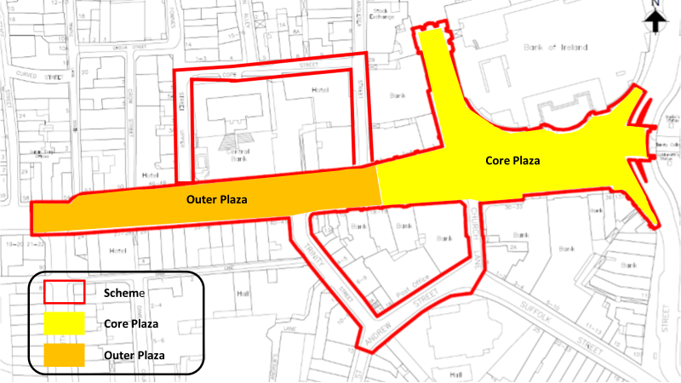

The MCA is to be developed in line with relevant guidance including the Department of Transport, Tourism and Sport (DTTaS) Common Appraisal Framework for Transport Projects and Programmes (2016) and the National Transport Authority Project Management Guidelines.

The following report is structured as follows:

- The Policy Context for the College Green Scheme is presented in Section 2; this forms the basis for selection of the MCA criterion;
- The approach taken to Multi-Criteria Appraisal (MCA) of the five proposed options is outlined in Section 3;
- The original scheme proposed for College Green is presented in Section 4 as well as feedback from An Bord Pleanála regarding the grounds for refusal;
- The city centre proposals for BusConnects, in particular those in the vicinity of the study area, are outlined in Section 5;
- Section 6 provides details of the outcome of several trial closures of College Green undertaken by DCC to observe the impact on behaviour and travel patterns;
- Details of the five revised options for the College Green Scheme are presented in Section 7;
- Section 8 presents the MCA Results; and
- Section 9 outlines the conclusion and next steps.

Policy Context
A review of relevant policies and studies was undertaken to provide some background for the proposed Scheme and to inform development of the MCA criterion. The full review can be found in Appendix A.

While a large number of objectives are outlined in the various policy documents reviewed, a number of themes are common to all, summarised as follows:

- An objective to ensure that attractive, liveable, well designed, high quality urban places are delivered and the need for improvements to the public realm to achieve this;
- The need for environmental sustainability and improvements to air quality to prevent people being exposed to unacceptable levels of pollution in urban and rural areas;
- Recognition of the positive contribution that the efficient, effective and sustainable movement of people and goods positive can make to economic, social and cultural progress; and
- The requirement to encourage a shift away from private cars towards more sustainable modes and a recognition of the need to deliver existing plans and upgrade proposals to provide safe, convenient reliable facilities and services to encourage this shift to public transport, walking and cycling;
- A desire to ensure that transport services and public spaces are accessible to all;
- The importance of a high-quality public realm, especially in and around key public spaces such as the grand Civic Spine in Dublin City Centre; and
- The importance of promoting a variety of recreational and cultural events within civic spaces.

Approach to Multi-Criteria Appraisal (MCA)

Overview
The Common Appraisal Framework (CAF) (Department of Transport, Tourism and Sport, 2016) was used as the basis for the MCA as required for all similar infrastructure projects. The following six criteria for appraisal and associated sub-criteria, as set out in the CAF were used as the basis for the MCA:

Table 3.1 – MCA CAF Criteria
CAF Criteria | CAF Sub-Criteria
Environment | Air Quality
 | Noise & Vibration
 | Landscape & Visual Quality
 | Cultural, Archaeological & Architectural Heritage
Accessibility & Social Inclusion | Vulnerable Groups
Physical Activity
Safety | Safety of vulnerable road users
Integration | Transport Integration
 | Land Use Integration
 | Other Government Policy Integration
Economy | Transport Efficiency & Effectiveness
 | Transport Reliability & Quality
 | Other Economic Impacts

As the CAF appraisal criteria are too general for the purpose of the College Green Plaza MCA, more bespoke appraisal criteria were developed, as presented in Table 3.2 below. These criteria were selected on the basis of being:

- Directly related to the CAF appraisal criteria; or
- Directly linked to the objectives of the scheme; or
- Consistent with current Government and Dublin City Council objectives.

As outlined in the Introduction, the Scheme consists of the red line boundary encompassing the area between South Great George’s Street / Dame Street junction and the Luas Line at Trinity College. Within the Scheme there are two distinct areas.

- Core Plaza: This area comprises the areas of College Green and Foster Place between the Luas Line at Trinity College and the junction of College Green / Anglesea Street. The Core Plaza is the main civic and public space within the Scheme and has the greatest concentration of cultural, archaeological, architectural and heritage assets. The Core Plaza has a higher sense of place and low movement function.
- Outer Plaza: comprises the areas between South Great George’s Street / Dame Street junction to the junction of Anglesea Street. Within the Scheme the Outer Plaza has a higher movement function and a reduced place function in comparison to the Core Plaza.
Within the comparative assessment, all the options are assessed on the basis of impact across the Scheme. The exception to this is for Landscape and Visual Quality and Cultural, Archaeological & Architectural Heritage which have been used for comparative assessment within the Core Plaza only. The rationale for this is that the Core Plaza, being the main civic and public space within the Scheme, offers the greatest concentration of cultural, architectural, heritage and landscape assets.

A succinct rationale for each of the criterion is presented in Table 3.2.

Table 3.2: MCA Criteria
CAF Criteria | CAF Sub-Criteria | Appraisal Criterion | Rationale for Inclusion  (O) = Scheme Objective  (P) = Consistent with Policy
Environment | Air Quality | Minimise emissions to provide a high-quality environment within the Scheme | (P) Improving air quality
 | Noise & Vibration | Minimise noise and vibration to provide a high-quality environment within the Scheme | (O) Alleviate congestion in the area of College Green
 | Landscape & Visual Quality | Optimise the aesthetical value of the Core Plaza | (P) Ensure attractive, liveable, well designed, high quality urban places
 | Cultural, Archaeological & Architectural Heritage | Optimise the architectural and cultural value of the Core Plaza
 |  | Provide a cultural space for large civic events | (P) Promote a variety of recreational and cultural events within civic spaces
Accessibility & Social Inclusion | Vulnerable Groups | Ensure the environment is accessible for people with disabilities | (O) Transform College Green into a more accessible and usable space.  (P) Ensure that public spaces are accessible across all societal needs, ages and abilities.
 |  | Provide a vibrant socially inclusive space for all to rest and enjoy | (P) Ensure attractive, liveable, well designed, high quality urban places
Physical Activity |  | Optimise pedestrian movement within the Scheme | (O) Provide an uninterrupted pedestrianised route from St. Stephen’s Green to the quays
 |  | Optimise cyclist movement within the Scheme | (O) Provide cyclists with a designated cycle track
Safety | Safety of vulnerable road users | Improve pedestrian safety within the Scheme | (P) Provide safe, convenient reliable facilities to encourage shift to walking and cycling
 |  | Improve cyclist safety within the Scheme
Integration | Transport Integration | Integration of the Scheme with the existing and planned GDA Strategic Cycle Network | (P) as outlined in Appendix A  (O) Generate a key safe city centre link connecting to the cycle provisions planned for Dame Street and Westmoreland Street
 |  | Integration of the Scheme with the existing and planned pedestrian network | (O) Provide an uninterrupted pedestrianised route from St. Stephen’s Green to the quays
 |  | Integration of the Scheme with the existing and planned public transport network | (P) Provide safe, convenient reliable facilities and services to encourage this shift to public transport
 | Land Use Integration | Alignment of the Scheme with adopted DCC spatial policies for the city centre and Central Spine | (P) Provide a high-quality public realm, especially in and around key public spaces such as the grand Civic Spine in Dublin City Centre
 | Other Govt Policy Integration | Alignment of the Scheme with Ireland 2040/ NDP, CAP | (P) A desire for a shift away from private car towards more sustainable modes and a recognition of the need to deliver existing plans and upgrade proposals to provide safe, convenient reliable facilities and services to encourage this shift to public transport, walking and cycling
 |  | Alignment of the Scheme with the Eastern and Midland Regional Spatial and Economic Strategy (RSES)
Economy | Transport Reliability & Quality | Assist in delivering a high-quality sustainable transport network in Dublin to support adopted economic policy, including:  - High quality pedestrian network;  - High quality cycle network; and  - High quality public transport network. | (O) Provide an uninterrupted pedestrianised route from St. Stephen’s Green to the quays, significantly improving pedestrian journey times.  (O) Provide cyclists with a designated cycle track which will physically separate the cyclist from Luas and bus movements.  (P) Provide safe, convenient reliable facilities and services to encourage this shift to public transport, walking and cycling
 | Other Economic Impacts | Support the continued economic success of the area to support, communities, business, visitors and tourism | (P) Recognition of the positive contribution that the efficient, effective and sustainable movement of people and goods positive can make to economic, social and cultural progress

Methodology
The adopted methodology, in-line with CAF requirements, is comparative. In the case of the College Green Plaza MCA, the assessment aims to identify the best performing option of the five proposed, reducing the number of options from five to one, an Emerging Preferred Option (EPO).

A comparative assessment was undertaken where for each positively scored criterion there was an opposing negatively scored option. A five-point comparative scale was used for each appraisal criterion, and an average score for each of the individual CAF criteria was calculated. The EPO is the option that attained the highest comparative score across all six CAF criteria.

Table 3.3 provides an overview of the comparative colour coded scale for assessing the criteria and sub-criteria.

Table 3.3: Appraisal Criteria Comparative Colour-Coded Ranking Scale
Colour | Description
+2 | Significant comparative advantage over other options
+1 | Some comparative advantage over other options
0 | Comparable to other options
-1 | Some comparative disadvantage over other options
-2 | Significant comparative disadvantage over other options

This assessment did not apply any weighting to the individual criteria assessments, so that each of the criterion will retain equal importance. While appreciating that one or more of the six assessment criteria (and sub-criteria) may be important to particular stakeholder groups, the appraisal must consider all scheme impacts.

Assessment Approach
The aim of the MCA was to assess both the quantifiable and non-quantifiable impacts and benefits of each option under each of the six CAF Criteria, sub-criteria and appraisal criterion. The information used in the assessment included a range of qualitative and quantitative information relating to the baseline conditions within and adjacent to the Scheme. This included a range of data within the Environmental Impact Assessment Report (EIAR) that was submitted in support of the original College Green application. Traffic and pedestrian surveys undertaken by DCC in November 2018 provided data on movements in and around the Scheme. In addition, a review of policy and research documents helped to understand and quantify the potential impacts of the CAF criteria on the options. No traffic modelling was undertaken for the proposed options. An overview of the assessment approach is outlined below.

Environment
The main environmental factor differentiating the options relates to the level and content of vehicular traffic passing through the scheme. Vehicular transport is a major contributor to harmful environmental emissions, including greenhouse gases (CO2). Transport emission in the form of Nitrogen Oxides (NOx) and Particulate Matter (PM₁₀ and PM₂₅) adversely impacts on public health. Noise and vibration associated with vehicular movement can also affect quality of life and ability for persons to enjoy a space. These factors can result in direct impacts and indirect through changes to cultural, heritage assets and landscape quality.

Accessibility and Social Inclusion
Government policy in relation to Social Inclusion is set out in the National Action Plan for Social Inclusion (NAPSI). This policy looks to reduce and eliminate poverty and social inclusion particularly as it affects vulnerable groups, including people with disabilities. The assessment compared the options based on how the designs accommodated vulnerable groups, particularly people with disabilities, as well as providing an inclusive space that all communities can enjoy.

Physical Activity
Under this criterion, options that provide the greatest opportunity to optimise active mobility (walking and cycling) within and across the Scheme were considered to present comparative advantage over other options. Options were assessed based on the standard and extent of walking and cycle infrastructure and the extent to which movement by these modes was impeded through conflicts or barriers caused by vehicular movements.

Safety
Transport policy such as the Road Safety Authority’s Road Safety Strategy 2013 , has a specific focus on reduction of collisions, particularly for vulnerable road users including pedestrians and cyclists. The assessment of Safety is therefore based on the probability of incident reduction and avoidance, for pedestrians and cyclists. Vehicular transport is a major contributor to accidents.

Integration
The Integration criteria measures the compatibility of the options to relevant transport, land use and other Government policies. The options were assessed against a range of the most relevant local (DCC Spatial Strategy), regional (BusConnects, GDA cycle network, ) and national (NPF / NDP, CAP) policies. The options with the best strategic fit to these policies scored more positively in this criteria.

Economy
In the assessment of the Economy the ability of the proposals to support continued economic success of the area was assessed. The assessment considered a broad range of factors that influence economic outputs including the social and environmental impacts. A review of literature and research documents including the 2014 report by Living Streets titled The Pedestrian Pound and CABE (Commission for Architecture and the Built Environment), Paved with Gold (2007) provides evidence that city centre schemes that improve the urban realm, increase pedestrianisation and reduce vehicular dominance of a space result in greater socio-economic benefits. Therefore, options that had greater levels of pedestrianisation and urban realm improvements and reduce vehicular dominance are more likely to score positively in this criteria.

Original Proposal for College Green Plaza

Overview of the Original Scheme
The aim of the original planning application to develop College Green Plaza as set out in the Environmental Impact Assessment Report (EIAR) was that the:

“Proposed Project will transform College Green and redefine the area as a Civic Space of National importance in line with Dublin City Council’s long-standing objective for College Green. The Proposed Project will contribute to the achievement of the vision for College Green set out both in the Dublin City Development Plan 2016-2022, City Centre Transport Study (2016) and the Heart of Dublin City Centre Public Realm Masterplan (Dublin City Council, 2016) for the City” (EIAR Chapter 1).

To meet the above aim a number of objectives were set as follows:

- Alleviate congestion in the area by barring all traffic travelling in an east-west direction across College Green;
- Transform the area of College Green into a more accessible and usable space by linking the Luas to a fully pedestrianised area;
- Provide an uninterrupted pedestrianised route from St. Stephen’s Green to the quays, significantly improving pedestrian journey times;
- Provide cyclists with a designated cycle track which will physically separate the cyclist from Luas and bus movements; and
- Cycle provision in the Plaza area will generate a key safe city centre link connecting to the cycle provisions planned for Dame Street and Westmoreland Street.
The overarching aim and objectives for the scheme have not changed and alternative options developed by DCC for the study area have been developed to achieve the same aims and objectives outlined above.

Existing Site Characteristics
The site is located in a built-up urban environment in the centre of Dublin City. The overall site area is 13,960m² and includes the full area of College Green, Foster Place, parts of Dame Street, Trinity Street, St Andrews Street, Church Lane and the very northern end of Grafton Street as shown in Figure 4.1.

Figure 4.1: Red Line boundary from EIAR showing extent to the proposed College Green Plaza
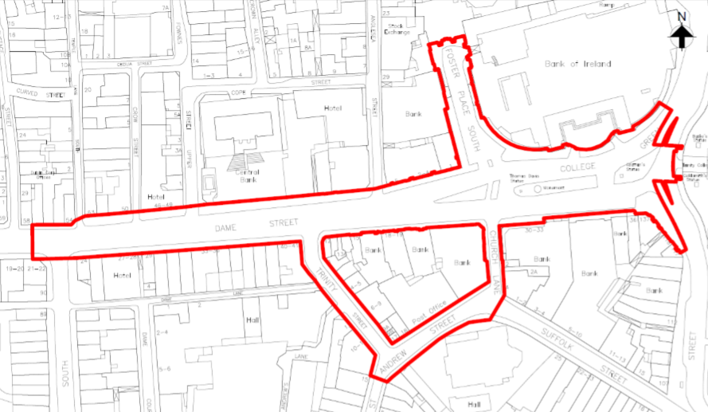

Existing traffic and transport arrangements within the site are as follows:

- Traffic Management: College Green currently operates as a Bus Corridor with the following restrictions in place:
  - Westbound –Monday to Friday 7am to 7pm only buses, taxis and bicycles can travel this direction through the corridor;
  - Eastbound – Monday to Friday 7am to 10am only buses and bicycles can travel this direction through the corridor; 10am to 7pm only buses, taxis and bicycles can travel through the corridor;
  - Southbound - Monday to Friday 7am to 10am only Luas buses, and bicycles can travel this direction through the corridor; 10am to 7pm only Luas, taxis, buses, and bicycles can travel this direction through the corridor; and
  - Northbound – Buses and cyclists with taxis only allowed from 24:00-0600. This restriction is because of the restricted access at the bottom of Dawson Street.
Outside of these hours, including all day on Saturdays and Sundays, the corridor is open in all directions to all vehicles.

- Bus Network: There are substantial bus movements through the Scheme, with a large number of routes converging on the area and significant numbers of passengers alighting and boarding. Surveys undertaken in 2019 recorded a total of 167 bus movements through the east-west axis of College Green during the AM peak hour (08.00 – 09.00), with a further 185 movements through the north-south axis. The general bus routes taken through the study area, as per Figure 6.2 – Chapter 6 of the EIAR are illustrated in Figure 4.2;
Figure 4.2: Bus routes through the study area
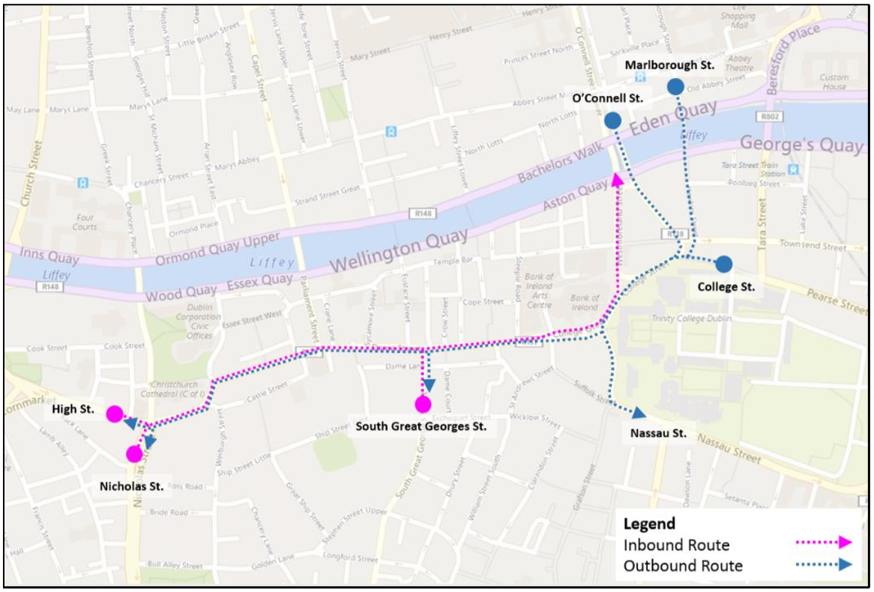
Source: College Green Plaza EIAR, Chapter 6

- Luas: The Luas Cross City, which runs to the east of the site, became operational in December 2017 and operates at an average frequency of one tram (southbound) every 4 minutes during AM and PM peak operating periods Monday to Friday, with one service every 7 minutes on Saturdays;
- Pedestrian Movement: As outlined in the NTA submission to the EIAR, surveys undertaken in 2015 showed 124,000 pedestrians use College Green along north-south axis each day. Pedestrian movements are even higher when east-west movements are considered; and
- Cycling Infrastructure: There are currently limited segregated cycle facilities within the site with cyclists having to mix with general traffic. A two-way contra flow cycle facility is in place on Westmoreland Street at the eastern edge of College Green fronting the Bank of Ireland building as shown in Figure 4.3. Surveys undertaken in 2018 recorded significant daily cyclist movements through College Green, with approx. 6,500 along the east-west axis and approx. 2,800 along the north-south axis. The central traffic island on College Green contains a cycle rack with capacity for circa 29 bicycles. There are two dublinbikes stations near the study area on Exchequer Street and on Fownes Street Upper.

Figure 4.3: Cycling facilities through College Green
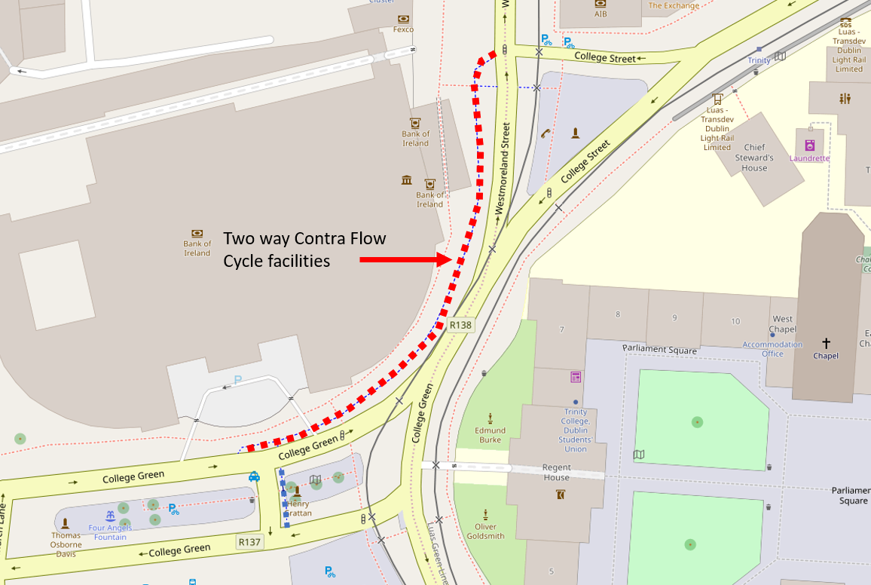
Source: College Green Plaza EIAR, Chapter 6, date

- Taxi: Traffic surveys undertaken in 2019 indicate that there are approx. 7,000 daily taxi movements through College Green along the east-west axis and approx. 1,950 along the north-south axis. There are two taxi ranks in the study area, as follows:
- On College Green adjacent to the traffic island supporting the Thomas Davis statue and Memorial Fountain. This taxi stand is approximately 24 metres long accommodating 5 taxis; and
- On Foster Place which accommodates approximately 9 permanent taxi bays and a further 11-nighttime bays.
- Loading facilities on the original proposal were proposed on the eastern side of Trinity Street, the western side of Church Lane as well as existing facilities on Andrews Street will be maintained. Servicing vehicles along with general traffic was allowed to enter the western part of College Green Plaza and turn within the circus in order to get to and from these loading bays. No service vehicle access was proposed beyond the circus within the eastern side of College Green Plaza.

Proposed Scheme
The original scheme proposed for College Green Plaza is illustrated in Figure 4.4. The scheme was submitted to An Bord Pleanála (ABP) for planning approval in October 2017 but was subsequently refused permission in September 2018. A summary of the scheme as outlined in the various planning documents and Inspectors reports is as follows:

“The proposed civic plaza would extend west-east from the junction with Anglesea Street to the front of Trinity College and north-south from College Street to the end of Grafton Street. It would occupy an area of c 7300m² with a maximum length of 63m (east-west) and a maximum width of 34m (north-south).

The space would be divided into three distinct zones from east to west, as follows;

- A ‘circus’ on the axis of Foster Place and Church Lane (diameter circa 24.5m). It would separate the pedestrian priority area to the east from a more conventional street arrangement to the west. The centre of the ‘circus’ would accommodate the relocated Thomas Davis monument with the Four Angels fountain. The ‘circus’ would provide a turnaround for the limited traffic entering from Dame Street;
- The east end would be designed as a fully pedestrianised space framed by the facades of the Bank of Ireland and Trinity College. It would accommodate a new central water fountain feature and the space would be available for events and celebrations. The existing Henry Grattan statue would remain in this area, its position largely unchanged, except for a minor adjustment to align with the axis of the Plaza; and
- Foster Place would be developed as a pedestrian priority square framed by London Plane trees.”
Figure 4.4: Original Proposed Scheme (2017)
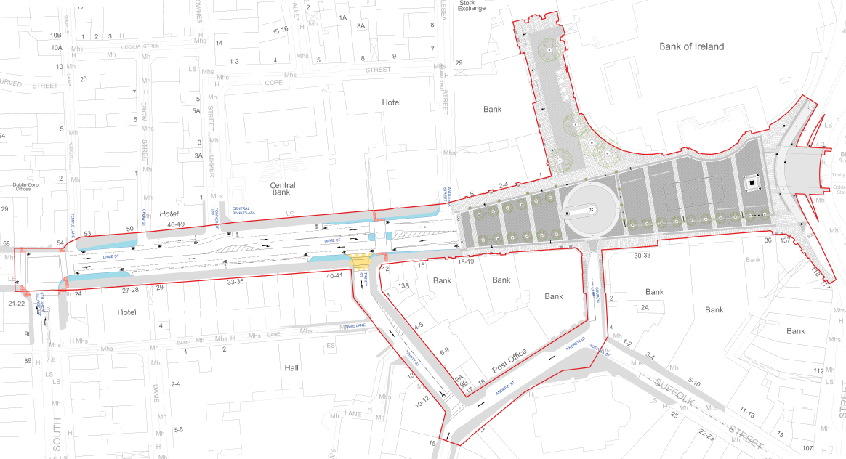

The Inspector stated that “the development of the pedestrian orientated space would necessitate the implementation of new traffic management measures, including the re-routing of buses, removal of taxi ranks, provision of new taxi ranks, provision of loading bays, cycle lanes and new signage (to direct traffic away from College Green, bus passengers to new stops and taxi customers to relocated ranks). Parliament Street will be restricted to public transport only from 7am to 7pm Monday to Friday”. (source: ABP Inspectors Report page 10).

Figure 4.5 shows the general multi-modal movement strategy for the Scheme as outlined in Chapter 4 of the EIAR.
Figure 4.5: General Movement Strategy
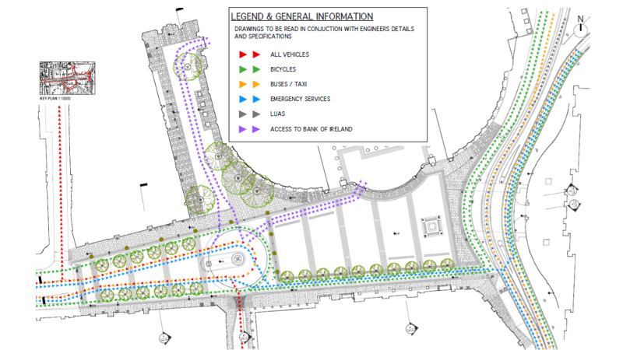
Source: College Green Plaza EIAR, Chapter 4

Buses currently using Dame Street to cross the city were to be diverted onto other routes, while buses which continue to access bus stops on this section of Dame Street were to turn at College Green using a new turning circle at the junction of Foster Place and Church Lane. Buses currently using South Great George’s Street before passing through College Green (and vice versa) were to be rerouted as shown in Figure 4.6.

Figure 4.6: Bus rerouting for services currently using South Great Georges Street to College Green
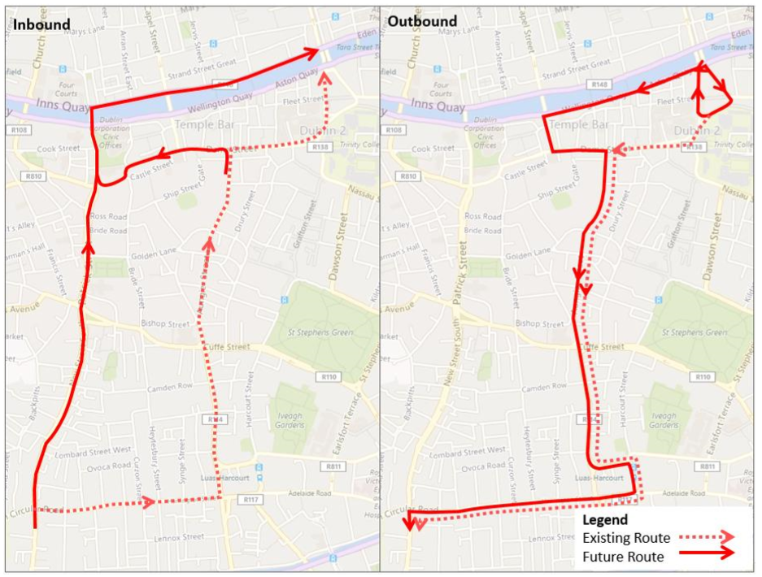
Source: College Green Plaza EIAR, Chapter 6, ARUP

Bus routes that currently pass through College Green, other than those using South Great George’s Street, which do not terminate / originate in the vicinity were to be rerouted to the Quays as indicated in Chapter 6 of the EIAR and as shown in Figure 4.7 below.

Figure 4.7: Bus Rerouting for services not using South Great George’s Street
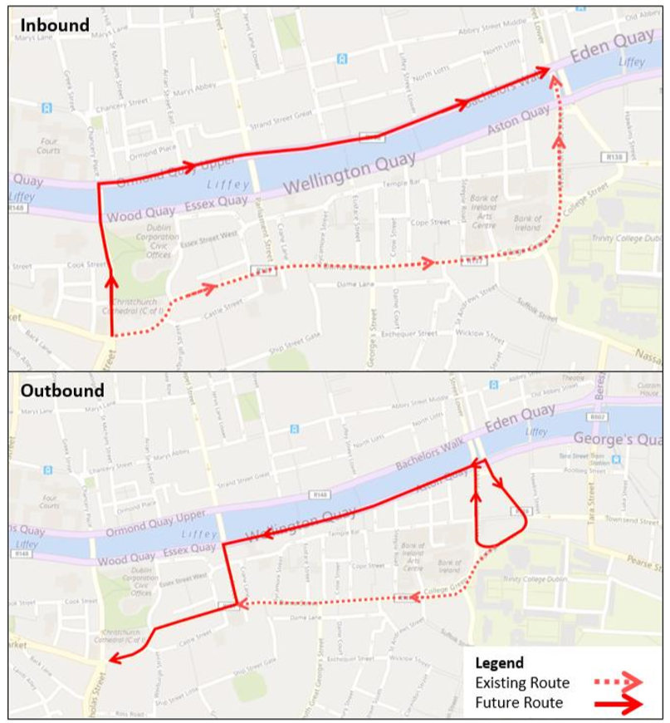
Source: College Green Plaza EIAR, Chapter 6, ARUP

The rerouting of buses would have resulted in the relocation of bus stops in the study area to alternative locations along the new routes. The scheme included a dedicated two-way cycle track on the eastern and southern sides of College Green Plaza, shown in Figure 4.8. On Dame Street, an east and west bound cycle track would be provided in both directions. A total of 32 bicycle parking spaces were proposed within the Scheme.

Figure 4.8: Cycle facilities for Option 1 in the Plaza
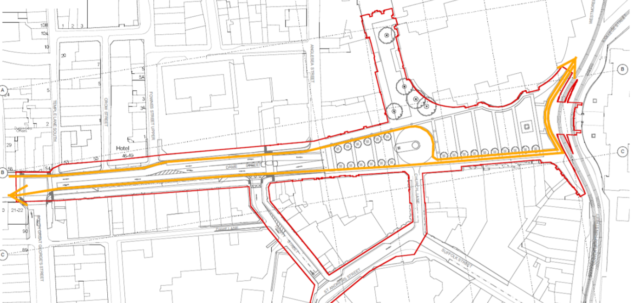
Source: College Green Plaza EIAR, Chapter 4,
The existing permanent taxi rank on College Green was to be relocated to Dame Street with capacity increased from 5 taxis to 8. The existing night-time rank with capacity for 3 taxis on the northern side of Dame Street would be converted to a permanent taxi rank. Additional night-time taxi capacity, equating to 21 spaces, would also be provided through the use of proposed loading bays on Trinity Street, Church Lane and Dame Street.

A single lane carriageway was proposed east and west bound on Dame Street between the junction of George’s Street and Anglesea Street. In the vicinity of the junction with Trinity Street there is a right turn pocket provided for general traffic.

The scheme did not propose any amendments to Anglesea Street/ Cope Street / Fownes Street Upper.

An Bord Pleanála Decision
Following refusal of the proposed College Green Plaza by An Bord Pleanála, the following feedback was provided by the Planning Inspector:

“It is considered that the principle of the proposed development is acceptable and that it would produce a quality public realm that would significantly enhance the amenity and attractiveness of this city centre location, would significantly improve the visual amenities of the area and would facilitate improved appreciation of the architectural and cultural heritage of this important site”.

A summary of the Inspector’s findings, as outlined in Section 11 of that report dated the 17th September 2018 is set out below:

- The principle of the development is acceptable;
- The scheme would produce a quality public realm which will significantly enhance the amenity and attractiveness of this city centre location;
- The proposal would result in significantly improved facilities for pedestrians and cyclists;
- The proposal offers a significant improvement to the visual, cultural and heritage appreciation of the space;
- The impact outside the site for general traffic and specially bus traffic is significant and negative. The inspector’s report noted “significant shortcoming” in the modelling work undertaken that “undermines its reliability in terms of identifying the extent of traffic impacts arising from the proposed development”;
- The transfer of buses and associated passengers to the Quays was not adequately justified and its impacts are likely to be significant and negative;
- The impacts of the scheme for servicing, access to parking and taxis was acceptable; and
- The air and noise impacts could be adequately mitigated.

Summary
The original proposal for the College Green Plaza was to transform College Green and redefine the area as a civic space of national importance. The scheme proposed for College Green Plaza was refused permission by An Bord Pleanála in September 2018. The ABP Inspector’s Report concluded that, while the scheme would produce a quality public realm which will significantly enhance the amenity and attractiveness of this city centre location and result in a significantly improved facilities for pedestrians and cyclists, the impact outside the site for general traffic and especially bus traffic is significant and negative.

College Green is currently an important route for pedestrian and cyclist movements. The original scheme aimed to alleviate congestion in the area by barring all traffic travelling in an east-west direction across College Green, thereby providing an uninterrupted pedestrianised route from St. Stephen’s Green to the quays and providing cyclists with a designated cycle track which will physically separate the cyclist from Luas and bus movements. To facilitate the proposed scheme a number of existing bus routes would need to be re-routed.

Bus Connects Proposals for City Centre
BusConnects is the NTA’s programme to greatly improve bus services across the Dublin region. The aim is to deliver an enhanced bus system that caters for existing and future demand in a more reliable and efficient manner, that is better, for the city, its people and the environment. The aim is to run more buses, more often to more places to increase the reach of bus services and greatly increase patronage, thereby facilitating a reduction in car borne journeys and congestion. The BusConnects programme is made up of a number of strands including the Core Bus Corridors Project and Network Redesign. It is the latter BusConnects Network Redesign programme that will impact on bus movements within and adjacent to the Scheme.

The BusConnects Network Redesign will be introduced in phases. The current plan is for the first phase to be implemented in early 2021 with full roll-out of the network taking approximately two years to complete. There are significant changes proposed to the bus network in the City Centre area, including within and adjacent to the scheme area. Table 5.1 outlines the routes that are proposed to pass through the scheme area, and their frequencies, while Figure 5.1 shows the BusConnects network in the vicinity of the scheme location.

Table 5.1: BusConnects routes and services passing through the scheme area
Route | Description | Peak Frequency
A1 | Beaumont - City Centre - Knocklyon | Every 12 mins
A2 | Airport - City Centre - Ballinteer - Dundrum | Every 12 mins
A3 | DCU - City Centre - Tallaght | Every 12 mins
A4 | Swords - City Centre - Dundrum | Every 12 mins
71 | Tallaght - Ballymount - Warrenmount - East Wall | Every 30 mins
72 | Drimnagh - Warrenmount - East Wall | Every 30 mins
73 | Marino - City Centre - Walkinstown | Every 10-15 mins
85 | Tallaght - Ballyboden - Harold's Cross - Parnell Square | Every 10-15 mins
Source: BusConnects Network Dublin

Figure 5.1: BusConnects Network in the vicinity of the scheme
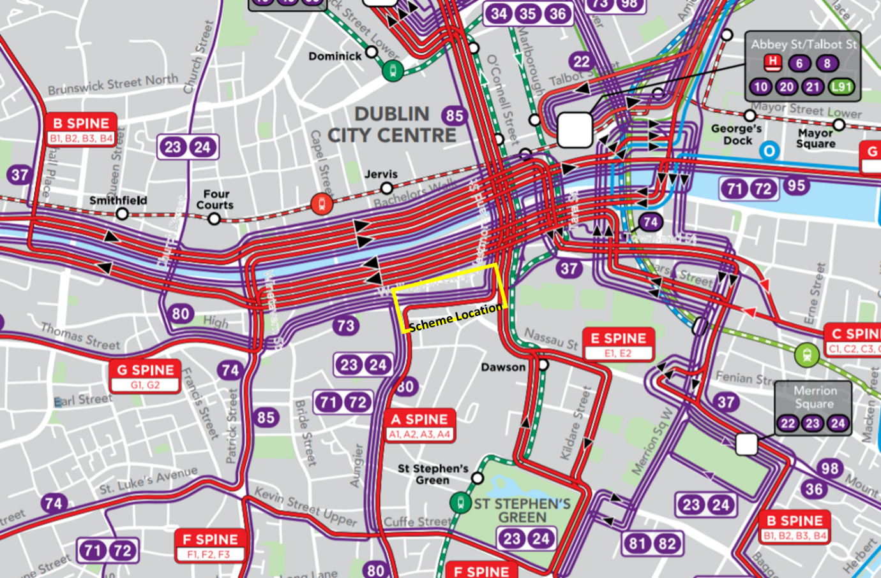
Source: BusConnects Network Dublin

In a submission to the non-statutory public consultation for a previous version of the proposed redesigned Bus Connects Network, DCC proposed a number of amendments to the routes that are proposed to pass through the scheme area, these included:

- Moving services on the “A” Spine and the 71/72 routes away from George’s Street and Dame Street using the Dawson Street / Kildare Street route instead to connect to Camden Street at Wexford Street and Harcourt Street; and
- Moving east-west services, such as Routes 73 and 85 away from Dame Street, to run via Winetavern Street and along the Quays.
The effect of these options would result in the removal of all bus services associated with the BusConnects redesign from the College Green Plaza area. With the rerouting of services along other corridors this would remove one of the major concerns outlined in the Inspectors report and the decision to refuse the original proposal. This bus solution would also free up space within the Scheme for other uses.

In the 2019 Report on BusConnects Consultation, it was recognised that DCC’s proposals had potential benefits for the BusConnects Network, by spatially segregating the operation of bus services within the City Centre area, with less merging of north- south and east–west bus movements.

As such, two arrangements have been developed for bus movement through the College Green area, one arrangement to apply to the existing operations, and the second being an indicative arrangement to be implemented in the event of full pedestrianisation of College Green. Figure 5.2, below, illustrates the indicative bus network arrangements following the pedestrianisation of College Green. The report notes that these arrangements are subject to further revision in conjunction with the development of the College Green proposals by Dublin City Council.

Figure 5.2: Indicative BusConnects Network in the City Centre following Pedestrianisation of College Green
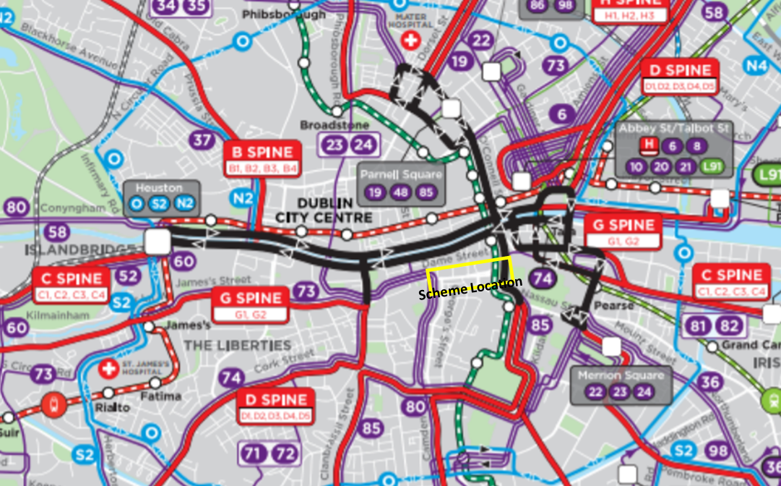
Source: Report on BusConnects Consultation (NTA, 2019)

College Green Trials
DCC organised three trial events at College Green during Summer 2019. The events allowed the public to enjoy a traffic free environment at College Green between 12pm and 4pm on three consecutive Sundays, the 21st of July, 28th of July and 4th of August.

A road closure was in place for each Sunday from 7am to 7pm to allow for the set up and removal of each event. These events also provided an opportunity for data to be collected and observations to be made on how the car free day was used and the impacts on all transport modes and movements in and around the area.

DCC produced a report outlining details from the three trail events entitled “Summer Days at College Green”. Relevant details from the report are set out below.

Arrangements
The arrangements delineated the pedestrian space using barriers as shown in Figure 6.3 and 6.4. For the first event, Figure 6.1, the trial area was from Foster Place to the pedestrian crossing at College Green. For the subsequent two events, Figure 6.2, the event space was increased and extended to Anglesea Street, following feedback and review from the first event.

Figure 6.1: Extent of Trial Area – Event 1 | Figure 6.2: Extent of Trial Area – Events 2 & 3
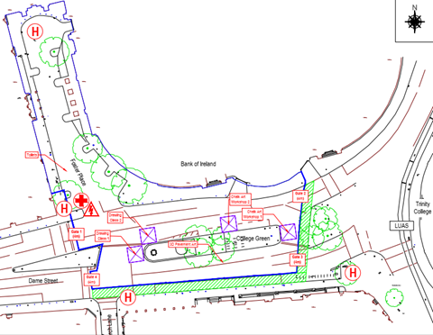 | 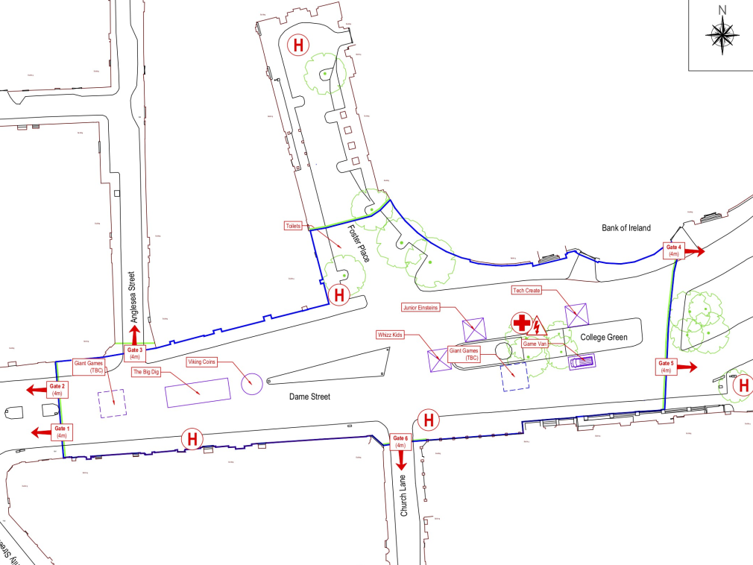
Figure 6.3: Barrier arrangements on Dame Street | Figure 6.4: Pedestrian use of the event space
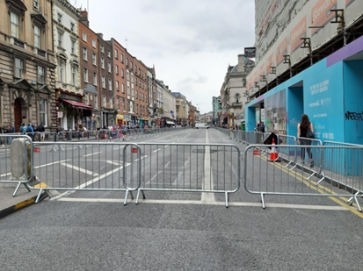 | 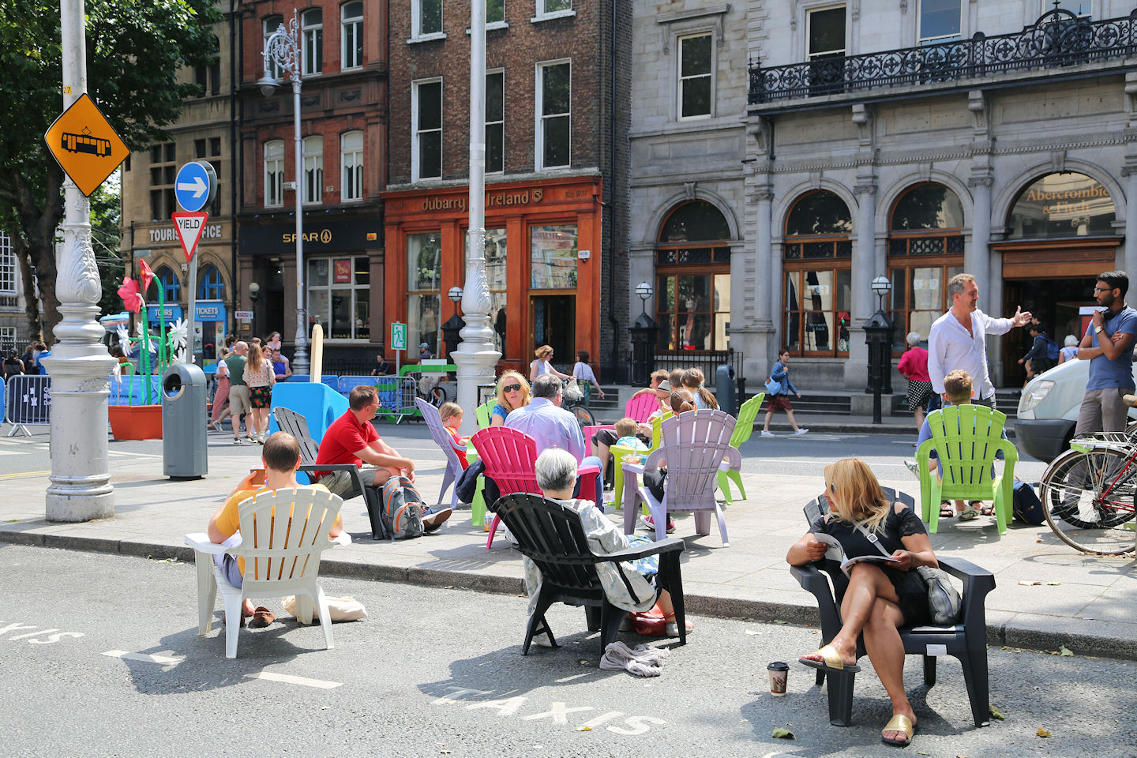

For the first trial event, a 2m cycle track was provided, segregated from the event space. For subsequent events, cyclists were requested to dismount at either end of the event space and walk their bike through the space.

For all three events:

- Westbound general traffic was diverted to the South Quays and Upper Dame Street. Eastbound traffic coming from the Christchurch direction was permitted to turn right at junction of Georges Street/Dame Street. Access to car parks was from Georges Street. Northbound and southbound traffic at College Green was unaffected;
- Buses were diverted onto the quays with eastbound buses using Winetavern Street and the North Quays and westbound buses using the South Quays and Parliament Street. At the George’s St/Dame Street junction all traffic including buses turned left from George’s St and from Dame St all traffic turned right onto George’s Street; and
- The taxi ranks at Foster Place and College Green were closed from 7am to 7pm and relocated onto D’Olier Street.
Figure 6.5 shows diverted bus movements that took place during the trial event and Figure 6.6 shows the space being enjoyed by pedestrians during the closure.
Figure 6.5: Buses turning on to Parliament Street | Figure 6.6: Pedestrian use of the event space
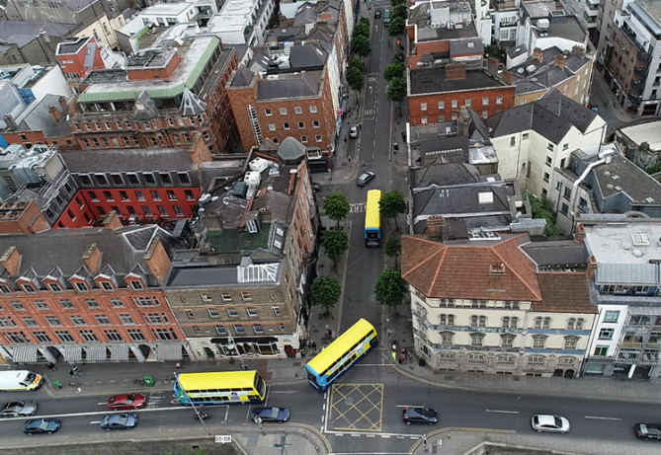 | 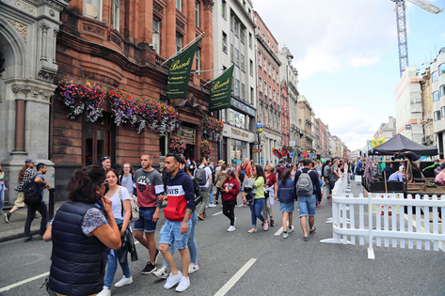

Impacts
DCC has documented a number of observations from the events as follows:

Pedestrians
An estimated 10,000 and 8,000 pedestrians passed through the event space on the first and second trial event days. There where are no details available of pedestrian usage on the third trial event. No issues were raised in relation to how pedestrians used the space or interacted with other road users.

Cyclist
There is limited data available relating to cyclist activity during the trials.

Buses
Bus journey times were recorded on each trial event day and compared to recorded journey times on a day under normal operations. A comparison of the recorded journey times showed general increases in journey times on the event days. Most increases were up to 5 minutes however there were some periods where delays on particular routes were over 10 minutes. In general, most of the increases in journey time occurred during the period 12:00 – 14:00. It should be noted that the trial events took place on a Sunday and so the scale of bus operations would not have been representative of a typical weekday.

Servicing
All premises on Dame Street and College Green were visited to ascertain if they had deliveries on a Sunday. For those business with Sunday deliveries, servicing was permitted on the trial days up to 11am.

Taxis
The taxi ranks at Fosters Place and College Green were closed from 7am to 7pm during the trial events and temporary taxi rank provided on D’Olier Street. The report stated that the observations of the temporary taxi rank showed a poor uptake by taxis of this facility.

Drone footage, captured during the trial events, showed:

- No congestion at College Green at Trinity, Westmoreland Street or D’Olier Street on the eastern edge of the College Green outside of the road closure;
- No traffic congestion or bus congestions on the South Quays (1pm);
- Queuing of general traffic on Bachelors Walk at 13:00;
- Slow moving general traffic on the north quays;
- No bus congestion/queuing on the north quays;
- Large number of private vehicles using or parked in the bus lanes; and
- No issues with buses taking the left turn onto Parliament St.
Two surveys were undertaken during the trial events. The first (by the DCC commissioned event management company) surveyed 50 individuals at random at College Green and the second (by Dublin Town) who surveyed 47 businesses in the area after the third event. Respondents of both surveys were asked if they would like to see the area permanently pedestrianised. The response from the public was overwhelmingly positive, with 92% of individuals in favour of the trial, while 53% of businesses were in favour of the trial.

Conclusion
In their assessment of the impact of the events, DCC concluded that:
- As trialled in the first event, the amount of pedestrianised space in the original College Green Plaza proposal is not significant, and consideration should be given to extending the space if possible. An extended space was trialled on both the second and third Sunday and worked better in terms of pedestrian movement;
- On the first event day, the interaction between cyclists and pedestrians was not successful and the pedestrian and cyclist delineation should be re-examined with the possibility of segregation for cyclists explored;
- The proximity of the proposed bus turning circle to the pedestrianised space should be revisited as it would potentially negatively impact on the area;
- Some bus journey times were slightly increased for some of the routes diverted onto the quays but there were no issues with pedestrian capacity at Bachelors Walk or Aston Quay. The bus movements at the Dame St/South Great George’s St junction worked well and there were no issues with left turning buses into or from Parliament Street. Again, it should be noted that the trial events took place on a Sunday and so bus operations would not have been representative of a typical weekday: and
- The north/south corridor in front on Trinity was improved with an increased benefit to pedestrians crossing at this location facilitated by additional green time, as well as improvements to the Luas operations due to the ban on east west movements of buses in front of Trinity College.

Revised Scheme Options for College Green
Since refusal of the original scheme for College Green Plaza in 2018, DCC has developed four alternative scheme options which aim to:

- Take cognisance of the original application and subsequent Inspectors report (set out in Section 4.4);
- Optimise the value of lessons learnt from trial closures of the space to vehicular traffic during the summer of 2019 (set out in Section 6); and
- Incorporate the proposed bus Network Redesign as part of Bus Connects which has changed the requirements for bus movements in the area (set out in Section 5).
The revised options are summarised as follows:

- Option 1 – This is the original College Green Plaza design that was submitted as part of the previous planning application as presented in Section 4;
- Option 2 – Feedback from the Planning Inspector was taken into account to incorporate a west to east bus lane within the original scheme design;
- Option 3 – This option increases the area of pedestrianisation and removes all buses from the Scheme. The main pedestrianised area would be the Core Plaza, with enhanced pedestrian facilities located on the Outer Plaza. This option provides vehicular access for deliveries and to car parks;
- Option 4 – This option proposes the full pedestrianisation of the Scheme from the junction of Dame Street / South Great Georges Street to Westmoreland Street. In this option all buses are removed from the Scheme. Some limited, controlled vehicular access would be allowed in the Scheme Servicing access would be provided during the early morning and late evening periods for businesses fronting the Outer Plaza similar to existing arrangements for Grafton Street; and
- Option 5 – This option increases the area of pedestrianisation similar to Option 3 and allows bus movement in a west to east direction with a bus lane on the northern side of the space which also facilitates emergency vehicle access.
Detailed drawings for each option are presented in Appendix B and a more detailed description of each option is provided below.

All options would allow vehicular access to Bank of Ireland (BOI) located in the Core Plaza area off Foster Place. For all options it is assumed that vehicle movements to and from the BOI would be the same.

It should be noted that Options 3 and 4 are proposed for a post bus network redesign scenario and assume that a favourable and efficient alternative for the routing of buses through the area has been implemented. As such, redevelopment at College Green is facilitated by the diversion of bus services.

Option 2 - Original College Green Plaza design with a westbound bus lane
This option, shown in Figure 7.1, is a variation of the original College Green Plaza design with the provision of a west to east bus lane and has been developed to reflect feedback provided by the Planning Inspector. The extent of the pedestrianised area and the traffic management arrangements remain unchanged. The through movement of buses would negate the requirement for the turning circle, which would be removed from the design. As per Option 1, some vehicular access through the Core Plaza would be allowed to facilitate access to existing car parks of Bank of Ireland.

Option 2 allows for bus movements from Dame Street towards Westmoreland Street. For this option it is assumed that the same frequency of eastbound bus movements as currently experienced (70 buses per hour at present, 12 buses post bus connects) would move through the Scheme. The bus lane runs through the Core Plaza, starting at the eastern side of College Green Plaza at the junction of Dame Street / Anglesea Street and runs along the northern side of the Core Plaza to Westmoreland Street. Bus stops are located on Dame Street in the Outer Plaza.

Eastbound cyclists from Dame Street would use a 60mm raised kerb through the Scheme. Due to space limitations, the facility would then divert to the southern perimeter of the Core Plaza. This would require cyclists to cross the proposed bus lane twice. A signalised pedestrian crossing would also be required. Loading and parking access in the vicinity would be maintained.

Figure 7.1: Option 2 General Arrangements and Layout
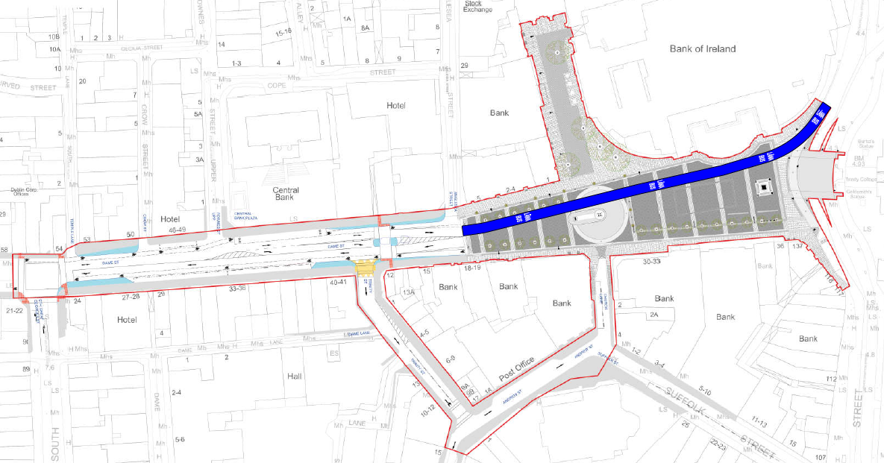

Option 3 – Increased pedestrianisation and removal of buses
This option increases the pedestrianised area and removes all buses from the Scheme as shown in Figure 7.2. The Core Plaza between Anglesea Street and Trinity would continue to be the main public and civic area. The Core Plaza would be fully pedestrianised from the cycle track to the Bank of Ireland. There would be enhanced pedestrian facilities located on the Outer Plaza encompassing Dame Street between the junctions with Anglesea Street and South Great George’s Street. The width of footpaths on the north and south side of Dame Street are extended with a significantly reduced carriageway provided, in comparison to Option 1 and 2.

Bus services would be redirected onto alternative routes. With no buses turning in the Scheme there is no requirement for the turning circle which would be removed.

In this option, vehicular access for deliveries, taxis and local car parks would be allowed in the Outer Plaza. Vehicular access would be provided by dedicated carriageways with kerbs as indicated in Figure 7.2.

A right turn to Trinity Street is provided for access to parking and loading. This requires vehicles to cross a two-way cycle track.

Trinity Street (south bound only) is designated as a loading route to serve businesses in the area with a route through to Andrew Street, Suffolk Street and Grafton Street available between 6am and 11am only. Bollards will be in place on Suffolk Street from 11am to ensure compliance.

As per all options vehicular access and egress to the Core Plaza will only be provided to the front car park at Bank of Ireland. This will be controlled access and a route will be delineated using public realm measures. Traffic management measures including bollards will limit access to the Core Plaza area beyond Anglesea street.

A 4m two-way segregated cycle facility with a 60 mm kerb is provided through the Plaza running from the junction of South Great George’s Street to Westmoreland Street. The facility runs parallel to the carriageway as far as Anglesea Street where it runs through the southern side of the Core Plaza to Westmoreland Street. The two-way cycle track continues up to South Great George’s Street. Here, the track splits into a single lane cycle track with westbound cycle provision provided on the southern side of Dame Street and eastbound cycle provision on the north side of Dame Street.

Church Lane would be closed under this option and will provide cycle facilities to link the cycle track at the Core Plaza to the Grafton Quarter area.

Figure 7.2: Option 3 General Arrangements and Layout
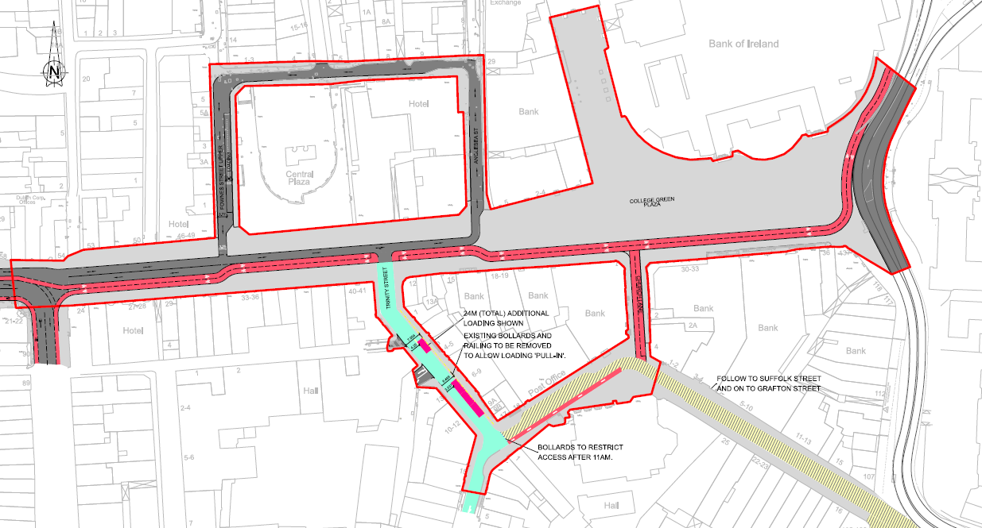

Option 4 - Further extended pedestrianisation, removal of buses and reduction of traffic through controlled vehicular access
This option proposes the pedestrianisation of the scheme from the junction of Dame Street / South Great George’s Street to Westmoreland Street as shown in Figure 7.3. As in Option 3, the Core Plaza between Anglesea Street and Trinity will continue to be the main public and civic area and would be fully pedestrianised from the cycle track to the Bank of Ireland. In this option, the Outer Plaza would operate as a “shared space” where pedestrians have priority over vehicular traffic. In a shared space design there is no segregation, such as kerbs, carriageways, road surface markings, signage, etc., between pedestrians and vehicular traffic. The shared space design would be located on Dame Street, between the junctions with Anglesea Street and South Great George’s Street. It should be noted that a shared space approach is opposed by disability groups representing the bling, partially sighted and deaf people.

Bus services would be redirected onto alternative routes. As with other similar options, with no buses turning in the Scheme there is no requirement for the turning circle which would be removed.

In this option the shared space design would maintain vehicle access in a more informal way with no designed carriageways. Different vehicle access arrangements would be in place through the Scheme. As in all options vehicles requiring access to Bank of Ireland car park would be allowed to access and egress through the Scheme throughout the day. Access for service vehicles for the purpose of loading and unloading would only be allowed in the Outer Plaza. Service vehicle access would be limited to certain times of the day, such as the early morning, in a similar approach to the servicing arrangements on Grafton Street and Henry Street. At all other times no access for service vehicles would be allowed. This servicing and access strategy would be controlled by appropriate traffic management measures, including bollards at the South Great George’s Street junction, and traffic orders.

In this option no taxis would be permitted in the Scheme.

Church Lane would be closed under this option and will provide cycle facilities to link the cycle track on the Core Plaza to the Grafton Quarter area.

A 4m two-way segregated cycle track on a 60mm kerb would be provided along the southern edge of the Scheme. At the eastern end of the Core Plaza it follows the Luas line to meet Westmoreland Street.

Figure 7.3: Option 4 General Arrangements and Layout
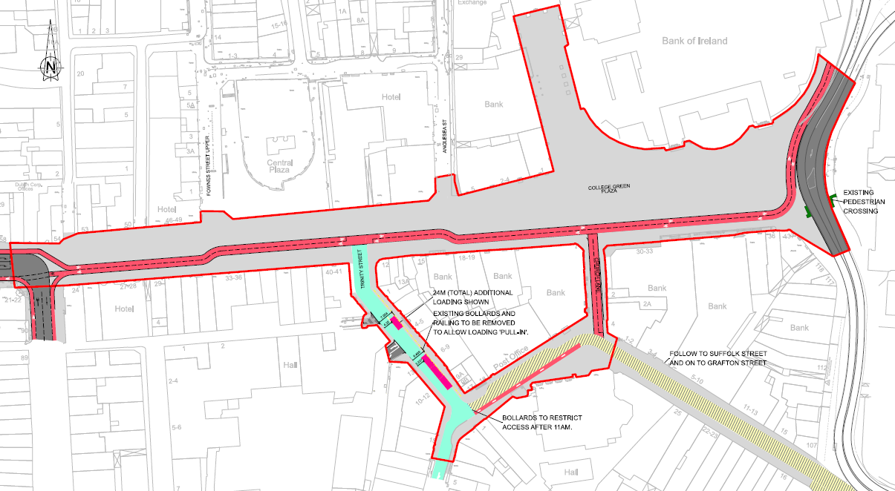

Option 5 - Extended pedestrianisation with bus access
This option is a variation of Option 3, with a bus lane running through the Core Plaza facilitating west to east bus services reflecting feedback of the Planning Inspector. This option is shown in Figure 7.4. The proposed bus lane commences at the junction of Dame Street / Anglesea Street and runs to Westmoreland Street. A bus stop is provided on the Outer Plaza on Dame Street between Anglesea Street and Fownes Street. With no buses turning in the Core Plaza there is no requirement for the turning circle, which is not included in this option.

Similar to Option 3, loading access would be provided throughout the day on Outer Plaza with vehicles egressing the space using the Anglesea Street to Fownes Street loop. A right turn to Trinity Street is provided for access to parking and loading. This requires vehicles to cross over a two-way cycle track. At the junction of Dame Street and Anglesea Street the road terminates with no further access for east bound vehicles, except buses through the Core Plaza.

A 4m wide two-way cycle facility with a 60 mm kerb is provided through the Scheme running from the junction of South Great George’s Street to Westmoreland Street. The facility runs parallel to the carriageway to Anglesea Street where it runs through the southern side of the Core Plaza to Westmoreland Street. At the western end of the Scheme, the two-way cycle track splits into a single lane cycle track with west bound cycle provision provided on the southern side of Dame Street and east bound cycle provision on the north side of Dame Street.

Trinity Street (south bound only) is designated as a loading route to serve businesses in the area with a route through to Andrew Street, Suffolk Street and Grafton Street available between 6am and 11am only. Bollards at the junction of Trinity Street and Andrew Street will be in place from 11am to ensure compliance. The Trinity Street/ St Andrews Street/ William Street South corridor would provide another loading route, particularly when the time restriction on entry toward Grafton Street are in place.

Figure 7.4: Option 5 General Arrangements and Layout
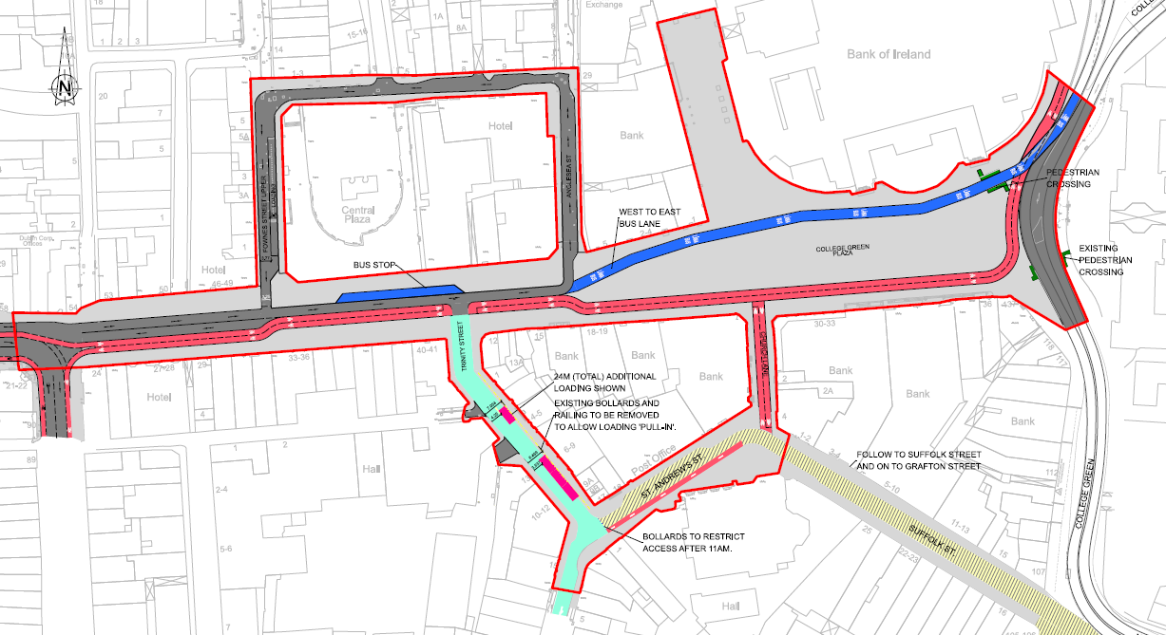

MCA Results
Results of the MCA are presented in Table 8.1. In general, the options that limit vehicular activity within and through the Scheme performed better than those options with higher vehicular movement across all six of the CAF criteria. The rationale for this is that reduced vehicular activity in the Scheme has a corresponding positive impact on:

- Local environmental factors such as air, noise and visual impact as well as creating a more attractive space to promote recreational and cultural events;
- Accessibility & Social Inclusion, by transforming the Scheme into a more accessible and usable space to be enjoyed by all across societal demographics, ages and abilities;
- Physical Activity, by creating an extended pedestrianised area and thereby facilitating and encouraging greater active travel (walking and cycling) and improved opportunities for permeability and local connections;
- Safety, by reducing the potential for accidents due to a reduced interaction between vehicles with other vulnerable road users, particularly cyclist and pedestrians.
- Integration as it aligns with national, local and regional policies objectives to promote active travel and to reduce reliance on vehicle travel and the adverse impacts of vehicular travel on the environment; and
- Economic uplift through the creation of well-designed space where people want to dwell, relax, enjoy and spend more time in.
In general, options that allowed bus movements within and through the Core Plaza scored negatively across all six of the CAF criteria. The Core Plaza is an area of heavy pedestrian and cycle movements with a high civic function and the movement of buses through it reduces the usability of the spaces and results in severance to movements that produces negative scores across the CAF criteria.
The following sections provide some commentary and context to the scoring of each option against each of the six CAF criteria.

Environment
For this criterion, the impact of air quality and noise and vibration have been assessed across the Scheme. In the two sub-criteria of Landscape & Visual Quality and Cultural, Archaeological and Architectural Heritage the comparative assessment relates to the Core Plaza only. The rationale for the latter is that the Core Plaza includes the main civic zone and the area of greatest cultural, archaeological, architectural and heritage assets and value, therefore the area is most sensitive to these sub-criteria environmental factors.

The main environmental differentiating factor between the options relates to the level and content of vehicular traffic passing through the scheme. Vehicular transport is a major contributor to harmful environmental emissions, including Nitrogen Oxides (NOx) made up of nitrogen oxide (NO₂) and nitrogen dioxide and Particulate Matter (PM₁₀ and PM₂₅). The noise and visual pollution that results from vehicle movement along with harmful emissions can make a place less attractive for people to dwell, enjoy and relax as well as having a significant adverse impact on the built environment. Therefore, the options which reduce and/or remove vehicular traffic from the Scheme scored more positively in this criteria than those with higher levels of vehicles.

All options allow some vehicular access through the Core Plaza to facilitate access to local car parks such as Bank of Ireland. Similarly, in all options there is no servicing allowed in the Core Plaza. However, Option 1, 2 and 5 also allow bus movements through the scheme and in the case of Options 2 and 5 there is a provision of a west-east bus corridor through the Core Plaza area. The level of traffic movements permitted in the Outer Plaza differ significantly between the five options.

Both Option 3 and Option 4 have no through bus movements within the Scheme and allow identical vehicular movements through the Core Plaza to access local car parks (as do all the options) and therefore score positively in this criteria. However, there are differences in the level of vehicular movements and the control on entry between Option 3 and Option 4 in the Outer Plaza. With Option 4, vehicular access for service vehicles would be controlled and limited to certain times of the day and no through taxi access would be allowed. While with Option 3, service vehicle and taxis would be allowed in the Outer Plaza throughout the day. Option 4 therefore has a slightly reduced vehicular impact than Option 3 that resulted in it having a positive score of +2 in this criteria versus +1.6 for Option 3.

Options 2 and 5 show significant comparative disadvantage to the other options and therefore scored negatively across all environmental sub-criteria In both these options the presence of a west to east bus lane and associated bus movements through the Core Plaza area was considered to result in significant adverse environmental impacts in comparison to the other options.

Option 1 also scored negatively. The environmental impact of buses turning at the circus located at the western end of the Core Plaza is considered to result in adverse impacts, although the peripheral nature of the movements at the edge of the Core Plaza means that these adverse impacts are not considered as pronounced as Option 2 and 5.

Accessibility and Social Inclusion
The Accessibility and Social Inclusion assessment compared the options based on how the designs accommodated vulnerable groups, particularly people with disabilities as well as providing an inclusive space that all communities can enjoy. Options with reduced vehicular presence performed better in this criterion by reducing the potential conflict points with vulnerable groups and the potential to reallocated road space to other uses for a range of societal groups.

In the assessment of this criteria, both Options 3 and Option 4 were deemed to show significant comparative advantage over the other options. The rationale for this is that vehicle volumes across the Scheme and in particular in the Core Plaza are lower than the other options and there are less potential conflict points between vulnerable road users and vehicular traffic. Combined with the increased level of pedestrianisation across the Scheme (in particular in the Outer Plaza), this allows the space in these options to be designed in a more inclusive way for a range of societal groups.

Although both options have a comparable overall score for this CAF criteria, there was some variation between the two options at the sub-criteria level, as set out below.

While both options have an identical design in the Core Plaza, their design approach and movement characteristics differ in the Outer Plaza. Both have significantly increased levels of pedestrianisation, however, in Option 3 vehicle movement trough the Outer Plaza is facilitated by a standard design of footpaths, kerbs and carriageway, while in Option 4 the Outer Plaza is designed as a shared space with no delineation between pedestrians and vehicles. As noted in their submission to the Original Planning Application and at the Oral Hearing, disability groups expressed concerns over the safety of a shared surface approach. Therefore, Option 3 achieved a comparatively higher score than Option 4 in the sub-criteria of creating an environment that is accessible for people with disabilities.

In the sub-criteria of providing a vibrant socially inclusive space for all to rest and enjoy, the assessment showed that the shared space design of Option 4 in the Outer Plaza, provides a greater flexibility and opportunity to reallocate this space for a wider range uses to meet a wider range of societal needs. Therefore Option 4 had a comparatively higher score in this sub-criterion than Option 3.

The result of combining the two sub-criteria scores is that Option 3 and Option 4 achieve an equal score for this CAF criteria of +1.5.

Options 2 and 5, with higher traffic movements and bus services allowed through the Scheme and in particular the Core Plaza, presented significant comparative disadvantages to the other options as this creates a barrier for people with disabilities users to move through the space and reduces the opportunities for users to rest and enjoy the space making their designs less inclusive.

Option 1 also scored negatively in this criterion due to the presence of bus and vehicular turning movements at the circus at the western edge of the Core Plaza in front of Foster Place. In our assessment, this creates a barrier to movement and is potentially a significant conflict point at this key juncture in the scheme. This would adversely impact vulnerable groups and reduces the potential of the space to be as inclusive in comparison to other options. In the assessment the disadvantage of this option was not considered as pronounced as Options 2 and 5.

Physical Activity
Under this criterion, options that provide the greatest opportunity to optimise active mobility (walking and cycling) within and across the Scheme were considered to present comparative advantage over other options. Options with reduced vehicular and bus movements across the Scheme would reduce barriers to active travel and therefore score more positively in this criterion.

Option 4 presents the greatest advantage in this criterion. Vehicular movements across the Scheme in this option are less than the other options. In particular, the shared space design in the Outer Plaza and controls on vehicular access to this space is likely to provide the greatest opportunity to encourage physical activity. In particular, the lack of an east-west carriageway in the Outer Plaza is considered to provide enhanced opportunities for improved north -south connectivity across Dame Street that is not met by other options.

Option 3, with a similar design approach to Option 4, also shows some comparative advantages in this criterion. Both options were considered to optimise cycle movement within the Scheme. Although Option 3 has a slightly greater conflict point than Option 4 at the junction of Dame Street / Trinity Place this difference was not considered significant and both options had a comparable score. For Option 3, in the sub-criteria of optimising pedestrian movement, the presence of a carriageway on Dame Street in the Outer Plaza is considered to supress north-south pedestrian movement in comparison to Option 4 resulting in a lower score in this sub-criterion.

Options 2 and 5 have higher vehicular movements through the scheme than Options 4 and 3. Both options allow bus movement to occur throughout the Scheme and through the Core Plaza creating a north-south barrier and severance that could suppress active travel. The impacts on active travel are particularly pronounced in the Core Plaza where 2018 pedestrian counts show that the north-south flows are the predominant movement at this location.

Option 1 also showed some comparative disadvantages in comparison to Options 4. This is based on the assessment that buses, taxis and general traffic travelling westbound along Dame Street would turn at the circus located at the western extent of the Core Plaza creating a potential barrier that would discourage active travel. This adverse impact is not as pronounced as in Option 2 and 5 as it occurs on the periphery of the most sensitive area, the Core Plaza.

Safety
The assessment of Safety has been based on the probability of incident reduction and avoidance, particularly for vulnerable road users such as pedestrians and cyclists. Therefore, the options with enhanced pedestrian and cycle facilities, reduced vehicular activity and/or those that reduced the number of potential conflict points between vehicles and pedestrians and cyclist across the Scheme scored more positively.

Option 4 presents the greatest comparative advantage over the other options. There are less vehicular movements in Option 4, across the Scheme, than the other options and the design approach reduces the number of conflict points between pedestrian and cyclists and vehicles. Option 4 is therefore considered the option that maximises accident avoidance and presents greatest advantage for safety.

As Option 3 has a similar design approach to Option 4, it also scored positively in this CAF criteria. . Both Option 3 and 4 were considered to improve cyclist safety across the scheme providing a fully segregated cycle facility with minimal conflict points with vehicular traffic. Option 3 scored less favourably to Option 4 in the sub-criteria of improving pedestrian safety as in this option there is considered to be a higher volume of traffic experienced in the Outer Plaza versus Option 4.

Options 2 and 5 have the highest volume of traffic occurring within the Scheme, including bus movements through the Core Plaza. The presence of buses in the Core Plaza in an area with high pedestrian and cycle flows is would increase the potential for accidents to occur. Therefore Options 2 and 5 showed a significant comparative disadvantage over the other options.

With Option 1, vehicle and bus turning movements around the circus at the western edge of the Core Plaza results in safety concerns for pedestrian and cyclists and hence a negative score in relation to Option 3 and 4. However, as these adverse impacts occur at the periphery of the Core Plaza, this option did not score as negatively as Option 2 and 5.

Integration
The Integration criteria measures the compatibility of the five options to relevant transport, land use and other government policies.

Overall, Options 3 and Option 4 showed some comparative advantage in this CAF criteria. There were considerable differences between the scoring of the options at the sub-criteria level.

The cycle proposals outlined in the GDA Cycle Network Plan for the Scheme are for an east - west primary cycle route (Route 7). As all five options provide a fully segregated east-west cycle route through the Scheme, they are all considered to meet the GDA network plan requirements and therefore have comparable scores.

In relation to Integration with the existing and planned pedestrian network, Options 1, 3 and 4 are considered to be more in line with Dublin City Development Plans objectives to “prioritise the redevelopment of College Green as a pedestrian friendly civic space, including pedestrianisation of Foster Place” as they do not allow through bus movements. These options therefore showed some comparative advantage over Options 2 and 5 which provide a west to east bus lane running through the Core Plaza area that would reduce the pedestrian friendliness of the space in these options.

In relation to integration with the public transport network, Options 2 and 5 that provide a west to east bus corridor through the Scheme, were considered to integrate better with the existing bus network and therefore scored more positively in this sub-criterion. Options 3 and 4 with no bus facilities showed significant comparative disadvantages in this sub-criterion. Option 1 scored positively in this sub-criterion, although not to the same extent as Options 2 and 5 as bus services do not run through the Core Plaza proving a full west -east connection.

The options that scored most positively in land use integration were those that aligned closely with DCC spatial policies for the city centre and Central Spine. With reduced traffic volumes and a greater level of pedestrianisation and extent of public realm improvements across the Scheme Options 3 and 4 are consider aligned better to this DCC policy and therefore scored more positively in this sub-criterion. Options 1, 2 and 5 with higher vehicular volumes and activity in the Scheme were not considered to align as positively with DCC spatial policies and therefore had a similar negative score.

In relation to Other Government Policy Integration, Options 3 and 4 are considered to have some comparative advantage over the remaining options as they seek to prioritise active travel and reduced reliance on vehicular transport through their design approach which is considered to be more in line with the policy approach of National and Regional Policies, specifically NPF, NDP, CAP, E&MRSES. The reaming three options are considered comparative neutral score.

Overall within the CAF criteria of Integration, Options 3 and 4 showed a comparative advantage over the other options. Options 1, 2 and 5 are considered to have a comparable neutral score of zero for the Integration criteria.

Economy
The economic criteria measure the compatibility of the five options against a range of sub-criteria including, transport reliability and quality and other economic impacts.

Delivering a high-quality sustainable transport network to support the adopted economic policy requires the provision of a high-quality pedestrian network, high quality cycle network and a high-quality public transport network.

The quality of the pedestrian network for Option 3 and 4 was considered to be more advantageous due to extended pedestrianisation and the removal of bus services from the Core Plaza. Options 3 and 4 scored more positively in this sub-criterion, while the other options had comparable neutral scores.

All five options provide trip quality and journey time improvements for cyclists. With all options a segregated cycle track in both directions are provided through the Scheme. Based on the current level of design available, the Level of Service (LoS) provided for cyclists in all five options is similar and therefore all options are rated as neutral.

In relation to the provision of a high-quality public transport network, the options were assessed based on their impact on both the bus network and Luas operations. The EIAR (Chapter 6) and the Inspectors Traffic and Transport Assessment (Section 3) noted that proposals that divert buses away from College Green could result in longer delays and journey times for bus services outside the Scheme area. This could undermine confidence in reliability with an impact on patronage. However, these issues may be addressed through the ongoing Bus Network Redesign. For the Luas, there could be some positive impacts for operations as options which remove traffic from College Green would allow dual running of Luas services with an improved quality of service and improved journey time reliability.

In the qualitative assessment, the adverse impact of redirected bus services from College Green are considered to outweigh the positive impact on Luas services with Options 2 and 5 scoring more positively than the other options. These options provide a west-east bus corridor through the Plaza that maintain public transport connectivity. Option 1 also scores positively in this sub-criterion as it facilitates dual north-south Luas operations and provides for some bus connectivity. , However, unlike Option 2 and 5, bus services do not run through the Scheme providing the same quality of service as these options. Although Options 3 and 4, allow for optimal Luas operations, the potentially adverse impact on the bus network means these options score negatively relative to other options in this sub-criterion.

The Other Economic Impacts sub-criteria assessed how the options support the continued economic success of the Scheme to support communities, businesses, visitors and tourists. Previously referenced CABE and Living Streets research, provides evidence of the strong correlation between urban realm improvements and pedestrianisation to improve socio-economic output in central urban areas. The research finds that urban realm improvements and reduced car and bus dominated spaces result in a uplift in footfall, economic spend, property prices and commercial rates. The same factors will make the space more accessible and attractive to tourists by providing a better appreciation of the natural, cultural and heritage assists within the scheme and in particular the Core Plaza. The socio-economic benefits have been found to outweigh any adverse impacts associated with reduced parking or loading restrictions. Therefore, those options that provided a greater degree of urban realm enhancements scored more highly in this sub-criterion.

Both Option 3 and 4 have similarly high levels of urban realm improvements in the Core Plaza. Option 4, with its shared space in the Outer Plaza, is considered to provide a greater extent of urban realm improvements than Option 3 and therefore shows some comparative advantage. Conversely, those options with increased vehicular activity and/or a reduced public realm particularly in the Core Plaza area i.e. Option 2 and 5, had scored negatively. Option 1 had a neutral score in comparison to the other options. The presence of the bus and vehicle turning area at the western edge of the Core Plaza was considered to reduce the economic potential of the area, however, this adverse impact was not considered to be as pronounced as Option 2 and 5.

Overall, across the CAF criteria of Economy, Options 3 and 4 with a positive score (+ 0.5) provide the greatest comparative economic benefits. Option 1 had a positive score of +0.25 and Options 2 and 5 had a neutral comparable score of zero.

Summary of MCA Findings
The results of the MCA show that with a positive score of +8.4, Option 4 presents the greatest advantage across the six CAF criteria. This option includes a further extended pedestrianisation and significant reduction of traffic movements. Option 3 also presents a positive score of +7.

Both options have a similar design approach to how the Core Plaza is treated as a fully pedestrianised area with no through bus movements. The difference between the two options is in how the Outer Plaza area is designed and how various modes are treated through this space along with differing control approaches to certain vehicle movements.

The design approach for Option 4 is a shared surface approach throughout, while Option 3 has a more standard design in the Outer Plaza incorporating footpaths, kerbs and carriageways that delineate space between pedestrians and vehicular traffic. With Option 4, there are controls on when service vehicles can access the Outer Plaza and no taxis permitted, while in Option 3 service vehicles and taxis are not restricted on when they can access the Outer Plaza.

Option 4 showed the greatest comparative advantage in all of the six CAF criteria, namely; Environment, Accessibility and Social Inclusion, Physical Activity, Safety, Integration and Economy. Option 4 scored positively on the basis that:

- Through the complete removal of bus services and a significant reduction in vehicular traffic, this option presents the greatest environmental advantage;
- The reduction in vehicular traffic and increased pedestrianisation this option creates a more accessible and socially inclusive spaces for full spectrum of societal groups;
- The reduction of vehicular presence and creation of an extended pedestrianised area facilitates and encourages physical activity through active travel (walking and cycling) and improved opportunities for permeability and local connectivity;
- The reduction in traffic levels in the Scheme reduces the number of potential conflict points and improves safety for all user, especially vulnerable groups such as pedestrians and cyclists;
- The proposal is more in alignment with national, local and regional policies objectives to promote active travel and to reduce reliance on vehicle travel and the adverse impacts of vehicular travel on the environment;
- The creation of a more coherent, usable, pleasant urban space where users are more likely to linger, enjoy and feel safe creates a greater socio-economic uplift; and
- The shared space design of the Outer Plaza, up to the junction of Dame Street / South Great Georges Street, provides enhanced benefits across a number of the CAF criteria and sub-criteria in comparison to the other options.
Option 3 showed similar scores to Option 4 and a comparative advantage to the other options in three of the six CAF criteria including: Accessibility and Social Inclusion, Safety and Integration. The slightly lower score in comparison to Option 4 is a result of the design approach to the Outer Plaza only. However, the design does present some comparative advantage to Option 4 in providing a space that is more accessible to vulnerable users such as blind, visually impaired and deaf groups.

The options that allowed a greater degree of vehicular access within the Scheme and a west to east bus lane, Option 2 and 5, scored negatively overall (both -7.3) in comparison to the other options. Both of these options scored negatively in four of the six CAF criteria of Environment, Accessibility and Social Inclusion, Physical Activity and Safety. In the other criteria of Integration and Economy, both options had neutral scores. Given the overall negative scores for Option 2 and Option 5 it is not recommended that these options are taken forward for further consideration.

Option 1, the original proposal, had an overall negative score of -0.65. This option scored negatively in three of the six CAF criteria of Environment, Accessibility and Social inclusion, Physical Activity and achieved a positive score in the criteria of Safety, Integration and Economy. Given the overall negative score in three of the CAF criteria and more positive scores achieved for Options 4 and 3, it is not recommended that this option is taken forward for further consideration.

Table 8.1: MCA Scoring matrix for the 5 Options
CAF Criteria | CAF Sub-Criteria | Appraisal Criterion | Appraisal Score
 |  |  | Option 1 | Option 2 | Option 3 | Option 4 | Option 5
Environment | Air Quality | Minimise emissions to provide a high-quality environment within the Scheme | -2 | -1 | 1 | 2 | -1
 | Noise & Vibration | Minimise noise and vibration to provide a high-quality environment within the Scheme | 0 | -2 | 1 | 2 | -2
 | Landscape and Visual Quality | Optimise the aesthetical value of the Core Plaza | 0 | -2 | 2 | 2 | -2
 | Cultural, Archaeological & Architectural Heritage | Optimise the architectural and cultural value of the Core Plaza | 0 | -2 | 2 | 2 | -2
 |  | Provide a cultural space for large civic events | 0 | -2 | 2 | 2 | -2
 | Criteria Sub-Total (Average) |  | -0.4 | -1.8 | 1.6 | 2 | -1.8
Accessibility & Social Inclusion | Vulnerable Groups | Ensure the environment throughout the scheme is accessible for people with disabilities | -1 | -2 | 2 | 1 | -2
 |  | Provide a vibrant socially inclusive space for all to rest and enjoy | 0 | -2 | 1 | 2 | -2
 | Criteria Sub-Total (Average) |  | -0.5 | -2 | 1.5 | 1.5 | -2
Physical Activity | Active Travel | Optimise pedestrian movement within the Scheme | 0 | -2 | 1 | 2 | -2
 |  | Optimise cyclist movement within the Scheme | -1 | -2 | 2 | 2 | -2
 | Criteria Sub-Total (Average) |  | -0.5 | -1.5 | 1.5 | 2 | -2
Safety | Safety of vulnerable road users such as pedestrian and cyclists | Improve pedestrian safety within the Scheme | 0 | -2 | 1 | 2 | -2
 |  | Improve cyclist safety within the Scheme | 1 | -1 | 2 | 2 | -1
 | Criteria Sub-Total (Average) |  | 0.5 | -1.5 | 1.5 | 2 | -1.5
Integration | Transport Integration | Integration of the Scheme with the existing and planned GDA Strategic Cycle Network | 0 | 0 | 0 | 0 | 0
 |  | Integration of the Scheme with the existing and planned pedestrian network | 1 | 0 | 1 | 1 | 0
 |  | Integration of the Scheme with the existing and planned public transport network | 1 | 2 | -2 | -2 | 2
 | Land Use Integration | Alignment of the scheme with adopted DCC spatial policies for the City Centre and Central Spine | -2 | -2 | 2 | 2 | -2
 | Other Govt Policy Integration | Alignment of the scheme with Ireland 2040/ NDP, Climate Action Plan (CAP), Eastern and Midland RSES | 0 | 0 | 1 | 1 | 0
 | Criteria Sub-Total (Average) |  | 0 | 0 | 0.4 | 0.4 | 0
Economy | Transport Reliability & Quality | Assist in delivering a high-quality sustainable transport network in Dublin to support adopted economic policy, including: | - | - | - | - | -
 |  | - High quality pedestrian network | 0 | 0 | 1 | 1 | 1
 |  | - High quality cycle network | 0 | 0 | 0 | 0 | 0
 |  | - High quality public transport network | 1 | 2 | -1 | -1 | 2
 | Other Economic Impacts | Support the continued economic success of the area to support, communities, business, visitors and tourism | 0 | -2 | 2 | 2 | -2
 | Criteria Sub-Total (Average) |  | 0.25 | 0 | 0.5 | 0.5 | 0
Total Appraisal Score |  |  | -0.65 | -7.3 | 7 | 8.4 | -7.3

Conclusion & Next Steps
The results of the MCA indicate that Option 4, with extended pedestrianisation, removal of buses and the reduction of traffic with controlled vehicular access to the Scheme, scored highest with a score of +8.4.

With a positive score of +7, Option 3, with increased pedestrianisation and removal of buses, also scored positively across the MCA with significant advantages over Options 1, 2 and 5.

Both Options 3 and 4 present an identical approach to the design and movement characteristics of the Core Plaza and only differ in their treatment of the Outer Plaza and levels of traffic allowed in this space. In Option 4, the Outer Plaza is designed as a shared space, while with Option 3, the approach is more of a standard design using footpaths, kerbs and carriageway to delineated priorities for different modes.

The benefits of Option 3 are not as pronounced as Option 4 due to permitted vehicular traffic along in the Outer Plaza on Dame Street, this results in reduced benefits across the CAF criteria as outlined in Section 8.

Based on the similarity of Options 3 and 4 and the relative benefit that both options present, it is recommended that both options are taken forward by DCC for further consideration and design development.

- Policy Context
A review of relevant policies and studies was undertaken to provide some background for the College Green Plaza scheme and to inform development of the MCA criterion.

Project Ireland 2040 National Planning Framework
The National Planning Framework (NPF), is a planning framework to guide development and investment up to 2040. The NPF provides a framework for the development of country, its regions, its cities and major settlements. It empowers each region to lead in the planning and development of their communities, containing a set of national objectives and key principles from which more detailed and refined plans will follow.

The NPF outlines 10 National Strategic Outcomes (NSOs), that will help to deliver shared benefits with the implementation of the plan, according to its objectives as illustrated in Figure A.1.

Figure A.1: NPF National Strategic Outcomes
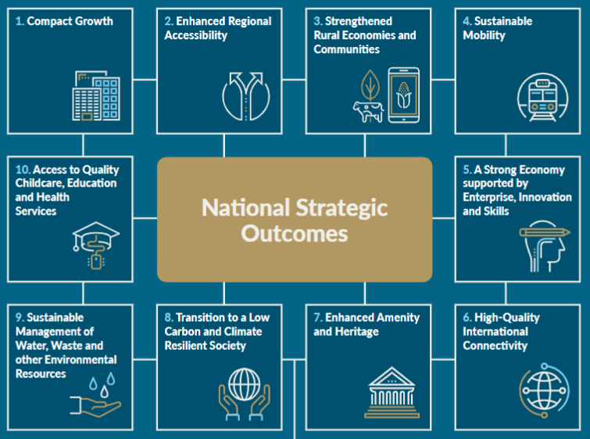

Within the NPF, a number of National Policy Objectives (NPOs) are set out guide regional and local planning and sustainable development policy in Ireland. They include:

- NPO 4 - Ensure the creation of attractive, liveable, well designed, high quality urban places that are home to diverse and integrated communities that enjoy a high quality of life and well-being;
- NPO 27 - Ensure the integration of safe and convenient alternatives to the car into the design of our communities, by prioritising walking and cycling accessibility to both existing and proposed developments and integrating physical activity facilities for all ages; and
- NPO 64 - Improve air quality and help prevent people being exposed to unacceptable levels of pollution in our urban and rural areas through integrated land use and spatial planning that supports public transport, walking and cycling as more favourable modes of transport to the private car, the promotion of energy efficient buildings and homes, heating systems with zero local emissions, green infrastructure planning and innovative design solutions.
The NPF also outlines a number of key future growth enablers for Dublin, including:

- The development of an improved bus-based system, with better orbital connectivity and integration with other transport networks;
- Public realm and urban amenity projects, focused on streets and public spaces, especially in the area between the canals; and
- Delivery of the metropolitan cycle network set out in the Greater Dublin Area Cycle Network Plan inclusive of key commuter routes and urban greenways on the canal, river and coastal corridors.

National Development Plan (2018 – 2027)
The National Development Plan 2018 - 2027 (NDP) is a blueprint, setting out a strategic framework for public capital investment over the next ten years with a particular focus on the investment priorities that will underpin the implementation of the National Planning Framework.

A fundamental purpose of the NDP is ensuring that public capital investment is clearly aligned to the delivery of the objectives and priorities detailed in the NPF, with funding allocated on a thematic basis to each of the ten NSOs outlined in the NPF.

Public investment in environmentally sustainable public transport systems in major urban areas and nationally is recognised as a primary enabler to NSOs under the NPF relating to Compact Growth in urban areas and Improved Regional Connectivity and is one of a number of the most important priorities to achieve climate action objectives.

The NDP outlines a number of investment actions aimed at delivering NSO 4 Sustainable Mobility, including:

- Delivery of the full BusConnects programme for all of Ireland’s cities (inclusive of ticketing systems, bus corridors, additional capacity, new bus stops and bus shelters etc.); and
- Delivery of comprehensive cycling and walking network for Ireland’s cities.
With regard to NSO 7 Enhanced Amenity & Heritage, the NDP notes that the “value of cultural heritage as a key component of, and contributor to, the attractiveness and sustainability of our cities, towns, villages and rural areas in terms of developing cultural creative spaces, private inward investment, and attracting and retaining talent and enterprise. This includes all elements of living space including streets, public spaces, built heritage and natural amenity areas, cultural and sporting opportunities and sustainable transport networks, all of which play a central part in defining the character and attractiveness of places”.

The NDP proposes an integrated multi-modal network to provide for the efficient, effective and sustainable movement of people and goods, and outlines a range of infrastructure and service improvements required to achieve this.

Eastern and Midland Regional Assembly Spatial & Economic Strategy (2019-2031)
The Eastern and Midland Regional Assembly (EMRA), one of three Regional Assemblies in the Republic of Ireland, works with key stakeholders at EU, national, regional and local level to enable regional development. The Regional Spatial and Economic Strategy (RSES) is a strategic plan and investment framework to shape the future development of the Region to 2031 and beyond. The primary statutory objective of the Strategy is to support
implementation of Project Ireland 2040 - which links planning and investment through the National Planning Framework (NPF) and ten-year National Development Plan (NDP).

Figure A.2: NDP Concept of Healthy Placemaking
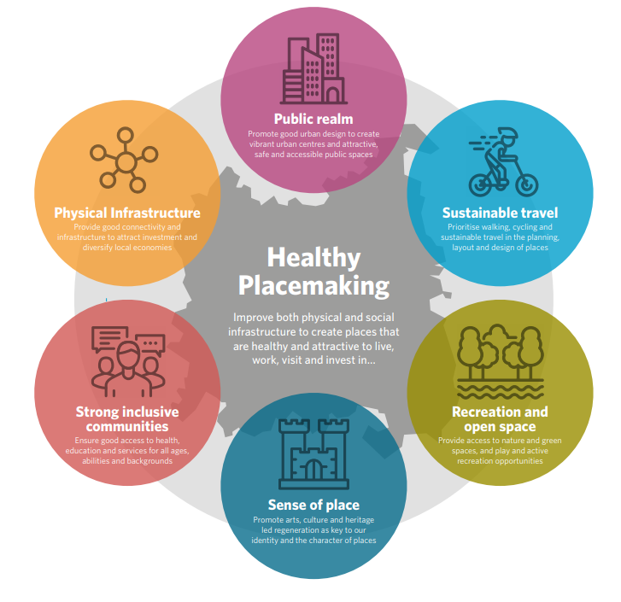
One of the key principles outlined in the RSES is Healthy Placemaking. This seeks to create vibrant urban centres with a diverse mix of retail, residential and commercial functions and high-quality public spaces that are accessible across all societal needs, ages and abilities.

Contained within the RSES is the Dublin Metropolitan Area Strategic Plan (MASP), which has been prepared to ensure continued competitiveness of Dublin and a supply of strategic development for sustainable growth. The MASP is an integrated land use and transportation strategy that sets out a number of strategic development areas that are to be delivered in tandem with Metrolink, DART and LUAS expansion programmes, Bus Connects and the Greater Dublin Metropolitan Cycle Network, along with the provision of metropolitan scale green infrastructure and amenities.

Dublin City Development Plan (2016-2022)
The Dublin City Development Plan provides an integrated, coherent spatial framework to ensure the city is developed in an inclusive way which improves the quality of life for its citizens, whilst also being a more attractive place to live, visit and work.

The development plan sets out a new approach to meet the needs and aspirations of citizens of Dublin and the country, based on the principles of sustainability and resilience on the social, economic and environmental fronts.
The Development Plan sets the following vision for Dublin:

“Within the next 25 to 30 years, Dublin will have an established international reputation as one of Europe’s most sustainable, dynamic and resourceful city regions. Dublin, through the shared vision of its citizens and civic leaders, will be a beautiful, compact city, with a distinct character, a vibrant culture and a diverse, smart, green, innovation-based economy. It will be a socially inclusive city of urban neighbourhoods, all connected by an exemplary public transport, cycling and walking system and interwoven with a quality bio-diverse green space network. In short, the vision is for a capital city where people will seek to live, work, experience, invest and socialise, as a matter of choice”.

A Core Strategy has been developed to deliver on this vision. Key objectives and policies, of relevance to this study, are outlined below:

- Policy SC2: To develop the city’s character by cherishing and enhancing Dublin’s renowned streets, civic spaces and squares… to protect the grain, scale and vitality of city streets; to revitalise the north and south Georgian squares and their environs, and to upgrade Dame Street/ College Green as part of the Grand Civic Spine;
- Policy SC3: To develop a sustainable network of safe, clean, attractive pedestrian routes, lanes and cycleways in order to make the city more coherent and navigable;
- Policy SC4: To promote a variety of recreational and cultural events in the city’s civic spaces;
- Policy SC7: To protect and enhance important views and view corridors into, out of and within the city, and to protect existing landmarks and their prominence. (the view from Dame Street towards College Green and Trinity College is outlined as a key view);
- Objective SC01: To implement a programme of environmental improvements along the Grand Civic Spine from Parnell Square to Christchurch Place, including College Green and Dame Street, arising from the opportunities provided by the introduction of the College Green bus priority system, the Luas cross-city line and the ‘Dubline’ initiative;
- Policy SC19: To promote the development of a network of active, attractive and safe streets and public spaces which are memorable, and include, where appropriate, seating, and which encourage walking as the preferred means of movement between buildings and activities in the city;
- Policy SC20: To promote the development of high-quality streets and public spaces which are accessible and inclusive, and which deliver vibrant, attractive, accessible and safe places and meet the needs of the city’s diverse communities;
- Objective SC08: To prioritise the redevelopment of College Green as a pedestrian friendly civic space, including the pedestrianisation of Foster Place.;
- Policy CEE12: To promote and enhance Dublin as a world class tourist destination for leisure, culture, business and student visitors;
- Policy RD7: To facilitate indoor and outdoor markets both in the city centre and throughout the city, and to promote the clustering of complementary uses that add character and vitality to an area;
- Policy RD22: To encourage environmental and streetscape improvement works conducive with the improvement of the pedestrian environment and the creation of better linkages within and between shopping areas in the city centre retail core in line with the objectives of ‘Your City, Your Space - Dublin City Public Realm Strategy, 2012’ (www.dublincity.ie);
- Policy MT2: Whilst having regard to the necessity for private car usage and the economic benefit to the city centre retail core as well as the city and national economy, to continue to promote modal shift from private car use towards increased use of more sustainable forms of transport such as cycling, walking and public transport;
- Policy MT3: To support and facilitate the development of an integrated public transport network with efficient interchange between transport modes, serving the existing and future needs of the city in association with relevant transport providers, agencies and stakeholders;
- Policy MT4: To promote and facilitate the provision of Metro, all heavy elements of the DART Expansion Programme including DART Underground (rail interconnector), the electrification of existing lines, the expansion of Luas, and improvements to the bus network in order to achieve strategic transport objectives.;
- Objective MT04: To support improvements to the city’s bus network and related services to encourage greater usage of public transport in accordance with the objectives of the NTA’s strategy and the government’s ‘Smarter Travel’ document;
- Policy MT11: To continue to promote improved permeability for both cyclists and pedestrians in existing urban areas in line with the National Transport Authority’s document ‘Permeability – a best practice guide’;
- Objective MT09: …to implement the NTA’s Greater Dublin Area Cycle Network Plan;
- Objective MT10: To improve existing cycleways and bicycle priority measures throughout the city, and to create guarded cycle lanes, where appropriate and feasible.;
- Policy MT12: To improve the pedestrian environment and promote the development of a network of pedestrian routes which link residential areas with recreational, educational and employment destinations to create a pedestrian environment that is safe and accessible to all;
- Objective MT021: To avail of opportunities to increase footpath widths particularly within the city centre where appropriate;
- Policy MT14: To minimise loss of on-street car parking, whilst recognizing that some loss of spaces is required for, or in relation to, sustainable transport provision, access to new developments, or public realm improvements;
- Policy MT21: To improve the management and control of traffic in the city, to increase internal and external sustainable accessibility, to improve road safety, to safeguard commercial servicing requirements, to mitigate the impact of construction works and to minimise the adverse environmental impacts of the transport system;
- Objective MT047: To develop a city centre pedestrian network which includes facilities for people with disabilities based on the principles of universal design; and
- Objective MT050: To introduce traffic-free areas on sections on Drury Street, South William Street, Exchequer Court, Dame Court and Dame Lane while ensuring that access to car parks and deliveries is still provided for.

Your City Your Space - Dublin City Public Realm Strategy (2012)
The Dublin City Public Realm Strategy sets out the key actions and projects to deliver a high-quality public realm in and between key public spaces, both in established and emerging clusters. The ‘grand civic spine from Parnell Square to Christchurch, via O’Connell Street, College Green and Dame Street’ is outlined as one of the key elements of the public space network within the Strategy.

To deliver improvement in the public realm, the Strategy focuses on 15 long-term actions and a definitive two-year work plan with twelve assigned projects.

The Strategy outlines the prominent role that College Green has to play as a civic space in the social and cultural history of Dublin. It also outlines the concept of the ‘civic spine’, the name given to the route through the city centre along which the city’s primary civic, economic, cultural and historic attractions are located. It runs from Parnell Square through O’Connell Street, College Green and Dame Street to Christchurch Place. This route forms the spine for the central network of city streets that make up the inner-city area. It is of national and civic importance as a ‘ceremonial route’ for civic processions such as parades and demonstrations.

The Strategy sets out that the desired character and experience of the civic spine as such:

“The Liffey Corridor and the Civic Spine are the most important series of streets and spaces in the city and as such the quality of the public realm is exemplary and of the highest international standard. The public realm is coherent and consistent in design and constructed using the highest quality materials creating a pleasant environment in which it is easy to move around. A mix of activities are accommodated which make the Civic Spine a key attraction nationally”.

Transport Strategy for the Greater Dublin Area (2016-2035)
The Transport Strategy for the Greater Dublin Area is a comprehensive, integrated, strategy that encompasses infrastructure, services and policy measures across all modes. It provides a framework for the planning and delivery of transport infrastructure and services in the Dublin area over the next two decades. The Strategy’s main purpose is ‘to contribute to the economic, social and cultural progress of the Greater Dublin Area by providing for the efficient, effective and sustainable movement of people and goods’.

To this end, among other proposals, the future year transport network envisaged in the Strategy includes:

- A series of measures, including significant infrastructural investment, in order to minimise delays to buses. The measures outlined in the Strategy form the basis of the BusConnects Dublin programme, outlined in more detail in Section 3;
- Implementation of the proposals of the GDA Cycle Network plan, entailing the expansion of the urban cycle network to over 1,485 kilometres in length; and
- Upgraded pedestrian facilities across the region.

BusConnects Dublin
BusConnects Dublin is NTA’s programme to greatly improve bus services across the Dublin region. The programme was designed to respond to the bus-related proposals in the Transport Strategy for the Greater Dublin Area. Its aim is to deliver an enhanced bus system that is more sustainable for the city, its people and the environment. With more buses, more often, to more places. BusConnects is designed to provide a better, more reliable and more efficient bus service for everyone. BusConnects Dublin is a programme of nine elements that includes:

- A network of Next Generation bus corridors – over 230km of bus lanes (and 200km of cycle lanes) to make journeys faster and more reliable;
- A complete redesign of the bus network – to provide a more efficient network with high frequency spines, new orbital routes and increased bus services. The revised bus network is due to be finalised in May 2020;
- State-of-the-art ticketing and a cashless payment system – to simplify and streamline the process of paying for bus journeys;
- A simpler fare structure – to make movement between different bus services seamless and easy, without financial penalty;
- Park & Ride Facilities - to enable those travelling longer distances to make part of the journey by car, then leave the car in a dedicated car park and complete the journey by bus;
- A new bus livery – providing a common style across different operators that conveys the image of a modern, effective transit system;
- New bus stops and shelters – with better route and fare information provided in each case and with timetable information specific to each stop; and
- Low emission vehicles – to enhance the environmental contribution of the bus system, half of the bus fleet, approximately 500 buses, will be converted to low emission vehicles by 2023. Full conversion will be completed by 2030.
More details on BusConnects and, in particular, the route proposals of greatest relevance to this study, are provided in Section 4.

A Sustainable Transport Future (2009)
The DTTAS Smarter Travel Policy, outlines the vision of achieving a sustainable transport system by 2020. The overarching aim of the strategy is to reduce work-related commuting by car from current modal share (at the time) of 65%, to 45%, by 2020, with car drivers to be accommodated on other modes such as walking, cycling and public transport.

The Policy also outlines how cycling and walking will be pivotal in achieving some of the goals in national health policies to promote physical activity. The Smarter Travel Policy envisaged the development of a culture of cycling to the extent that, by 2020, 160,000 people nationally would cycle for their daily commute and 10% of all trips will be by bike.

National Cycle Policy Framework (2009)
The development of The National Cycle Policy Framework was one of the key actions outlined in the Smarter Travel Policy. The NCPF sets out 19 specific objectives, and details the 109 individual but integrated actions, aimed at ensuring that a cycling culture is developed in Ireland to the extent that the targets outlined in the Smarter Travel Policy can be achieved. Of relevance to this study are:

- Objective 1 of the NCPF is to Support the planning, development and design of towns and cities in a cycling and pedestrian friendly way: and
- Objective 2 is to ensure that urban road infrastructure is designed / retrofitted so as to be cyclist friendly and encourages the use of cycle lanes and cycle tracks (where possible) to make a route cycle-friendly.

GDA Strategic Cycle Network Plan (2013)
The Greater Dublin Area Cycle Network Plan was commissioned by the NTA to prepare a Cycle Network Plan, comprising the Urban Network, Inter-Urban Network and Green Route Network, for each of the seven Local Authority areas comprising the Greater Dublin Area (GDA).

The plan provided a snapshot of the cycle network in the GDA, as it was in 2013, and outlined what bicycle facilities were available, where they were missing sections, what their condition was and what improvements were likely to be required. In addition, a strategic cycle network map of the GDA was prepared to help the NTA in allocating funding towards the implementation of strategically important schemes.

The plan detailed a series of categories for routes within the urban cycle network. Primary routes are defined as ‘main cycle arteries that cross the urban area and carry most cycle traffic’. Two proposed primary routes run through the east-west axis of College Green:

- Route 7: West Sector to College Green via Thomas Street, Christchurch and Dame Street; and
- Route 11: South Central Sector to O'Connell Bridge via Ranelagh - Harcourt Street - York Street - South William Street - College Green - Westmoreland Street.
The plan also proposes a series of cross-city links, to connect several of the primary routes that run through the city centre. Several of these routes run through College Green, including:

- Route C1: North-South Central Spine: Parnell Square - O'Connell Street - Westmoreland Street - College Green; and
- Route C2: East-West Central Spine: Merrion Square - Nassau Street - College Green - Dame Street – Christchurch.
- The City Centre network in the vicinity of College Green is illustrated in Figure A.3.

Figure A.3: GDA Strategic Cycle Network in vicinity of College Green
- 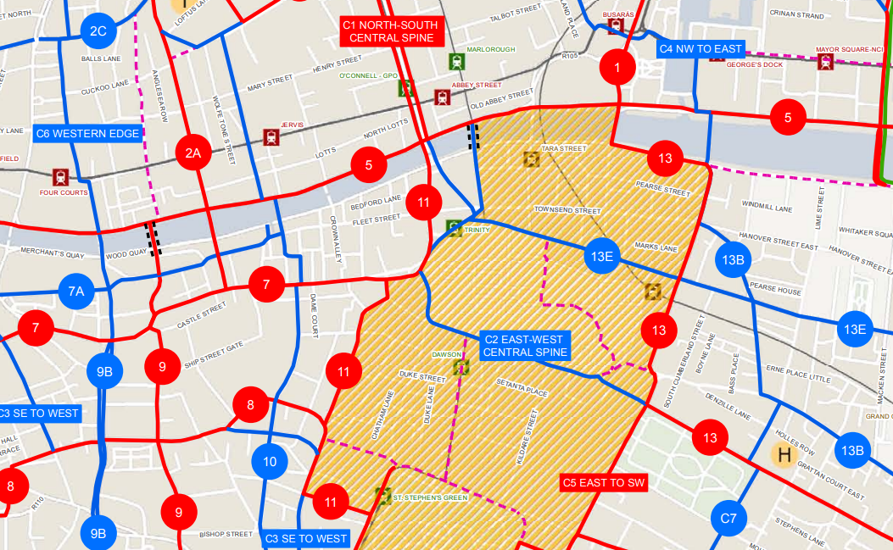
Scheme Location
- 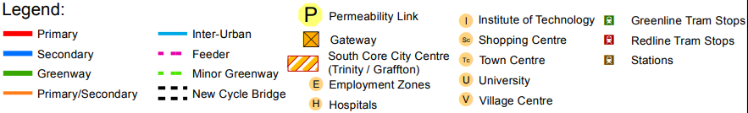
Source: GDA Cycle Network Plan
- Drawing of Options 1 to 5

Dublin City Council, 2016) for the City” (EIAR Chapter 1).
Inspectors Report Section 2.0 Proposed Development page 9
An Bord Pleanála - Board Order 29S.JA0039 page 3
https://busconnects.ie/media/1987/2019-consulation-report-170920.pdf
Other times may be considered by DCC subject to consultation with relevant stakeholders, business, residents, etc.
It is assumed that emergency vehicle access through this area would be possible if required and that limited controlled access for vehicles accessing the front car park of the Bank of Ireland would be allowed.

