Options for public realm improvements to Dame Street as part of the College Green project

Overview
Dublin City Council is progressing an ambitious plan to rediscover and reinvent the historic College Green as the major public space at the heart of the city.
Following the unsuccessful application to An Bord Pleanála (ABP) in 2018, Dublin City Council held a series of trial traffic-free events in College Green including Summer Sundays, Culture Night and Car Free day. The lessons learned from these events have guided the Council in both reviewing the previous proposal and in preparing a number of new options.
More recently, the Covid-19 pandemic has served to reiterate the importance of pedestrian friendly outdoor public open spaces to the ongoing vitality, economy and health of the city.
In September 2020, the National Transport Authority published the final version of the Bus Connects Network Redesign which proposes to significantly reduce the numbers of routes and buses in the College Green area. In addition the Bus Connects Network Redesign includes an option and a network map with buses rerouted out of College Green and Dame Street (between Anglesea Street and South Great George’s Street). As the relocation of bus routes and bus stops was a significant issue in the 2018 College Green planning decision, the Council is being informed by the Bus Connects Network Redesign in further developing proposals for the area.
The removal of buses from this area as part of the Bus Connects Network, once College Green is traffic free, would create an opportunity to significantly improve the public realm along Dame Street between South Great George’s Street and Anglesea Street, as part of the College Green Plaza project.

Bus Connects Network Redesign
In September 2020, the National Transport Authority (NTA) published the final version of the Bus Connects Network Redesign https://busconnects.ie/initiatives/new-dublin-area-bus-network/ which proposes to significantly reduce the numbers of routes and buses in the College Green area.

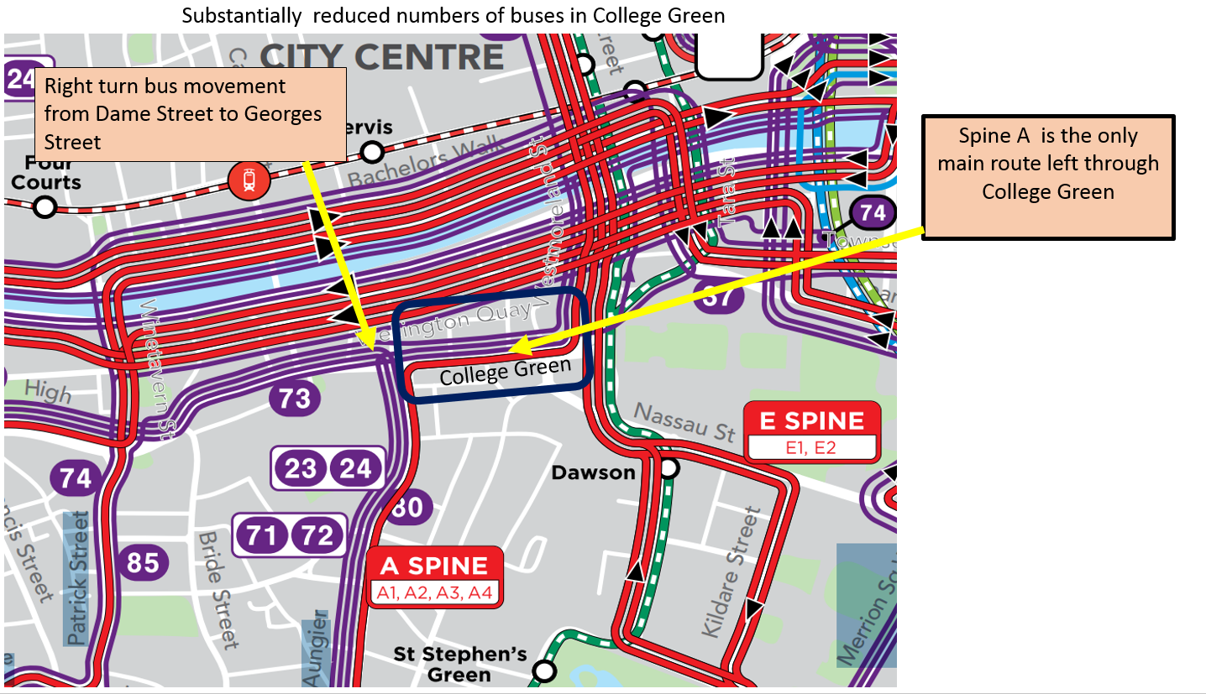
Figure 1 Bus Connects Redesign Network Map - substantially reduced numbers of buses in College Green

In addition the Bus Connects Network Redesign includes an option and a network map with buses rerouted out of College Green and Dame Street (between Anglesea Street and South Great George’s Street).

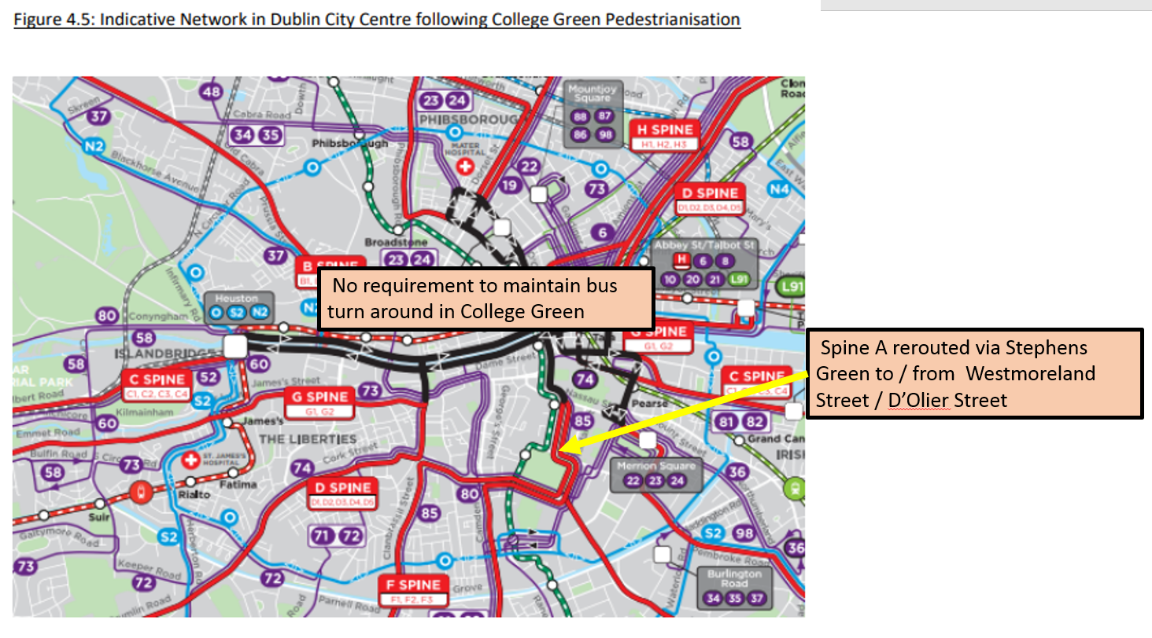
Figure 2 Bus Connects Redesign Network Map – option with buses rerouted out of College Green and Dame Street

The rerouting of these buses out of College Green had been one of the major reasons for the unsuccessful planning application for the College Green Civic Plaza project in 2017.

Implications of the Bus Connects Network Redesign on proposals for College Green Plaza
The option in the BusConnects Network Redesign to reroute buses out of College Green and Dame Street (between Anglesea Street and South Great George’s Street) means that there is an opportunity to provide a pedestrian plaza to College Green, once it is closed to vehicular traffic. In addition, this option also removes the provision of a turning circle for buses immediately west of Church Lane, thus facilitating the extension and enlargement of the pedestrianised plaza further west as far as Anglesea Street. A two–way cycle route would still be retained as part of the proposals.
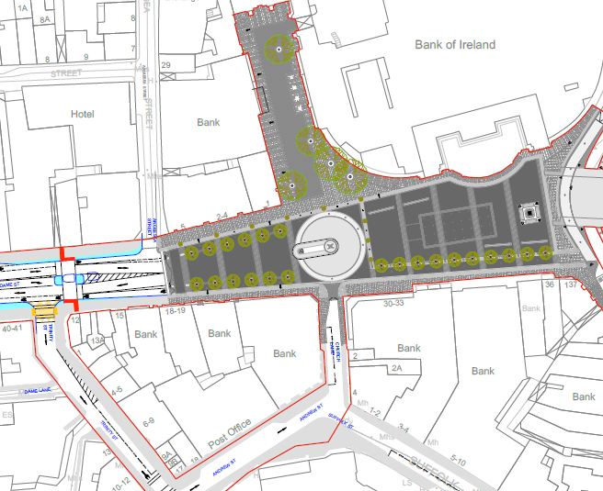
Anglesea Street
Space required to facilitate bus turning movements
Bus Turning Circle
Figure 3 Original College Green Plaza design with buses facilitated

Implications of the Bus Connects Network Redesign on proposals for the Dame Street area (between Anglesea Street and South Great George’s Street)
With an option under the Bus Connects Network Redesign to remove buses from College Green and the Dame Street area (between Anglesea Street and South Great George’s Street), there is an opportunity to further reduce vehicular traffic and enhance the quality of the public realm at the proposed College Green Plaza further west towards Dame Street as far as the junction with South Great George’s Street. The two–way protected cycle route would be extended from College Green as far as the junction with South Great George’s Street.

Revised scheme options for College Green (Core Plaza area) and Dame Street area (Outer Plaza Area)
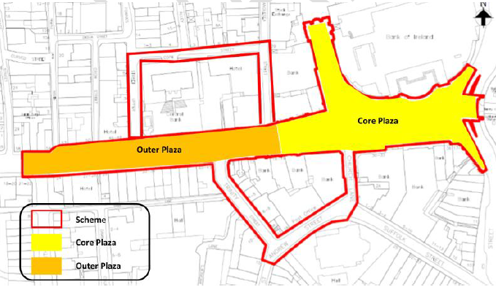
Figure 4 Core Plaza Area and Outer Plaza area
Dublin City Council commissioned Aecom Consultants to undertake a Multi Criteria Appraisal (MCA) of a number of revised scheme options for College Green in order to assess which should be taken forward for more detailed work and statutory approval. These scheme options aim to:
- Take cognisance of the original application and subsequent Inspectors report from An Bord Pleanala
- Optimise the value of lessons learnt from trial closures of the space to vehicular traffic during the summer of 2019; and
- Incorporate the proposed bus Network Redesign as part of Bus Connects which has changed the requirements for bus movements in the area.

The revised options are summarised as follows:
- Option 1 – This is the original College Green Plaza design that was submitted as part of the previous planning application with little public realm improvement in Dame Street.
- Option 2 – Feedback from the Planning Inspector was taken into account to incorporate a west to east bus lane within the original scheme design;
- Option 3 – This option increases the area of pedestrianisation and removes all bus requirements from the Scheme. The main pedestrianised area would be the Core Plaza, with improved public realm provision on Dame Street. This option provides vehicular access for deliveries and to car parks and a two way protected cycle track.
- Option 4 – Is similar to Option 3 but vehicular access for deliveries would only be allowed up to 11:00 to Dame Street east of Georges Street, this allows considerable opportunity for public realm improvements as the space is traffic free after 11:00 with a two way cycle track.
- Option 5 – This option increases the area of pedestrianisation similar to Option 3 but would allow bus movement in a west to east direction with a bus lane on the northern side of the College Green space.

The Multi Criteria Appraisal (MCA) scored Option 4 highest with Option 3 also scoring very highly. Because the two options score quite highly it was recommended to undertake a public consultation exercise at this point to help inform the design process.

CAF Criteria | CAF Sub-Criteria | Appraisal Criterion | Appraisal Score
 |  |  | Option 1 | Option 2 | Option 3 | Option 4 | Option 5
Environment | Air Quality | Minimise emissions to provide a high-quality environment within the Scheme | -2 | -1 | 1 | 2 | -1
 | Noise & Vibration | Minimise noise and vibration to provide a high-quality environment within the Scheme | 0 | -2 | 1 | 2 | -2
 | Landscape and Visual Quality | Optimise the aesthetical value of the Core Plaza | 0 | -2 | 2 | 2 | -2
 | Cultural, Archaeological & Architectural Heritage | Optimise the architectural and cultural value of the Core Plaza | 0 | -2 | 2 | 2 | -2
 |  | Provide a cultural space for large civic events | 0 | -2 | 2 | 2 | -2
 | Criteria Sub-Total (Average) |  | -0.4 | -1.8 | 1.6 | 2 | -1.8
Accessibility & Social Inclusion | Vulnerable Groups | Ensure the environment throughout the scheme is accessible for people with disabilities | -1 | -2 | 2 | 1 | -2
 |  | Provide a vibrant socially inclusive space for all to rest and enjoy | 0 | -2 | 1 | 2 | -2
 | Criteria Sub-Total (Average) |  | -0.5 | -2 | 1.5 | 1.5 | -2
Physical Activity | Active Travel | Optimise pedestrian movement within the Scheme | 0 | -2 | 1 | 2 | -2
 |  | Optimise cyclist movement within the Scheme | -1 | -2 | 2 | 2 | -2
 | Criteria Sub-Total (Average) |  | -0.5 | -1.5 | 1.5 | 2 | -2
Safety | Safety of vulnerable road users such as pedestrian and cyclists | Improve pedestrian safety within the Scheme | 0 | -2 | 1 | 2 | -2
 |  | Improve cyclist safety within the Scheme | 1 | -1 | 2 | 2 | -1
 | Criteria Sub-Total (Average) |  | 0.5 | -1.5 | 1.5 | 2 | -1.5
Integration | Transport Integration | Integration of the Scheme with the existing and planned GDA Strategic Cycle Network | 0 | 0 | 0 | 0 | 0
 |  | Integration of the Scheme with the existing and planned pedestrian network | 1 | 0 | 1 | 1 | 0
 |  | Integration of the Scheme with the existing and planned public transport network | 1 | 2 | -2 | -2 | 2
 | Land Use Integration | Alignment of the scheme with adopted DCC spatial policies for the City Centre and Central Spine | -2 | -2 | 2 | 2 | -2
 | Other Govt Policy Integration | Alignment of the scheme with Ireland 2040/ NDP, Climate Action Plan (CAP), Eastern and Midland RSES | 0 | 0 | 1 | 1 | 0
 | Criteria Sub-Total (Average) |  | 0 | 0 | 0.4 | 0.4 | 0
Economy | Transport Reliability & Quality | Assist in delivering a high-quality sustainable transport network in Dublin to support adopted economic policy, including: | - | - | - | - | -
 |  | - High quality pedestrian network | 0 | 0 | 1 | 1 | 1
 |  | - High quality cycle network | 0 | 0 | 0 | 0 | 0
 |  | - High quality public transport network | 1 | 2 | -1 | -1 | 2
 | Other Economic Impacts | Support the continued economic success of the area to support, communities, business, visitors and tourism | 0 | -2 | 2 | 2 | -2
 | Criteria Sub-Total (Average) |  | 0.25 | 0 | 0.5 | 0.5 | 0
Total Appraisal Score |  |  | -0.65 | -7.3 | 7 | 8.4 | -7.3
Table 1 MCA
Dublin City Council now proposes to only continue work on either Option 3 or 4. The other options will not be progressed. The two options are illustrated below:
Option 3:
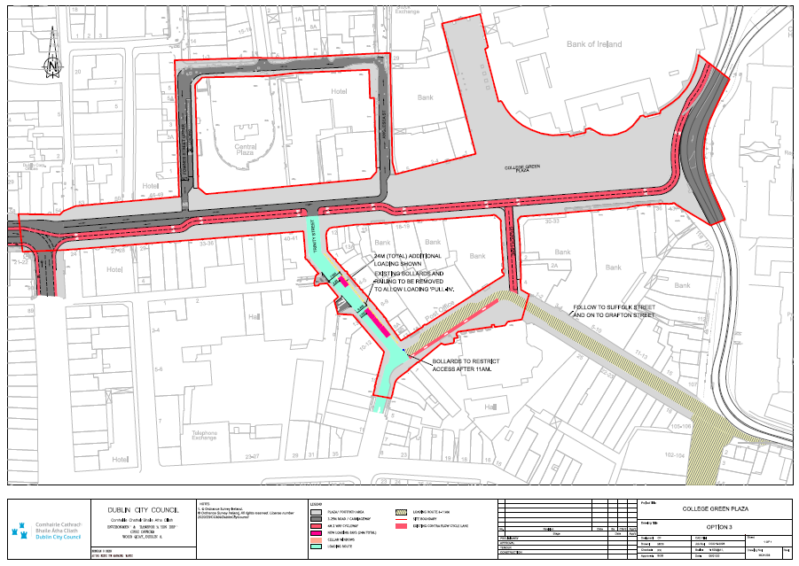
Figure 5 24hour vehicular deliveries and access from Dame Street: between South Great George’s Street and Anglesea Street area (MCA Option 3). Multi Criteria Analysis (MCA) diagram

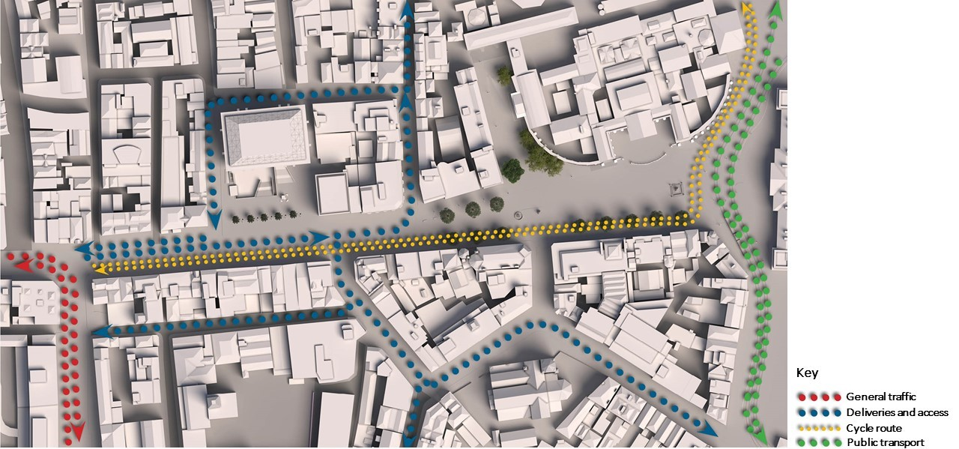
Figure 6 24hour vehicular deliveries and access from Dame Street: between South Great George’s Street and Anglesea Street area (MCA Option 3). Traffic movement diagram showing situation up to 11.00am
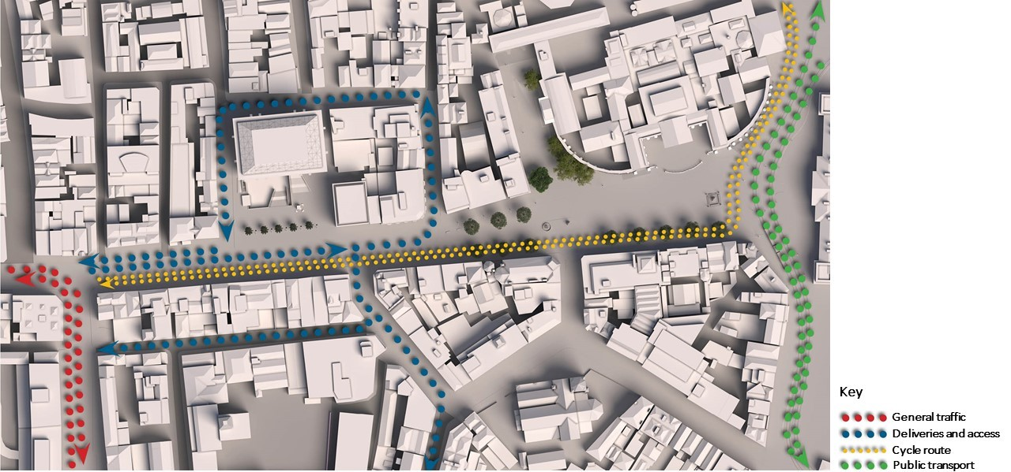
Figure 7 24hour vehicular deliveries and access from Dame Street: between South Great George’s Street and Anglesea Street area (MCA Option 3). Traffic movement diagram – after 11.00am

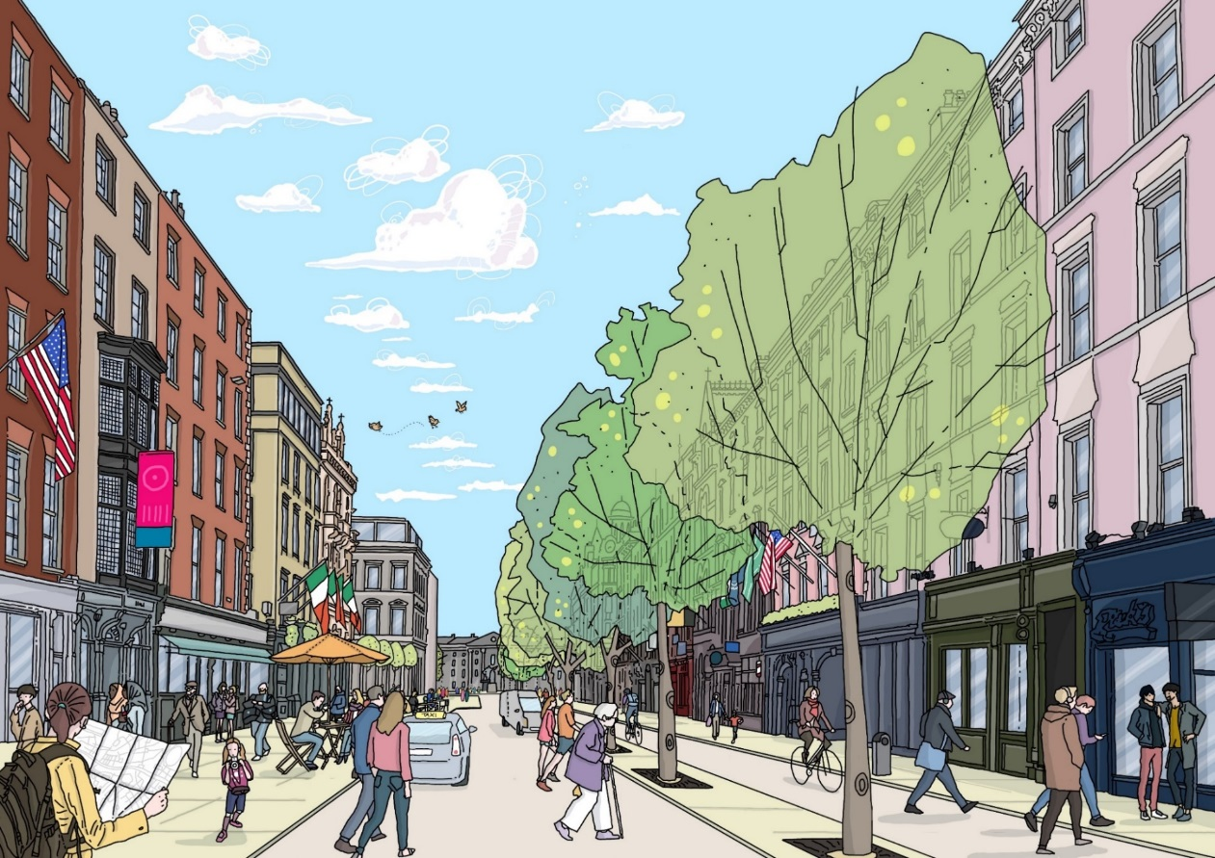
Figure 8 24hour vehicular deliveries and access from Dame Street: between South Great George’s Street and Anglesea Street area (MCA Option 3). Concept illustration of space in use, looking east along Dame Street towards Trinity College

Option 4:
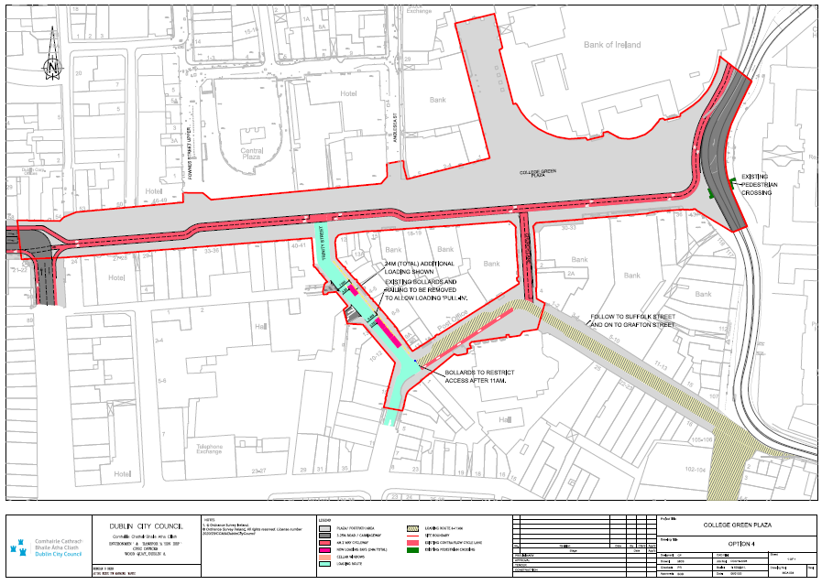
Figure 9 Vehicular deliveries and access from Dame Street: between South Great George’s Street and Anglesea Street area from 6am to 11am, and traffic-free after 11am (MCA Option 4). Multi Criteria Analysis (MCA) diagram

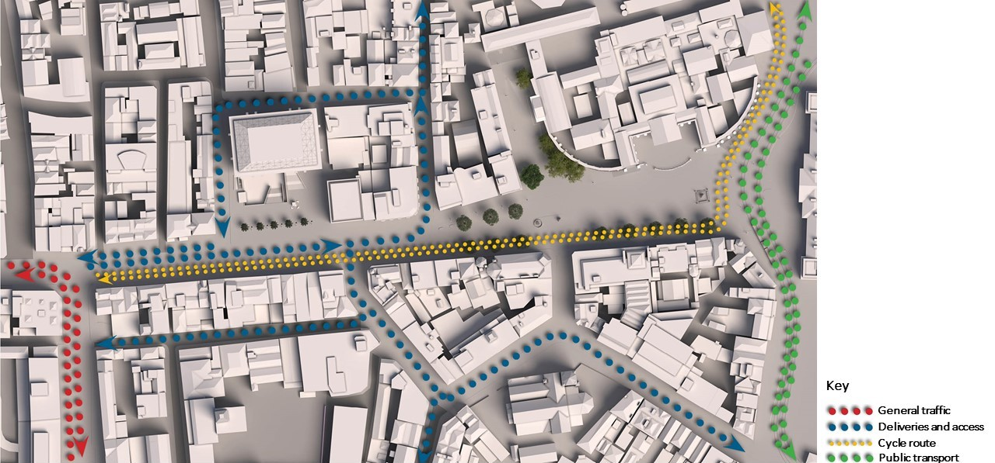
Figure 10 Vehicular deliveries and access from Dame Street: between South Great George’s Street and Anglesea Street area from 6am to 11am, and traffic-free after 11am (MCA Option 4). Traffic movement diagram showing situation up to 11.00am
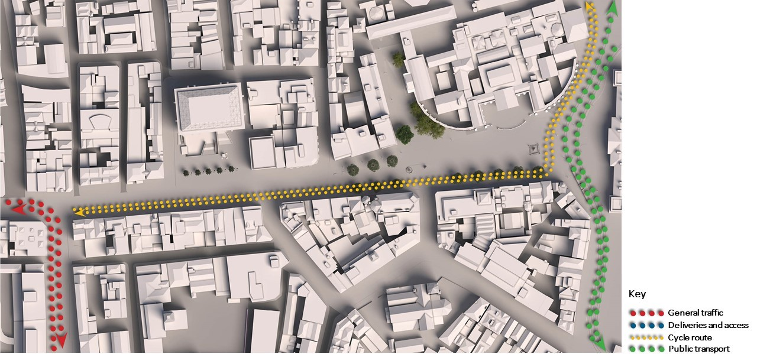
Figure 11 Vehicular deliveries and access from Dame Street: between South Great George’s Street and Anglesea Street area from 6am to 11am, and traffic-free after 11am (MCA Option 4). Traffic movement diagram showing situation after 11.00am

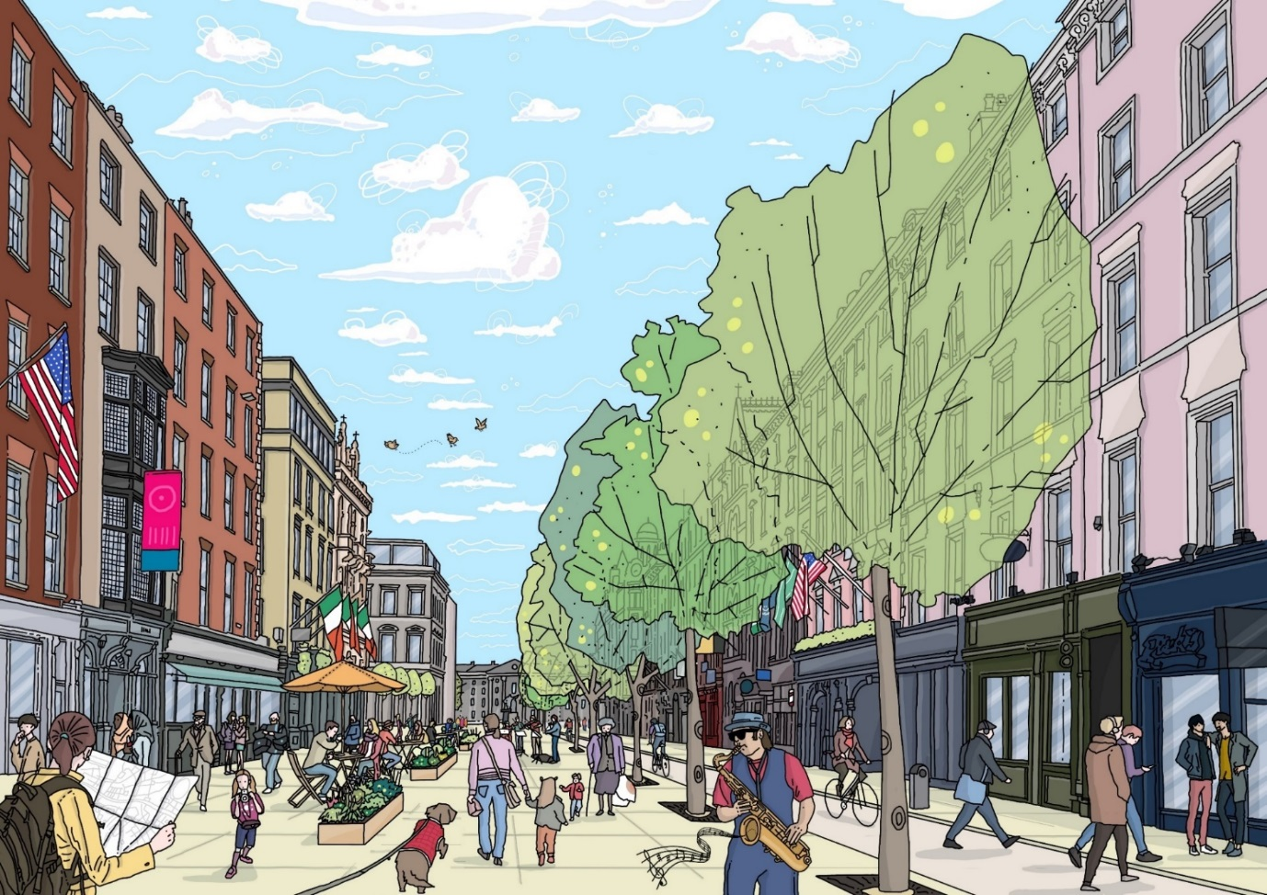
Figure 12 Vehicular deliveries and access from Dame Street: between South Great George’s Street and Anglesea Street area from 6am to 11am, and traffic-free after 11am (MCA Option 4). Concept illustration of space in use, looking east along Dame Street towards Trinity College

Access and deliveries
Local access and deliveries for both Options 3 & 4 can still be provided to the Outer Plaza areas from Trinity Street and Anglesea Street. Deliveries would use a one way system to service the area with vehicular access retained within the Outer Plaza area only.
Under Option 3 access and deliveries would be provided on a 24 hour basis.
Under Option 4 access and deliveries would be provided from 06:00 to 11:00 only.
In both options, a two way protected cycle route would be provided to run along the south side of the proposals.

Enhanced public realm opportunities
With buses and private vehicular traffic removed under both Options 3 & 4 of the Multi Criteria Appraisal (MCA), there would be a completely pedestrianised space in the Core Plaza area at College Green stretching from Trinity College to Anglesea Street.
Under both Options, there is an opportunity to enhance the quality of the public realm further west in the Outer Plaza area from Anglesea Street along Dame Street as far as the junction with South Great George’s Street.
Under Option 3, the quality of the public realm can be enhanced by widening footpaths along Dame Street and by reducing vehicular traffic to local access and deliveries only, on a 24 hour basis.
Under Option 4, the quality of the public realm can be enhanced by making this space traffic-free along Dame Street once local access and deliveries are complete after 11am. A similar arrangement is in place on Grafton Street and Henry Street. This would result in a significantly extended civic space for the city, stretching from Trinity College along Dame Street as far west as the junction with South Great George’s Street.

