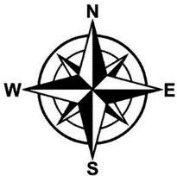
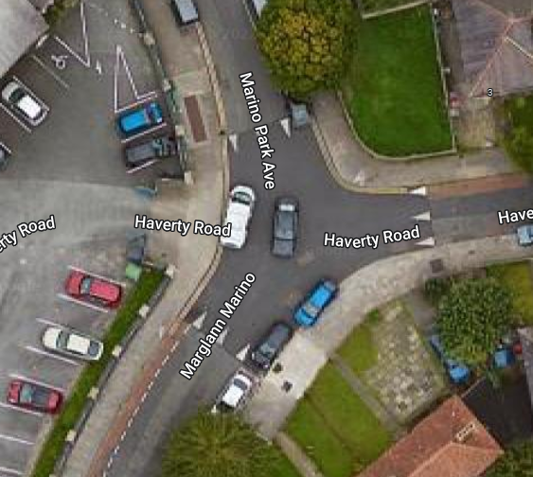
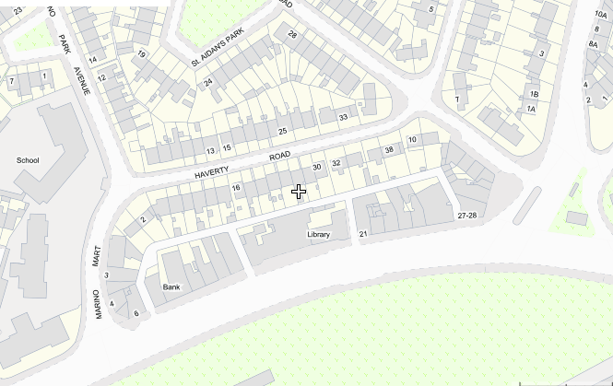
(Except Cyclists & Local Access)
Indicative location of Filtered Permeability Measures i.e. signage, bollards and/or planters
Indicative location of Filtered Permeability Measures i.e. signage, bollards and/or planters
Existing No Right Turn (Except Cyclists)
(Except Cyclists)
ENVIRONMENT & TRANSPORTATION DEPARTMENT  CIVIC OFFICES  WOOD QUAY  DUBLIN 8 | CONCEPT SKETCH OF PROPOSED FILTERED PERMEABILITY TRIAL FOR HAVERTY ROAD
RUS 013: NO LEFT TURN (with Supplementary Sign shown above)

RUS 012: NO RIGHT TURN (with Supplementary Sign shown above)

RUS 011: NO STRAIGHT AHEAD (with Supplementary Sign shown above)

