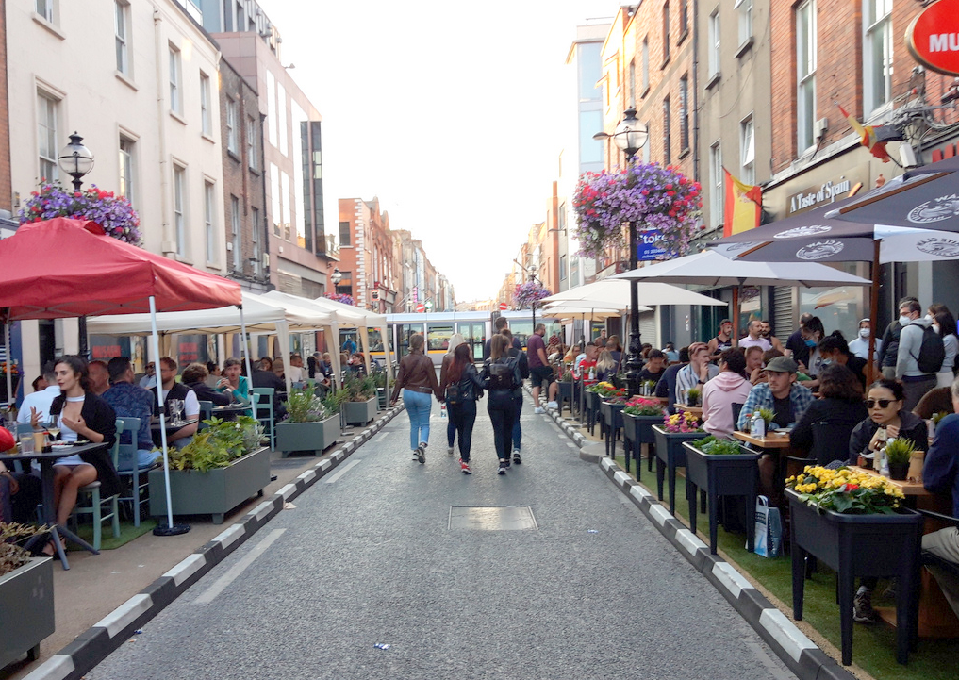
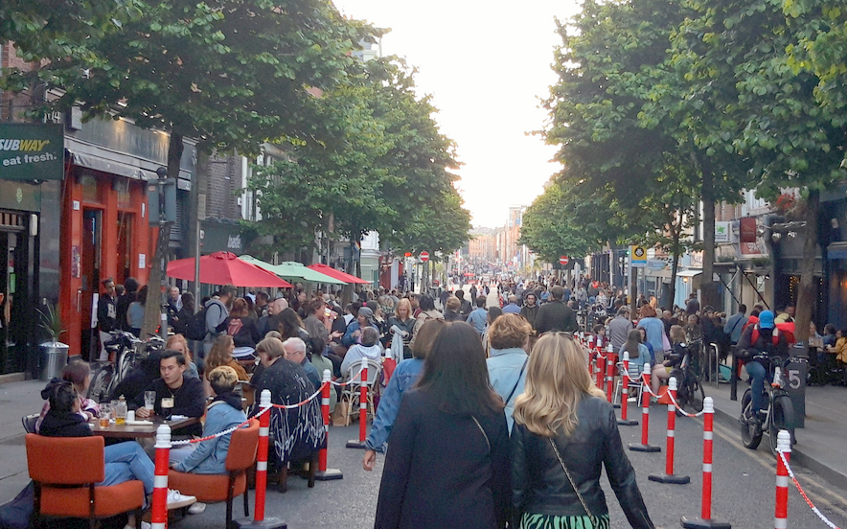
Capel Street and Parliament Street
Non-Statutory Consultation
August 2021

Table of Contents
Introduction 1
Weekend Evening Traffic Free Arrangement 3
Traffic and Pedestrian volumes and routes 5
Options for Capel Street and Parliament Street 7
Capel Street Options 7
Parliament Street Traffic free 11
Parliament Street Options 11
Consultation 12
Next Steps 12

Introduction
In response to the restrictions in place due to Covid 19, DCC have undertaken a number of interventions to assist with business reopening and providing additional pedestrian space, this followed a public consultation in May 2021 which received almost 4,000 submissions.
The interventions were to remove some parking and loading bays and replace them with temporary build outs giving a total of 560 m² additional space for outdoor dining and pedestrian space. At three locations, 52 Zebra protectors were used to provide protected outdoor space including on Strand Street. In addition the area on Capel Street from Parnell Street to Ryder’s Row was closed to vehicular traffic to create a new pedestrian area. These interventions meant that hospitality businesses could reopen and use the new space created while allowing the existing footpaths to be kept clear. It is the intention of DCC to leave all these interventions as they are for now and to ascertain the public s views on these and other proposals for the street.
Following the public consultation in May 2021, it was also clear that there was a strong desire from the public that there should be a more ambitious intervention which would make the Capel Street traffic free. Having considered this and bearing in mind the diverse nature of the non-hospitality businesses on the street, it was felt that an evening weekend closure would be the most appropriate. It was also decided that as the majority of traffic using Parliament Street travels across Grattan Bridge from Capel Street, that this also gave an opportunity to trial making Parliament Street traffic free for the same hours.
From the 11th of June 2021, Capel St. and Parliament St. was made traffic-free on a Friday, Saturday and Sunday evening from 18:30 to 23:30 for a period of 6 weekends on a trial basis. This was part of Dublin City Council’s Office of City Recovery to support business in the City and facilitate outdoor dining and was planned and implemented by the Traffic Department in DCC.
The traffic-free trial also effectively made the following streets traffic-free at these times:
- Parnell St. from Ryders Row to Capel St.
- Little Britain St. from Campbell’s Court to Capel St.
- Mary St. from Jervis Lane Upper to Capel St.
- Mary St. Little from Anglesea Row to Capel St.
- Mary’s Abbey from Aran St. to Capel St.
- Abbey St. from Jervis Lane Upper to Capel St.
- Strand St. Little from Aran St. to Capel St.
- Strand St. from Jervis St. to Capel St.
- Essex Gate from Exchange St. to Parliament St.
- Essex St. East from Sycamore St. to Parliament St.
Therefore in considering the options for Capel Street it must be borne in mind the numbers of streets that are affected and the considerable number of residents in the general area who do not live on Capel Street but will be affected by any changes to it. A leaflet drop to over 3,000 residences and premises in the affected area has also been arranged to ensure the maximum involvement of local residents and businesses in this process.
Following the initial six weeks the weekend traffic free evenings were extended for a further six weeks until the end of August when indoor dining would have resumed. The decision to extend the traffic-free weekends until the 26th of September was made by Dublin City Council management following representations by the Lord Mayor of Dublin and her fellow Councillors.
A consultation was planned to obtain people’s views on the traffic free evenings and future improvements for the street. This document contains some background information on how the traffic free arrangement were implemented and their impacts as well as a number of different options for people to consider and give their views on. It is important to stress that any option chosen should work for as many people as possible and be as inclusive as possible.

Weekend Evening Traffic Free Arrangement
The Traffic Free weekend set up commenced at 18.30 on Friday, Saturday and Sunday evening until 23.30pm.
On Capel Street this meant closing off all access routes to the street for vehicles, while ensuring that pedestrians, cyclists and emergency services would have full access. In order to ensure that residents on the numerous roads affected by the Capel Street Closure could still access their residences, a comprehensive traffic management plan was put in place including providing traffic management marshals at multiple locations to facilitate access for residents and visitors. In addition the parking on Capel Street finished at 18:30 but vehicles remaining after that time had to be facilitated to safely leave.
The changes were as follows:-
- Little Britain Street – Local access only, no access beyond Campell’s court
- Abbey Street Upper – Local access only via Wolfe tone St. Jervis Lane Lower traffic reversed and operated under traffic marshals
- Mary Street – no access beyond Wolfe Tone Street
- Mary Street Little – No access to Capel Street, local access only as far as Anglesea row
- Strand Street Great – Local Access, two way system operated under traffic management
- Strand Street Little – Local Access, two way Stop/Go system operated under traffic management
This required 18 traffic management marshals to facilitate access and these movements.
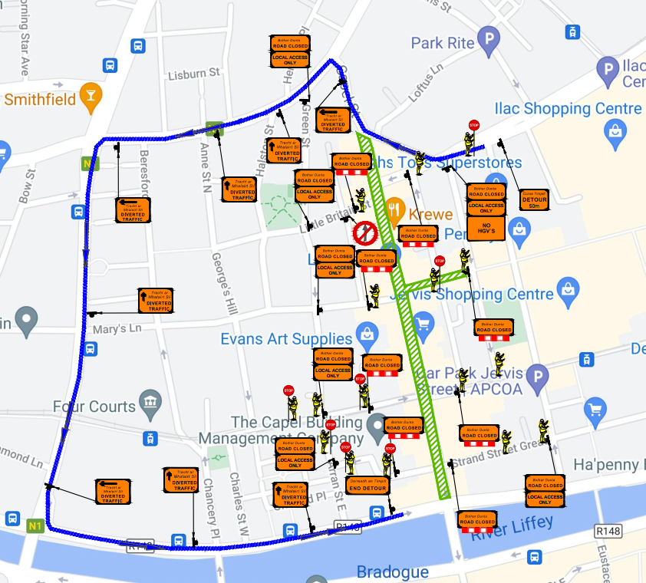
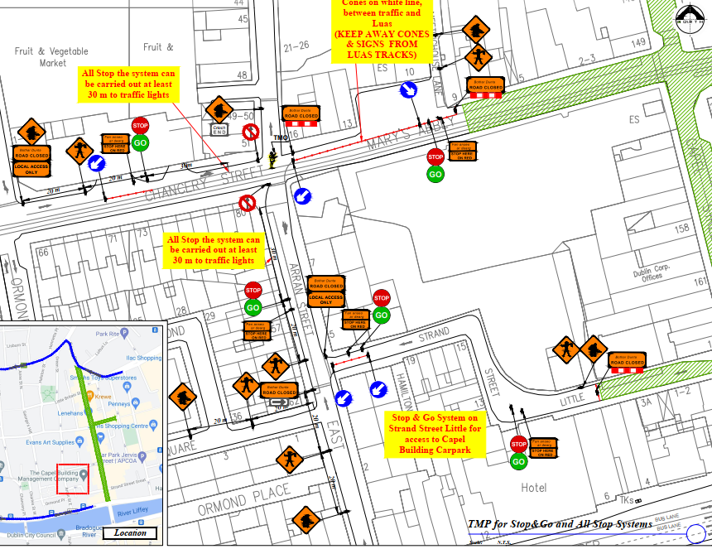
Figure 1 Extracts from the Traffic Management Plan
Similarly on Parliament Street, all access to the street was closed off except for pedestrians, cyclists and emergency services and this meant that Essex Street East was effectively also made traffic free. Grattan Bridge was reduced to one lane and all vehicular traffic was diverted onto the south quays. On Parliament 12 Zebras were used to provide additional outdoor dining space and again these facilities will remain until 2022.
To facilitate local resident access:
Essex Gate was closed. Local access was maintained on Exchange Street lower and Exchange Street upper.
This required 4 traffic management marshals to facilitate access and these movements.
The Traffic Free evenings on Capel Street, allowed for a better atmosphere whilst outdoor dining was taking place. However no roadway space was used during the hours for outdoor dining as the space had already been provided using build outs and zebras.
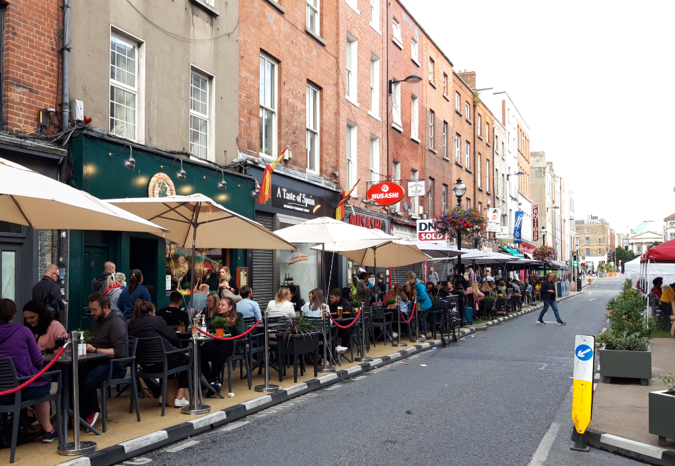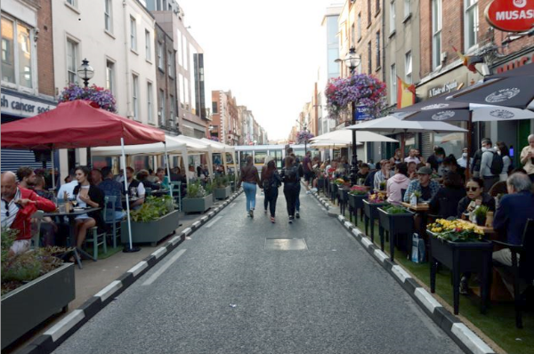
Figure 2 Outdoor dining on Capel Street during Traffic Free evenings
An item which raised concerns however was the substantial congregation of people at the junction of Capel Street /Strand Street and also along Strand Street, where additional toilet facilities and barriers had to be put in place to try to ensure that disturbance to residents was minimised. Also every weekend the gardaí were required to provide resources to facilitate vehicles to get through the crowd when the road reopened at 23.30.
On Parliament Street the use of the space was substantially different with the roadway itself utilised for outdoor dining and provided space that otherwise would not have been available, this enabled businesses to reopen in some cases only during the traffic free weekends due to space constraints otherwise.
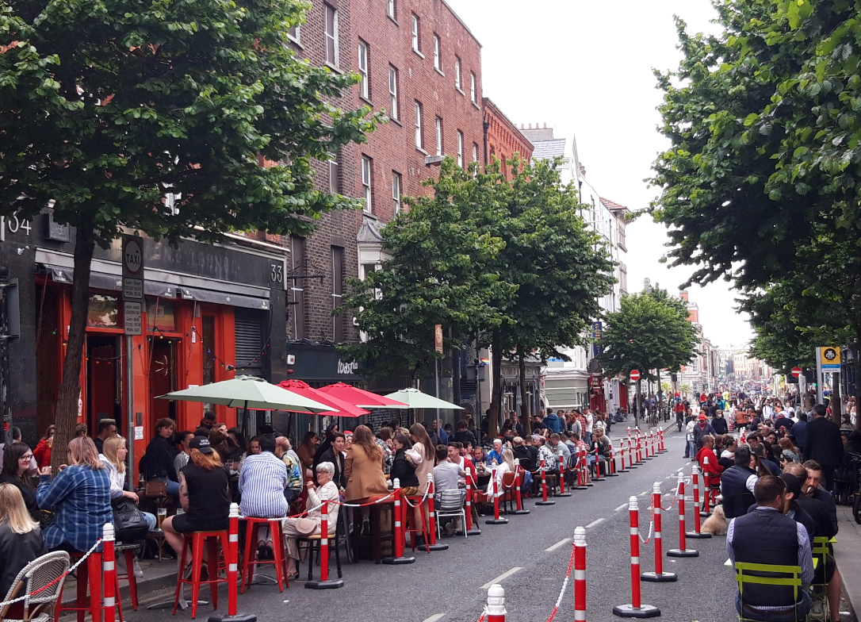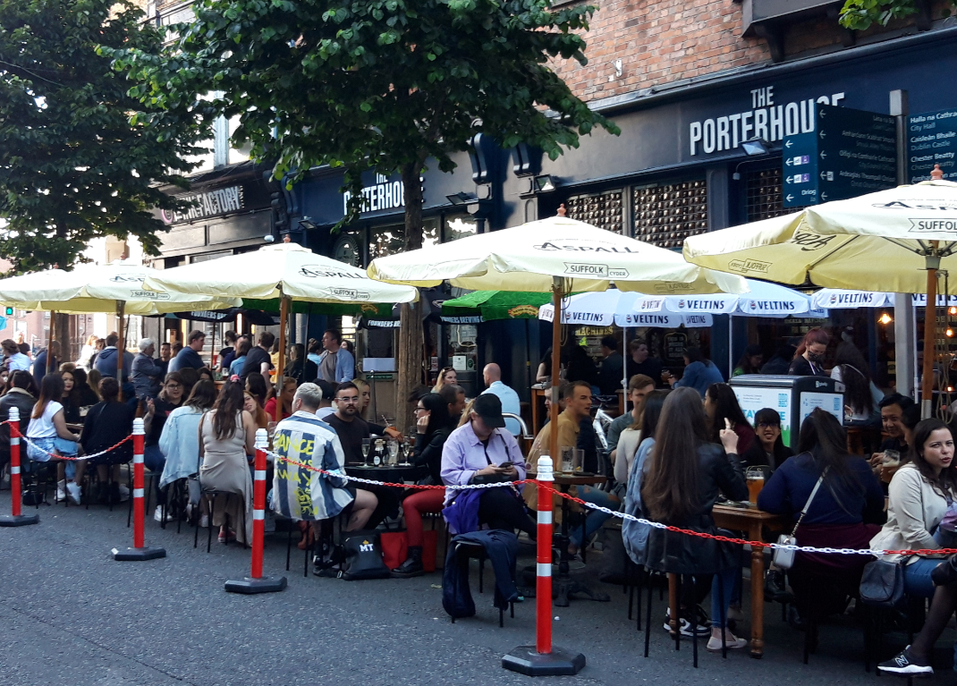
Figure 3 Parliament Street outdoor dining using carriageway space

Traffic and Pedestrian volumes and routes
A 24 hour count was undertaken on Thursday the 5th of August (ie a day when the road was open to vehicles all day). The results showed the following number of users on the street:
Capel St
Mode | Number
Pedestrians | 8,651
Cyclists | 1,148
Vehicles | 7,873

Parliament St
Mode | Number
Pedestrians | 10,008
Cyclists | 2,037
Vehicles | 4,652

We also know from the counts that approximately 80% of the vehicles from Capel Street travel onto Grattan Bridge. Of these, two thirds travel across Grattan Bridge to traverse Parliament Street and one third route to the South quays. From Parliament Street there is a split of approximately two thirds of vehicles heading west onto Lord Edward St and one third east onto Dame Street. This suggests that the majority of the Capel Street traffic is heading westbound out of the city.
An analysis was undertaken comparing traffic volumes of Friday evenings before the Traffic Free evening and during it which revealed a new movement pattern in response to the Traffic Free Trial on Capel Street. The new movement shows traffic rerouted onto King Street, turning left on Church Street, continuing across Father Matthew Bridge and up Bridge Street. The increases are shown on Figure 1 below. This new movement replaces trips that would have previously exited Capel Street South and crossed Grattan Bridge.

Figure 4 Redistributed Trips
In general the traffic rerouting worked well but complaints were received from the Jervis Street shopping centre regarding delays exiting their car park during Croke Park match days. DCC traffic have instituted some changes around the area to better manage issues with match day traffic. In addition these new traffic arrangements have not been trialled during day time traffic.
The Traffic Free evening will have been running for a total of 16 weeks when they finish at the end of September.
This consultation is now looking to seek people’s views on:
- Their experience of the Traffic free weekend evenings and

- What worked, what didn’t work from a resident, business owner and street user perspective?

- What options should be further explored for both Capel Street and Parliament Street

- Any suggestions people may have for improvements, changes etc.

Options for Capel Street and Parliament Street
There are five main options for Capel Street which are detailed below:

Capel Street Options
Option 1 – Maintain the current arrangement
Maintain the current arrangement on Capel Street where new footpath extensions have created additional space for outdoor dining whilst maintaining all current traffic flows in the area.

Option 2 – Capel Street traffic free between Parnell Street and the north quays
This option would require a substantial permanent traffic management plan to be developed so that the arrangement could work without the large amount of traffic management operatives that are currently required. This would mean changes to traffic flow to the streets around Capel Street to facilitate local residents, a reduction of on street parking in the area (note there are 2,500 carpark spaces within a 4 minute walk of Capel Street) and limited loading hours.
A comprehensive consultation with businesses and residents would need to be undertaken. This option could run at different hours such as:
- 7 days a week, all day except for specific delivery hours (typically 6am to 11am)

- Evenings from 18.30 to 23.30 all week

- Evenings from 18.30 to 23:30 at the weekends

It should be noted that the map shown is indicative and more detailed traffic management changes would have to be worked up, in order to assess the feasibility or otherwise of the proposal.

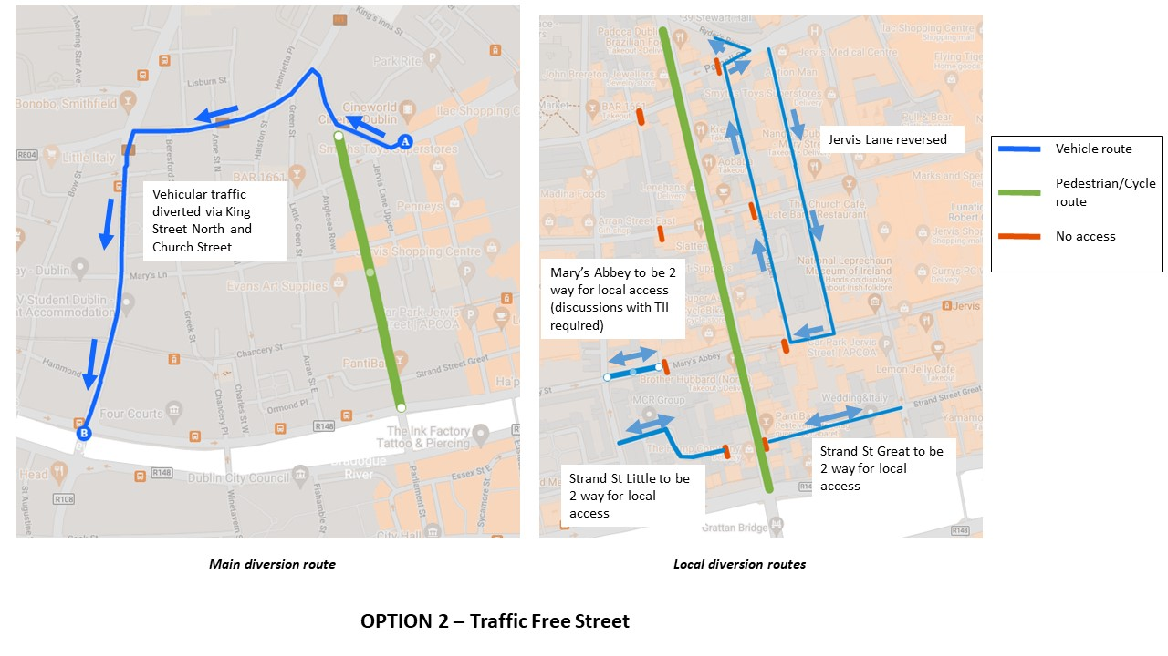
Option 3 – Traffic Free between Parnell Street and Mary’s Abbey on Capel Street
This option would allow the northern end of Capel Street to be traffic free and would remove the through traffic from the top of street, allowing local access to continue to use the lower end of the street and simplifying any traffic changes required.

Option 4 – Traffic Free between Parnell Street and Strand Street on Capel Street
This option would allow for traffic free operation of the majority of Capel Street but would leave the one way system in operation on Great and Little Strand Street and so not require such extensive local changes for residents.

Option 5 – Restore the arrangement from prior to May 2021
Remove the footpath extensions and reinstate the parking and traffic lanes.

Parliament Street Traffic free
The making of Parliament Street traffic free is linked to that of Capel Street. Although more straightforward as it only has one side street, if Capel Street remained open to vehicles the south quays and Fishamble Street would be under severe pressure if Parliament Street was closed and would likely have a negative impact on Capel Street as vehicles would take much longer to clear.
Therefore Parliament Street traffic arrangements need to be is considered in tandem with a complete or partial closure of Capel Street and the same times etc. should apply to both.

Parliament Street Options
Option 1 – Traffic Free Parliament Street
This would mean the closure to vehicles on Parliament Street for :-
- 7 days a week, all day except for specific delivery hours (typically 6am to 11am)
- Evenings from 18.30 to 23.30 all week
- Evenings from 18.30 to 23:30 at the weekends
Access to Essex Street East would be via Crane Lane or Sycamore Street. Exchange Street Lower would be reserved and Exchange Street Upper made one way southbound. There may also be a requirement for changes to Fishamble street.
There would also be a requirement to reroute bus routes 69,79,79A. during the weekend evening closure the diversion routes were:

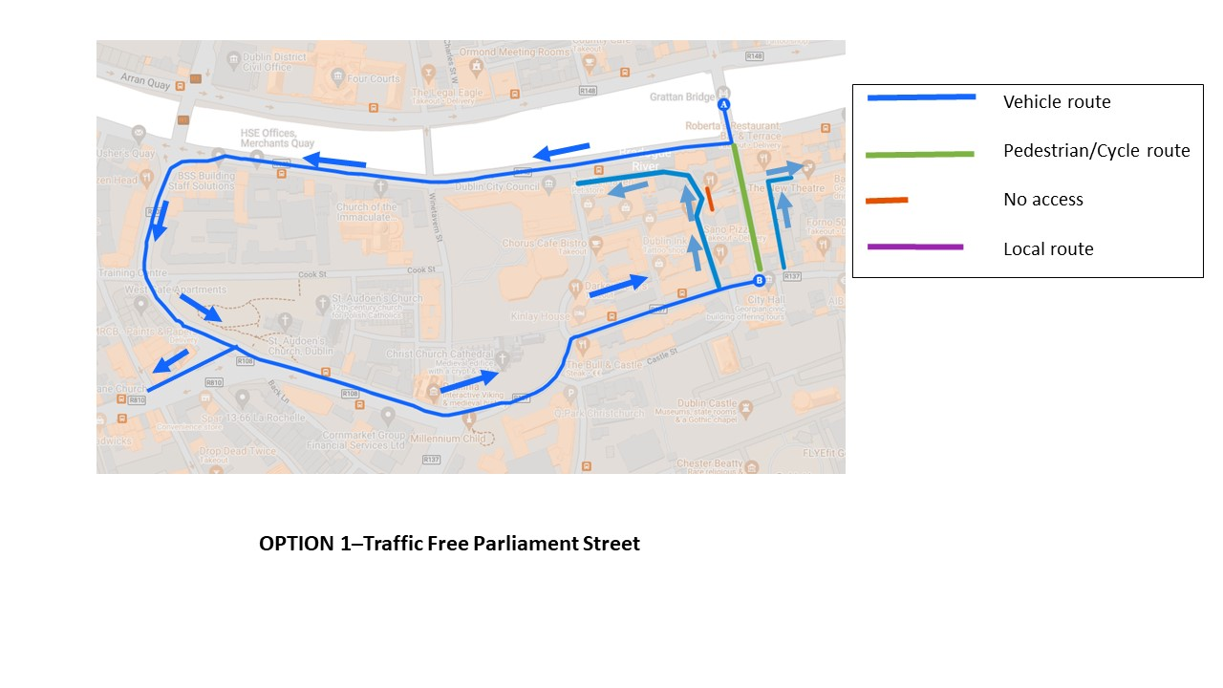

Option 2 – Reduce to one vehicle lane
This would only be feasible if traffic volumes from Capel Street were reduced (Option C3 or C4). All traffic and access arrangements would remain the same and the bus route would be maintained. There would be a significant reduction in traffic in combination with the removal of through traffic on Capel Street and footpaths could be extended to provide additional space.

Option 3 – Maintain current arrangement
Maintain the current layout on Parliament Street.

Consultation

A three week non statutory public consultation commencing on the 30th of August will take place to get the views or residents, businesses and the general public on what they would like to see for Capel Street and Parliament Street

Next Steps

- Four week extension of the weekend traffic free evenings until the 26th of September
- Three week non statutory public consultation from the 30th of August until 20th of September
- Consultation with the emergency services.
- Consultation with disability groups.
- Report to be prepared for consideration by the elected members
- Following the consultation and consideration by Councillors of the consultation report detailed planning of the preferred option will be advanced.
- Any option which is advanced will be subject to further consultation and any necessary statutory requirements.

