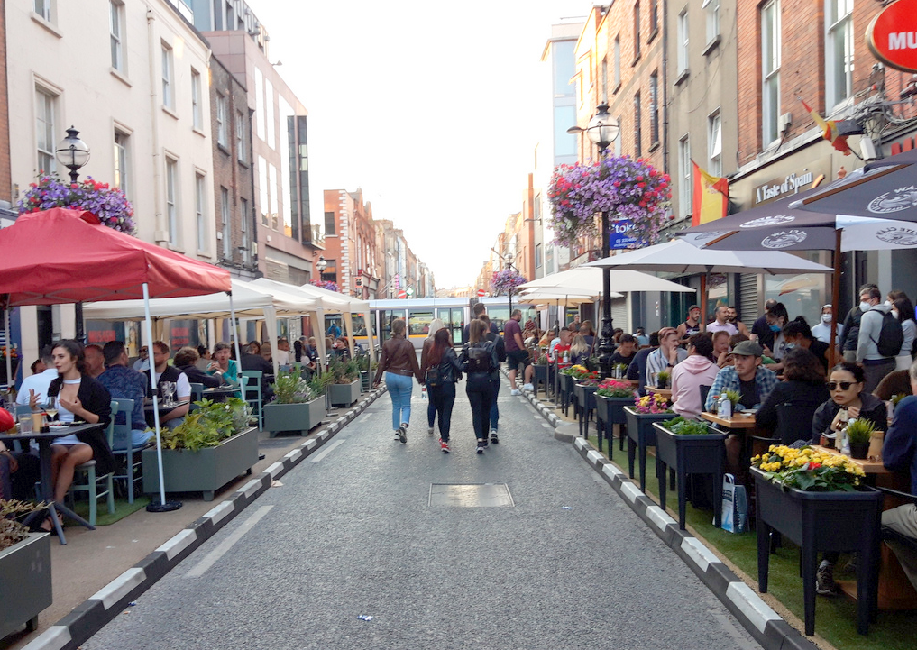
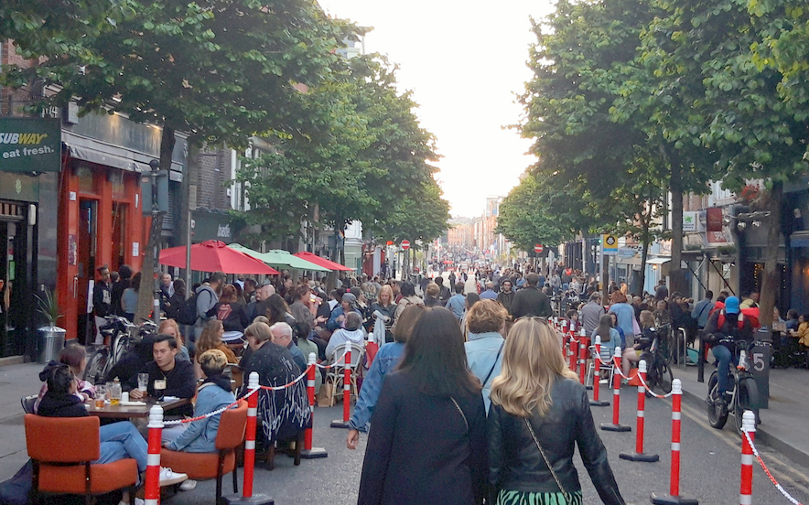
Capel Street and Parliament Street
Report on Non-Statutory Consultation
November 2021
Brendan O’Brien Head of Technical Services
Claire French Senior Executive Engineer

Table of Contents
Introduction 1
Consultation 2
Submissions 2
Capel Street Consultation results 3
Feedback on Experience of traffic free street – Capel Street 3
Residents 5
Businesses 6
Public 7
Other 7
City Councillor or TD 8
Feedback on which options should be further developed 9
Options presented 9
Consultation results on options presented 11
Feedback on Traffic Free times 14
Parliament Street Consultation Results 15
Feedback on Experience of traffic free evenings 15
Residents 16
Businesses 17
Public 17
Other 18
Feedback on which options should be further developed 19
Consultation results on options presented 20
Feedback on Traffic Free times 22
Traffic data 23
Capel Street 23
Parliament Street 25
Future Options to be Developed 27
Next Steps 28

Introduction
In response to the restrictions in place due to Covid 19, DCC Covid mobility team have undertaken a number of interventions to assist with business reopening and providing additional pedestrian space, this followed a public consultation in May 2021 which received almost 4,000 submissions.
The interventions were to remove some parking and loading bays and replace them with temporary build outs giving a total of 560 m² additional space for outdoor dining and pedestrian space. At three locations, 52 Zebra protectors were used to provide protected outdoor space including on Strand Street. In addition the area on Capel Street from Parnell Street to Ryder’s Row was closed to vehicular traffic to create a new pedestrian area. These interventions meant that hospitality businesses could reopen and use the new space created while allowing the existing footpaths to be kept clear. It is the intention of DCC to leave all these interventions as they are for now and to ascertain the public s views on these and other proposals for the street.
From the 11th of June 2021, Capel St. and Parliament St. was made traffic-free on a Friday, Saturday and Sunday evening from 18:30 to 23:30 for a initially for period of 6 weekends on a trial basis but was extended to a total of 17 weeks until the 3rd of October.
Towards the end of the Traffic Free weekend evenings a non statutory public consultation was held to obtain views on peoples experience over the 17 weeks and also what options they would like to see further developed. This report on the consultation summarises the results of the consultation.

Consultation
A consultation was held to obtain people’s views on the traffic free evenings and future improvements for the street. This consultation was held on the Dublin City Council Consultation Hub and ran from the 30th of August 2021 until the 20th of September 2021. A leaflet drop to over 3,000 residences and premises in the affected area was arranged to ensure the maximum involvement of local residents and businesses in this process.
This consultation sought people’s views on:
- Their experience of the Traffic free weekend evenings and

- What worked, what didn’t work from a resident, business owner and street user perspective?

- What options should be further explored for both Capel Street and Parliament Street

- Any suggestions people may have for improvements, changes etc.

Submissions
The following submissions were received:

Format | Number
Online submissions | 6,728
Email submissions | 228
Written submissions | 1
Total: | 6,957

Capel Street Consultation results

Feedback on Experience of traffic free street – Capel Street
People were asked “How did these streets being traffic-free affect your experience of the streets?”
Overall, there was a very positive response with 95% of respondents deeming the traffic free street improved their experience:

Figure 1 Capel Street experience overall results

Examining the responses by respondent type:
137 respondents | 238 respondents
28 respondents | 33 respondents
5,898 respondents | 240 respondents
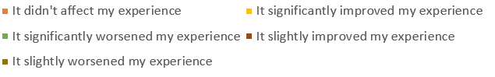
Figure 2 Capel Street experience result breakdown by group

Residents

There were 375 online responses from residents.

From the online submissions, the majority of residents on Capel Street and on side streets who responded felt the traffic free experience slightly or significantly improved their experience of Capel Street. The main benefits commented by residents were:

- Cleaner air, reduced pollution
- Less noise
- Better atmosphere, more vibrant
- More pleasant to walk
- Brought life to the street in the evening
- Safer for pedestrians and cyclists
- “a place to meet, rather than a place to pass through.”
- Eating outdoors more pleasant
- Felt like more of a community
- Felt safer
- “it was incredible to see Capel Street become a hub of activity rather than a shortcut to somewhere else”.
- Calmer
- Better sense of community
- More space for pedestrians
- Eating outdoors more pleasant

Residents who felt it slightly or significantly worsened their experience mentioned the following issues:

- Noise (practically around the Strand St area)
- Drinking
- Anti-social behaviour
- Litter
- Urination
- Length of diversions for residents

There were also emails received from residents during the 17 weeks as well as during the consultation identifying issues of noise, litter and urination particularly around the Strand Street junction where large crowds gathered every Friday and Saturday evening. DCC provided portaloos every Friday and Saturday evening to attempt to counter the public urination issue and extra bins were also provided.
An Garda Siochana were required every Friday and Saturday evening at half 11 to allow the road to reopen due to the crowd at the Strand Street junction.

Businesses
There were 61 online responses from businesses.
The majority of businesses who responded to the online consultation felt the traffic free experience slightly or significantly improved their experience of Capel Street.
The main benefits commented by businesses on Capel Street or on a side street to Capel Street were:
- Attracted more people
- Better atmosphere
- Safer
- Reduced noise
- Brought life and atmosphere to the street
- People more comfortable to stroll around

Businesses who felt it slightly or significantly worsened their experience (6 in total) mentioned the following issues:

- Urination
- Litter

There were a number of email submissions from businesses in the area including in the Jervis shopping centre, Illac shopping centre, Park Rite, Dublin Town.
Many of the submissions were similar and raised the same points:
- Significant traffic congestion
- Balanced approach, pedestrianisation Friday, Saturday and Sunday evening from 7.30 when most retailers have closed.

Public
There were 5,898 online responses from the public.
The online response from the public showed that 97% felt that the traffic free evenings significantly or slightly improved their experience
The main benefits commented by members of the public were:

- Cleaner air, reduced pollution
- Less noise
- Better atmosphere, more vibrant
- More pleasant to walk
- Brought life to the street in the evening
- Safer for pedestrians and cyclists
- “a place to meet, rather than a place to pass through.”
- Eating outdoors more pleasant
- Felt safer
- Calmer
- Better sense of community
- More space for pedestrians
- Eating outdoors more pleasant
Members of the public who felt it slightly or significantly worsened their experience mentioned the following issues:

- Traffic congestion
- Loss of parking
- Litter

Other
There were 242 online responses from “Other” who represented businesses in other areas of the city, residents in other areas of the city, taxi drivers, Management companies, landlords and workers in the area.

The main benefits commented by “Other” were similar to the Public responses:
- More inviting
- More vibrant
- Better atmosphere
- Calmer
- Nicer to dine outdoors without the traffic
- Felt safer
- Visited the street when wouldn’t have before

“Other” who felt it slightly or significantly worsened their experience mentioned the following issues:
- Crowds
- Litter, noise, urination
- Traffic on other routes

City Councillor or TD
There were fourteen online responses identifying themselves as City Councillor or TD, seven of whom are Dublin City Councillors, one a TD and one a Senator. Of these all felt the traffic free evenings improved their experience of the street.

Feedback on which options should be further developed
The following options were presented and opinions sought on what merits a more detailed development:

Options presented
Option 1 – Maintain the current arrangement
Maintain the current arrangement on Capel Street where new footpath extensions have created additional space for outdoor dining whilst maintaining all current traffic flows in the area.
Option 2 – Capel Street traffic free between Parnell Street and the north quays
This option would require a substantial permanent traffic management plan to be developed so that the arrangement could work without the large amount of traffic management operatives that are currently required. This would mean changes to traffic flow to the streets around Capel Street to facilitate local residents, a reduction of on street parking in the area (note there are 2,500 carpark spaces within a 4 minute walk of Capel Street) and limited loading hours.
A comprehensive consultation with businesses and residents would need to be undertaken. This option could run at different hours such as:
- 7 days a week, all day except for specific delivery hours (typically 6am to 11am)

- Evenings from 18.30 to 23.30 all week

- Evenings from 18.30 to 23:30 at the weekends

It should be noted that the map shown is indicative and more detailed traffic management changes would have to be worked up, in order to assess the feasibility or otherwise of the proposal.

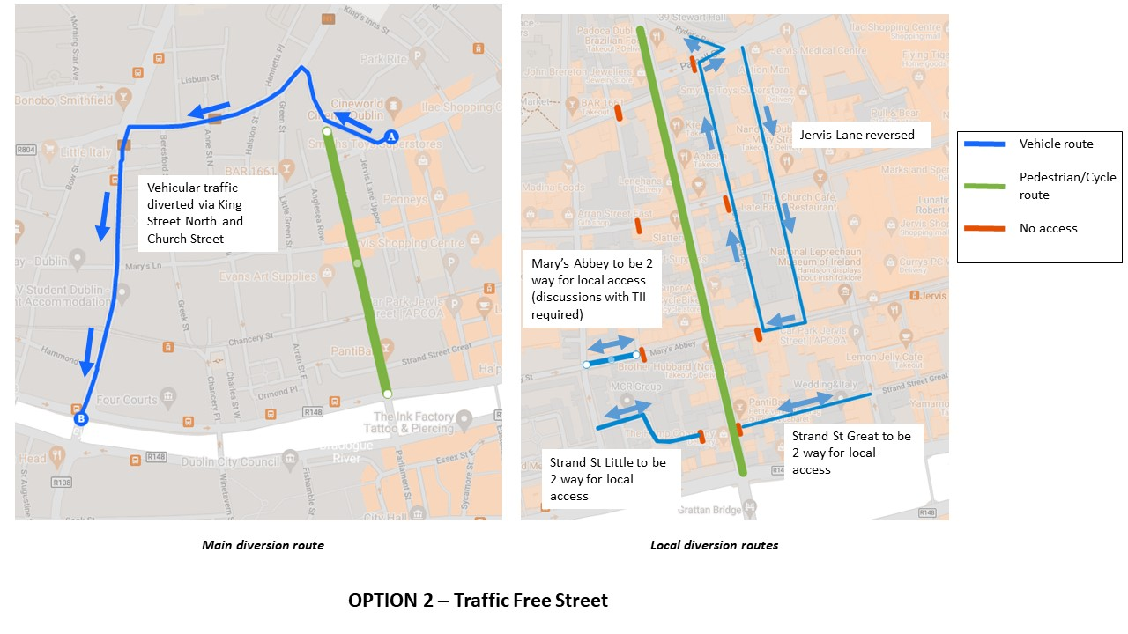

Option 3 – Traffic Free between Parnell Street and Mary’s Abbey on Capel Street
This option would allow the northern end of Capel Street to be traffic free and would remove the through traffic from the top of street, allowing local access to continue to use the lower end of the street and simplifying any traffic changes required.

Option 4 – Traffic Free between Parnell Street and Strand Street on Capel Street
This option would allow for traffic free operation of the majority of Capel Street but would leave the one way system in operation on Great and Little Strand Street and so not require such extensive local changes for residents.
Option 5 – Restore the arrangement from prior to May 2021
Remove the footpath extensions and reinstate the parking and traffic lanes.

Consultation results on options presented
The majority of respondents (90%) responded that they would like to see some form of traffic free arrangement for Capel Street further developed.

Broken down by respondent group:
137 respondents | 238 respondents
28 respondents | 33 respondents
5,898 respondents | 240 respondents
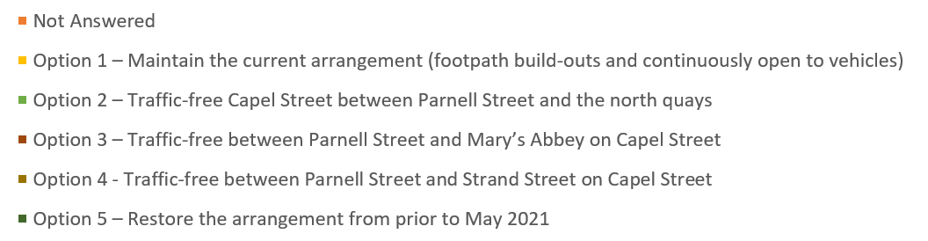

There is strong support from all groups and further developing traffic free arrangements for Capel Street with the strongest support from the general public (91%) with lesser but still significant support from residents (78%) and businesses (80%) .
A summary of the percentage of each group is shown in Figure 7 below:

Feedback on Traffic Free times
Respondents were also asked “If you would like to see Option 2 Full Traffic-free Street, which would you prefer?” to gauge if there was a preference for full traffic streets or evenings only.. The public were strongly in favour of seeing a full 7 day a week traffic free arrangements allowing for deliveries, whilst businesses were more split with some preferring to just have the arrangement in place at evenings. Many of the written submissions also had a preference for evenings only.

Parliament Street Consultation Results
The making of Parliament Street traffic free is linked to that of Capel Street. Although more straightforward as it only has one side street, if Capel Street remained open to vehicles the south quays and Fishamble Street would be under severe pressure if Parliament Street was closed and would likely have a negative impact on Capel Street as vehicles would take much longer to clear.
Therefore Parliament Street traffic arrangements need to be is considered in tandem with a complete or partial closure of Capel Street and the same times etc. should apply to both.

Feedback on Experience of traffic free evenings
People were asked “How did these streets being traffic-free affect your experience of the streets?”
Overall, there was a very positive response with 95% of respondents deeming the traffic free street improved their experience:

Examining the responses by respondent type shows there is some variation between different groups:
25 responses | 71 responses
13 responses | 12 responses
5,914 responses | 242 responses

Residents

There were 66 online responses from residents.

From the online submissions, the majority of residents on Parliament Street and on side streets who responded felt the traffic free experience slightly or significantly improved their experience of Capel Street, although for residents directly on the street it was lower (64%). The main benefits commented by residents were:

- Safer
- Calmer
- Better atmosphere
- Quieter

Residents who felt it slightly or significantly worsened their experience mentioned the following issues:
- Noise (particularly music)
- Litter

Businesses
There were 25 online responses from businesses.

From the online submissions, the majority of residents on Parliament Street and on side streets who responded felt the traffic free experience slightly or significantly improved their experience of Capel Street, although for residents directly on the street it was lower (64%). The main benefits commented by residents were:

- Increased footfall
- Better atmosphere
- More space to provide outdoor seating
Only 2 businesses gave details of why they felt it slightly or significantly worsened their experience mentioning traffic in the area and querying access and deliveries.

Public
There were 5,914 online responses from the public.
The online response from the public showed that 97% felt that the traffic free evenings significantly or slightly improved their experience
The main benefits commented by members of the public were:
- More space for pedestrians
- Safer
- Increased footfall
- Better air quality
- Quieter (without vehicle sounds)
- Calmer
- Better atmosphere
- Better for outdoor dining

Members of the public who felt it slightly or significantly worsened their experience mentioned the following issues:
- Traffic congestion
- Increased traffic on Fishamble Street

Other
There were 242 online responses from “Other” who represented businesses in other areas of the city, residents in other areas of the city, taxi drivers, Management companies, landlords and workers in the area.

The main benefits commented by “Other” were similar to the Public responses:
- Safer
- Calmer
- Better for outdoor dining
- Reduced emissions
- More attractive to visit

“Other” who felt it slightly or significantly worsened their experience mentioned the following issues:
- Traffic congestion

Feedback on which options should be further developed
The following options were presented and opinions sought on what merits a more detailed development:
Option 1 – Traffic Free Parliament Street
This would mean the closure to vehicles on Parliament Street for :-
- 7 days a week, all day except for specific delivery hours (typically 6am to 11am)
- Evenings from 18.30 to 23.30 all week
- Evenings from 18.30 to 23:30 at the weekends
Access to Essex Street East would be via Crane Lane or Sycamore Street. Exchange Street Lower would be reserved and Exchange Street Upper made one way southbound. There may also be a requirement for changes to Fishamble street.
There would also be a requirement to reroute bus routes 69,79,79A. during the weekend evening closure the diversion routes were:

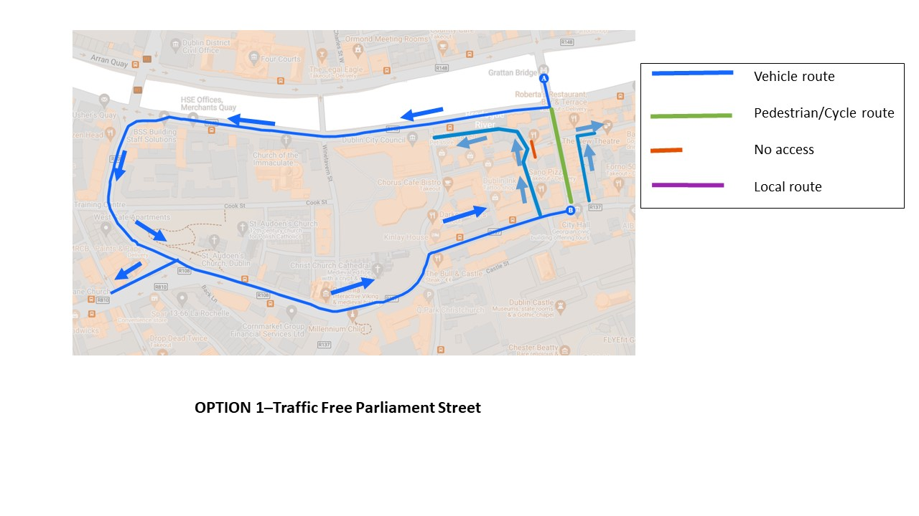

Option 2 – Reduce to one vehicle lane
This would only be feasible if traffic volumes from Capel Street were reduced (Option C3 or C4). All traffic and access arrangements would remain the same and the bus route would be maintained. There would be a significant reduction in traffic in combination with the removal of through traffic on Capel Street and footpaths could be extended to provide additional space.

Option 3 – Maintain current arrangement
Maintain the current layout on Parliament Street.

Consultation results on options presented
The majority of respondents (87%) responded that they would like to see a traffic free arrangement for Capel Street further developed with a further 7% preferring to see the street reduced to one lane.

Examining the response by group, there is support for further developing traffic free arrangements for Parliament Street with the strongest support from the general public (88%). The majority of Residents and businesses on the street also support a traffic free arrangement but to a lesser extent. Approximately a quarter of businesses who responded who prefer that one lane of traffic is maintained.
25 respondents | 71 respondents
13 respondents | 12 respondents
5,914 respondents | 242 respondents
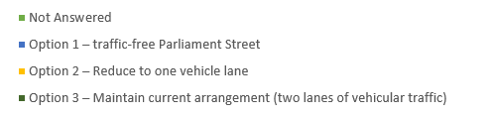

A summary of the percentage of each group is shown below:

Feedback on Traffic Free times
Respondents were also asked “If you would like to see Option 1 Full Traffic-free Street, which would you prefer?” to gauge if there was a preference for full traffic streets or evenings only. The public were strongly in favour of seeing a full 7 day a week traffic free arrangements allowing for deliveries, whilst businesses and residents were more split with some preferring to just have the arrangement in place at evenings.

Traffic data

Detailed 24 hour traffic and pedestrian counts were undertaken on Wednesday the 15th September at 15 locations on and around the Capel Street and Parliament street areas. This provides information on the current use of the street and also provides a baseline to measure any changes that are implemented against.
The results show:

Capel Street
83% of the traffic on Capel Street passes through with 54% of traffic arriving via Parnell street and the rest from the side streets. Vehicles includes cars, LGVs, HGVs, taxis and motorbikes.
Capel St traffic arriving from: | Total vehicles | %
Parnell St to Capel St | 4,763 | 54%
Little Britain St to Capel St | 1,180 | 13%
Mary St to Capel St | 639 | 7%
Mary St Little to Capel St | 542 | 6%
Marys Abbey to Capel St | 724 | 8%
Abbey St Upper to Capel St | 148 | 2%
Strand St Great to Capel St | 799 | 9%
Total | 8,795
For the same period there were also:
Mode | Numbers
Cyclists | 1,251
Pedestrians | 9,600
This shows the importance of providing pedestrian space in this area.

A breakdown of the hourly traffic volumes show that there is an even spread of traffic volumes throughout the 07:00- 19:00 period.

For pedestrians the peak is at lunch time and in the afternoon. Presently there are very few pedestrians at night, reflecting the current restrictions and also numbers are less in the morning peak, possibly as many workers have not fully returned to their workplace. It would be expected that pedestrian numbers at these times will increase.

Parliament Street
96% of the traffic on Parliament Street passes through with 91% of traffic arriving from Grattan bridge with a minor amount of traffic arriving from the side streets. Vehicles includes cars, LGVs, HGVs, buses, taxis and motorbikes.
Parliament St traffic arriving from: | Total vehicles | %
Grattan Bridge to Parliament St | 4,374 | 91%
Essex gate (W) to Parliament St | 406 | 8%
Essex street (E) to Parliament St | 45 | 1%
Total | 4,825
Table 3 Parliament Street vehicular traffic volumes
For the same period there were also:
Mode | Numbers
Cyclists | 2,298
Pedestrians | 7,798

The summary graphs below show pedestrians are currently the largest user of the streets. There are also high cyclist numbers on Parliament Street.

Future Options to be Developed
The results of the consultation show a strong desire for options to be explored which reduce or
eliminate the vehicular traffic on Capel Street and Parliament Street. These options will have an
effect on residents, businesses and traffic in the area so a more detailed assessment on potential
measures is required.
It is clear that from the residents, businesses and the general public that there is a strong desire to
see a change from the current traffic arrangements to new arrangements with less traffic.
This clear desire as part of this consultation now requires us to consider options which would reduce
traffic, allow access residents and businesses and which would increase safety for pedestrians and
cyclists in the area.
However these two streets are part of the city network and so consideration for how any changes to
Capel Street will affect the Markets public realm plan and the Liffey Street enhancement scheme
needs to be considered, as well as impacts in the wider area. Changes to Parliament Street may
affect bus services and also the surrounding Street Network including Fishamble Street so cannot be
looked at in isolation.
In addition, any proposals must be self-enforcing and cannot require the ongoing deployment of
traffic management personnel on an ongoing basis in order to implement it.
Regarding the hours of operation of any traffic free proposals, it must be acknowledged that the
traffic free operation has not been trialled during daytime or during the week and this must be
factored into any plan.
Options for Capel Street may include:
- Traffic Free apart from deliveries between 6am and 11am
- Traffic Free in the evenings only
- Reversal of traffic to remove the majority of traffic whilst still providing resident access, delivery access and parking for retail.
Options for Parliament Street to be detailed include:
- Traffic Free apart from deliveries between 6am and 11am
- Traffic Free in the evenings only
- Traffic reduced to one lane.
It is proposed to now explore options for how the above could be achieved in a self-enforcing
manner, which does not require traffic management staff to be on site.

Next Steps
- Options to be detailed
- Briefing for councillors on potential options in Q 1 2022
- Consultation on detailed options
- Potential trialling of one or more option
- Consideration of any statutory planning issues which may arise.

