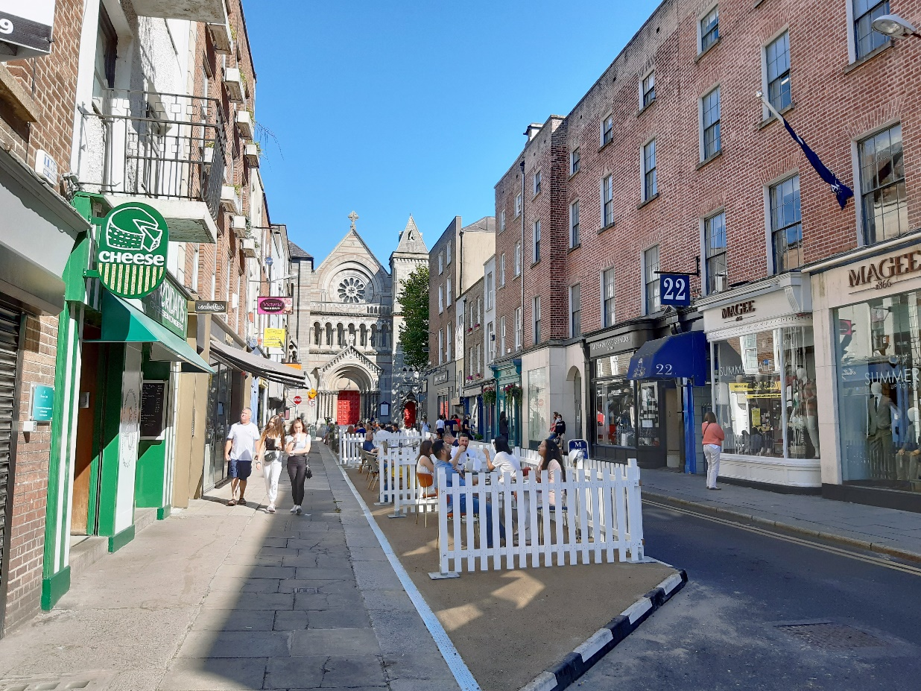

Duke Street/ Anne St South Public Realm Scheme

Report on Non-Statutory Consultation

March 2022
Table of Contents
1. INTRODUCTION 1
2. CONSULTATION 2
2.1. SUBMISSIONS 2
2.2. CONSULTATION SURVEY FEEDBACK 3
2.2.1. Breakdown of Respondents 3
2.2.2. How has the increased pedestrianisation of St. Anne Street affected your experience? 3
2.2.3. What benefits have the changes made to the area? 4
2.2.4. Have there been any negative impacts as a result of these changes? 5
2.2.5. What would you like to see as part of the permanent scheme? 7
2.2.6. What would you like to see prioritised in the permanent public realm scheme? 8
2.2.7. Do you have use of off-street parking? 8
2.2.8. Questions for businesses/delivery drivers 8
2.2.9. Do you have any suggestions or comments for the Scheme? 9
2.2.10. DUBLINTOWN EMAIL SUBMISSION 12
2.2.11. WRITTEN SUBMISSION OF MR. CIARÁN CUFFE, MEP for DUBLIN 14
2.3. MAIN FINDINGS OF THE CONSULTATION 15
3. NEXT STEPS 16

INTRODUCTION
This Public Realm improvement scheme is a priority project for Dublin City Council as we pursue the implementation of the ‘Your City - Your Space’, Dublin City’s Public Realm Strategy (2012) and ‘The Heart of Dublin’ Public Realm Master Plan (2016). This next phase of the Grafton Street Quarter public realm improvements includes Duke Street, Anne Street South, Lemon Street, Duke Lane Upper, Duke Lane Lower and Anne’s Lane. These are important pedestrian routes linking Grafton Street with the South Georgian City via Dawson Street.
The vision for this scheme, as set out in the Grafton Street Quarter Public Realm Plan 2014, is to extend the high quality Grafton Street experience into this key area. This network of streets and laneways provide great opportunities for place making. By implementing a design, which prioritises pedestrians and public space activation, we hope to add economic value to the city’s primary retail core by converting these streets into destinations to visit and linger in, rather than, to simply pass through. The intention is to deliver a high quality canvas for a bustling street life, which will attract the general public throughout the day and night.
The design will place a particular focus on universal design and conservation, with new greening interventions and sustainable drainage solutions also playing an important role in enhancing this environment. Recent COVID Mobility measures provided more space for outdoor dining and increased the pedestrianisation zone in the area, this scheme intends to build on these positive changes.
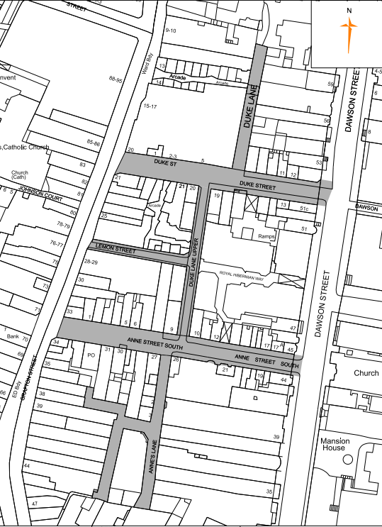
Scheme extent

CONSULTATION
A non-statutory consultation was held to obtain people’s views on the ongoing pedestrianisation of South Anne Street and future improvements in the general area east of Grafton Street. This consultation was held on the Dublin City Council Consultation Hub https://consultation.dublincity.ie/traffic-and-transport/duke-street-anne-st-south-public-realm-scheme/ and ran from the 31st January 2022 to 20th February 2022. It was further published on social media, to Dublin Town, Vulnerable Users Organisations etc. A leaflet drop to over 1,000 residences and premises in the local area was arranged to ensure the maximum involvement of local residents and businesses in this process.
This consultation sought people’s views on:
- Their experience of the current temporary arrangements- revised traffic flows, pedestrianisation of all of South Anne St after 11am, increased outdoor dining facilities

- What worked, what didn’t work from a resident, business owner and street user perspective?

- What is important to them for this space and what specific matters should be prioritised in the future public realm improvement scheme

- Any suggestions people may have for improvements, changes etc.

- Specific details of delivery and waste collection arrangements for businesses in the vicinity

SUBMISSIONS
The following number of submissions were received:
Format | Number
Online submissions | 292
Email submissions | 1
Written submissions | 1
Total: | 294

CONSULTATION SURVEY FEEDBACK

    - Breakdown of Respondents (294 responses)
Description | Total | Percent
Local Business Owner | 22 | 7.5%
Local Resident | 43 | 14.6%
Pedestrian/Cyclist Street User | 161 | 54.8%
Delivery driver/Waste Disposal Service Provider | 3 | 1.0%
Motorist/Taxi Driver | 8 | 2.7%
Work in this area | 41 | 13.9%
Public Representatives | 2 | 0.7%
Other | 13 | 4.4%
Not Answered | 1 | 0.4%

Over 54% of responses submitted by pedestrian/cyclist street users, almost 15% from local residents, 14% from people who work in the area and over 7% from local business owners,
    - How has the increased pedestrianisation of St. Anne Street affected your experience?
Respondents were asked “How has the increased pedestrianisation of St. Anne Street affected your experience?”
Over 92% stated that the pedestrianisation improved their experience, including over 80% whose experience had significantly improved, with less than 5% having a negative experience

What benefits have the changes made to the area?

Respondents were asked “What benefits have the changes made to the area”
The majority of views on the extended pedestrianisation of South Anne Street were positive with people citing the calmer atmosphere, the extra space to move around, allowed them to spend more time in the area. A more pleasant space with less noise and air pollution. A safer space to congregate, a vibrant inviting relaxing space. An inviting destination to meet up with people
Sample Quotes from the feedback:
“The changes to the area have allowed for more people to access the area as pedestrians (including disabled pedestrians), allowing more time and space to access businesses and enjoy the location, similar to Grafton Street.”
“It has made the area more welcoming to pedestrians. I'm a private tour guide who leads small groups around Dublin. It’s now possible to stop and actually look at the building on South Anne Street, previously one had to watch out for cars, avoid parked cars or not stop on a very narrow footpath which would cause a blockage. Tourists are now more interested in stopping on South Anne Street for food or drinks than they would have been before”
The sense of life in the area has massively increased as business can spill outside. Outdoor seating areas increase the energy and vitality of an areas, as well as being more appealing through most of the year. Finally, what once felt like mere side streets to Grafton are now places in their own right to be appreciated and explored, as well as feeling like an important constituent part of the overall area. Dublin is starting, finally, to feel like a European city.
“Safer and more comfortable walking experience
- Generated a nice and welcoming atmosphere with the outdoor seating
- More likely to walk along the street and browse the shops as there is more pedestrian space”
“Less pollution and noise from traffic. More space, safer, more pleasant experience. Attracts more people to the area which benefits local commerce. Better air quality for people”

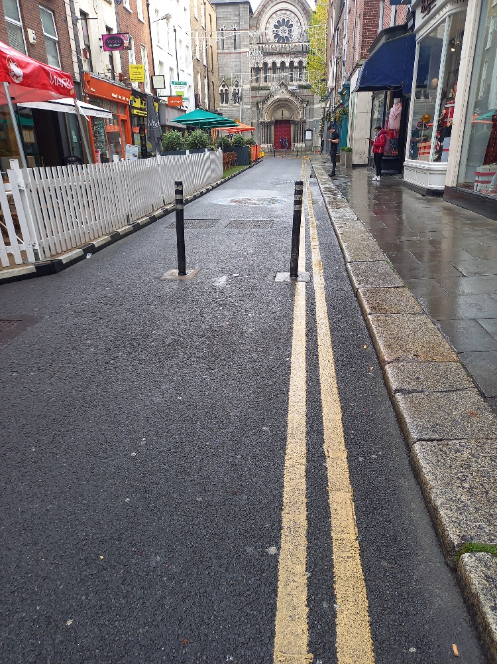

Have there been any negative impacts as a result of these changes?

Respondents were also asked “Have there been any negative impacts as a result of these changes”
57% stated that there were no negative impacts and some commented that the progress on pedestrianisation was too slow and should be accelerated and expanded to more streets in and beyond the Grafton Street area. While 23% outlined negative impacts, 20% did not submit a response.
Some of the most common negative impacts raised by respondents are grouped below:
- Poor quality of build outs, do not look great and cluttered space with street furniture, signs etc.
- Illegal parking e.g. cars blocking pedestrians crossing at Dawson Street
- Restricted access for local businesses and residents and service providers
- Difficulties encountered by visually impaired and those with mobility issues in accessing and using pedestrianised area
- Lack of adequate facilities including bike parking stands, public seating, litter bins and loading bays.
- Poor condition of existing pavements

Sample Quotes from the feedback:
“I'm afraid pedestrianisation efforts might stop here. I hope removing cars will continue to be an ongoing effort and South William Street needs to be fully pedestrianized too! It would be terrible if this would be considered "good enough", we need even more car free areas in Dublin!”
“The public realm is a shambles, broken footpaths, poor quality surfaces, street clutter, a lack of uniformity and polish to what should be a prestige area of the city centre”
“Yes without a doubt. But if local residents and local business owners can access Duke lane upper to Duke St, to Dawson St, without restriction that will change it for us for better.”
“Yes, as a service technician trying to work in the city centre parking is virtually impossible. Loading bays are disappearing and when you do find one it's full or cars or taxis.”
“Dublin City Council should remain cognisant of the need to ensure people with a disability can get around our City. With fewer cars, comes lower risks. However, pedestrianisation can bring with it further street clutter in the form of street furniture. It is very positive to see that more areas of Dublin are having seating added to them, but additional items on the path can have the effect of making it inaccessible for some. In conjunction with a project to increase pedestrianisation around the City, Dublin City Council should assess street clutter and should remove unnecessary items which impede mobility and visual amenity.”
“Yes some idiots keep parking at the end of Sth. Anne Street at junction with Dawson, almost as a disgruntled protest at it being pedestrianised. This needs fixing as it blocks the crossing for pedestrians and it is a massive danger. Extend the bollards out so that they are in line with the footpath on Dawson.”
“Increased anti-social behaviour. Vehicular permeability disimproved particularly when public protests take place and Kildare Street and/or the eastern end of Molesworth Street are blocked off by An Garda Siochana. Alternate access routes are not available.”

What would you like to see as part of the permanent scheme?

Respondents were asked “What would you like to see as part of the permanent scheme?:
- Revert to original traffic arrangements (only the west side of Sth Anne St/Duke St is pedestrianised after 11am)
- Maintain new traffic arrangements (all of Sth Anne St is pedestrianised and west side of Duke St after 11am, local access maintained elsewhere with two way traffic on Duke Lane Upper)”
The survey found 91% of respondents stated that new traffic arrangements should remain in place, and 6% of respondents wanted to revert to the original traffic arrangements i.e. only West side of South Anne St/Duke St pedestrianised after 11am).

What would you like to see prioritised in the permanent public realm scheme?

Respondents were asked to select a maximum of three options from the list in table below that they would like to see prioritised in the permanent public realm improvement scheme

Description | No. of Selections | % Overall | Ranking
Tree planting | 178 | 61 | 1st
Increased priority provided to pedestrians | 168 | 58 | 2nd
Increased public seating | 166 | 57 | 3rd
Increased outdoor dining spaces | 106 | 36 | 4th
Bike stands | 93 | 32 | 5th
Public Water Bottle refill station | 51 | 17 | 6th
Dedicated pedestrian walkways | 50 | 17 | 7th
Shared spaces | 20 | 7 | 8th
Other | 16 | 5 | 9th
Reduced outdoor dining spaces | 14 | 5 | 10th

The top three ranked options, tree planting, increased priority to pedestrians and increased public seating were all selected by over 57% of the respondents. The next most popular option ranked 4th increased outdoor dining spaces was selected by 36% and bike stands ranked 5th was selected by 32%.
Responses submitted under option ‘Other’ included public toilets in the vicinity, more bins and street cleaning of pavements, more loading bays, improved public lighting, increased policing in area reduced clutter, rain gardens, more permanent structures for outdoor dining and restricted access for vehicular traffic.

Do you have use of off-street parking?
Respondents were asked if they had the use of an off-street parking space in the area and 7% stated they have, while 93% said they have not.

Questions for businesses/delivery drivers

Questions 9-15 of the survey were directed to businesses/delivery driver/waste service provider operating in this area and details were requested of their current arrangements. A small sample of 15 responded to this part of the survey.
The main findings were as follows:
- 8 out of 14 deliveries take place before 11am and 7 after 11am, including 6 deliveries occurring between 11am and 3pm
- 12 out of 14 responses indicate daily deliveries/collections of which 7 indicate more than one daily delivery/collection
- Majority of deliveries/collections relate to general business activities while only 2 were for refuse collection
- 11 out of 14 responses indicated that restricting deliveries/collections to before 11am would have an impact on their business including 6nr who stated it would have a major impact
- 9 out of 12 responses indicated car and light commercial vans used for deliveries/collections.
Respondents were asked for any suggestions to make it easier for deliveries/collections to be accommodated and 8 responses were received which are summarised as follows:
- Provide more loading bays and enforce their use to keep them clear of taxis and cars. Also could booking system be introduced for loading bays using an App;
- Maintain existing access via Dawson Street, Duke Street & Duke Lane Upper
- Keep large deliveries to early mornings preferably before 7.30 am. Use cargo bikes more extensively for deliveries in area.

Do you have any suggestions or comments for the Scheme?

Respondents were asked for any suggestions/comments regarding the scheme and 164 responses were submitted. The main responses received are summarised below:
- General consensus appears to be that pedestrianisation is a positive development but is progressing too slowly and should be accelerated and expanded further throughout and beyond the Grafton Street area and policy of actively removing vehicles from shared spaces in City Centre should be implemented.
- Use high quality paving materials similar to surfaces on Grafton Street and Royal Hibernian Way
- Introduce a safe inviting space where people will want to meet and socialise together
- Improvements in Public realm scheme should include appropriate seating, outdoor dining areas, tree planting & greening, bins, bike stands etc. The recent Chatham Street scheme was referenced as a good model to follow.
- Ensure public realm space accessible for all including visually impaired, people with mobility issues etc.
- Rationalise street signage, bollards, mini-pillars, cabinets etc. to minimise street clutter.

Sample Quotes from the feedback – Respondents Suggestions & Comments:
“I would like to see this scheme extended to the western side of Grafton Street as well to cover the area between Grafton Street and South Great George's Street. It will create a much more attractive urban environment which will be good for the vibrancy of the city centre and good for business”
“Ideally I would like if these streets had a good mix of public amenities (seating, drinking water fountains, tree cover) and private offerings (outdoor restaurant seating) that led to a diverse set of people using the space. Using limited street space for the storage of cars diminishes the amenity value of the area for the large majority of people who do not need to access the area by vehicle.”
“Recently renovated Chatham Street is a much more inviting model, which should be replicated here. Involving seating and greenery in any redesign makes for a much more inviting and laid-back experience”
“Use public seating design and trees from recent Chatham street development as a model for both streets. Can all street clutter e.g. sign poles, mini pillars, bollards etc. be rationalised and as much as possible removed. Mini pillars in particular are incredibly unsightly; much more effort needs to go into removing them. A Dublin bike stand should be considered in addition to permanent Sheffield stand type bike stands”
“A better quality public realm experience that is consistent throughout the area and increased greening/tree planting. Increased public seating and outdoor dining areas. Increased secure bike parking facilities.”

“Go the extra mile get in the stone masons & create a lasting impression for generations.
Look to the paving/walk way in the Royal Hibernian Way nearby, much better quality, standard & look.”

“There is a dearth of secure bicycle parking in the area between Dawson Street and Grafton Street. While the indoor facility on Drury Street is great for longer-term bike parking, there is a need for bike parking on South Anne Street. This will hopefully result in less street clutter from cyclists using the nearest available sign pole on already cluttered footpaths”

“Can all street clutter e.g. sign poles, mini pillars, bollards etc. be rationalised and as much as possible removed. Mini pillars in particular are incredibly unsightly, much more effort needs to go into removing them.”
“With respect to Grafton Street DCC should be much more ambitious with the next iteration of the Dublin City Centre Public Realm Masterplan. DCC should include a long term plan to remove all car parks and car parking from the entire Grafton Street quarter from Dawson Street to Georges Street.
“For this initiative I suggest that all deliveries to this area and the Grafton street area in general should be restricted to before 7am. The current practice of allowing deliveries up to 11am is outdated and makes the entire area almost unusable to pedestrians”

“We would like to see Duke St being pedestrianised to have space for more outdoor dining in the area.”

“Make more use of Anne’s lane which would again make it a pleasant street especially at night”
“Difficulty for installation and servicing equipment in Hospitality business.
Equipment, cylinders analysers are heavy and van must be accessible to premises.
Emergency call can happen at any time”
“Why has it taken 8 years to get this to yet another round of consultation? Please stop making round after round of consultation and then ignoring the overwhelming support for pedestrian-focused schemes. Cars are not the future of Dublin, so start implementing pedestrian areas consulted on over the last 10 years:”
“I saw that in the last public consultation almost everyone was in favour, so I'm just questioning in general why we have to keep doing consultations. Can't it just be pedestrianised permanently and leave it at that? It's so much nicer than it was before. It feels like you keep having consultations because you want to get a different answer.”
“More public toilets should be considered nearby also”
“More frequent street cleaning - the pavements are disgusting”
“High quality materials to be used, planting of trees, benches.
Look at Dutch model where all deliveries in urban areas happen before morning time as a means of reducing road traffic congestion”
“Stop deliveries between 8am and 8pm. Too many poles, de-clutter and use paving that doesn’t discolour straight away”.

“The whole area is getting run down partly due to the ridiculous difficulties in driving into the city and the outrageous parking charge increases”.

“Good public realm design principles would encompass the following from the list of options - increased public seating, public water bottle station, bike stands, tree planting, increased outdoor dining space, pedestrian priority and widened and improved pedestrian walkways. All of this should be implemented as part of the project to really enhance this part of the city centre and attract people in. The city needs as much pedestrianisation as possible!”

“Yes if we could reduce outdoor dining as it is effecting all retailers here and only benefits eateries”
“We would really like some consideration given to a standardised design for outside seating screens/awnings/canopies etc. - if all premises had a similar setup it would create an improved streetscape.
On the subject of the overall streetscape, it would be really good to minimise the number of signage posts and non-essential street furniture - to reduce visual clutter would help the overall aesthetics.In addition we would suggest that strong consideration should be given to permitting the fixing of terrace screens (or equivalent) into the pavement, in poorer weather it is common to see these screens topple over and given Irish weather this seems an unnecessary hazard.”
“The negative impacts of increasing pedestrianisation whose impacts are most keenly felt by people who are blind or vision impaired include:
- removal of raised kerbs which previously defined boundaries to carriageways and footways, as both long cane and guide dog users depend on these raised kerbs for wayfinding;
- lack of supplementary wayfinding - such as tactile guidance strips - in the absence of raised kerbs; - proliferation and/or poor design and placement of public street furniture, including seating, waste receptacles, Traffic Signs and public lighting;
- proliferation and/or poor design and placement of "sandwich boards" and other commercial signage, outdoor seating, planters, railings and other physical barriers being introduced in the public realm by adjoining businesses.
- Management, enforcement and licensing of public and private street furniture must be a priority to ensure safe, equitable access to the space.”
“Cyclists weaving through pedestrians is less than ideal.”
“Delivery drivers have found it very restrictive but for the most part appear to have adapted well over time”
“No street presence due to street furniture blocking our doorways”
“Delivery issues relating to parking”
“Lack of access has had an immediate impact on our business. Deliveries and access to our premises have been compromised, restricted by limiting hours from 6am-11am. Anne's Lane has traditionally been an access artery for a substantial backbone of the Grafton and Dawson area, and I feel this should remain a priority to enable, not disable, business workflow.

DUBLINTOWN EMAIL SUBMISSION
DublinTown consulted and received feedback from businesses in the area about issues that needed to be addressed and prioritised in the Duke Street Anne Street South Public Realm Improvement Scheme.
They noted that these two streets and their adjoining laneways provide important function for the area, offering independent retail, cafés, pubs and gallery spaces to complement the retail offering and international brands available on Grafton Street. The layout of the streets highlights the conscious, planned permeability laid out by Joshua Dawson et al in the 18th Century and is a wonderful example of Georgian era city planning with the likes of South Anne Street terminating in the beautiful vista of St. Ann’s Church.
They emphasised how the measures introduced to alleviate the impacts of COVID-19 including new seating licences and the build out of the pavement on South Anne Street had proved popular and have helped support businesses in the area.
They believe there is much to recommend this area and they believe that simple additions and improvements, similar to those made in other successful schemes, such as at Chatham Street would be significantly beneficial.
Their main priorities are briefly outlined below with some of their queries and comments.
Seating and Access
- Feedback from businesses suggests that they want to keep and perhaps even increase this seating and they are of the view that customer demand, even in poorer weather, wants to see outdoor seating remain. Suggest footpaths should be widened permanently to a high standard to accommodate this and that where possible additional infrastructure could be provided, such as planters, power supply points etc.
- There is a demand from hospitality businesses in Duke Lane and Anne’s Lane to be accommodated with outdoor seating and a more pedestrian friendly environment.
- Preference for outdoor seating areas directly adjacent to their buildings, this would mean that these areas would be easier to heat or provide cover via canopies. The widened footpath could then accommodate pedestrian traffic on the likes of South Anne Street.
- Maintain local access to certain private car parks and lock ups on, or adjoining South Anne Street, Duke Street.
- Anne’s Lane and Duke Lane Upper there is strong desire from businesses in these areas to increase the space available for outdoors seating.
Material choice and Maintenance
- Use of high quality materials and finishes were mentioned, similar and in keeping with the improved paving within the wider area.
- Specific mention of regular care, cleansing and maintenance regime of any new pavements that are laid.
Bins
- Several businesses in the area have requested more litter bins for the streets in question.
- Anne’s Lane is the “back of house” for numerous businesses on Grafton Street. The storage, presentation and collection of bins in this area should be considered so that as little disruption is caused to those actively trading onto the laneway as possible.
- Liaise with waste collection providers to work out the best manner in servicing the area.
Planting
- Desire for greater planting and greenery in the street both from aesthetic and sustainability purposes, to be looked at and reviewed on a site-specific basis.
- There was also interest in perhaps involving property owners in greening projects such as window boxes, hanging basket and green walls. Would have to be looked at on a site-specific basis.
Public Seating
- Are there plans for public seating or benches on any of the streets or lanes? If so are there designs or materials already agreed upon?
Lighting
- Is lighting planned for the street to be installed as lampposts, wall mounted lamps or as a mix?
- Need to improve the lighting in Lemon Street which remains dark and uninviting despite being a key point of access from Grafton Street.
Animation or street art or signage
- Is consideration being given to any street art or sculpture for the area? Suggestions had been made for signage indicating the locations of Anne’s Lane or Duke Lane? Previously branded archways were suggested for the entrance to Anne’s Lane to identify it.
Timing and scheduling of works
- There is concern from many businesses, who have faced closures and reduced trade due to COVID-19 restrictions, of the impacts of works on the street. Detail will be needed of phasing and timelines of the works as well as what measures will be taken to ensure minimal impact on trade and footfall and what measures will be put in place to make sure the street remains visually attractive through the works.

WRITTEN SUBMISSION OF MR. CIARÁN CUFFE, MEP for DUBLIN

Mr. Ciarán Cuffe, MEP submitted a written submission to Dublin City Council and requested that the following items be considered and incorporated into the Duke Street Anne Street South Public Realm improvement scheme.
“1. Use high quality materials, including native Irish stone where feasible.
2. Incorporate green infrastructure including shrubs, grass and mature trees. I recommend that you study the recent public realm scheme on ‘Boulevard Anspach’ in Brussels, Belgium for inspiration.
3. Allow for high levels of bicycle parking on street
4. Provide drinking foundations.
5. Consider features that would be attractive to children.
6. Ensure that quality public seating is provided.
7. Adopt a cut-throat approach to reducing the amount of signage.
8. Allocate 1% of the budget to public art and sculpture
9. Consider the views of those with disabilities in the plans and consider parking for those with disabilities at an early stage.
10. Review recent thinking on ‘shared space’ including research from ‘Trinity Haus’ that highlights the problems associated with sharing space with vehicles and others in confined conditions.”

MAIN FINDINGS OF THE CONSULTATION

- 294 responses received, 55% from pedestrian/cyclist street users, almost 15% from local residents, 14% from people who work in the area and over 7% from local business owners

- 92% of all respondents stated that the increased pedestrianisation in South Anne Street improved their experience, including over 80% whose experience had significantly improved, with less than 5% having a negative experience

- 57% of all respondents stated there were no negatives impacts to the extended pedestrianisation, while 23% outlined negative impacts

- 91% of all respondents stated that the increased pedestrianisation in South Anne Street and current traffic arrangements should remain in place, while 5% wanted to revert to the previous setup and traffic arrangements.

- Over 57% of all respondents selected tree planting, increased priority to pedestrians and increased public seating as their main priorities for the future public realm improvement scheme. The next most popular choice increased outdoor dining spaces was selected by 36% and bike stands was selected by 32%.

- 7% of respondents have the use of an off-street parking space in the area, 93% have not.

- Main issues that need to be addressed in the future scheme include safe access for all including vulnerable users, reduction of street clutter, provision of public amenities including seating, outdoor dining etc. and identification of practical green solutions for the area.

NEXT STEPS

- Further on-street trialling and monitoring of alternative layouts
- Further consultation with local businesses and stakeholders
- Prepare preliminary design
- Complete required assessments & surveys for preparation of planning report
- Briefing for councillors on proposed public realm improvement scheme
- Prepare planning report.
- Submission to the Council of a Part 8 planning application

