September 2023
Dublin City Council, with the support of the National Transport Authority, proposes to implement front-of-school works to improve the safety of students and vulnerable road users accessing and exiting schools at St. Fiachra’s Junior National and Senior National Schools at Montrose Park, Beaumont in Dublin 5.
The Council asked the school community and local residents for feedback in a non-statutory consultation in May 2023. Based on the feedback received, the design has been updated to incorporate changes. This document outlines details of the new School Zone.
What are School Zones?
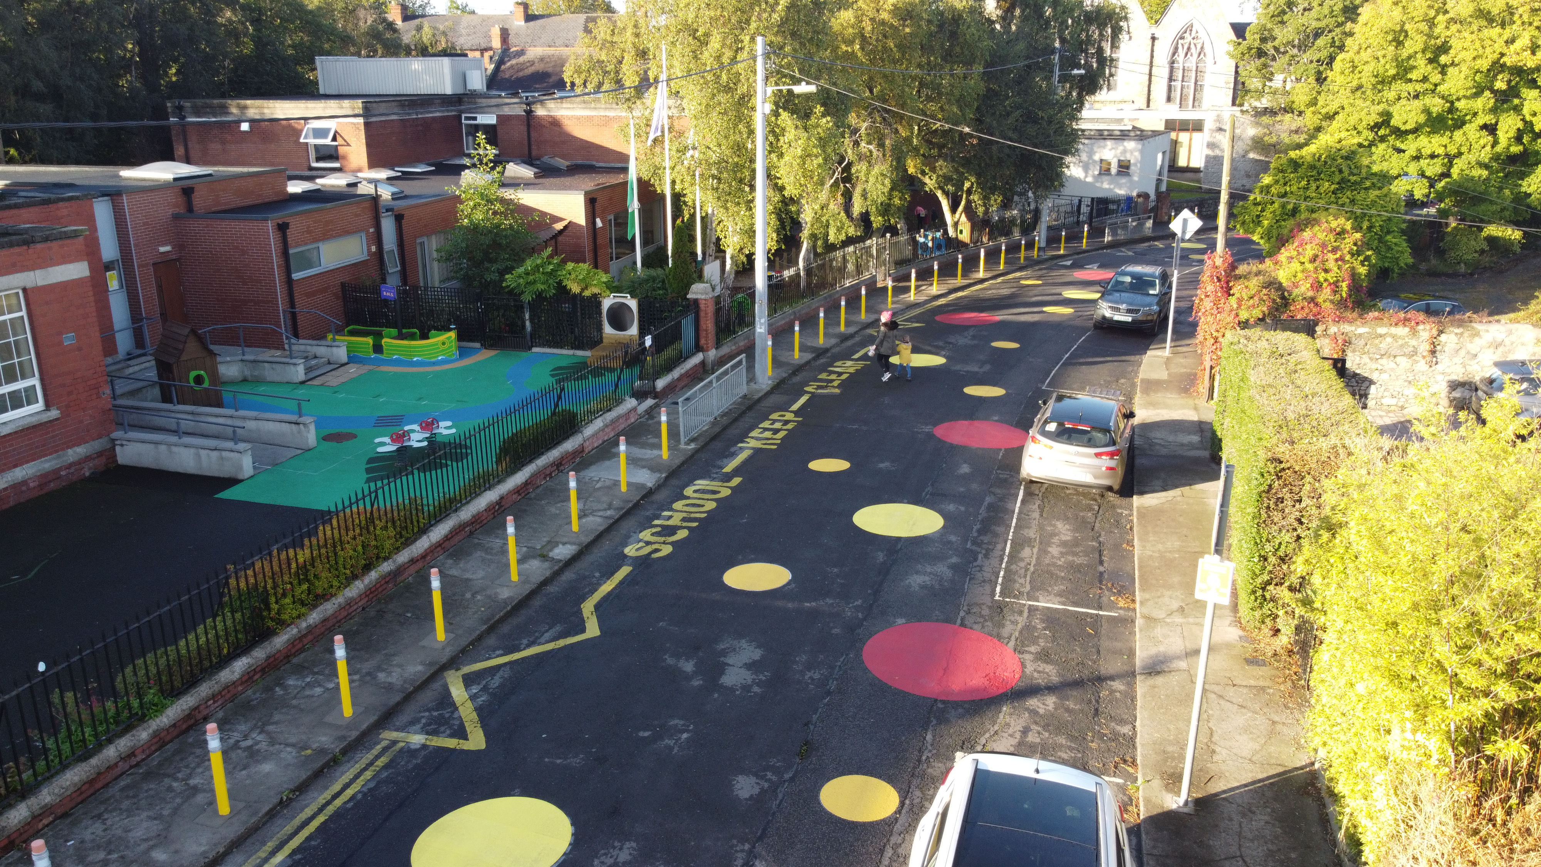School Zones are built infrastructural upgrades that are designed to give priority to students at the school gate by freeing up footpaths and reducing vehicle drop-offs, pick-ups and idling. The aim is to increase safety at the front of a school and to prioritise active travel (walking, cycling, wheeling and scooting) to and from school.

Image 1: Example of School Zone at Star of the Sea School, Sandymount, Dublin 4

School Zones are implemented around the world in order to:
- Increase student safety
- Reduce vehicle drop-offs, pick-ups and idling outside the school gate
- Reduce congestion and prioritise active travel (walking, cycling, wheeling and scooting) to and from school
- Encourage slow, safe driving in the area of the school
- Promote considerate parking
- Reduce emissions and pollution, and improve air quality and noise quality by reducing volume of traffic at schools and vehicles with engines idling

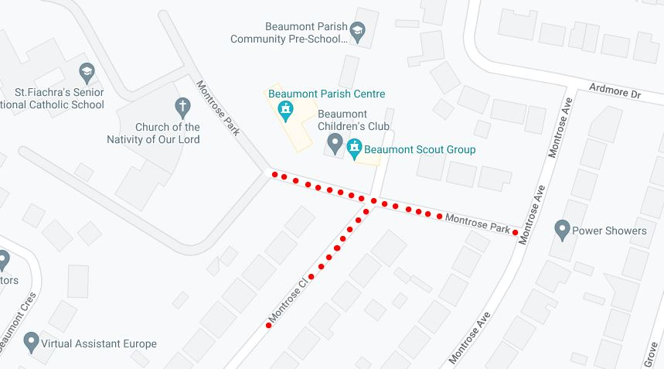
Where will these works take place?
These works will take place on Montrose Park and Montrose Close, Beaumont, Dublin 5, on approach to St. Fiachra’s Junior National and Senior National Schools.

Image 2: Extent of the works at St. Fiachra’s Junior National and Senior National Schools

What works will take place at St. Fiachra’s Junior National and Senior National Schools Montrose Park, Beaumont, Dublin 5?
The works will consist of:
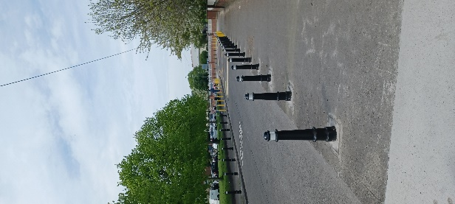
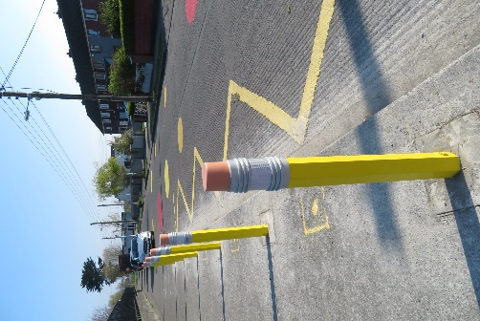
Rigid yellow pencil bollards (depicted as pink on the design drawing) along the immediate edge of the northern footpath of Montrose Park with gaps to allow for vehicular access. The number of these bollards has been reduced since the previous design.
Lighthouse bollards (depicted as black/white circles on the design) on both sides of the footpath along Montrose Close up to its junction with Montrose Park and also along the northern footpath of Montrose Park from house nos. 2 to 20, with gaps to allow for vehicular access. These have replaced yellow pencil bollards from the previous design.
Image 3: Example pencil bollard on footpath, Cromcastle, Kilmore, Dublin 5
Image 4: Example lighthouse bollards in Walksintown, Dublin 12

Blue and green flexible pencil bollards along the immediate edge of the southern footpath of Montrose Park on approach to the school.
All house entrances to remain unobstructed by bollards.

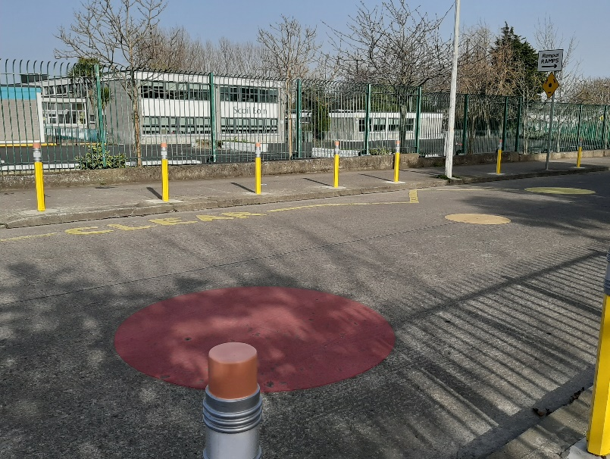
Colourful road markings consisting of yellow and red circles painted directly on the road on Montrose Park on approach to the school at the Church of Nativity entrance.

Image 5: Example Circle Road Surface Markings on Thornville Road, Kilbarrack, Dublin 5
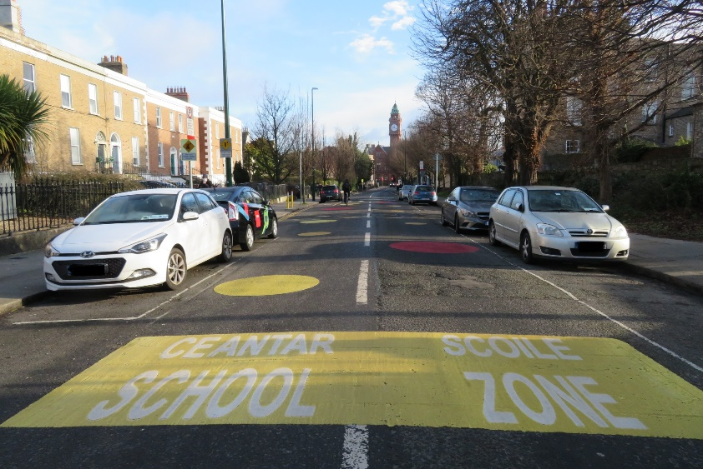
White text ‘School Zone’ in a yellow box road marking, to be painted directly on the road, on approach on the west side of Montrose Park. The marking originally planned on the eastern end of Montrose Park beside the sped ramp has been removed from the updated design.

Image 6: Example Road Surface Sign for School Zone on Leinster Road, Rathmines, Dublin 6

The existing yellow box, which had been removed in the previous design, has been retained in the updated design.

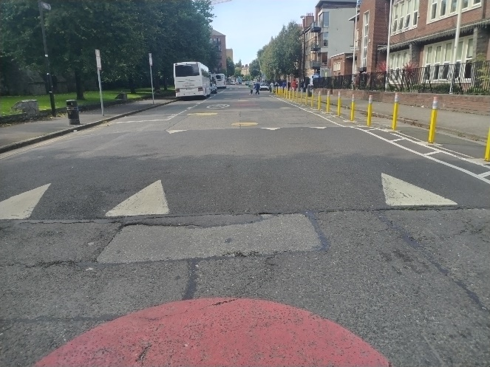
The existing speed ramp on Montrose Park will be retained.
A new speed ramp to be installed on Montrose Park, adjacent to the junction with Montrose Avenue.

Image 7: Example speed ramp on Strand Road, Sandymount, Dublin 4

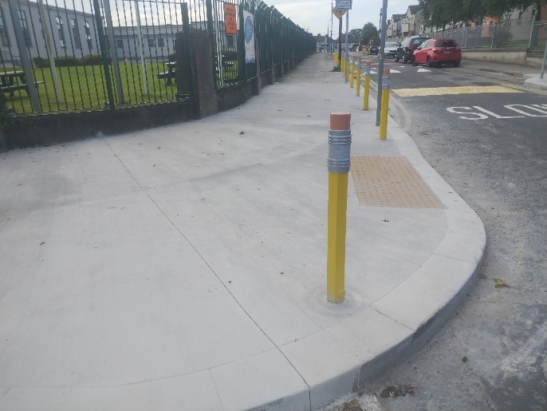
Footpath build-outs to be constructed at the junction of Montrose Park/Close, to reduce the corner radii and decrease the crossing length. The buildouts will reduce the speed of cars coming into the area by forcing them to slow down taking the corner. The buildouts will also give more space for people waiting to cross.

Image 8: Example path buildout on Clancarthy Road, Donnycarney, Dublin 5
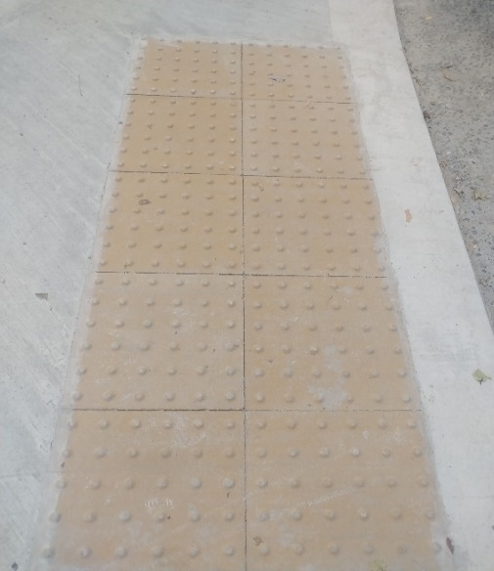

These crossing points will be fitted with the buff, coloured blister tactile pavement inserts and will have bollards at the edges to prevent vehicles using them as parking areas. This tactile paving prevents trips and slips. The paving is more user-friendly for people with mobility and visual impairment needs. They are depicted as brown hatching on the path in the design drawing.

Image 9: Example tactile blister pavements inserts
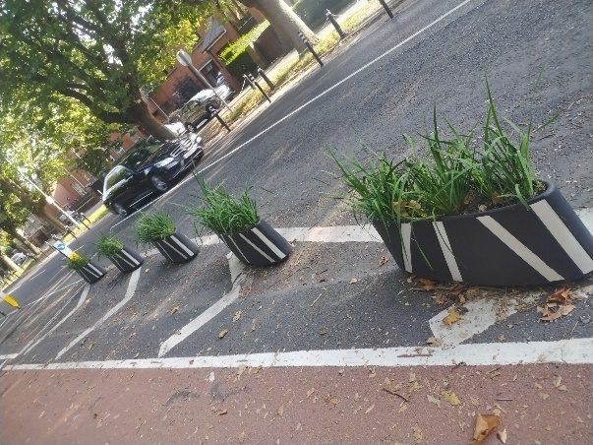
Zebra planter boxes to be placed on the southern side of the carriageway on Montrose Park, adjacent to its junction with Montrose Avenue. These are in lieu of green and blue pencil bollards in the original design. The success of these planters will be reviewed in six months.

Image 10: Example planter boxes on Griffith Avenue, Dublin 9

Why are we implementing this School Zone?
Traffic-related safety concerns have been reported and observed by the schools, parents, neighbours, Dublin City Council’s School Warden Service, Parking Enforcement and School Mobility Officer, including:
- The high volume of vehicular traffic at school times outside the school gate and coming into Montrose Park, Montrose Close and Montrose Avenue. Parents feel that outside the school gate is “the most dangerous part of the school journey" with vehicular parking, dropping off in the middle of the road, reversing and u-turns
- Vehicular parking either fully or partially on the footpath on both sides of Montrose Park and Montrose Close
- Pedestrian congestion when a high volume of people at school times are travelling down the narrow paths in the Montrose estate

Full updated drawings, information about the feedback received and School Zone guidance documents are available online at https://consultation.dublincity.ie/ (search St Fiachra’s Junior National and Senior National Schools).
A hard copy poster of the drawing will be available to view at the school gate.
Image 11: Snippet of design drawings for St. Fiachra’s Junior and Senior Schools

