2nd October 2023
Dublin City Council with the support of the National Transport Authority proposes to implement front-of-school works to improve the safety of students and vulnerable road users accessing and exiting schools at Drumcondra National School, Church Ave, Grace Park Rd, Drumcondra, Dublin 9.
The Council asked the school community and local residents for feedback in a non-statutory consultation in May 2023. Based on the feedback received, the design has been updated to incorporate changes. This document outlines details of the new School Zone.
What are School Zones?
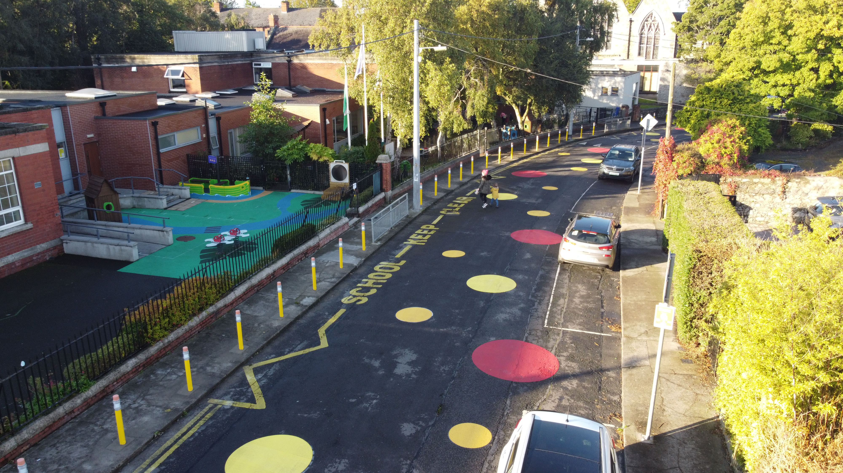School Zones are built infrastructural upgrades that are designed to give priority to students at the school gate by freeing up footpaths and reducing vehicle drop-offs, pick-ups and idling. The aim is to increase safety at the front of school and prioritise active travel (walking, cycling, wheeling and scooting) to and from school.
Image 1: Example of School Zone at Star of the Sea School, Sandymount, D4
School Zones are implemented around the world in order to:
- Increase student safety.
- Reduce vehicle drop-offs, pick-ups and idling outside the school gate.
- Reduce congestion and prioritise active travel (walking, cycling, wheeling and scooting) to and from school.
- Encourage slow, safe driving in the area of the school.
- Promote considerate parking.
- Reduce emissions and pollution, and improve air quality and noise quality by reducing volume of traffic at schools and vehicles with engines idling.

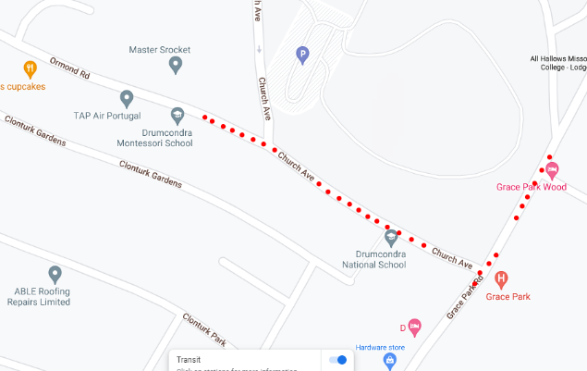
Where will these works take place?

These works will take place on Church Ave and Grace Park Road, Drumcondra, Dublin 9.

Image 2: Extent of Works at Drumcondra National School

What works will take place at Drumcondra National School, Church Ave, Grace Park Rd, Drumcondra, Dublin 9?
The works will consist of:
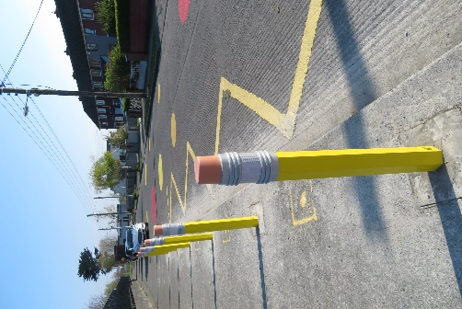
Blue and green pencil bollards along the edge of the southern carriageway of Church Avenue from its junction with Grace Park road to the school entrance. These are depicted as blue and green dots on the design drawing.
Yellow pencil bollards on the east side of the footpath on Grace Park Road adjacent to the existing ramp to prevent illegal parking on the path and to raise awareness of the presence of Grace Park Educate Together School entrance. These are depicted as orange dots on the design drawing.
All house vehicular entrances to remain unobstructed.
Image 3: Example pencil bollard on footpath, Cromcastle, Kilmore, D5

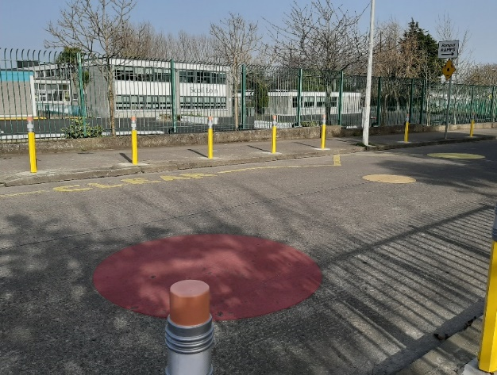
Colourful road markings consisting of yellow and red circles painted directly on the road on Church Avenue outside the school entrance.
Image 4: Example circle road surface markings, Thornville Rd, Kilbarrack, D5

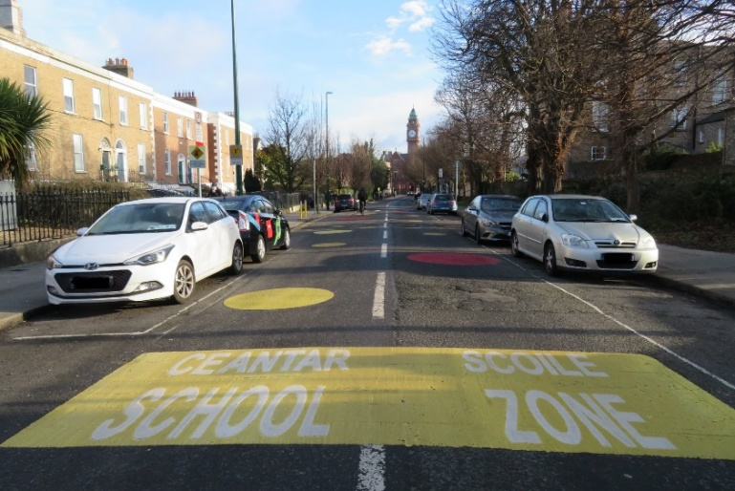

School Zone road surface signs will be painted directly on the road outside the school on Church Avenue on approach from Ormond Road and Grace Park Road.
Image 5: Example road surface sign for School Zone, Leinster Road, Rathmines, D6

The existing speed cushions on Church Avenue and Grace Park Road will be retained.
The right and left ban turns have been removed from the updated design, based on feedback from the consultation.
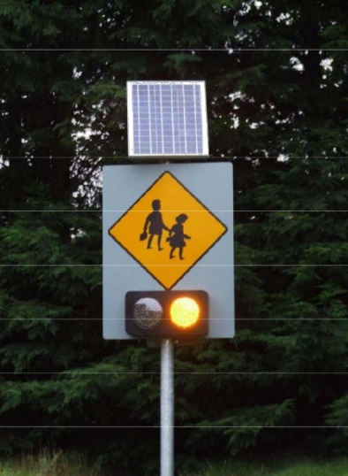
2 new School Ahead with Flashing Amber signs will be installed on the northern side of Church Avenue and on the southern side of Church Avenue at the junction with Grace Park road.
Image 6: Example School Ahead flashing amber sign

The single yellow line suggested on the southern side of Church Avenue, has been removed from the updated design, based on feedback from the consultation
The existing double yellow lines remain outside the school on both sides of Church Avenue. These are depicted as double black lines next to the kerb on the design drawing.

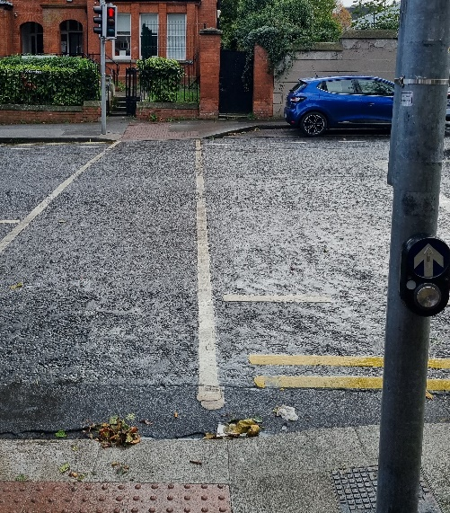

A signalised pedestrian crossing will be installed outside the Irene Social and Sports Club on Gracepark Road.
Image 7: Pedestrian crossing, South Circular Road, D8

Why are we implementing this School Zone?
Traffic related safety concerns have been reported and observed by the schools, parents, neighbours, Dublin City Council’s School Warden Service, Parking Enforcement and School Mobility Officer, including:
- Mounting of footpaths on Church Avenue when large vehicles want to pass each other with limited awareness that the school is situated on the road.
- Speeding towards the school to try and avoid congestion at the school gates where the road narrows.
- Close proximity of children to traffic due to narrow footpaths.
- The high volume of vehicular traffic at school drop-off and collection times.
- Safety issues relating to the very narrow road with poor visibility at corners accommodating two lanes of traffic.

Full updated drawings, information about the feedback received and School Zone guidance documents are available online at https://consultation.dublincity.ie/ (search Drumcondra National School).
A hard copy poster of the design will be available to view at the school gate.

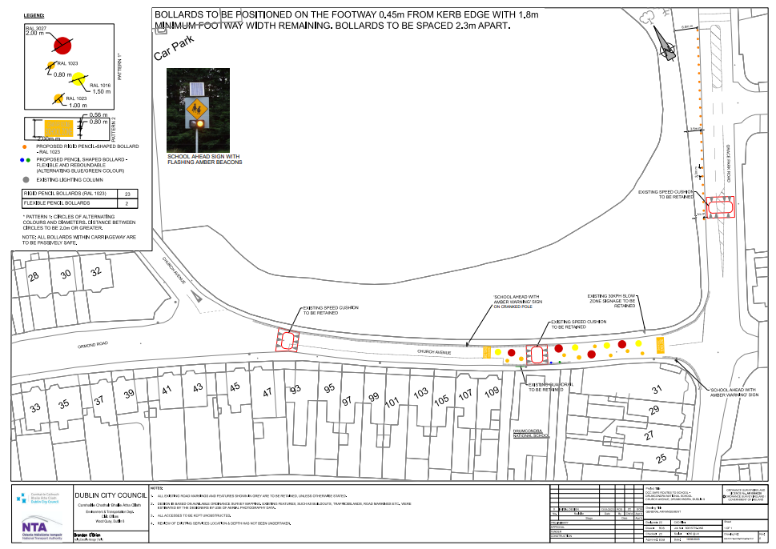
Image 8: Snippet of design drawings for Drumcondra National School
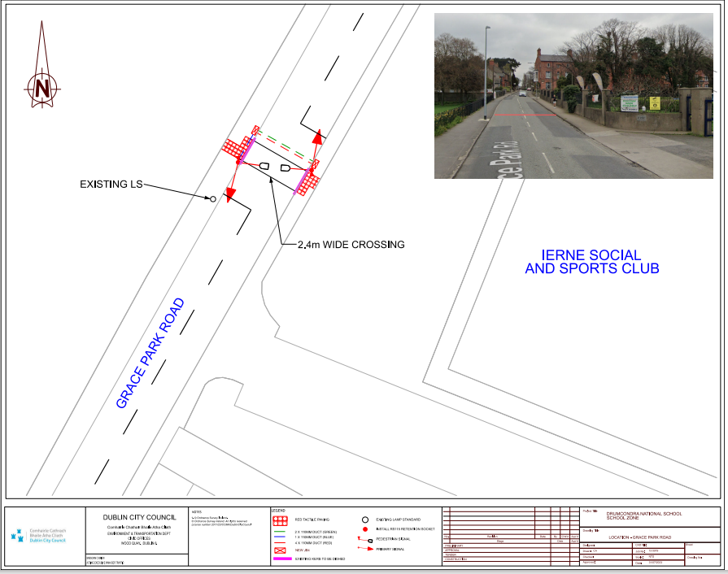
Image 9: Snippet of Design Drawing for the Pedestrian Crossing at the Irene Social and Sports Club

