Proposed Filtered Permeability (No-Through Road except cyclists) Trial for Church Street East / East Road junction.

Dear Resident/Business,

Dublin City Council have received numerous correspondence in recent years regarding transport-related issues on Church Street East and Abercorn Road including cut-through traffic.

In March 2022, our Elected Councillors proposed to implement Filtered Permeability measures on Church Street East to alleviate these issues for a six month trial period. It is anticipated that the trial can be installed in late 2022 / early 2023 if there is support from local residents and stakeholders.

The trial will include the provision of a series of bollards and/or temporary planters with appropriate traffic road markings and signage placed along the eastern end of Church Street East at the Church Street East / East Road junction. Please see a sketch of the proposed measures overleaf.

The impact of this measure will be that motorised cut-through traffic will be eliminated on Church Street East so that drivers will no longer be able to use this route as a short-cut from Sheriff Street Upper to East Road (and vice-versa).

Filtered permeability through the bollards will enable pedestrians and cyclists to continue to take this route. Access through the bollards will be maintained for emergency vehicles. Local vehicular access to Church Street East and neighbouring streets will be retained although some journeys will be required to take a more circuitous route via the Abercorn Road / Sheriff Street Upper junction.

The existing No Left Turn (Except Cyclists 16.00-19.00 Mon-Fri) from Sheriff Street Upper to Abercorn Road will be removed to allow all vehicles to take this turn.

The reduction in motorised traffic will result in a safer space for pedestrians and cyclists travelling along this route, and will likely create a safer and more liveable area for residents of Church Street East and the local area.

A 2 week non-statutory public consultation has commenced from 27th September to 11th October 2022 to gather feedback on these proposals via our DCC Consultation Hub (visit https://consultation.dublincity.ie/). The feedback from this will be presented to local Councillors and a decision will be made whether or not to proceed with the implementation of this trial.

Thank you for your time and your interest on this subject.
Environment & Transportation Department,
Dublin City Council
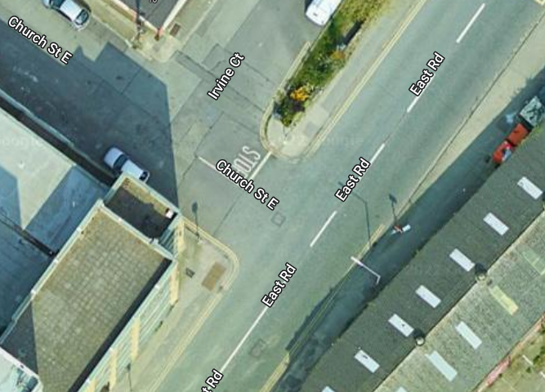
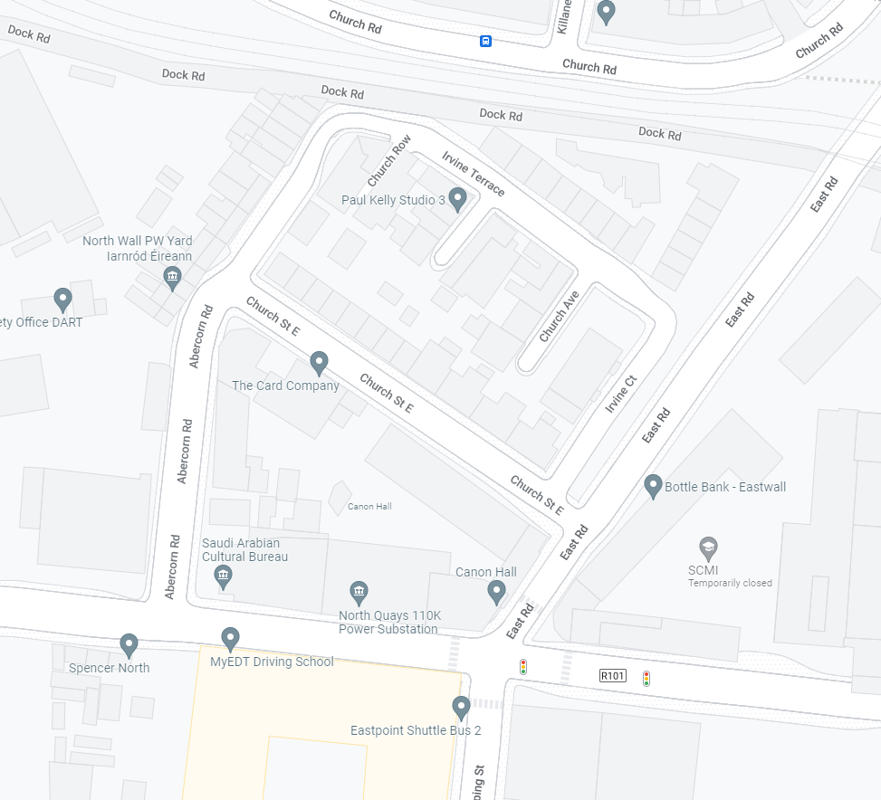
Sheriff Street Upper
(Except Cyclists)
Indicative location of Filtered Permeability Measures i.e. signage, bollards and/or planters
Indicative location of Filtered Permeability Measures i.e. signage, bollards and/or planters
ENVIRONMENT & TRANSPORTATION DEPARTMENT  CIVIC OFFICES  WOOD QUAY  DUBLIN 8 | CONCEPT SKETCH OF PROPOSED FILTERED PERMEABILITY TRIAL FOR CHURCH STREET EAST / EAST ROAD JUNCTION
RUS 013: NO LEFT TURN (with Supplementary Sign shown above)

RUS 012: NO RIGHT TURN (with Supplementary Sign shown above)

RUS 011: NO STRAIGHT AHEAD (with Supplementary Sign shown above)

