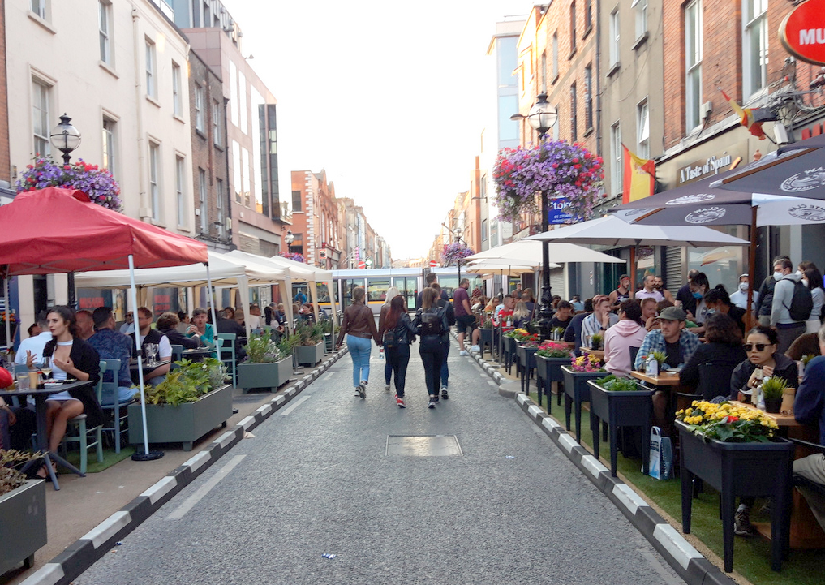
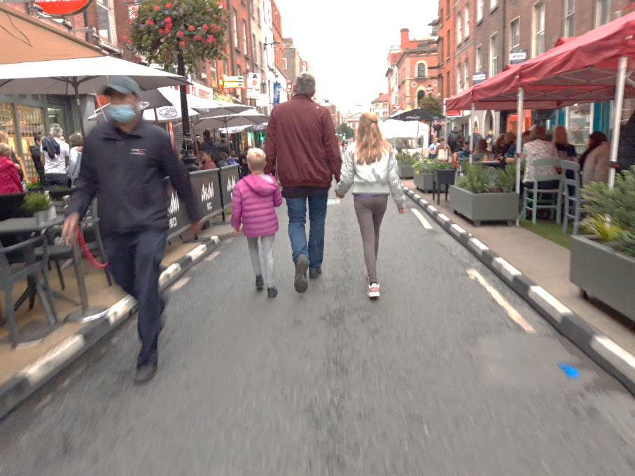
Capel Street Traffic Free Proposal
March 2022
Brendan O’Brien Head of Technical Services
Claire French Senior Executive Engineer

Table of Contents
Introduction 1
Consultation 2
Constraints 3
Resident Access 3
Luas junction at Mary’s Abbey/ Abbey Street Upper 6
Strand Street Little/Strand Street Great 7
Mary Street 10
Proposals 12
Permanent closure at Parnell Street 12
Delivery Access 13
Traffic Free arrangement 14
Parking 17
Disabled Bays 17
Loading 19
General Traffic 20
Traffic Free Area 20
Street Improvements 20
Traffic Free Times 21
Consultation 21
Next Steps 21

Introduction
In Summer 2021, following requests to assist with business reopening and to provide additional pedestrian space a number of interventions were installed on Capel Street following a public consultation in May 2021 which received almost 4,000 submissions.
The interventions were to remove some parking and loading bays and replace them with temporary build outs giving a total of 560 m² additional space for outdoor dining and pedestrian space. At three locations, 52 Zebra protectors were used to provide protected outdoor space including on Strand Street.
In addition, from the 11th of June 2021, Capel St. and Parliament St. was made traffic-free on a Friday, Saturday and Sunday evening from 18:30 to 23:30 for a initially for period of 6 weekends on a trial basis but was extended to a total of 17 weeks until the 3rd of October.
Towards the end of the Traffic Free weekend evenings a non-statutory public consultation was held to obtain views on peoples experience over the 17 weeks and also what options they would like to see further developed. Based on the responses which strongly indicated a preference for a Traffic Free arrangement on Capel Street, DCC Traffic Department examined how best to achieve this whilst still allowing loading, servicing and maintaining existing resident and business accesses.
This report presents a proposal for a Traffic Free arrangement for Capel Street that takes into account the different users of the area.

Consultation
A consultation was held to obtain people’s views on the traffic free evenings and future improvements for the street. This consultation was held on the Dublin City Council Consultation Hub and ran from the 30th of August 2021 until the 20th of September 2021. 6,957 submissions were received.
Overall, there was a very positive response with 95% of respondents deeming the traffic free street improved their experience:

The majority of respondents from different groups wanted to see some form of a Traffic Free arangement for Capel Street:
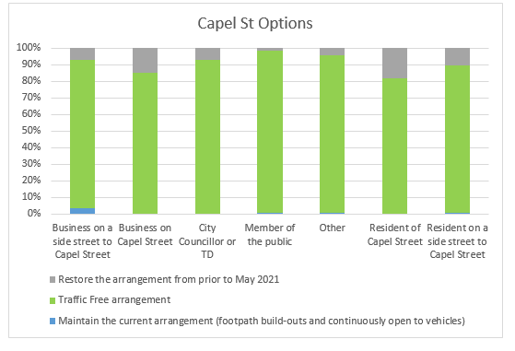
Based on the signifcant response from all groups that the preference is for Traffic Free on Capel Street, this is what has been examined in detail. Issues raised throughout the consultation have also been taken into account.

Constraints
There are a number of constraints in closing off the entirety of Capel Street from Ryder’s Row to North Quays:
- Maintaining access for Residents of surrounding areas
- Luas junction at Mary’s Abbeys
- Width and layout of Strand Street Great and the proposed construction works

Resident Access
Capel Street is unlike other pedestrian streets such as Grafton Street and Henry Street, as there are residents living directly on the street and a large amount of residents on the streets directly adjacent to Capel Street. There is however no access, car parking or permit parking on Capel Street itself which maximises the amount of space that could be made traffic free. The area was examined to ensure that existing residential and office carparks can still be accessed and have a viable exit route.

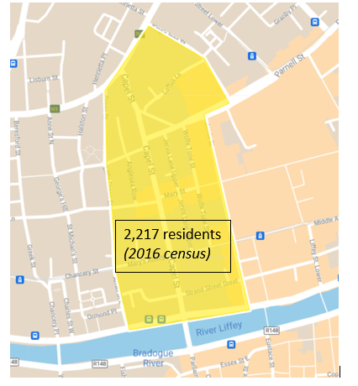
Figure 1 Resident population
A key factor for the development of any proposals is to have them as much as possible self-enforcing and not requiring traffic management personnel to be on site during the hours of operation. Figure 2 shows the traffic management plan required for Capel Street which required 18 operatives each evening to manage access for residents.
Therefore a number of locations needed to be assessed in greater detail in order to determine if this criterion could be met.
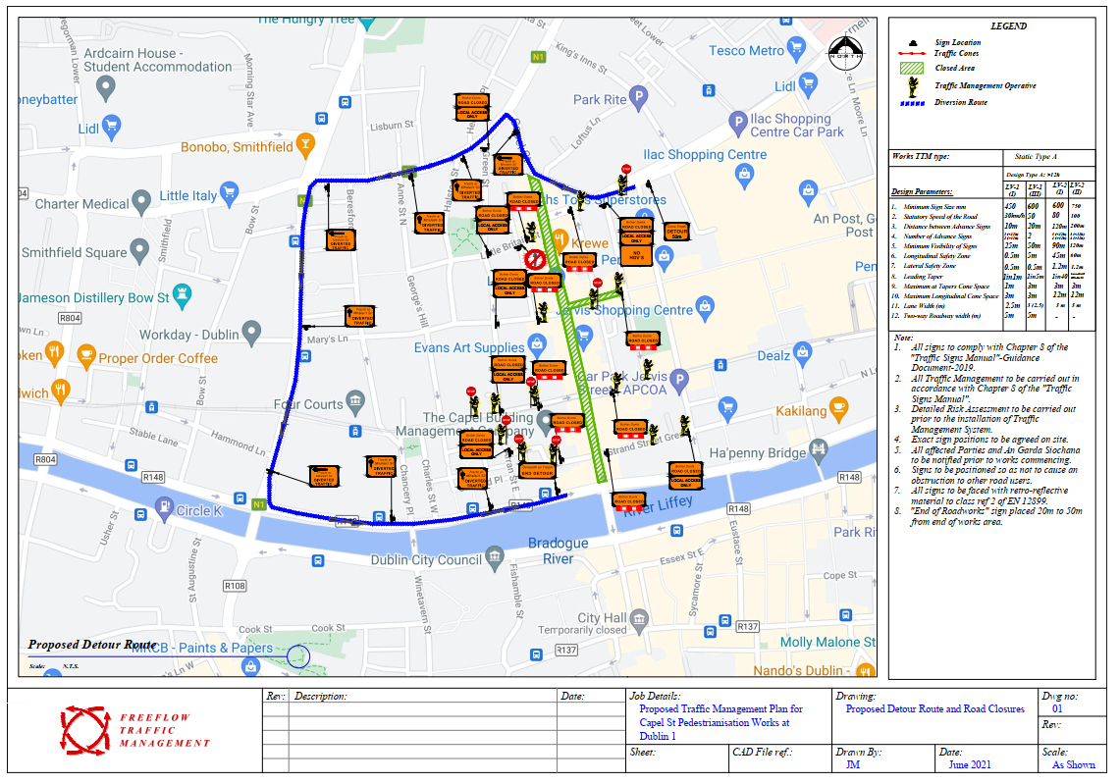
Figure 2 Overall Traffic Management plan for Capel Street during Summer 2021

Luas junction at Mary’s Abbey/ Abbey Street Upper
Currently at the Luas junction on Capel Street at Mary’s Abbey and Abbey St Upper, all traffic is directed onto Capel Street.
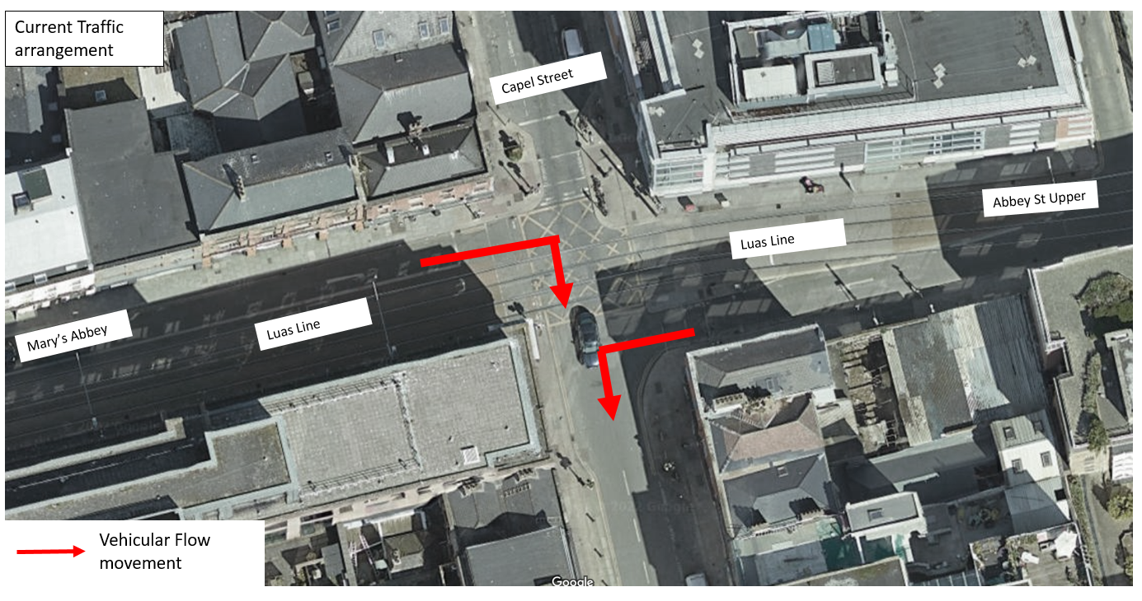
Figure 3 Capel Street/Abbey Street Upper/Mary's Abbey junction

The Luas will obviously have to continue to travel across Capel Street and so any Traffic Free Areas will need to break at this point and the existing traffic signals etc. would need to remain in place.
There is also a number of constraints at this location.
- An existing carpark on Abbey St Upper associated with the residential development there will continue to have access and egress from its current location.
- On Mary’s Abbey access will continue to be required to Meetinghouse Lane and for servicing the various business in this area.
- Luas Traffic operation. The operation of the Luas could not be compromised by any proposed solution.
Following discussions with TII it has been agreed that in a new arrangement vehicles from Abbey Street Upper may proceed straight across the junction towards Marys Abbey, which then allows the requirement for a continuous left turn on to Capel Street to be removed.
Vehicles will travel on the luas line as far as Arran Street East where they must turn right. Access to Meetinghouse lane will be via Abbey St Upper and the luas line in an East to West direction. The current eastbound carriageway on Mary’s Abbey will become loading bays which will be installed to provide loading outside the loading window to Capel Street.
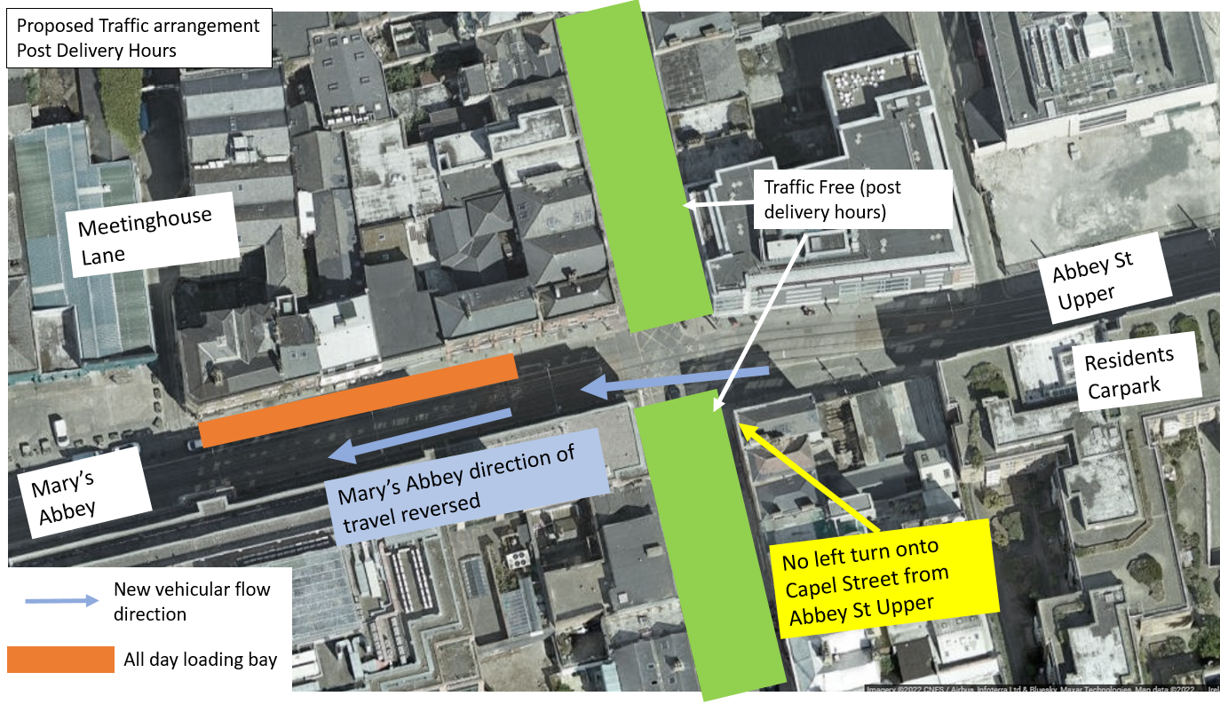
Figure 4 Proposal for Capel Street/Abbey Street Upper/Mary's Abbey junction
The Capel St/Abbey St Upper/Mary’s Abbey and the Arran St East/Mary’s Abbey junction require the most civil works as new signals will be required to be installed to facilitate this arrangement. These changes will be permanent due to the complexity of rearranging and reprogramming these junctions. This will then allow residents on Abbey Street Upper to still be facilitated 24*7 as well as the businesses on Mary’s Abbey with this revised arrangement.

Strand Street Little/Strand Street Great
At the junction of Capel Street and Strand Street, traffic currently travels from east to west (from Strand St Great to Strand St Little), from Strand St Great to Capel St and from Capel St southbound and to Strand St Little.
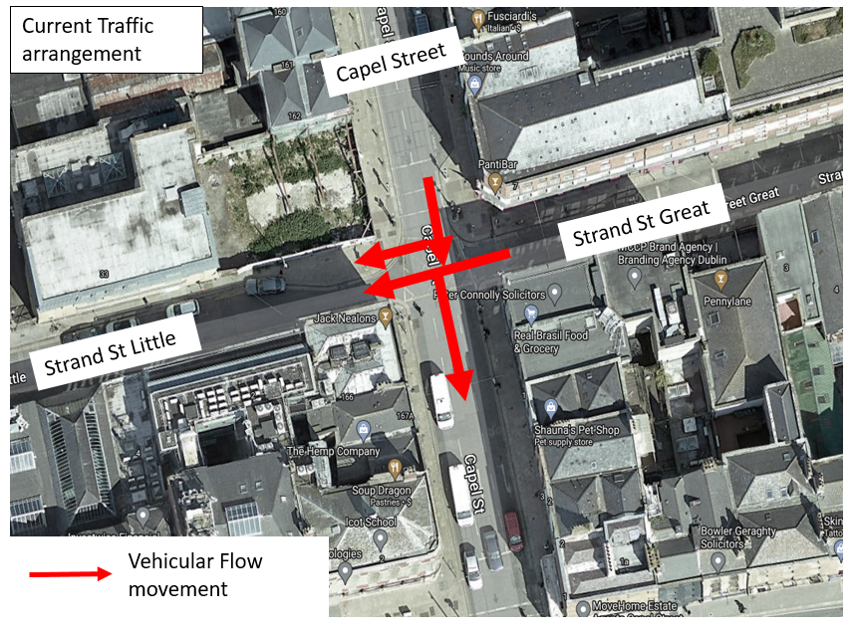
Figure 5 Capel Street/ Strand Street Great/ Strand Street Little current junction movement
There are a number of reasons why maintaining traffic, at least initially on Strand Street Great and Strand Street Great is required:
- Liffey Street Scheme – The Part 8 Area Committee Notification Report states that “Permanent vehicular access, for all but the larger delivery vehicles will be maintained between Middle Abbey Street and The Lotts/Strand Street junction with an exit to Capel Street along this route”.
- Width constraints of Strand Street Little
The Liffey Street scheme has a section of Liffey Street between Strand Street Great and the Quays from 11:00 each day which does not allow any through traffic. Traffic must therefore use Strand Street Great to either exit via Jervis Street or via Capel Street on to the Quays, in addition any vehicles wanted to enter Strand Street Little would now also be required to use this route.
Strand Street Little is approximately 4.1m in width on approach to a blind 90 degree bend and also has a car park which requires access and egress. This is not sufficient width or visibility for 2 way traffic. During the Summer 2021 events this was managed by a shuttle Stop/Go system which required 4 operatives. Therefore in order to still allow for access here there is a requirement to leave Strand Street Great open at its junction with Capel Street.

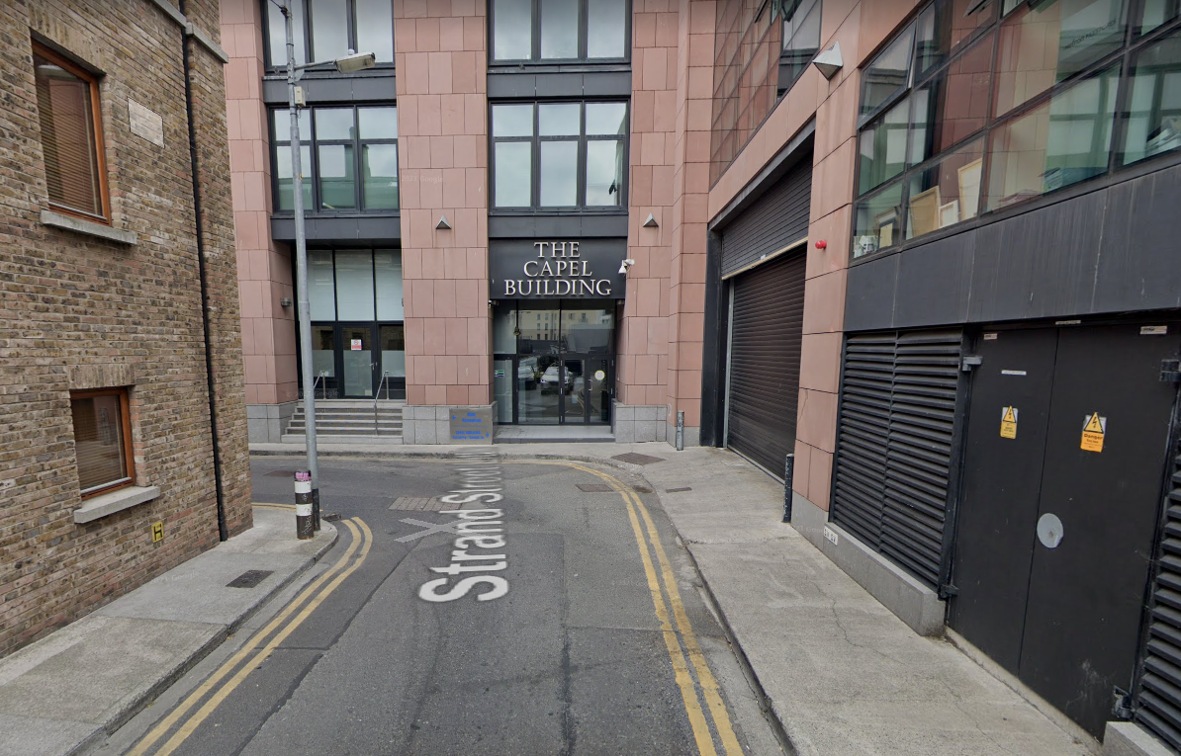
Figure 6 Narrow width of Strand Street Little
- Construction on the corner of Capel Street/Strand Street Little
Ref. 3609/20 at 162-164a (inclusive) Capel Street and 33-36 (inclusive) Strand Street Little, Dublin 7, Planning permission for development to include demolition of buildings and redevelopment of partly vacant site for hotel with ancillary bar/cafe lobby fronting Capel Street/ Strand Street Little junction and shop in 162 Capel Street was approved following an appeal by an Bord Pleanala. This is involves construction of a 5 to 9-storey over basement mixed use development. It would not be feasible for construction vehicles to be running two way on Strand Street Little or using the otherwise closed to vehicles sections of Capel Street.
- Residents concerns

During the consultation residents of Strand Street Little and Strand Street Great expressed their concerns at seeing Strand Street closed in terms of access and due to noise and anti-social issues they experienced during the 2021 closures.

Proposal – It is proposed to leave Strand Street Little and Strand Street Great open to all traffic and to review its operation in the future to determine if any changes are required.
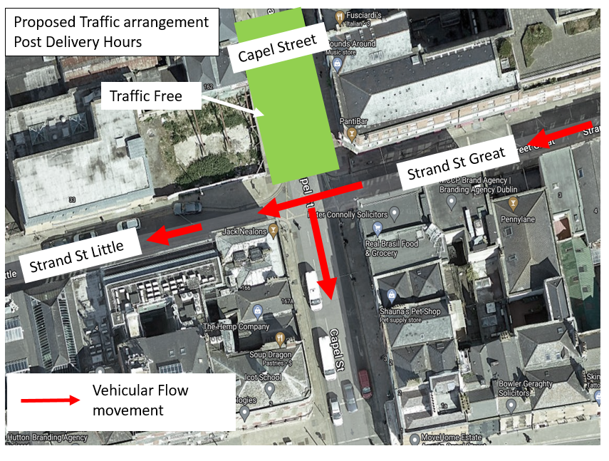
Figure 7 Capel Street/ Strand Street Great/ Strand Street Little proposed junction movements

Mary Street
Currently traffic on Mary Street exits onto Capel Street.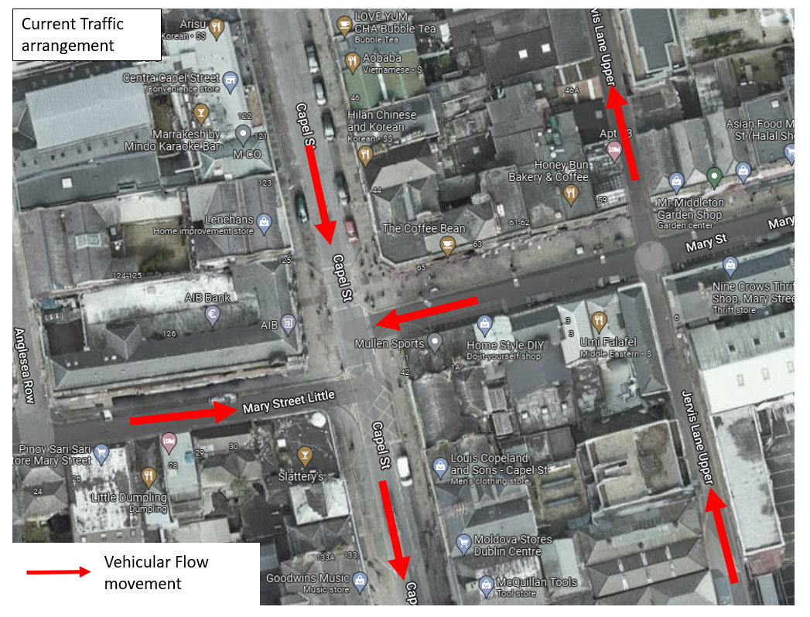
Figure 8 Capel Street/Mary Street Little/Mary Street current traffic movements
There is a change in traffic direction on Mary Street proposed, with traffic now proposed to be in a West East direction. This will allow for deliveries to be made to Mary Street but will not allow a traffic route to Capel Street to be opened up via Wolf Tone Street.
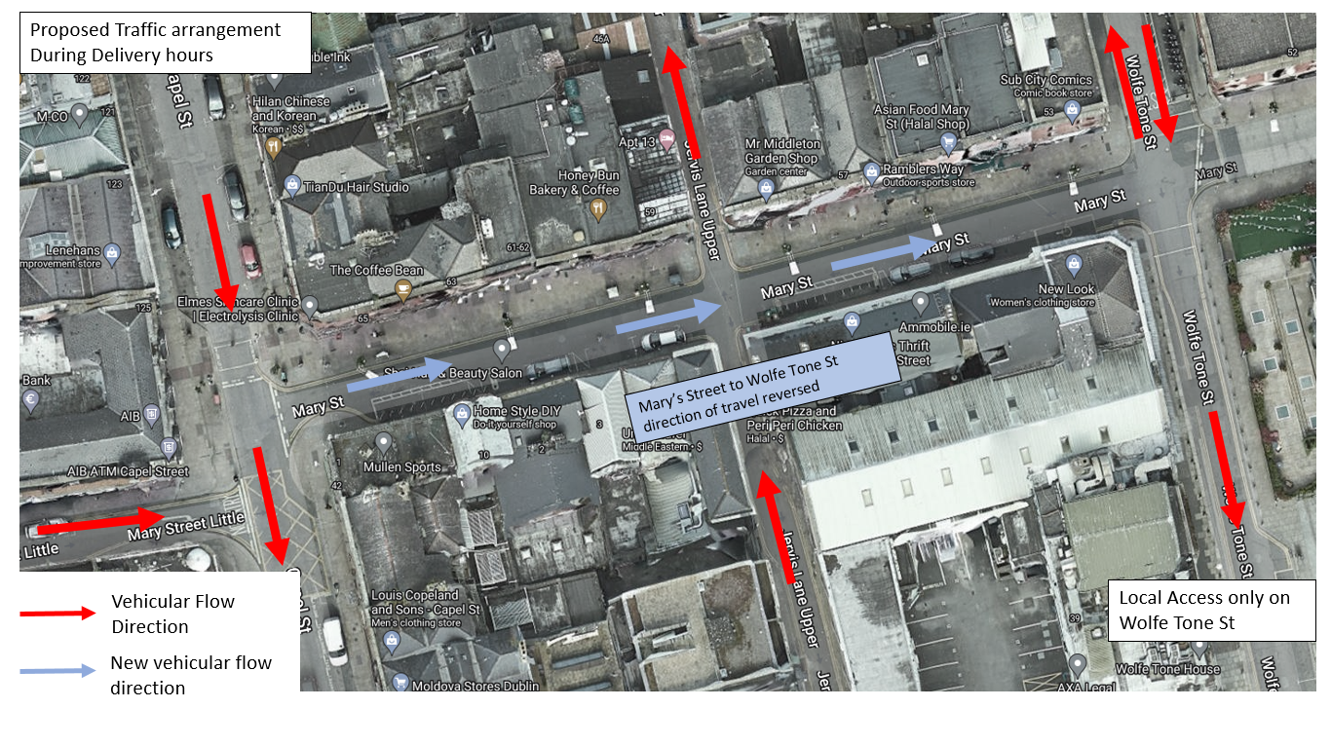
Figure 9 Capel Street/Mary Street Little/Mary Street proposed traffic movements during delivery hours

Post Delivery hours the section that has been reversed will also become Traffic Free.
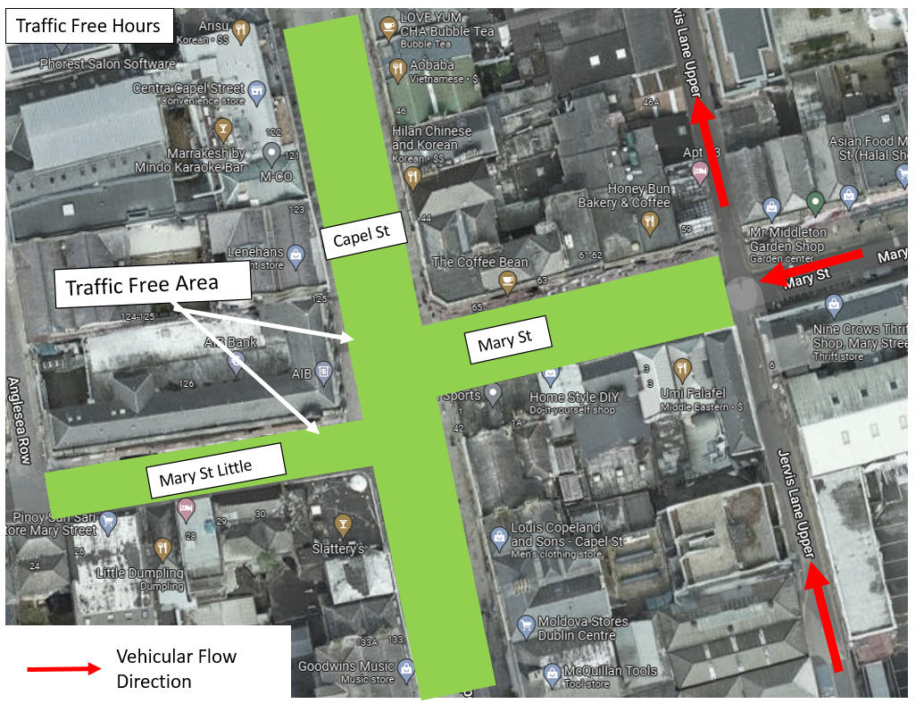
Figure 10 Capel Street/Mary Street Little/Mary Street proposed traffic movements during Traffic Free hours

Proposals

Permanent closure at Parnell Street
It is proposed to permanently close Capel Street at Parnell Street to remove through traffic from the Street at all times. Emergency vehicles will still be able to access Capel Street at this point. This will result in a large decrease of through vehicles even when loading is permitted.
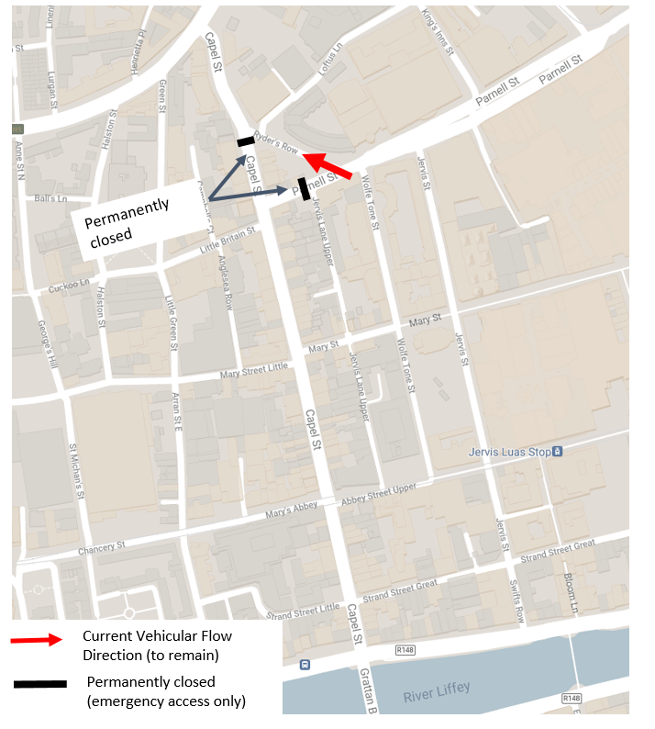
Figure 11 Permanent closure to through traffic on Capel Street

Delivery Access
During delivery hours (typically 6am to 11am) deliveries will be able to access the street via:
- Little Britain Street
- Mary Street Little
- Abbey Street Upper

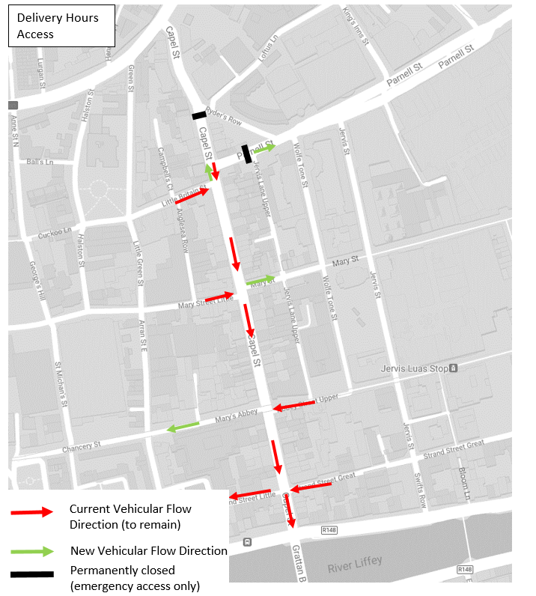
Figure 12 Delivery access

Traffic Free arrangement
Following the delivery window access to Capel Street will be prohibited and bollards will be erected.
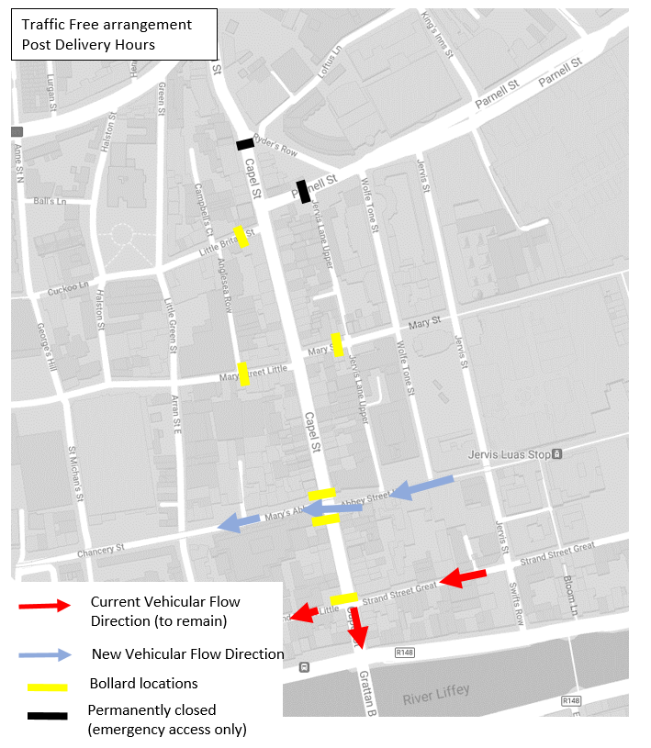
Figure 13 Traffic Free Arrangement

There will be no vehicles traveling on Capel Street between Parnell Street and Strand Street, which will create two large traffic free areas which are bisected by the Luas junction and local access movement from Abbey Street Upper to Mary’s Abbey.

Emergency Vehicular Access.
Emergency Vehicular access is maintained at all times as the emergency services will be able to access all locations on Capel Street.
Disabled Parking
Additional spaces have already been provided around the area during the traffic free trials and these have stayed in place. One disabled car park space will be relocated and additional ones added in Strand Street Great and Mary Street.
Deliveries
It is proposed that deliveries are allowed on the Street from 06:00- 11:00 7 days a week. Deliveries would access Capel Street from a number of different locations ensuring that all premises on the street can have their loading requirements accommodated. In addition this will enable residents to also take deliveries during these hours also.
Car Parking
The retention of on street car parking spaces is problematic in an arrangement such as Capel Street as drivers may park up to the 11:00 time and if they do not exit at that stage when legally required to do so, then they will block these spaces for any other use. In addition they may then cause problems for pedestrians when they do leave. Therefore it is proposed to remove all car parking spaces from the street and convert them to a mixture of loading bays or build outs for additional pedestrian/ outdoor space. This will then mean that there will be sufficient spaces for all the loading requirements up to 11:00, a complaint that has been raised with us is that there is currently not enough loading facilities on the street and this change will address this.
Cycling
This is an important North South cycle route with a contraflow section on Ryders Row/ Capel Street allowing access from Bolton Street. Therefore it is proposed cycling will still be allowed on the street and in time the option of contra flow cycling will also be explored.
Alignment

The Traffic Free area will extend from Ryder’s Row to the Abbey Street Upper junction, including parts of Mary Street and Mary Street Little, and from the Abbey Street Upper junction to the Strand Street junction:
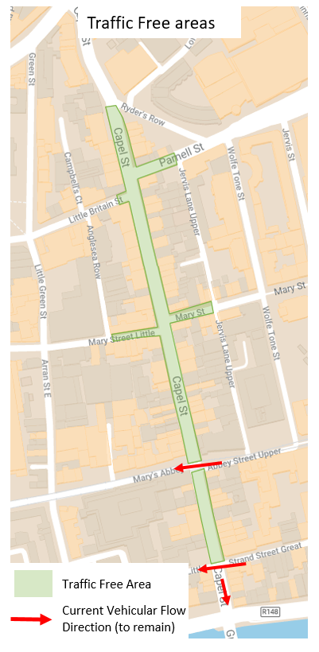
Figure 14 Traffic Free area

Parking
On street parking (18 spaces) are to be removed and converted to loading space/ extended footpath space.
The area is well served with on street parking immediately adjacent to the street and approximately 2,500 spaces within a few minutes of the street.
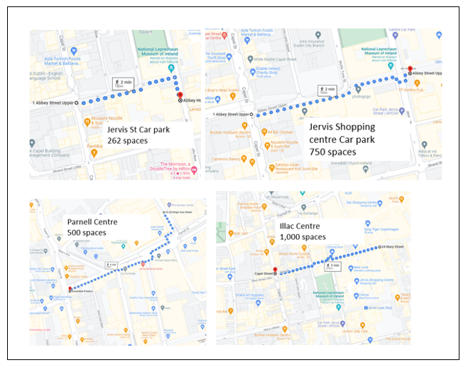
Figure 15 Off Street parking in Capel Street area

Disabled Bays

There is currently 1 disabled bay on Capel Street. The spaces on Little Britain Street, Swifts Row and on Ormond Quay that were installed for the Summer 21 event will be made permanent. There is also potential to add a further 2 spaces on the side streets to Capel Street.

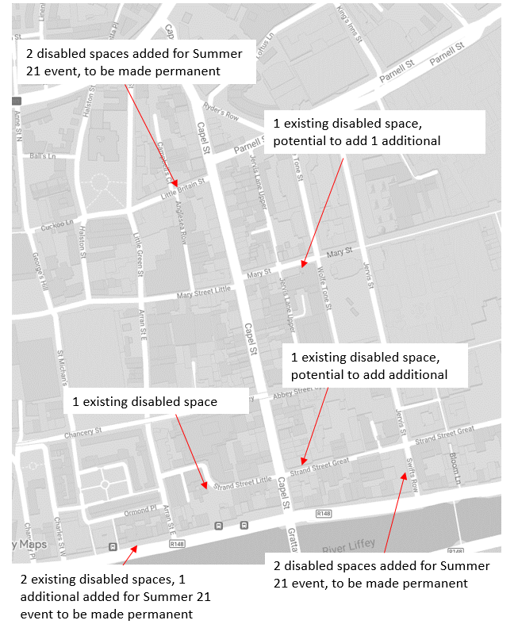
Figure 16 Disabled bay locations

Loading
Deliveries will be able to access Capel Street between 6am and 11am daily. Parking spaces will be converted to loading spaces
In addition, there will loading bays on adjacent side streets that will provide loading options outside the delivery window on Capel Street:
- Little Britain Street
- Mary Street
- Mary’s Abbey (newly extended)
- Strand Street Great (new)
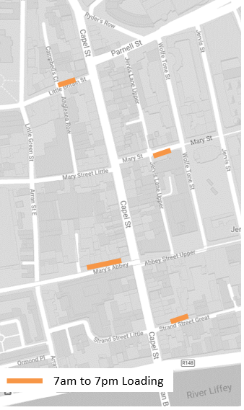
Figure 17 Loading areas adjacent to Capel Street which will be available 07:00- 19:00

General Traffic
There will be no access on Capel Street for general traffic. Deliveries only will be allowed between 6am and 11am with no vehicles permitted outside these hours. Emergency vehicles will have full access to the street.

Traffic Free Area
This proposal will create a large area of traffic free space with an area slighter greater than both Henry Street and Grafton Street.
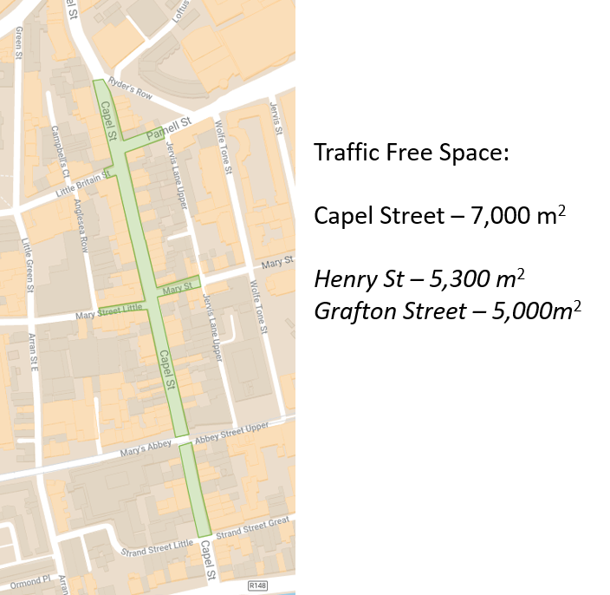
Figure 18 Area of Traffic Free space

Street Improvements
When the measures are first introduced some initial street improvements will carried out including removal of signs and decluttering, refreshing existing buildouts, installation of some additional buildouts, coloured surfacing on existing carriageway and greening of the street.
City recovery will engage a landscape services to examine the street and how improvements to the streetscape may be made in the short term.
It is not possible within the timeframe proposed here ( i.e. Summer 2022) to make permanent carriageway/footpath upgrades, such as are underway for Liffey Street, as a part VIII process would be required as well as the engagement of the appropriate consultants and contractors.
Once the proposed arrangement has bedded in then a permanent scheme can be designed and implemented in the future.

Traffic Free Times
It the recommendation that the arrangement commences with deliveries facilitated between 6am and 11am and at all other times the street is Traffic Free. Over the course of the summer these arrangements will be monitored to determine if any changes are required, taking into account the needs of businesses and residents.

Consultation
Following the March Central Area Committee meeting a 2 week non statutory consultation for all but specifically targeting local residents and businesses will be undertaken on the proposed arrangement for Capel Street.
The feedback from this will be presented to local councillors at the April meeting along with any changes if required.

Next Steps
The next steps are:
March
- Agree times Capel Street will be Traffic Free with Councillors at the March Central Area meeting
- Commence consultation
- Agree and finalise design at Luas junctions with TII
- Commence monthly traffic counts in area
April
- Assess consultation and present feedback to the April Central Area meeting
- Commence civil works (mainly at Luas junction)
May
- Implement proposal
- Initial street improvements
September
- Report to Councillors at the September Central Area meeting on how the arrangement is functioning

