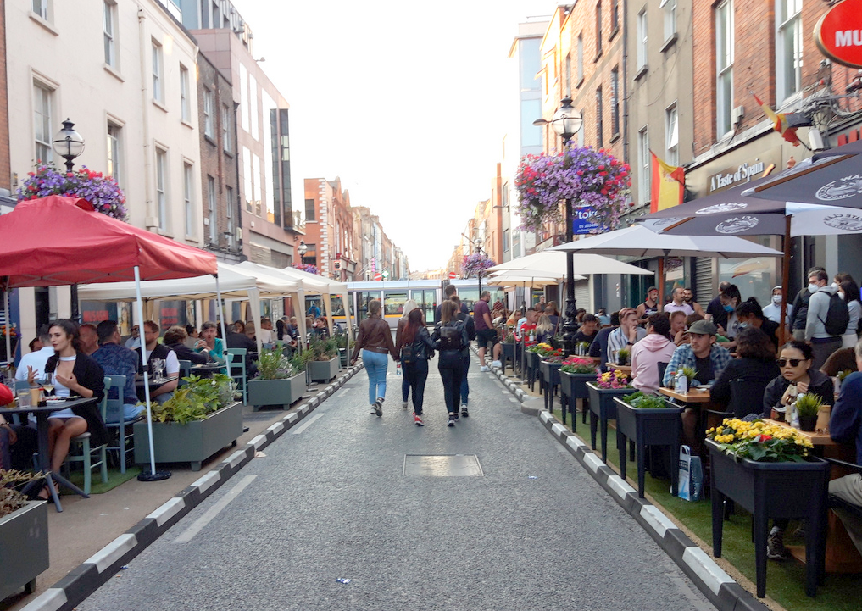

Capel Street Traffic Free Proposal
Report on Non Statutory Public Consultation
May 2022
Brendan O’Brien Head of Technical Services
Claire French Senior Executive Engineer

Table of Contents
Introduction 1
Consultation 2
Time of Traffic Free 3
Resident submissions 4
Businesses 5
General Public 7
Business groups 8
Disability groups 9
Other groups 10
Other Stakeholders 10
Recommondation 10
APPENDIX A 11

Introduction
In Summer 2021, following requests to assist with business reopening and to provide additional pedestrian space a number of interventions were installed on Capel Street following a public consultation in May 2021 which received almost 4,000 submissions.
From the 11th of June 2021, Capel St. and Parliament St. was made traffic-free on a Friday, Saturday and Sunday evening from 18:30 to 23:30 for a initially for period of 6 weekends on a trial basis but was extended to a total of 17 weeks until the 3rd of October.
Towards the end of the Traffic Free weekend evenings a non-statutory public consultation was held to obtain views on peoples experience over the 17 weeks and also what options they would like to see further developed. 6,957 submissions were received. There was a very positive response with 95% of respondents deeming the traffic free street improved their experience and the 89% of respondents wanting to see some type of Traffic Free arrangement on Capel Street.
Based on the responses which strongly indicated a preference for a Traffic Free arrangement on Capel Street, DCC Traffic Department examined how best to achieve this whilst still allowing loading, servicing and maintaining existing resident and business accesses. These proposals were presented to Centre Area Councillors and then to the public as part of a non-statutory public consultation to see what people’s views on the proposals were. The Consultation was held between 11th March and 4th April 2022.

Consultation
There were a total of 1,766 submissions received:
Submission by:
Online through consultation hub | 1,687
By email | 79*
Total | 1,766
* 53 email submissions were the same identical two sentences

Overall there is widespread support for the proposals with 91% of all submissions in favour of the proposals.

A copy of all submissions received are contained in Appendix A.

Time of Traffic Free

The proposed time for Capel Street deliveries for 6am to 11am daily and Traffic Free the rest of the day is due to:
- Consistency – 6am to 11am are deliveries hours on Henry Street, Grafton St, Grafton Street area.
- Pedestrian use of the street – the busiest time for pedestrians is between 11am and 7pm, almost two-thirds of the daily pedestrian totals occur during these hours. By not including these hours it would exclude the majority of pedestrians from benefiting from a Traffic Free environment. Pedestrian volumes are very consistent throughout the week with no great differences by day. Monday to Thursday lunchtime is usually the busiest hour on the street for pedestrians, Friday to Sunday 4pm is the busiest time. There are three times as many pedestrians and cycles using the street than cars every day; during lunchtime (1-2pm) there are six times as many pedestrians on the street as cars.
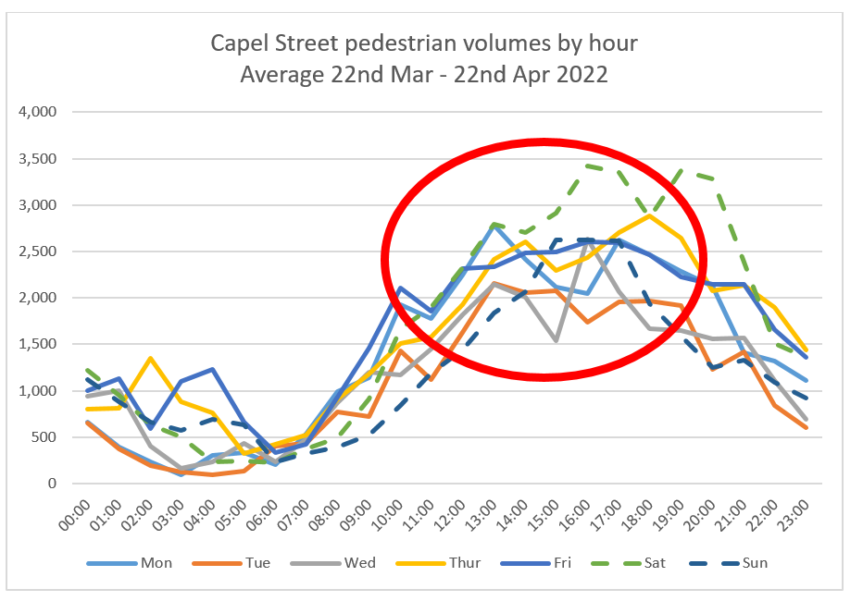

Resident submissions
There were 201 submissions from residents, 42 on Capel Street itself and 159 from the area. On Capel Street itself 79% of respondents support the proposal and in the local area 86% support the proposal.

The main reasons residents were in favour was due to the improvement to the street, the uncomfortableness of the street at present, the reduction in noise, the feeling that Dublin currently prioritises cars over residents, the atmosphere and community it creates.
The responses also showed there are a large numbers of locals who don’t have a car and walk in the area, which is verified by data from the Central Statistics office which showed that 53% of households in the immediate area have no car, as high as 67% of household have no car on some streets.
Some of the comments received from residents were:
“I live on Capel St so it will impact my day-to-day life - I'm overwhelmingly in favour of pedestrianising Capel Street”
“It will make it a lot easier for me to shop and run errands on Capel street as a pedestrian. I do not have access to a car and I walk everywhere in Dublin.”
“Add to a greater sense of community. A living city.”
“It will massively improve my quality of life by increasing the number of people visiting the area, reducing noise and air pollution, and making me feel safer”
“It will improve my local area and provide much needed traffic free space in the city centre”
Concerns related to Noise, anti-social activity and access to different estates or carparks (all of which have been checked and all of which still have full access). Concerns mainly related to issues from Summer 2021, however with indoor dining now resumed and Strand Street Little and Great remaining open these shouldn’t reoccur. There are no changes to adjacent Arran Street (which was a concern), no loss of parking and no additional traffic being directed to use that street.

Businesses
There were 53 identical submissions received from businesses:
“We object to the 24/7 pedestrianisation proposal for Capel street as it will have a detrimental effect on our business. We seek a compromised solution that doesn’t threaten our future employment”

These were mainly from businesses in the Jervis Centre, fourteen from Louis Copeland staff and 24 from unknown businesses who didn’t include their business name or location.

There are no proposals for a 24/7 pedestrianisation. The proposal allows for deliveries between 6.00 – 11.00am. In these submissions, no details were provided on concerns or suggestions of what is proposed. As detailed in this report the majority of pedestrian users are during the late morning and afternoon so the proposal includes for Traffic Free hours during this time to benefit these users of the street.

A number of submissions were received from the following objecting to the current proposal and seeking to allow Traffic Free after 7.30pm only:

- Jervis Shopping Centre
- Ilac Shopping Centre
- Ilac and Parnell Carpark
- Arnotts

The key issues raised include:

- Carpark access and egress and alternative routes. There is mention in a number of submissions about Ryder’s row being a single lane following the introduction of a cycle lane – this is incorrect, Ryder’s row is still two lanes and will remain so. Access to all carparks, public and private is being maintained

- Difficulty exiting the carparks, particularly at Christmas – carparks make up a small amount of traffic in the area. From the figures submitted by the carparks this equates to less than 60 cars an hour.
- Capel Street is a primary artery - The street has historically been seen as vehicular through route but this ignores the fact that it has changed into a mixed used street of residential, commercial and retail and where sustainable modes (walking and cycling) are the biggest users of the streets. The alternative route of Kings St N (R804) and Church St (R108) are the primary routes in the area. The proposal has been designed so that the residential streets immediately adjacent to Capel St will not become an alternative route for the Capel St traffic

- Access for services and deliveries - Deliveries and services will have access to Capel Street between 6am and 11am with much more loading space being provided on Capel Street than there is currently, No business will be more than a 1 minute walk from all day loading bays provided on the side streets.

- This proposal will lead to the “permanent closure of many retail outlets in the north city centre area, and possibly the closure of at least one of the car parks serving this business area” – it is not anticipated that this will be the case, nor has it been explained why this would happen. The biggest users of Capel Street are currently pedestrians. There are only 17 car parking spaces on Capel Street itself which would contribute a small amount to the of pedestrians on the street.

- The proposals will result in traffic congestion on the narrow residential around Capel Street affecting residents all day every day – The proposals have been so designed to ensure there is no “rat running” or benefit to be gained from cutting through the side streets around Capel Street

- “it is well known that the reduction of Capel Street to a single lane led to significant traffic congestion in December 2021. The current proposal will cause significant impact to retail businesses in the Henry Street/ Mary Street area, in an already challenging economic climate” - December 2021 saw the highest levels of footfall since 2013 on Henry St

- “the current process also increases the likelihood of legal based responses which could lead to court challenges, injunctions and appeals” – significant consultation has been held on this proposal with substantial numbers responding each time and with over 7,000 leaflets being distributed in Capel Street and surrounding areas to ensure maximum input from residents and other stakeholders. There has been great engagement and support from the public and their elected representatives and there is we believe sufficient consensus to make this a great opportunity to change this street for the benefit of the majority and it is certainly hoped that legal challenges will not arise and delay this proposal. It will be reviewed at the end of the summer with a report being presented to councillors in order to assess what worked and what had not.
Just six objections on the proposal from businesses on Capel street itself were received (Louis Copeland, Goodwins, McQuillian Tools, 37 Capel St, Mitchell’s car accessories, Dynolocks.)

Key response to business concerns:
- Deliveries and how they will be facilitated. Deliveries will be facilitated every day between 6am and 11am. There will be three times as much space for loading as there is currently
- No business will be more than a 1 minute walk from a loading bay on one the streets
- No business will be more than a 2 minute walk away from an on street parking space
- Other junctions in the area will be managed by our control centre and our traffic systems on a 24*7 basis and in addition to this monthly traffic counts will take place throughout the area

Understandably, businesses can be nervous about changes to the streets. However the measures proposed are flexible and can be amended if required and will be reviewed in September. An email received a number of months after similar measures were put in in May 2020 from a retailer (non food/beverage) on Drury St shows how once a business experiences a new arrangement it can be seen as a benefit:
“I just wanted to let it be known that we now love the pedestrianisation. At the time and during Covid lockdowns as shop owners we felt it was pushed on us. However cars are still able to get into the car parks easily and the delivery vans deliver up until 11am.Its worked out so well for us. The street vibe is really good and the place feels much busier and safer. Its so nice to have our beautiful window visible. Other years there were vans always illegally parked on front of our shop all day causing engine noise ,fumes and blocking our lovely window.”

General Public
There were 1,311 submissions from the general public. 97% of respondents are in support of the proposal.

Many of the submissions highlighted that this was the 3rd consultation on Capel Street in less than a year, all of which have been very positive about bringing change to the street. There was also urging to go ahead and implement and for the majority to be listened to. The submissions focused mainly on the benefit it would bring to street as a whole (rather than just to facilitate outdoor dining), how much more attractive and comfortable the street would be to visit, how much more likely people were to both visit and spend more time there.
Some of the comments include:
“I want to visit Capel st more and will do so once it is pedestrianised”
“It will improve the attractiveness of Capel street to me as a customer and it will help make Dublin a safer, more liveable, more sustainable, and fairer city”
“As a customer of businesses in Capel Street the closure to traffic will make it easier to move around and spend more time browsing the shops and enjoying a meal there”
“I often use the road as a thoroughfare when driving to work, but would much rather use other routes and have Capel St pedestrianised”
“Cleaner air quality, safer for pedestrians, especially children and people with mobility issues. Incentive to shop in town rather than suburbs”
There were some concerns, these mainly related to alternative routes for vehicles and the interaction between cyclists and pedestrians. Alternative routes will be highlighted when the scheme is first implemented and a traffic management plan will be in place. There will be no changes to footpaths and kerb lines and the existing pedestrian crossings will also all be kept operational.

Business groups
Dublin Chamber are in support of the proposal:
“Dublin Chamber acknowledges the extensive trialling which took place on Friday, Saturday, and Sunday evenings from 6.30pm to 11.30pm over 17 weeks from June to October 2021, and commends the Council’s efforts in this regard the consultation held between August and September 2021 demonstrated strong support for traffic free arrangements, including from businesses located on and adjacent to Capel Street”.

Whilst Dublin Town welcome the focus on Capel Street, they are looking for a compromised solution for evenings post 7.30pm. Their key concerns include:
- The arterial nature of Capel Street and the impact that the removal of traffic from the street is likely to have on adjoining streets - Capel Street is not an arterial route. It is a mixed used street of residential, commercial and retail and where sustainable modes (walking and cycling) are the biggest users of the streets. The alternative route of Kings St N (R804) and Church St (R108) are the primary routes in the area. The proposal has been designed so that the residential streets immediately adjacent to Capel St will not become an alternative route for the Capel St traffic
- Access for services and deliveries - Deliveries and services will have access to Capel Street between 6am and 11am with much more loading space being provided on Capel Street than there is currently, No business will be more than a 1 minute walk from all day loading bays provided on the side streets.
- Local residents are likely to require maintained vehicular access and deliveries to residents - All access will be maintained. Deliveries can be accommodated on Capel Street daily from 6 – 11am or from an all day loading bay on one of the side streets
- In general, there is a lack of detail as to how the circuitous routes proposed will interact with each other. It is not clear that the road capacity is available to accommodate this interaction leading to potentially dangerous situations arising - Details of alternative routes and a traffic management plan for the first few weeks on the implementation will be in place.
- “fear that the current process could have a polarising effect, resulting in objections and the pursuance of legal actions, that can be avoided, but which would make future collegiate efforts more difficult. They may also only serve to delay the positive interventions which would enhance the city experience for all.”

Disability groups
NCBI (National Council for the Blind Ireland) are supportive of the proposal - “NCBI Service Users access Capel Street and surrounding streets in order to avail of the many essential services, businesses and amenities located in this part of Dublin city centre. NCBI supports the principle of developing a traffic-free Capel Street as the proposed development holds potential to promote active travel modes, particularly walking, a more people-friendly, sustainable city and in particular the independence and mobility of vulnerable pedestrians”. They have requested that “design of the public realm in and around a traffic-free Capel Street would reflect best practice in universal access and inclusion, including the provision of tactile warning surface indicators (TWSIs) to footways at all carriageway crossings, and the appropriate application of guidance paving and other aids to mobility and wayfinding in the public realm here”. Any future design of the street will consider these and the NCBI will be consulted. The existing kerb layout with tactiles and signalised crossings will be remaining.
There were two submissions from people who have disabilities and who were concerned about access and conflict with bikes. Disabled spaces will be available on the side streets as well as locations for drop off. Cycling will be permitted but it pedestrians will have priority. This was also raised by some members of the public. This will be monitored over the summer to see if there are any issues. The existing pedestrian crossings will remain in place.
Voice of Vision Impairment submitted a response to the consultation. Their concerns were:
- “the cycling lobby is known to encourage cycling organisation members to vote en masse for such schemes, massively dismantling any credibility that such surveys could be representative of the general public” - There was no evidence of any such lobbying from groups, other than businesses which submitted identical submissions
- “many disabled people need to be brought and dropped off as close as possible to their destination point. Up until this new design, blind people and other disabled people could easily do this on Capel Street”- Provision has been made to provide additional disabled spaces that are located at the different side streets to ensure access to all parts of the street. Drop offs will also be provided for at each side street
- “There is no tried and tested way or system for pedestrians to cross streets where the only traffic is comprised of bicycles and scooters, including ebikes and escooters. It is unacceptable that visually impaired people be thus expected to risk their safety by exercising their Human Right of accessing the public realm” - The existing pedestrian crossings that are on Capel Street will be remaining and will allow for crossing of the street under signal control

Other groups
The Irish Heart Foundation are supportive of the proposal “As the national heart and stroke charity of Ireland, the Irish Heart Foundation fully supports this measure for full pedestrianisation of Capel Street as it will boost active travel thereby improving cardiovascular health while lowering levels of toxic air pollution from vehicle emissions which have negative environmental health impacts.”
The Climate and Health alliance are also supportive “Full pedestrianisation and blocking of all road traffic from the entire length of Capel Street will bring about a multitude of physical health, mental health, environmental health, and economic benefits to the residents and businesses of Capel Street”.

Other Stakeholders
Meeting have been held with the following as part of the consultation:
- Local businesses as organised by Dublin Town
- An Garda Siochana
- Dublin Fire Brigade
- TII and Transdev

Recommondation
The overwhelming response has been to implement the proposal as presented for consultation which is for a Traffic Free Capel Street with deliveries between 6am and 11am. Concerns have been raised against the loss of the street as a through route for vehicles from businesses on the street and in particular on Henry Street, but it is felt that the correct route at this stage is to implement the proposal as set out.
The interventions are by way of temporary bollards and so can easily be removed or modified as required and no permanent works are required. To ensure smooth operation and to assist in people becoming familiar with the changed arrangements, traffic management personnel will be on site for the first two weeks of operation.
Therefore the Environment and Transportation Department would intend, with the support of local councillors, to implement the proposal as set out in the Consultation report for Traffic Free Capel Street with deliveries between 6am and 11am to be implemented in May.
The impact of the proposed new operation of Capel Street will be constantly monitored and a report brought to Councillors in September to assess how the changes have worked and if any alterations in its operation would be needed.

APPENDIX A

