BELCAMP BOUNDARY WALL CONSTRUCTION PROJECT
EIA SCREENING PRELIMINARY EXAMINATION REPORT
PREPARED BY RPS FOR DUBLIN CITY COUNCIL MAY 2023

Introduction
RPS was commissioned by Dublin City Council (DCC) to prepare a report to inform a Preliminary Examination in order to assess the need for an Environmental Impact Assessment (EIA) Screening with respect to the construction of a footpath and boundary wall at a site in Darndale, Belcamp, Co. Dublin. DCC is proposing that the construction works be carried out in tandem with the removal of an illegal waste mound at the site.

Purpose of the Report
The Preliminary Examination is being carried out to support the Part 8 Planning process which is envisaged will be required to be implemented by the applicant, DCC, for the construction project. This document has been prepared to inform whether an EIA Screening Determination is required to be made by the planning authority.
RPS has also completed a report to inform Appropriate Assessment (AA) Screening with respect to the proposed project. The AA Screening report is included in Appendix A.

Methodology
A high-level desk study was completed to identify the environmental characteristics of the site and its wider environment using the following sources:
- Geological Survey of Ireland (GSI) Spatial Viewer https://dcenr.maps.arcgis.com;
- EPA Maps: http://gis.epa.ie/Envision;
- Historic Environment Viewer https://maps.archaeology.ie/HistoricEnvironment/
This Assessment has been prepared by qualified and experienced RPS scientist with regard to principal national and European legislation and guidelines. The following list identifies these and other pertinent guidance documents:
- Planning and Development Act 2000 (as amended);
- Planning and Development Regulations 2001 (as amended);
- Directive 2011/92/EUas amended by 2014/52/EU;
- EPA (2015) ‘Advice Notes for Preparing Environmental Impact Statements Draft’
- EPA (2022) ‘Guidelines on Information to be contained in Environmental Impact Assessment Reports Draft’
- EPA (2021) Good Practice Guidance on Cumulative Effects Assessment in Strategic Environmental Assessment;
- European Commission (1999) Guidelines for the Assessment of Indirect and Cumulative Impacts as well as Impact Interactions;
- European Commission (2017) Environmental Impact Assessment of Projects – Guidance on Screening;
- DoEHLG (2003) Environmental Impact Assessment (EIA) - Guidance for Consent Authorities regarding Sub-Threshold Development; and
- DoHPLG (2018) Guidelines for Planning Authorities and An Bord Pleanála on carrying out Environmental Impact Assessment – August 2018.
- Office of the Planning Regulator (June 2021) “OPR Practice Note PN02 – Environmental impact Assessment Screening.”

Proximate Works and Reporting
Separately, DCC intends to remove an illegal waste stockpile from part of the site and adjacent lands which is not subject to Part 8 procedures. As the lands in question are in the ownership of Dublin City Council, it is the responsibility of Dublin City Council to have the waste removed in an environmentally sound manner to an approved facility in accordance with EPA guidelines. This clearance will be carried out on a phased basis and is required to be undertaken notwithstanding the proposed wall and footpath construction. The removal of the waste material will however assist in facilitating the proposed wall and footpath construction.
RPS has recently completed a Report for Appropriate Assessment (AA) Screening for same and DCC has made an AA Screening Determination. The removal of the waste material will also be screened for EIA as appropriate.

Legislative Context and Guidance

Legislative Context
As further described in Section 3 of this Report, the proposed works consist of Public Realm Improvements including construction of a footpath and construction of a wall along the northern boundary of a green open space at Darndale, Belcamp, Co. Dublin.
The EIA Directive 2011/92/EU requires that projects likely to have significant effects on the environment are made subject to an assessment with regard to their effects on the environment before development consent is given for such projects.
As it pertains to this application, the requirement to complete an EIA as per Directive 2014/52/EU amending Directive 2011/92/EU is transposed into Irish legislation primarily via the:
- Planning and Development Act 2000 (as amended) (the ‘Act’); and
- Planning and Development Regulations 2001 (as amended) (the ‘Regulations’).
Section 176 of the Act provides that regulations may be made which prescribe specific categories of development that may have significant effects on the environment and specifying the manner in which the likelihood of such significant effects is to be determined. These categories may involve thresholds or criteria to determine which classes of development may have significant effects. Schedule 5 of the Regulations then sets out the classes of development prescribed for same and includes thresholds in certain instances.
Article 120(1)(a) provides that “Where a local authority proposes to carry out a subthreshold development, the authority shall carry out a preliminary examination of, at the least, the nature, size or location of the development.”
Article 120(1)(b) confirms that “Where the local authority concludes, based on such preliminary examination, that—
(i) there is no real likelihood of significant effects on the environment arising from the proposed development, it shall conclude that an EIA is not required,
(ii) there is significant and realistic doubt in regard to the likelihood of significant effects on the environment arising from the proposed development, it shall prepare, or cause to be prepared, the information specified in Schedule 7A for the purposes of a screening determination, or
(iii) there is a real likelihood of significant effects on the environment arising from the proposed development, it shall— _(I) conclude that the development would be likely to have such effects, and (II) prepare, or cause to be prepared, an EIAR in respect of the development.”
Pursuant to Article 81(ca) of the Regulations 2001, a Planning Authority must indicate its conclusion under article 120(1)(b)(i) (i.e. a preliminary examination) or screening determination under article 120(1B)(b)(i) in the public notices that form part of a Part 8 process. This conclusion must also be made available for inspection in accordance with Article 83(1)(f).

Project Description

Site Location
The site is located to the south of the R139 Regional Road and a number of traveller accommodation sites namely, St. Dominic’s, Tara Lawns and Northern Close, to the west of Belcamp Cottages and north of residential housing estates Moatview Court and Belcamp Gardens. The works will take place along the northern boundary of the green open space area of Belcamp Park. The total area of works is estimated to be approximately 480m².
The project location is presented in Figure 3-1 and Figure 3.2.
Figure 3-1: Site Location
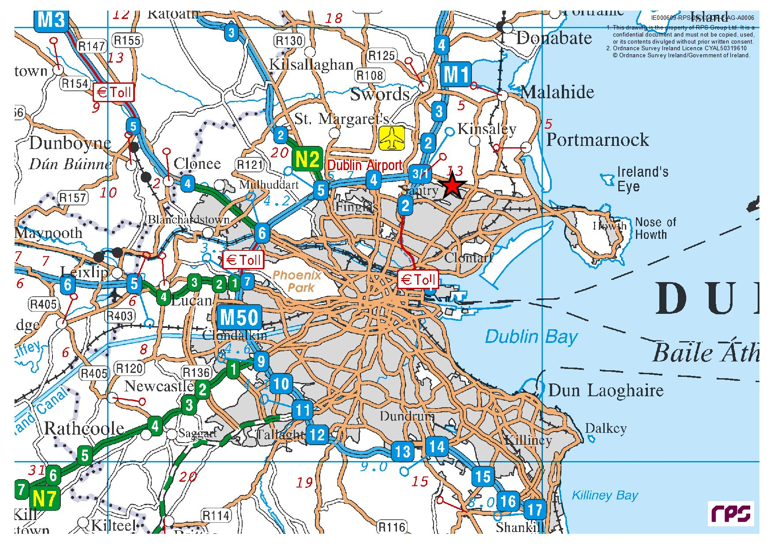

Figure 3-2: Proposed Works Location
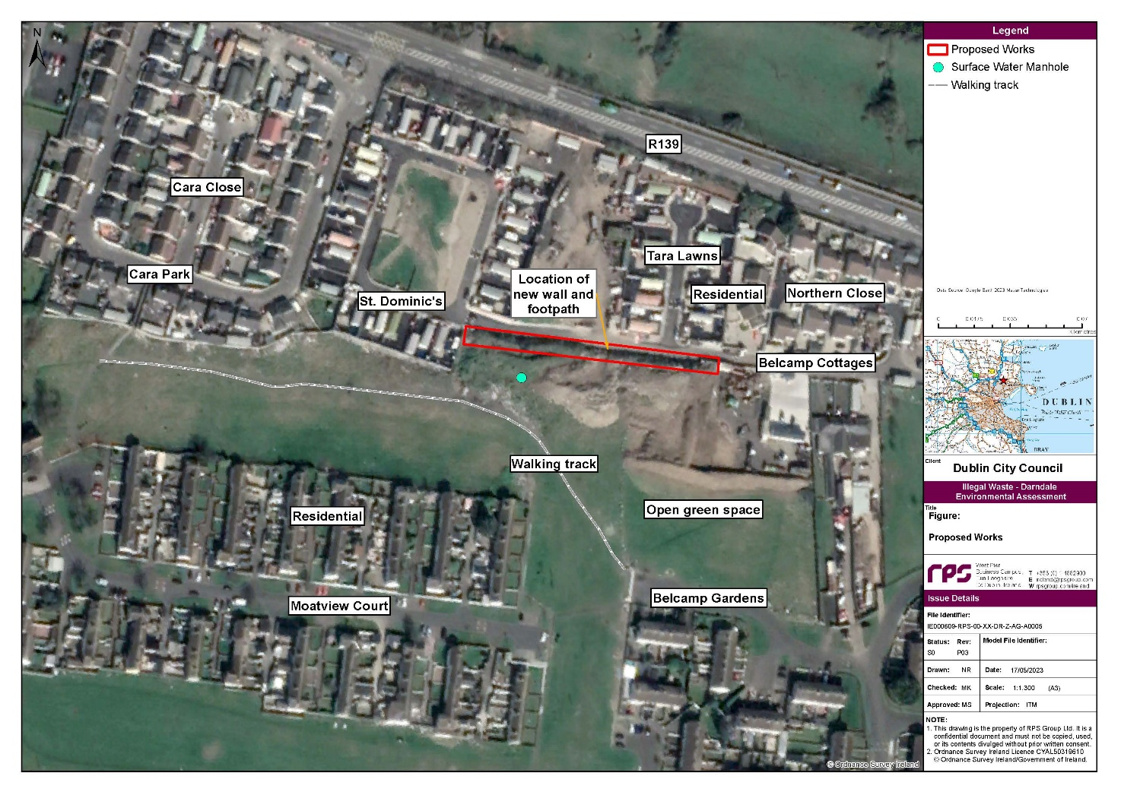

Project Overview
The proposed works include the construction of a 2m wide concrete footpath and a 2.5m high boundary wall (approx. 120m in length) along the northern boundary of the green open space area of Belcamp Park. It is proposed that the boundary wall be comprised of a precast reinforced concrete construction.
The preparatory work will involve excavation works to facilitate the construction of the foundation for the footpath and boundary wall; the foundation will comprise of compacted Clause 808 material on 75mm lean mix material. All waste material excavated as part of the works will be classified and stored appropriately and removed off-site to an appropriately authorised waste management facility.
The precast L-shaped wall units will be placed on the foundation to form the boundary wall. It is proposed to remove the existing concrete kerb, where one exists, along the access road to the north of the works. A concrete footpath will be constructed between the new boundary wall and the existing carriageway. It is not proposed to include any new drainage infrastructure.
Japanese knotweed (Reynoutria japonica) has been identified in parts of the waste mound. Removal of waste at these locations shall be undertaken under licence by competent Contractor and consigned to an appropriately authorised facility as part of separate works to be completed by Dublin City Council.

environmental sensitivities

Population and Human Health
The site is located in the Balgriffin Electoral Division within an area classified as Discontinuous Urban Fabric (Corine Landuse Classification, 2018). The site is located in close proximity to a number of residential areas namely, St. Dominic’s, Tara Lawns and Northern Close, to the west of Belcamp Cottages and north of residential housing estates Moatview Court and Belcamp Gardens. The closest school is located approximately 300m to the southwest of the site.
The site is located in public property located along the northern boundary of an area of green open space, no landtake is required for the project and the site will remain in public ownership following completion of the proposed works. In addition, following completion of the works, the provision of the footpath will improve pedestrian access between properties in the locality as well as providing an improved landscape and visual impact.
The construction methods employed and the hours of work proposed will minimise potential impacts. The proposed development will comply with all Health & Safety Regulations during the construction phase. Where possible, potential risks will be omitted from the design so that the impact on the demolition and construction phase will be reduced. The works will be small in scale and short term in duration during normal working hours therefore minimal disruption to local residents in terms of noise, dust or traffic generation is envisaged.

Soils and Subsoils
The site is located on an area of Made Ground which is the dominant soil type within Dublin City and its environs. The deeper subsoils are mapped by the Geological Survey Ireland as Till derived from limestones. The proposed development will require minimal excavations for shallow foundations, and potential for impacts to subsoils is not anticipated due to the small scale and nature of the development (wall and footpath construction).

Hydrogeology
The site is located within the Dublin (IE_EA_G_008) groundwater body. The WFD status of this groundwater body for the 2016-2021 period is classified as ‘good’, and this groundwater body is classified as ‘review’ regarding the risk of not achieving its WFD objectives (based on WFD risk for the 3rd Cycle of the WFD). This groundwater body was previously classified as ‘not at risk’ of not achieving its WFD objectives during the 2nd cycle of the WFD. The aquifer type underlying the site is classified by GSI as a ‘Poor Aquifer - Bedrock which is Generally Unproductive except for Local Zones’ (GSI, 2023). Groundwater vulnerability within the site boundary is classified as ‘low’. The following description of groundwater flow paths within the Dublin groundwater body is extracted from the GSI summary of initial characterisation document for the Dublin groundwater body:
“The general groundwater flow direction in this aquifer is towards the coast and also towards the River Liffey and Dublin City. This aquifer is not expected to maintain regional groundwater flow paths. Groundwater circulation from recharge to discharge points will more commonly take place over a distance of less than a kilometre. The majority of groundwater flow will be a rapid flow in to upper weathered zone but flow in conduits is commonly recorded at depths of 30 to 50 m b.g.l. The aquifer is not considered to have any primary porosity and flow will be through fractures, some of which will have been enlarged by karstification and dolomitisation. The fissured nature and the moderate permeability of the bedrock close to the surface imply that water will move at high velocities.”
The project will require minimum excavation of soils therefore groundwater interactions are not anticipated.

Hydrology
The project site is located within the Liffey and Dublin Bay catchment (catchment_ID: 09) and Mayne_SC_010 sub-catchment (subcatchment_ID: 09_17). The Mayne River (EPA waterbody name: Mayne_010) flows in a west-east direction approximately 200 m from the northern boundary of the site. The Mayne River was assigned a Q-value of 3 (Poor status) in 2022 by the EPA at a monitoring station located at Hole-in-the-Wall Road (station code: RS09M030500), which is located approximately 2.3 km northeast of the site. The Water Framework Directive (WFD) status of the Mayne River for the 2016-2021 period is classified as ‘poor’ and the river is considered to be ‘at risk’ of not achieving its WFD objectives (based on WFD risk for the 3rd Cycle of the WFD).

Air Quality
The EPA’s Air Quality Index Regions indicates that the site is located in an area of Air Quality rated 3-Good.

Protected Areas
There are no European Sites within, or within close proximity to the project site. The closest European Site to the project is Baldoyle Bay SAC (Site Code: 000199) which is located approx. 3.7 km east of the site as denoted in Figure 5-1 of the AA Screening Report, included in Appendix A. Given the limited sources of potential impacts on European Sites, the distance between the project and the European Site, the surface water runoff prevention measures that will be in place during the proposed works, and the potential for dilution in the surface water network in the unlikely event of any pollutants entering watercourses, there is no potential for likely significant effects arising as a result of the hydrological pathway between the project and Baldoyle Bay SAC.

Biodiversity
The AA Screening carried out with respect to the proposed project found that the project is not directly connected with or necessary to the management of a European Site. During the ecological survey carried out for the AA Screening, the habitats observed in the vicinity of the site included built land and artificial surfaces (consisting of residential and commercial properties, roads and associated infrastructure) and amenity grassland. No species or habitats associated with the European Sites within the Zone of Influence of the project were observed during this survey.

Cultural Heritage
A review of the surrounding vicinity to identify sites of heritage value was carried out, utilising the National Monuments Service online Historic Environment Viewer. The findings indicate that the site is not located in a sensitive area in terms of archaeology or historical monuments.

Assessment of Potential Impacts
Pollutants (e.g., arising from a fuel leak, sediment material) from within the project could enter the downstream receiving environment via the manhole of the adjacent surface water drainage system or via groundwater flow paths. However, taking into consideration the following, the project will not have any measurable effects on the water quality of the Mayne River or where it discharges to Baldoyle Estuary and the Irish Sea:
- The nearest manhole on the surface sewer line will be blocked temporarily as part of standard practice to sever any potential connectivity to the Mayne River.
- All gullies will be temporarily protected as part of standard practice, preventing run-off from entering the main line and subsequently the Mayne River.
- The project will require a limited amount of sub surface excavations to facilitate foundations, therefore groundwater interactions are not anticipated. Additionally, European Sites located upstream, within separate surface water catchments, and >1 km from the project are not considered to be hydrogeologically linked with the site.

Preliminary Examination reView

Guidance on EIA Screening
Guidance on EIA Screening is set out in the Office of the Planning Regulator (OPR) document entitled ‘OPR Practice Note PN02 – Environmental Impact Assessment Screening” (May 2021). This practice note provides useful information and guidance in relation to the requirement for Environmental Impact Assessment. Section 3.0 of the OPR PN02 sets out a “Step-by-step Approach” to EIA Screening. This includes;
- Step 1: Understanding the Proposal
- Step 2: Preliminary Examination and Conclusion
- Step 3 Formal Screening Determination
Extract included from OPR First Practice note PN02 which illustrates the “Step-by-step Approach” to EIA Screening.
Figure 5-1: Step-by-Step Approach to EIA Screening (OPR Practice Note PN02)

STEP 1 – Understanding the proposal
- Is the proposed development a project as per the EIA Directive? If NO it is not subject of EIA Directive and NO Screening required and NO EIA Required;
- Is the Project listed in Schedule 5 Part 1 or does it meet or exceed the thresholds in Part 2, of the Planning Regulations? If YES, NO screening Required and EIA is mandatory;
- Is the project ‘sub-threshold? If YES Proceed to STEP 2, Preliminary Examination is required;
- Has Schedule 7A information been provided with the proposal? If YES Proceed to STEP 3, Screening Determination is required.

STEP 2 – Preliminary Examination and Conclusion
Preliminary examination of at least, the nature, size or location of the development;
Nature of the development including production of wastes and pollutants.
Size of the development.
Location of the development including proximity to ecologically sensitive sites and the potential to affect other environmental sensitivities in the area.
Possible recorded conclusions to preliminary examination
- No real likelihood – Action: No further actions, record and state reasons for conclusion
- Significant doubt – Action: A formal screening determination is required. Request schedule 7A information. Proceed to Step 3.
- Real Likelihood – Action: EIA Required. Request EIAR (new notices necessary)

STEP 3 – Formal Screening Determination
Screening Exercise:
Is the proposal likely to have significant effects on the environment?
In making the determination, the planning authority must have regard to Schedule 7 criteria, Schedule &A information, results of relevant EU assessments, the location of sensitive ecological sites, or heritage or conservation designations. Mitigation measures will be considered
Screening Determination: Recorded outcomes to screening determination must state main reasons and considerations, with references to the relevant criteria listed in Schedule 7 of the Regulations and mitigation if relevant.

Is an EIA Required?
The screening matrix questions for EIA are detailed below
EIA Screening Matrix
Question No. 1
Is the project listed in Schedule 5 Part 1?
If Yes - EIA required but if No - Go to next question

Assessment
No
Question No. 2
Does the project meet or exceed the thresholds in Part 2 of the Planning Regulations?

Assessment

No. The proposed development is a project listed in Part 2, Schedule 5 of the Planning and Development Regulations, 2001, as amended, i.e. Class 10(b)(iv) Urban development.
However, the project is located on a site of less than 0.05ha hectares and falls comfortably below the 10ha threshold for parts of a built-up area outside of a business district.

On reviewing Schedule 5, the proposed development may consist of urban development under the ‘Infrastructure’ category of development prescribed for EIA under Schedule 5 of the Regulations. The guidance provided by the Office of the Planning Regulator (OPR) advises that “Commonly understood urban developments, that should be considered in the context of Schedule 5 Part 2, 10(b)(iv), would include public realm improvement schemes many of which would be subject to the Part 8 process if EIA is not required.”
The threshold for ‘urban development’ however as set out in Part 2, 10(b)(iv) of Schedule 5, comprises of “an area greater than 2 hectares in the case of a business district, 10 hectares in the case of other parts of a built-up area and 20 hectares elsewhere.” As the site area in this case comprises of less than 2ha and the site is not located within a business district but in another part of a built-up area, the development falls below the specified 10ha threshold in this case. Therefore, mandatory EIA is not required but the project comprises of a ‘sub-threshold development’.
As it has been concluded that the project is a sub-threshold development a Preliminary Examination will be undertaken.

Preliminary Examination of the Proposed Development
Step 2 is the Preliminary Examination of the nature, size and location of the development in terms of the type of development including the production of waste and pollutants, the size of the development, its location and proximity to ecological and/or environmentally sensitive sites. This examination is informed by the information and assessment provided in Section 4 of this report which considers the environmental sensitivities of the site.
A review of the proposed development in terms of the nature, size and location of the development including the proximity to ecologically sensitive locations is presented below.

Preliminary EIA Screening Examination
Nature of the Proposed Development
Is the nature of the proposed development exceptional in the context of the existing environment?
No, the development comprises the construction of a concrete footpath and boundary wall and is to be constructed in order to improve and enhance existing urban infrastructure, therefore, the nature of the proposed development is not considered exceptional in the context of the existing environment.
Will the development result in the production of any significant waste or result in significant emissions or pollutants?
No, the preparatory work will involve excavation works to facilitate the construction of the foundation for the footpath and boundary wall. Large scale excavation works are not required. All waste material excavated as part of the works will be classified and stored appropriately and removed off-site to an appropriately authorised waste management facility. No drainage works are proposed.
Size of the Proposed Development
Is the size of the proposed development exceptional in the context of the existing environment?
No, the development comprises the construction of a 2m wide concrete footpath and a 2.5m high boundary wall (approx. 120m in length) on a site of approximately 480m² located within a large city, therefore the size of the proposed development is not considered in exceptional in the context of the existing suburban environment.
Are there cumulative considerations having regard to other existing and/or permitted projects?
No, as part of an AA screening exercise undertaken for the proposed development, the likelihood of significant effects of the project in-combination with other developments in the Darndale area was reviewed with respect to European designated sites. On reviewing these projects in a wider environmental context, no potential is anticipated for in-combination effects arising from any proposed project or plan and this proposed development.
Location of the Proposed Development
Is the proposed development located on, in, adjoining or have the potential to impact on an ecologically sensitive site or location?
No, the review of the environmental setting of the site found that the proposed development is not located on or in an ecologically sensitive location. A review of the AA Screening Report carried out with respect to the project confirms that the site is not directly connected with or necessary to the management of a European Site.
Does the proposed development have the potential to affect other significant environmental sensitivities in the area?
No, due to the nature, extent and location of the proposed works which will improve the existing environment and the existing infrastructure at the site, no impacts on the environmental sensitivities of the area are envisioned

Preliminary Examination Conclusion
The screening exercise was completed in compliance with the relevant European and national legislation, and guidance.
Having regard to the limited nature and scale of the proposed development, the absence of any significant environmental sensitivity in the vicinity and the absence of connectivity to any sensitive location there is no likelihood of significant effects on the environment arising from the proposed development. It is concluded that the need for EIA can be excluded at preliminary examination stage and a screening determination is not required.

BELCAMP BOUNDARY WALL CONSTRUCTION PROJECT
AA SCREENING REPORT
PREPARED BY RPS FOR DUBLIN CITY COUNCIL MAY 2023

Executive summary
RPS was commissioned by Dublin City Council to prepare a screening for Appropriate Assessment (AA) report (Stage 1) with respect to the construction of a 2 m wide concrete footpath and 2.5 m high boundary wall (approximately 120 m in length) at a site in Darndale, Belcamp, Co. Dublin.
The project is not directly connected with or necessary for the management of any European Site.
Based on the information available at the time of this assessment, in view of best scientific knowledge and in view of the Conservation Objectives of the relevant European Sites, it is considered that the footpath and wall construction are not likely to have a significant effect alone or in-combination on any European Sites.
In conclusion, it is the opinion of RPS that AA (‘Stage 2’) is not required.

Introduction

1.1 Purpose of Document
This document is to inform the Competent Authority’s (CA) Appropriate Assessment (AA) with respect to the proposed construction of a 2 m wide concrete footpath and a 2.5 m high boundary wall (approximately 120 m in length) at a site in Darndale, Belcamp, Co. Dublin (hereafter referred to as “the project”). The site is located north of residential housing estate Moatview Court and adjacent to the R139 Regional Road and several traveller halting sites namely, St. Dominic’s, Tara Lawns and Northern Close.
This screening for AA report has been prepared to provide a sufficient level of information to the CA for it to complete a screening for AA of the potential for likely significant effects (LSEs) on European Sites, in view of their Conservation Objectives (CO), arising from the project, either individually or in combination with other plans or projects.
Where the CA determines that the project is not directly connected with or necessary to the management of the site as a European Site and if it can be excluded on the basis of objective scientific information that the project, individually or in combination with other plans or projects, will not have a significant effect on a European Site(s), the competent authority shall determine that an AA of the project is not required.
The document has been prepared by qualified and experienced RPS ecologists.
The document is structured as follows:
- Section 2: Legislative Context and Guidance sets out the guidance and approach which was used to complete the Stage 1 – Screening Assessment.
- Section 3: Project Description sets out the project which has been subject to Stage 1 – Screening Assessment.
- Section 4: Ecology Baseline summarises the methodology and findings of the desktop and field studies which have been completed to inform the Stage 1 – Screening Assessment.
- Section 5: Stage 1: Screening Assessment assesses the project and identifies if it is likely to result in a significant effect either alone or in-combination with other plans and projects.

Legislative Context and Guidance

2.1 Legislative Context
The requirement for AA derives from Article 6(3) of the EU Habitats Directive 92/43/EC.
Article 6(3) requires that:
“any plan or project not directly connected with or necessary to the management of the site but likely to have a significant effect thereon, either individually or in combination with other plans or projects, shall be subject to appropriate assessment of its implications for the site in view of the site’s conservation objectives. In the light of the conclusions of the assessment of the implications for the site and subject to the provisions of paragraph 4, the competent national authorities shall agree to the plan or project only after having ascertained that it will not adversely affect the integrity of the site concerned and if appropriate, after having obtained the opinion of the general public”.
Thus, Article 6(3) provides a two-stage process:
- The first stage involves a screening for AA.
- The second stage arises where, having screened the plan or project, it is determined that there is potential for LSEs and an AA is required to inform decision making by the relevant Competent Authority.

2.2 Guidance and Approach
This document has been prepared with reference to the following guidance and principles.
The principal national and European guidelines have been followed in the preparation of this document. The following list identifies these and other pertinent guidance documents:
- European Commission (EC) (2021) Assessment of Plans and Projects in relation to Natura 2000 Sites – Methodological Guidance on Article 6(3) and (4) of the Habitats Directive 92/43/EEC.
- Office of the Planning Regulator (OPR) (2021) Practice Note (PN01) ‘Appropriate Assessment Screening for Development Management’.
- EC Notice C (2018) 7621 ‘Managing Natura 2000 Sites: the provisions of Article 6 of the 'Habitats' Directive 92/43/EEC’, Office for Official Publications of the European Communities, Luxembourg.
- EC (2013) EC Interpretation Manual of European Union Habitats. Version EUR 28. European Commission.
- Department of Environment, Heritage and Local Government (DEHLG) (2010a) Appropriate Assessment of Plans and Projects in Ireland. Guidance for Planning Authorities. Department of the Environment, Heritage and Local Government, Dublin.
- DEHLG (2010b) DEHLG Government Circular - National Parks and Wildlife Service (NPWS) 1/10 and PSSP 2/10 on Appropriate Assessment under Article 6 of the Habitats Directive – Guidance for Planning Authorities. Department of Environment, Heritage and Local Government.
- EC (2000) Communication from the Commission on the Precautionary Principle. Office for Official Publications of the European Communities, Luxembourg.
The Commission’s 2018 Notice European and national case law have been reviewed and have informed the approach and content of this document in relation to key issues including the interpretation of concepts of site integrity, the absence of lacunae and the use of mitigation measures among others.

Project Description

3.1 Description of the Project

3.1.1 Introduction
This section provides a description of the project and an overview of investigations carried out to date.

3.1.2 Project Overview
The proposed works include the construction of a 2 m wide concrete footpath and a 2.5 m high boundary wall (approx. 120 m in length) along the northern boundary of the green open space area of Belcamp Park (currently in part occupied by stockpile largely comprised of illegal construction and demolition waste). It is proposed that the boundary wall be comprised of a precast reinforced concrete construction.
The preparatory work for this project will involve excavation works to facilitate the construction of the foundation for the footpath and boundary wall. The foundation will comprise of compacted Clause 808 material on 75mm lean mix material. All waste material excavated as part of the works will be classified and stored appropriately and removed off-site to an appropriately authorised waste management facility.
The precast L-shaped wall units will be placed on the foundation to form the boundary wall. It is proposed to remove the existing concrete kerb in place, where one exists, along the access road to the north of the works. A concrete footpath will be constructed between the new boundary wall and the existing carriageway. It is not proposed to include any new drainage infrastructure.
Drainage drawings provided by Dublin City Council (Water Services Division) show a surface water sewer located in close proximity to the site which discharges to the Mayne River, located 200 m north of the site. The southern spur of this line which contains manhole (SO19407903) is located just outside the southern boundary of the site of the proposed works. This manhole on the surface water sewer line will be blocked temporarily to sever any potential connectivity to the river and any gullies encountered will also be protected temporarily. Historical mapping (OSI, 2023) shows a stream in this area which is not visible on current EPA maps. There is a possibility that this stream was culverted in the past and has been incorporated into the current surface water drainage system present in the vicinity of the project.
It is understood that it is Dublin City Council’s intention to remove the stockpile of waste material which currently adjoins the site in a phased basis to allow construction of the wall. A number of site investigations were previously carried out with regard to the removal of this waste from the site including Environmental Risk Assessments, walkovers, and intrusive site investigations. An ecological survey of this site and its environs was carried out in February 2023 (Section 4.1.2).
Japanese knotweed (Reynoutria japonica) has been identified in parts of the waste mound. Removal of waste at these locations shall be undertaken under licence by competent Contractor and consigned to an appropriately authorised facility as part of separate works to be completed by Dublin City Council.
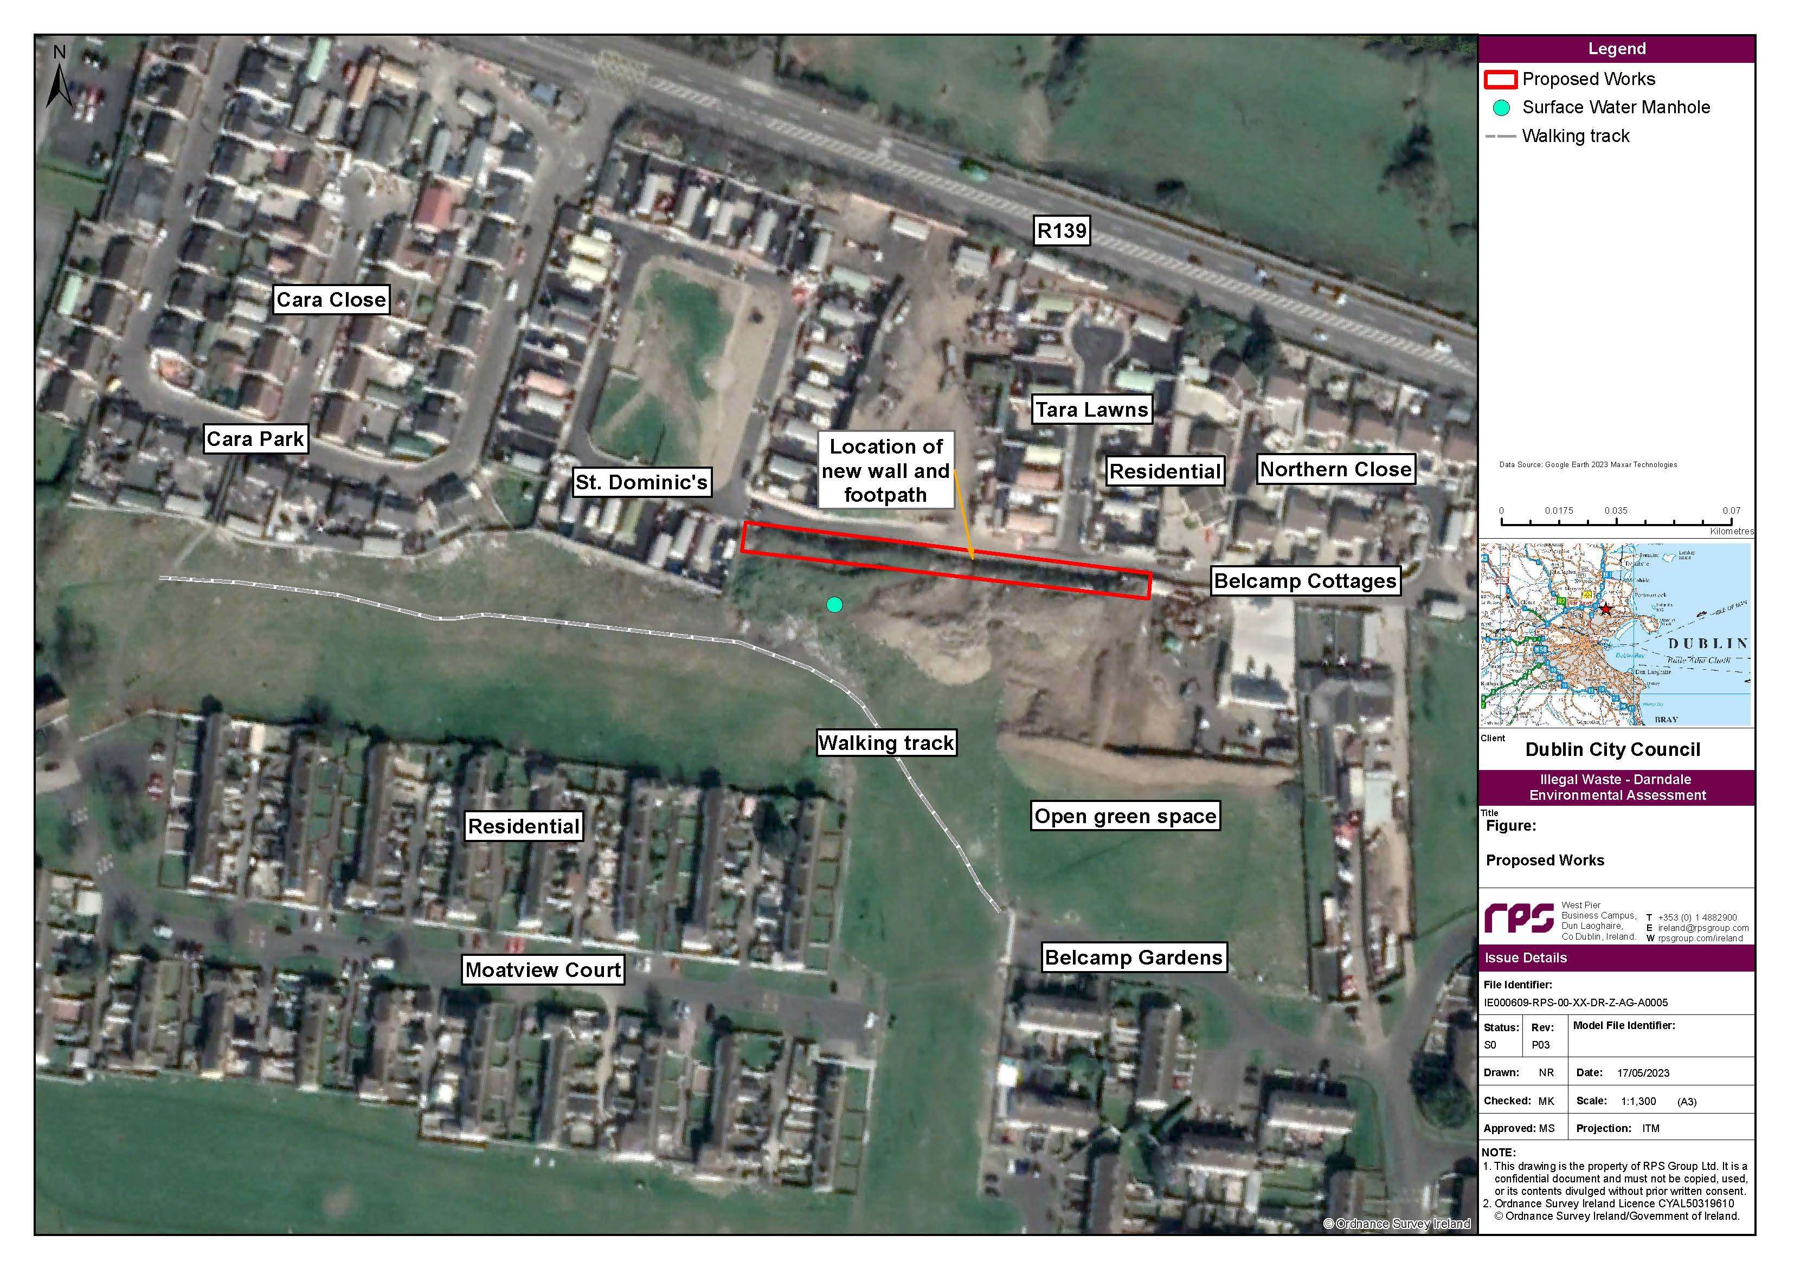
Figure 3-1: Proposed Works

Ecology Baseline

4.1 Methodology

4.1.1 Desk Study
A desktop study was completed to identify relevant European Sites and information regarding their qualifying interests (QIs), special conservation interests (SCIs) and Conservation Objectives, etc. While the distributions of the QI habitats for which the sites are selected are typically restricted to the individual site, QI/SCI species can range well beyond the boundaries of the site (e.g. bird species or otter (Lutra lutra)). The desk study established, from available publications and other publicly available resources, the known distributions and potential presences of such species beyond the defined boundaries of the European Sites for which they are listed as QIs/SCIs. The exercise collated information available from the following sources and informs the source-pathway-receptor (S-P-R) model analysis (see Section 5.2 below for more detail):
- Surveys of flora, fauna, and habitats available at Heritage Councils mapping website (https://heritagemaps.ie/WebApps/HeritageMaps/index.html).
- Distribution records for QI and SCI species of European Sites held online by the National Biodiversity Data Centre (NBDC) www.biodiversityireland.ie.
- Environmental Protection Agency (EPA) online interactive mapping tools (https://gis.epa.ie/EPAMaps) and (https://www.catchments.ie/maps/) for water quality data including surface and ground water quality status, and river catchment boundaries.
- Geohive online Environmental Sensitivity Mapping tool (https://airomaps.geohive.ie/ESM/).
- Geological Survey Ireland (GSI). (2023). Dublin Groundwater Body: Summary of Initial Characterisation. Available at: https://gsi.geodata.gov.ie.
- Information on the River Basin Management Plan 2018 – 2021 - https://www.housing.gov.ie/sites/default/files/publications/files/rbmp_full_reportweb.pdf.
- Mapping of European Site boundaries and Conservation Objectives for relevant sites, available online from the NPWS site synopses, Natura 2000 Standard Data forms and Conservation Objective Supporting Documents where available (https://www.npws.ie/protected-sites).
- Ordnance Survey of Ireland – Mapping and aerial photography (www.osi.ie).
- Information regarding planning applications for Dublin City Council (https://mapzone.dublincity.ie/MapZonePlanning) and Fingal County Council (https://www.fingal.ie/view-or-search-planning-applications).
- Information on the location, nature and design of the project.
- Photographs from site surveys and aerial imagery.

4.1.2 Ecological Survey
A site visit was carried out on 21st February 2023 consisting of a walkover of the site by an RPS ecologist. The aim of this walkover was to observe the habitats present in the vicinity of the project and note any signs of protected habitats and/or species that may be present. Nearby watercourses and visible drainage systems were also observed and noted.

4.2 Findings

4.2.1 Desk Study

4.2.1.1Site Location
The site is located in Darndale, Belcamp, Co. Dublin. It lies north of a residential housing estate, Moatview Court, and adjacent to the R139 Regional Road and several traveller halting sites, namely St. Dominic’s, Tara Lawns and Northern Close.
There are no European Sites within, or within close proximity to the project site. The closest European Site to the project is Baldoyle Bay SAC (Site Code: 000199) which is located approximately 3.7 km east of the site (Figure 5-1).

4.2.1.2 Hydrology and Hydrogeology
The project site is located within the Liffey and Dublin Bay catchment (catchment_ID: 09) and Mayne_SC_010 sub-catchment (subcatchment_ID: 09_17). The Mayne River (EPA waterbody name: Mayne_010) flows in a west-east direction approximately 200 m from the northern boundary of the site. The Mayne River was assigned a Q-value of 3 (Poor status) in 2022 by the EPA at a monitoring station located at Hole-in-the-Wall Road (station code: RS09M030500), which is located approximately 2.3 km northeast of the site. The Water Framework Directive (WFD) status of the Mayne River for the 2016-2021 period is classified as ‘poor’ and the river is considered to be ‘at risk’ of not achieving its WFD objectives (based on WFD risk for the 3rd Cycle of the WFD).
The site is located within the Dublin (IE_EA_G_008) groundwater body. The WFD status of this groundwater body for the 2016-2021 period is classified as ‘good’, and this groundwater body is classified as ‘review’ regarding the risk of not achieving its WFD objectives (based on WFD risk for the 3rd Cycle of the WFD). This groundwater body was previously classified as ‘not at risk’ of not achieving its WFD objectives during the 2nd cycle of the WFD. The aquifer type underlying the site is classified by GSI as a ‘Poor Aquifer - Bedrock which is Generally Unproductive except for Local Zones’ (GSI, 2023). Groundwater vulnerability within the site boundary is classified as ‘low’. The following description of groundwater flow paths within the Dublin groundwater body is extracted from the GSI summary of initial characterisation document for the Dublin groundwater body:
“The general groundwater flow direction in this aquifer is towards the coast and also towards the River Liffey and Dublin City. This aquifer is not expected to maintain regional groundwater flow paths. Groundwater circulation from recharge to discharge points will more commonly take place over a distance of less than a kilometre. The majority of groundwater flow will be a rapid flow in to upper weathered zone but flow in conduits is commonly recorded at depths of 30 to 50 m b.g.l. The aquifer is not considered to have any primary porosity and flow will be through fractures, some of which will have been enlarged by karstification and dolomitisation. The fissured nature and the moderate permeability of the bedrock close to the surface imply that water will move at high velocities.”

4.2.1.3 Fauna
Using the National Biodiversity Data Centre (NBDC) database, records of designated bird species for three SPAs (North Bull Island SPA, Baldoyle Bay SPA and Malahide Estuary SPA) within the Zone of Influence (ZoI) of the project were obtained and assessed for whether each species has been recorded as present within the project environs. Fourteen Special Conservation Interest (SCI) bird species were recorded within the 10 km² grid square within which the project falls (O14). Table 4-1 below presents a summary of the NBDC records for each of these species, along with their corresponding designations under the EU Birds Directive, Wildlife Acts, and Birds of Conservation Concern (BoCCI) status (Gilbert et al., 2021). Human presence and noise are considered permanent characteristics of the site due to its location adjacent to residential areas and the R139 regional road. The site itself is considered unlikely to support any notable population or assemblage of SCI bird species which could be attributable to any European Site locally.
NBDC Records (grid square O14) of QI/SCI Species Listed for European Sites within the ZoI of the Project
Table lists the following Species Name, Record Count, Date of Last Record, Time of Dataset Designation
Bar-tailed Godwit (Limosa lapponica), 3, 31/12/2011, Bird Atlas 2007 – 2011, EU Birds Directive Annex I, Wildlife Acts, and BoCCI Red List
Black-headed Gull (Chroicocephalus ridibundus), 15, 31/12/2011, Bird Atlas 2007 – 2011, Wildlife Acts and BoCCI Amber List
Black-tailed Godwit (Limosa limosa), 6, 31/12/2011, Bird Atlas 2007 – 2011, Wildlife Acts and BoCCI Red List
Curlew (Numenius arquata), 7, 27/06/2018, Birds of Ireland, EU Birds Directive Annex II, Wildlife Acts and BoCCI Red List
Dunlin (Calidris alpina), 5, 31/12/2011, Bird Atlas 2007 – 2011, EU Birds Directive Annex I, Wildlife Acts and BoCCI Red List
Golden Plover (Pluvialis apricaria), 4, 31/12/2011, Bird Atlas 2007 – 2011, EU Birds Directive Annex I, II & III, Wildlife Acts and BoCCI Red List
Grey Plover (Pluvialis squatarola), 2, 31/12/2011, Bird Atlas 2007 – 2011, Wildlife Acts and BoCCI Red List
Knot (Calidris canutus), 4, 31/12/2011, Bird Atlas 2007 – 2011, Wildlife Acts and BoCCI Red List
Light-bellied Brent Goose (Branta bernicla hrota), 3, 31/12/2011, Bird Atlas 2007 – 2011, EU Birds Directive Annex II, Wildlife Acts and BoCCI Amber List
Oystercatcher (Haematopus ostralegus), 6, 31/12/2011, Bird Atlas 2007 – 2011, Wildlife Acts and BoCCI Red List
Redshank (Tringa totanus), 10, 31/12/2011, Bird Atlas 2007 – 2011, Wildlife Acts and BoCCI Red List
Shelduck (Tadorna tadorna), 11, 18/05/2012, Birds of Ireland, Wildlife Acts and BoCCI Amber List
Teal (Anas crecca), 4, 31/12/2011, Bird Atlas 2007 – 2011, EU Birds Directive Annex II & III, Wildlife Acts and BoCCI Amber List
Turnstone (Arenaria interpres), 2, 31/12/2011, Bird Atlas 2007 – 2011, BoCCI Amber List

4.2.2 Ecological Survey
The main species recorded at the site during this survey were broad-leaved dock (Rumex obtusifolius) and common hogweed (Heracleum sphondylium). Japanese knotweed had been identified on the waste mound south of the site during a previous site walkover but was not identified at this time due to seasonal constraints. It is, therefore, assumed that Japanese knotweed is present at the site.
The habitats observed in the vicinity of the project included built land and artificial surfaces (consisting of residential and commercial properties, roads and associated infrastructure) and amenity grassland. No species or habitats associated with the European Sites within the ZoI of the project were observed during this survey.

Stage 1 – Screening Assessment

5.1 Directly Connected with or Necessary to the Management of European Sites
The project, as described in Section 3, is not directly connected with or necessary to the management of any European Sites.

5.2 European Sites
In order to determine the potential for LSE, it is necessary to identify the ZoI of the project and the European Sites therein. The ZoI of the project is the geographical area over which it could affect the receiving environment in a way that could have LSEs directly or indirectly on European Site(s). The ZoI is established using the S-P-R model which is a standard tool used in environmental assessment. In order for an effect to be likely, all three elements of this mechanism must be in place. The absence or removal of one of the elements of the mechanism results in no likelihood for the effect to occur.

5.2.1 Potential Sources
The sources of impact in this case are the works activities required to carry out the project. The sources of impact will arise within the boundary of the project. It is from these impacts that all ecological effects could arise.
The required works will include soil disturbance activities as excavations are dug for the wall and footpath foundations. There is potential for indirect effects to arise from sources within the site which could extend beyond the project boundary (e.g. downstream effects on water quality, noise disturbance).
The range of impacts and effects that could potentially arise as a result of the activities include:
- Accidental release of pollutants (e.g. fuels, oils and lubricants, sediments) to the Mayne River and consequent reduction in water quality in European Sites hydrologically linked to the project site during the works.
- Introduction or spread of invasive species.
- Disturbance of Qualifying Interest (QI) and/or SCI species associated with the works required for the project.

5.2.2 Potential Pathways
The potential pathways for effects are summarised as follows:
- Hydrological: Downstream changes in surface water quality during works particularly with respect to accidental release of pollutants (e.g. hydrocarbons from a fuel leak,, sediments), habitat degradation resulting from the inadvertent transfer of invasive plant species such as Japanese knotweed downstream via waterways.
- Hydrogeological: Changes in groundwater quality during works particularly with respect to accidental spillages of materials (e.g. from a fuel leak) which could migrate vertically to the underlying bedrock and laterally within the aquifer.
- Air/land: Indirect disturbance from noise or vibration on habitat upon which QI or SCI species or populations are dependent for part of their lifecycle outside the project boundary (e.g. breeding, foraging or resting sites for certain bird species).
- Land: Direct disturbance of QI or SCI species or populations because of their movement through or use of habitat within the project boundary for part of their lifecycle (e.g. the disturbance of foraging sites for certain SCI bird species).

5.2.3 Potential Receptors (European Sites)
In order to identify European Sites (i.e. the receptors with respect to S-P-R model) which could be subject to LSEs from the project, all European Sites within the Natura 2000 network were initially considered. The ZoI rules (see below) were applied with reference to available databases and mapping for the Natura 2000 network. As detailed above, the rules have been defined following a consideration of the potential sources of impact and defining the potential pathways of effects arising from these impacts upon the receptors. If no such pathway existed or the pathway did not extend sufficiently based on scientific analysis to impinge on the European Site (in whole or part) then no pathway for LSE was considered to exist.
Based on the pathways determined above, the European Sites that lie within or intersect with the following pathways and their associated extents will be identified for consideration of LSEs based on the following ZoI rules:
- Any European Sites within the boundary of the project will be automatically considered with regard to potential for LSE within the Stage 1 – Screening Assessment. This is to take account of direct impacts and effects.
- Any European Sites which lie within 200 m straight-line measurement of the project boundary will be automatically considered with regard to potential for LSE within the Stage 1 – Screening Assessment. This is to account for:
  - The potential incursion of construction personnel, vehicles or materials beyond the project boundary during construction
  - The extent of potential dust-generating effects and pollution from vehicle emissions.
- Any European Sites which lie within 50 m of the project boundary will be considered with respect to any vibration disturbance effects on QI or SCI species during construction and operation.
- Any European Sites which lie within 500m of the project boundary will be considered with respect to any noise disturbance effects on QI or SCI species during construction and operation.
- Any European Sites within the sub-catchment(s) of the project which support QIs/SCIs which are sensitive to hydrological change (flow or quality) and are downstream of the project boundary will be automatically considered with regard to potential for LSEs within the Stage 1 – Screening Assessment.
- Any European Sites upstream of the project boundary and hydrologically connected to it will be considered with regard to potential for LSEs within the Stage 1 – Screening Assessment if they support mobile aquatic QI/SCI species which could move through the project boundary to/from the European Site as part of their lifecycle.
- Any European Site which supports QI or SCI species which have been shown through desk study/survey to be present in ex-situ habitats within/adjacent to the project boundary.

5.3 Likely Significant Effects Alone
Applying the ZoI rules defined above, eight European Sites (six SACs and two SPAs) in the vicinity of Dublin Bay were excluded from further assessment based on the ZoI rules outlined in Section 5.2.3 above. These are listed in Table 5-1 below along with the rationale used for exclusion.
Applying the ZoI rules, four European Sites (one SAC and three SPAs) were identified as being within the potential ZoI of the project. These European Sites were carried forward for consideration of LSEs within this Stage 1 – Screening Assessment and are summarised in Table 5-2, with reference to their stated Qualifying Interests (QIs) and Special Conservation Interests (SCIs).
European Sites Excluded from Further Assessment
For each European Site indicate Distance from Project and Rationale for Exclusion from further assessment
North Dublin Bay SAC (Site Code: 000206)
4.0 km SE from project site location
Some areas of this SAC are located within the same sub-catchment as the project (Mayne_SC_010). However, this SAC is not located downstream of the site, therefore given the nature of the underlying groundwater body (Section 4.2.1.2) and the distance, this European Site is not considered to be within the ZoI of the project.
Malahide Estuary SAC (Site Code: 000205)
5.5 km N from project site location
Some areas of this SAC are located within the same sub-catchment as the project (Mayne_SC_010). However, this SAC is not located downstream of the site, therefore given the nature of the underlying groundwater body (Section 4.2.1.2) and the distance, this European Site is not considered to be within the ZoI of the project.
South Dublin Bay SAC (Site Code: 000210)
7.3 km S from project site location
This SAC is not located within the same sub-catchment as the project and therefore does not have a direct hydrological connection. Given the distance from the project and lack of hydrological connection, this SAC is not considered to be within the ZoI of the project.
Howth Head SAC (Site Code: 000202)
7.6 km SE from project site location
This SAC is not located within the sub-catchment associated with the project and therefore does not have a direct hydrological connection. Given the distance from the project and lack of hydrological connection, this SAC is not considered to be within the ZoI of the project.
Ireland’s Eye SPA (Site Code: 004117)
8.3 km E from project site location
This SAC is not located within the sub-catchment associated with the project and therefore does not have a direct hydrological connection. Additionally, no bird species listed as SCIs of this SPA have been recorded within the 10 km² grid associated with the project site. Given these factors and the distance from the project, this SPA is not considered to be within the ZoI of the project.
Rockabill to Dalkey Island SAC (Site Code: 003000)
8.5 km E from project site location
This SAC is not located within the sub-catchment associated with the project and therefore does not have a direct hydrological connection. Given the distance from the project and lack of hydrological connection, this SAC is not considered to be within the ZoI of the project.
Ireland’s Eye SAC (Site Code: 002193)
8.6 km E from project site location
This SAC is not located within the sub-catchment associated with the project and therefore does not have a direct hydrological connection. Given the distance from the project and lack of hydrological connection, this SAC is not considered to be within the ZoI of the project.
Howth Head Coast SPA (Site Code: 004113)
10.3 km SE from project site location
This SAC is not located within the sub-catchment associated with the project and therefore does not have a direct hydrological connection. Additionally, no bird species listed as SCIs of this SPA have been recorded within the 10 km² grid associated with the project site. Given these factors and the distance from the project, this SPA is not considered to be within the ZoI of the project.

European Sites and their QIs/SCIs within the ZoI of the project.
Baldoyle Bay SAC (Site Code: 000199)
QI Habitats
Mudflats and sandflats not covered by seawater at low tide [1140], Salicornia and other annuals colonising mud and sand [1310], Atlantic salt meadows (Glauco-Puccinellietalia maritimae) [1330], Mediterranean salt meadows (Juncetalia maritimi) [1410]
QI Species – N/A
SCI – N/A
Connectivity
Approx. 3.7 km E
There is potential for hydrological connectivity between Baldoyle Bay SAC and the site of the project via the Mayne River which discharges to the SAC before flowing into the Irish Sea.
North Bull Island SPA (Site Code: 004006)
QI Habitats - Wetlands [A999]
QI Species – N/A
SCI
Light-bellied Brent Goose (Branta bernicla hrota) [A046] , Shelduck (Tadorna tadorna) [A048] , Teal (Anas crecca) [A052], Pintail (Anas acuta) [A054], Shoveler (Anas clypeata) [A056], Oystercatcher (Haematopus ostralegus) [A130], Golden Plover (Pluvialis apricaria) [A140], Grey Plover (Pluvialis squatarola) [A141], Knot (Calidris canutus) [A143], Sanderling (Calidris alba) [A144], Dunlin (Calidris alpina) [A149], Black-tailed Godwit (Limosa limosa) [A156], Bar-tailed Godwit (Limosa lapponica) [A157], Curlew (Numenius arquata) [A160], Redshank (Tringa totanus) [A162], Redshank (Tringa totanus) [A162], Black-headed Gull (Chroicocephalus ridibundus) [A179]
Connectivity
Approx. 4 km SE

The project site is potentially within the foraging range of the SCI species listed for this SPA.

Light-bellied brent goose, shelduck, teal, oystercatcher, golden plover, grey plover, knot, dunlin, black-tailed godwit, bar-tailed godwit, curlew, redshank, turnstone, black-headed gull have been recorded within the 10 km² grid associated with the project site.
Baldoyle Bay SPA (Site Code: 004016)
QI Habitats - Wetlands [A999]
QI Species – N/A
SCI
Light-bellied Brent Goose (Branta bernicla hrota) [A046], Shelduck (Tadorna tadorna) [A048], Ringed Plover (Charadrius hiaticula) [A137], Golden Plover (Pluvialis apricaria) [A140], Grey Plover (Pluvialis squatarola) [A141], Bar-tailed Godwit (Limosa lapponica) [A157]
Connectivity
Approx. 4.1 km E

There is potential for hydrological connectivity between Baldoyle Bay SPA and the site of the project via the Mayne River which discharges to the SPA before flowing into the Irish Sea.

The project site is potentially within the foraging range of the SCI species listed for this SPA.

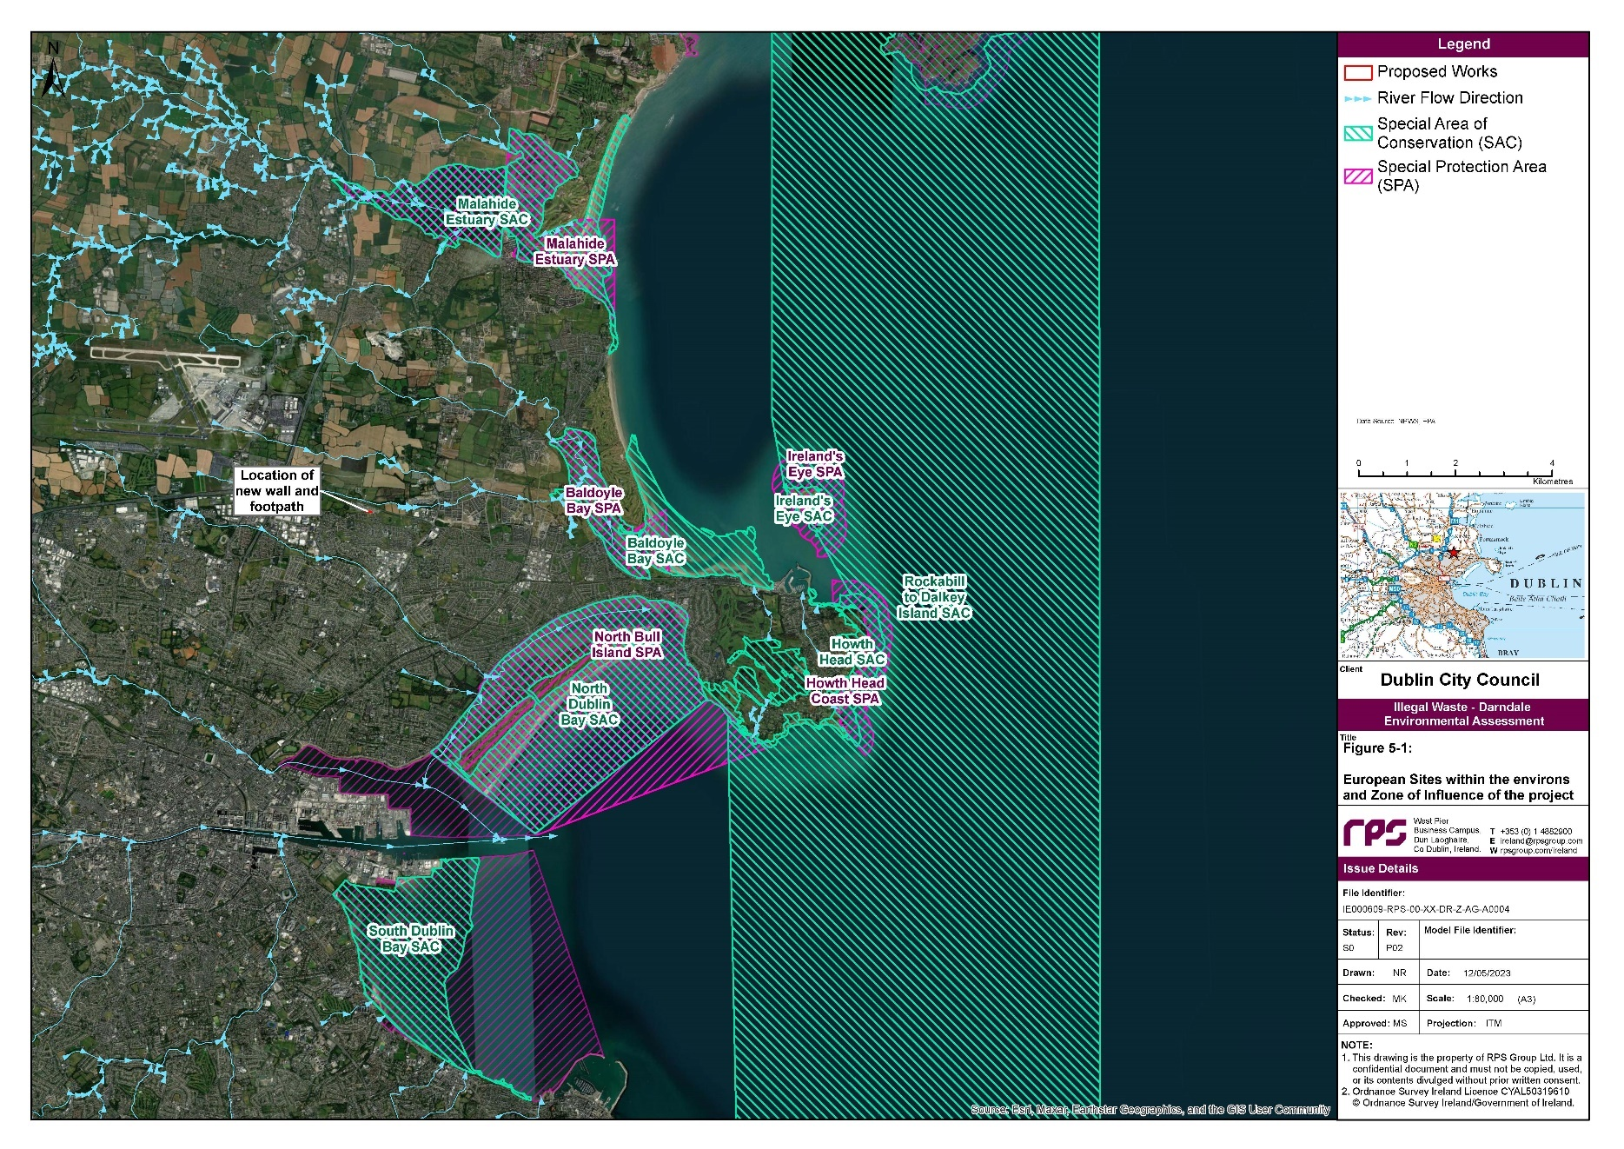
Figure 5-1: European Sites Within the Environs and Zone of Influence of the Project

Conservation Objectives of the European Sites within the ZoI of the Project
For each European Site QI/SCI identified with Conservation Objective
Baldoyle Bay SAC (Site Code: 000199)
Mudflats and sandflats not covered by seawater at low tide [1140] - To maintain the favourable conservation condition of mudflats and sandflats not covered by seawater at low tide in Baldoyle Bay SAC.
Salicornia and other annuals colonising mud and sand [1310] - To maintain the favourable conservation condition of Salicornia and other annuals colonising mud and sand in Baldoyle Bay SAC.
Atlantic salt meadows (Glauco-Puccinellietalia maritimae) [1330] - To maintain the favourable conservation condition of Atlantic salt meadows (Glauco-Puccinellietalia maritimae) in Baldoyle Bay SAC.
Mediterranean salt meadows (Juncetalia maritimi) [1410] - To maintain the favourable conservation condition of Mediterranean salt meadows (Juncetalia maritimi) in Baldoyle Bay SAC.
North Bull Island SPA (Site Code: 004006)
Light-bellied Brent Goose (Branta bernicla hrota) [A046] - To maintain the favourable conservation condition of Light-bellied Brent Goose in North Bull Island SPA.
Shelduck (Tadorna tadorna) [A048] - To maintain the favourable conservation condition of Shelduck in North Bull Island SPA.
Teal (Anas crecca) [A052] - To maintain the favourable conservation condition of Teal in North Bull Island SPA
Pintail (Anas acuta) [A054] - To maintain the favourable conservation condition of Pintail in North Bull Island SPA.
Shoveler (Anas clypeata) [A056] - To maintain the favourable conservation condition of Shoveler in North Bull Island SPA.
Oystercatcher (Haematopus ostralegus) [A130] - To maintain the favourable conservation condition of Oystercatcher in North Bull Island SPA.
Golden Plover (Pluvialis apricaria) [A140] - To maintain the favourable conservation condition of Golden Plover in North Bull Island SPA.
Grey Plover (Pluvialis squatarola) [A141] - To maintain the favourable conservation condition of Grey Plover in North Bull Island SPA.
Knot (Calidris canutus) [A143] - To maintain the favourable conservation condition of Knot in North Bull Island SPA.
Sanderling (Calidris alba) [A144] - To maintain the favourable conservation condition of Sanderling in North Bull Island SPA.
Dunlin (Calidris alpina) [A149] - To maintain the favourable conservation condition of Dunlin in North Bull Island SPA.
Black-tailed Godwit (Limosa limosa) [A156] - To maintain the favourable conservation condition of Black-tailed Godwit in North Bull Island SPA.
Bar-tailed Godwit (Limosa lapponica) [A157] - To maintain the favourable conservation condition of Bar-tailed Godwit in North Bull Island SPA.
Curlew (Numenius arquata) [A160] - To maintain the favourable conservation condition of Curlew in North Bull Island SPA.
Redshank (Tringa totanus) [A162] - To maintain the favourable conservation condition of Redshank in North Bull Island SPA.
Turnstone (Arenaria interpres) [A169] - To maintain the favourable conservation condition of Turnstone in North Bull Island SPA.
Black-headed Gull (Chroicocephalus ridibundus) [A179] - To maintain the favourable conservation condition of Black-headed Gull in North Bull Island SPA.
Wetlands [A999] - To maintain the favourable conservation condition of the wetland habitat in North Bull Island SPA.

Baldoyle Bay SPA (Site Code: 004016)
Light-bellied Brent Goose (Branta bernicla hrota) [A046] - To maintain the favourable conservation condition of Light-bellied Brent Goose in Baldoyle Bay SPA.
Shelduck (Tadorna tadorna) [A048] - To maintain the favourable conservation condition of Shelduck in Baldoyle Bay SPA.
Ringed Plover (Charadrius hiaticula) [A137] - To maintain the favourable conservation condition of Ringed Plover in Baldoyle Bay SPA.
Golden Plover (Pluvialis apricaria) [A140] - To maintain the favourable conservation condition of Golden Plover in Baldoyle Bay SPA.
Grey Plover (Pluvialis squatarola) [A141] - To maintain the favourable conservation condition of Grey Plover in Baldoyle Bay SPA
Bar-tailed Godwit (Limosa lapponica) [A157] - To maintain the favourable conservation condition of Bar-tailed Godwit in Baldoyle Bay SPA.
Wetlands [A999] - To maintain the favourable conservation condition of the wetland habitat in Baldoyle Bay SPA.
Malahide Estuary SPA (Site Code: 004025)
Great Crested Grebe (Podiceps cristatus) [A005] - To maintain the favourable conservation condition of Great Crested Grebe in Malahide Estuary SPA.
Light-bellied Brent Goose (Branta bernicla hrota) [A046] - To maintain the favourable conservation condition of Light-bellied Brent Goose in Malahide Estuary SPA.
Shelduck (Tadorna tadorna) [A048] - To maintain the favourable conservation condition of Shelduck in Malahide Estuary SPA.
Pintail (Anas acuta) [A054] - To maintain the favourable conservation condition of Pintail in Malahide Estuary SPA.
Goldeneye (Bucephala clangula) [A067] - To maintain the favourable conservation condition of Goldeneye in Malahide Estuary SPA
Red-breasted Merganser (Mergus serrator) [A069] - To maintain the favourable conservation condition of Red-breasted Merganser in Malahide Estuary SPA.
Oystercatcher (Haematopus ostralegus) [A130] - To maintain the favourable conservation condition of Oystercatcher in Malahide Estuary SPA.
Golden Plover (Pluvialis apricaria) [A140] - To maintain the favourable conservation condition of Golden Plover in Malahide Estuary SPA.
Grey Plover (Pluvialis squatarola) [A141] - To maintain the favourable conservation condition of Grey Plover in Malahide Estuary SPA.
Knot (Calidris canutus) [A143] - To maintain the favourable conservation condition of Knot in Malahide Estuary SPA.
Dunlin (Calidris alpina) [A149] - To maintain the favourable conservation condition of Dunlin in Malahide Estuary SPA.
Black-tailed Godwit (Limosa limosa) [A156] - To maintain the favourable conservation condition of Black-tailed Godwit in Malahide Estuary SPA.
Bar-tailed Godwit (Limosa lapponica) [A157] - To maintain the favourable conservation condition of Bar-tailed Godwit in Malahide Estuary SPA.
Redshank (Tringa totanus) [A162] - To maintain the favourable conservation condition of Redshank in Malahide Estuary SPA.
Wetlands [A999] - To maintain the favourable conservation condition of the wetland habitat in Malahide Estuary SPA

5.3.1 Assessment of Potential Effects
This section determines whether the impacts identified in Section 5.2 above could have significant effects on the QIs/SCIs of the European Sites identified within the ZoI of the project, in view of the CO of these European Sites (Table 5-3). The potential impacts arising from the project are as follows:
- Accidental release of pollutants (e.g. arising from a fuel leak, sediments) to the Mayne River and consequent reduction in water quality in European Sites hydrologically linked to the project site during the duration of the works,
- Introduction or spread of invasive species,
- Disturbance of QI/SCI species associated with the project works.

5.3.1.1 Accidental Pollution Event
Pollutants (e.g. arising from a fuel leak, sediments) from within the project could enter the downstream receiving environment via the manhole (SO19407903) on the southern spur of the adjacent surface water drainage system via nearby gullies or via groundwater flow paths. However, taking into consideration the following, the project will not have any measurable effects on the water quality of the Mayne River or where it discharges to Baldoyle Estuary and the Irish Sea:
- The nearest manhole on the surface sewer line (SO19407903) will be blocked temporarily as part of standard practice to sever any potential connectivity to the Mayne River.
- All gullies located in proximity to the waste mound will be temporarily protected as part of standard practice, preventing run-off from entering the main line at manhole SO19417001 and subsequently the Mayne River.
- European Sites located upstream, within separate surface water catchments, and >1 km from the project are not considered to be hydrogeologically linked with the site as outlined in Section 4.2.1.2.
It is not anticipated that the pollution events at the site of the project will have a likely significant effect on any European Sites.

5.3.1.2 Introduction or Spread of Invasive Species (Japanese knotweed)
Japanese knotweed is a non-native invasive plant species in Ireland and is listed on the Third Schedule of the Birds and Habitats Regulations. Invasive species can have significant negative impacts on their surrounding environment and cause damage to native ecosystem functions and services (e.g. by outcompeting native species). During previous site investigations, Japanese knotweed was previously recorded in the vicinity of the site. Activities such as excavation works have potential to impact European Sites that are connected to the site by the spread of plant fragments through the local surface water and drainage network.
These activities will be undertaken under licence by a competent Contractor and consigned to an appropriately authorised facility (see Section 3.1.2). Furthermore, there will be an ecological clerk of works supervising the excavation works for the footpath and wall to ensure that any potential fragments of Japanese knotweed rhizome encountered during works are dealt with accordingly. As noted in Section 5.3.1.1 above, the southern spur of the surface water network will be temporarily closed at manhole SO19407903 for the duration of the works, preventing a hydrological connection to the Mayne River. All gullies located in proximity to the site will be protected as part of standard practice, preventing run-off from entering the main line at SO19417001 and the Mayne River. It is not anticipated that the Japanese knotweed present at the site of the project will have a likely significant effect on any European Sites.

5.3.1.3 Disturbance Impacts
The project does not overlap with the boundary of any European Site. Therefore, there are no European Sites at risk of direct disturbance as a result of habitat loss or fragmentation impacts. Human presence and noise are considered permanent characteristics of the site due to its location adjacent to residential areas and the R139 regional road. The site itself is considered unlikely to support any notable population or assemblage of SCI bird species which could be attributable to any European Site locally.
There is potential for indirect disturbance from noise or vibration on habitat upon which QI or SCI species or populations are dependent for part of their lifecycle outside the project boundary (e.g. breeding, foraging or resting sites for certain bird species). The upper extent of potential noise disturbance is considered to be 500 m from the project boundary (worst case) for the construction phase. 500 m was determined based on a threshold of construction and operational noise of 50 dB L_{Aeq, 24hr}, below which it is anticipated that it will have no disturbance effect. The distance is based on noisy construction equipment operating at site boundaries.
There is one wetland habitat within the general environs of the project site (Darndale Park Pond, located approximately 330 m southeast of the site) which may support waterbirds, however, given the baseline conditions and built-up nature of the surrounding environment, significant effects on SCI bird species, should they occur at this location, are not anticipated.
Potential for Likely Significant Effects (LSEs) on European Sites in ZoI of Project
Baldoyle Bay SAC (Site Code: 000199)
Given the limited sources of potential impacts on European Sites, the distance between the project and the European Site, the surface water drainage protection infrastructure that will be in place during the proposed works, and the potential for dilution in the surface water network in the unlikely event of any pollutants entering watercourses, there is no potential for LSEs arising as a result of the hydrological pathway between the project and Baldoyle Bay SAC.
North Bull Island SPA (Site Code: 004006)
Given the limited sources of potential impacts on European Sites, the distance between the project and the European Site, the surface water drainage protection infrastructure that will be in place during the proposed works, and the potential for dilution in the surface water network in the unlikely event of any pollutants entering watercourses, there is no potential for LSEs arising as a result of the hydrological pathway between the project and North Bull Island SPA.
Human presence and noise are considered permanent characteristics of the site due to its location adjacent to residential areas and the R139 regional road. The site is unlikely to provide foraging or roosting habitat for SCI species associated with this North Bull Island SPA. Therefore, there is no potential for LSEs from the project on this European Site due to the lack of effective sources of effects (e.g. foraging habitat loss, disturbance etc.).
Baldoyle Bay SPA (Site Code: 004016)
Given the limited sources of potential impacts on European Sites, the distance between the project and the European Site, the drainage infrastructure that will be in place during the proposed works, and the potential for dilution in the surface water network in the unlikely event of any pollutants entering watercourses, there is no potential for LSEs arising as a result of the hydrological pathway between the project and Baldoyle Bay SPA.
Human presence and noise are considered permanent characteristics of the site due to its location adjacent to residential areas and the R139 regional road. The site is unlikely to provide foraging or roosting habitat for SCI species associated with Baldoyle Bay SPA. Therefore, there is no potential for LSEs from the project on this European Site due to the lack of effective sources of effects (e.g. foraging habitat loss, disturbance etc.).
Malahide Estuary SPA (Site Code: 004025)
Given the limited sources of potential impacts on European Sites, the distance between the project and the European Site, the drainage infrastructure that will be in place during the proposed works, and the potential for dilution in the surface water network in the event of any pollutants entering watercourses, there is no potential for LSEs arising as a result of the hydrological pathway between the project and Malahide Estuary SPA.
Human presence and noise are considered permanent characteristics of the site due to its location adjacent to residential areas and the R139 regional road. The site is unlikely to provide foraging or roosting habitat for SCI species associated with Malahide Estuary SPA. Therefore, there is no potential for LSEs from the project on this European Site due to the lack of effective sources of effects (e.g. foraging habitat loss, disturbance etc.).

5.4 Likely Significant Effects In-combination
As part of the screening for AA, in addition to the project, other relevant projects and plans in the region must also be considered at this stage. The following sections outline the results of this assessment.

5.4.1 Plans
The plans that are considered in-combination with the projects include:
- Dublin City Development Plan 2022 - 2028
- National Biodiversity Action Plan 2017 – 2021
- Dublin City Biodiversity Action Plan 2021 – 2025
- River Basin Management Plan 2018 – 2021

Dublin City Development Plan 2022 – 2028
The Dublin City Development Plan 2022 - 2028 sets out how the city will develop to meet the needs of all residents, workers and visitors (Dublin City Council (DCC), 2022).
With regard to European Sites, the plan states that:
“it is the policy of Dublin City Council to conserve, manage, protect and restore the favourable conservation condition of all qualifying interest/special conservation interests of all European sites designated, or proposed to be designated, under the EU Birds and Habitats Directives, as Special Areas of Conservation (SACs) and Special Protection Areas (SPAs) (European/Natura 2000 sites)”. The plan’s Natura Impact Report (Volume 6 of the plan) concluded that “following an examination, analysis and evaluation of the relevant information, including in particular the nature of the predicted impacts associated with the plan that it will not adversely affect the integrity of any European Site, either alone or in combination with other plans or projects”.
The plan also makes reference to upholding the objectives of the Dublin City Biodiversity Action Plan 2021 – 2025 (see Section 5.4.1.3 below).
Given the inclusion of protective policies for European Sites, in-combination effects from the Dublin City Development Plan 2022 – 2028 are not predicted.

National Biodiversity Action Plan 2017 – 2021
The National Biodiversity Action Plan (NBAP) 2017 – 2021 is a framework for the conservation and protection of biodiversity in Ireland (Department of Culture, Heritage and the Gaeltacht (DCHG), 2017). The main objective of the plan is to conserve and restore biodiversity and ecosystem services. The importance of conservation, the management of protected areas and species and the sustainable use of biodiversity has been identified as an action under several objectives in the NBAP. The objectives recognise the shared responsibility for the conservation of biodiversity and the sustainable use of its components, by all sectors. At time of writing, a new NBAP is currently being prepared.
As the overall aim of the NBAP is to protect biodiversity and to continue and improve the transposition of the EU Habitats Directive and the EU Birds Directive into national legislation, there are no predicted in-combination impacts from the NBAP 2017 – 2021 with the project.

Dublin City Biodiversity Action Plan 2021 – 2025
The Dublin City Biodiversity Action Plan 2021 – 2025 lays out Dublin City Council's strategy for the conservation and restoration of the city's biodiversity. Given that the overall objective of the plan is to conserve and restore biodiversity in Dublin City, in-combination effects with the Dublin City Biodiversity Action Plan 2021 – 2025 are not predicted.

River Basin Management Plan 2018 – 2021
The River Basin Management Plan (RBMP) 2018 - 2021 outlines the approach that Ireland will take to protect waters over the period to 2021. At time of writing, a new RBMP is currently being prepared. As the overall aim of the RBMP is to protect and/or restore waters in Ireland, there are no predicted in-combination impacts from the RBMP with the project.

5.4.2 Proposed Developments
In order to assess the likelihood of significant effects of the project in-combination with other developments, developments in the Darndale area were reviewed. Permitted developments in close proximity to the project site are outlined in hereunder.

Proposed Developments Within the Vicinity of the Project
Local Authority – Dublin City Council
Project Details
Planning Reference: 3041/22, Decision: Grant Permission,Location relative to project: Northwest of project boundary

Description
Development of a Synchronous Compensator Development (Grid Stabilisation Facility) on the site of a approx. 0.94 ha at lands south of Belcamp 220KV substation, Belcamp Dublin 17.
The proposed development will consist of the following elements within the administrative boundary of Dublin City Council:
New access entrance from the R139 and a clear span bridge crossing over River Mayne;
Internal access tracks, security fencing, temporary construction compound, landscaping, and drainage.
A concurrent planning application is being made to Fingal County Council which relates to a portion of lands to the north of the site (see Planning Reference F21A/0681 below).

Potential for in-combination effects

A Natura Impact Statement (NIS) was prepared for this proposed development which noted that the site of this proposed development is bisected by a stream which joins the Mayne River, resulting in a direct hydrological connection to Baldoyle Bay SAC (Site Code: 000199) and Baldoyle Bay SPA (Site Code: 004016). The NIS outlined a number of mitigation measures and concluded that with the implementation of these measures, this proposed development either alone or in-combination with other plans or projects, will not adversely affect the integrity of any European Site.

Local Authority – Fingal County Council
Project Details
Planning Reference: F21A/0681,Decision: Grant Permission, Location relative to project: Northwest of project boundary

Description
Development of a Synchronous Compensator Development (Grid Stabilisation Facility) on the site of approx. 1.65 ha at lands south of Belcamp 220kV Substation, Belcamp, Dublin 17.The proposed development will consist of the following elements within the administrative boundary of Fingal County Council:

A Grid Stabilisation Facility containing 1 No. High Inertia Synchronous Compensator (HISC) unit enclosed within a steel clad framed style structure (12.1 m max. height) and supported by 8 electrical equipment containers (containing ancillary power supply products including a static frequency converts, MV switchgear, exciters, LV distribution, control room, welfare and office), main, auxiliary & start-up electrical transformers, generator circuit breaker, switchgear equipment, External cooler units and 1 back up diesel generator and associated diesel storage tank;
A 220kV High Voltage Gas Insulated Switchgear (GIS) compound containing a GIS building with all control & HV equipment within a single storey building (13.2 m max. height). The building will be surrounded by a compound road and contained within a 2.6 m high galvanised steel palisade fence;
A 220 kV underground cable to the existing adjoining EirGrid substation boundary;
Associated elements comprising a clear span bridge over the River Mayne, various underground cables and ducts, equipment plinths, boundary security fence, compound lighting and palisade gates and fencing, security lighting, CCTV, internal access roads, hardstanding areas and all necessary foundations works for the above compounds.

A concurrent planning application is being made to Dublin City Council which relates to a portion of lands to the south of the site (see Planning Reference 3041/22 above).

Potential for in-combination effects

A Natura Impact Statement (NIS) was prepared for this proposed development which noted that the site of this proposed development is bisected by a stream which joins the Mayne River, resulting in a direct hydrological connection to Baldoyle Bay SAC (Site Code: 000199) and Baldoyle Bay SPA (Site Code: 004016). The NIS outlined a number of mitigation measures and concluded that with the implementation of these measures, this proposed development either alone or in-combination with other plans or projects, will not adversely affect the integrity of any European Site.

Taking this into account, no potential is anticipated for in-combination effects arising from the project and this proposed development.

Local Authority – Fingal County Council
Project Details

Planning Reference: SHD/014/21, Decision: Pending, Location relative to project: Northeast of project boundary

Description
The development will consist of the construction of a mixed-use development comprising of 2527 residential units (473 houses, 1780 apartments, and 274 duplex units) of which 1969 units are residential and 558 apartment units are ‘build-to-rent’ residential. The development will also include ancillary residential amenity facilities, 2 childcare facilities, 1 sports changing facilities building, 18 retail units and 3 cafés/restaurants.

Potential for in-combination effects

A Natura Impact Statement (NIS) was prepared for this proposed development which noted that the site of this proposed development is bisected by the Mayne River, resulting in a direct hydrological connection to Baldoyle Bay SAC (Site Code: 000199) and Baldoyle Bay SPA (Site Code: 004016). The NIS outlined a number of mitigation measures and concluded that with the implementation of these measures, this proposed development either alone or in-combination with other plans or projects, will not adversely affect the integrity of any European Site.

Taking this into account, no potential is anticipated for in-combination effects arising from the project and this proposed development.

5.4.3 In-combination Conclusion
For all developments considered as part of this in-combination assessment, due to the minor nature of the proposed project, and the consequent lack of significant sources of impact during the construction phase, and absence of impact sources during the operational phase, it is concluded that there is no potential for significant in-combination effects. Therefore, in-combination effects from other projects have been screened out from further assessment.

5.5 Conclusion of Stage 1 – Screening Assessment
RPS has prepared this report to inform screening for AA to assess whether the project, individually or in-combination with other plans or projects, and in view of best scientific knowledge, is likely to have a significant effect on any European Site(s).
The screening exercise was completed in compliance with the relevant European and national legislation, guidance and current case law. The potential impacts of the project have been considered in the context of the European Sites potentially affected, their QIs and their conservation objectives, through the application of the S-P-R model, which considered the potential extent of effects from the project and the potential in-combination effects with other plans or projects.
The overall findings, as set out in this report to inform screening for AA, are that the project is not directly connected with or necessary to the management of a European Site and it can be excluded on the basis of objective scientific information that the project, individually or in combination with other plans or projects, will not have a likely significant effect on a European Site.
In conclusion, it is the opinion of RPS that AA (‘Stage 2’) is not required.

References
Chartered Institute of Ecology and Environmental Management (CIEEM). (2018). Guidelines for Ecological Impact Assessment in the UK and Ireland – Terrestrial, Freshwater, Coastal and Marine.
Cutts, N. et al. (2009). Construction and Waterfowl: Defining Sensitivity, Response, Impacts and Guidance.
Department of Culture, Heritage and the Gaeltacht (DCHG). (2017). National Biodiversity Action Plan 2017-2021.
Department of Environment, Heritage and Local Government (DEHLG). (2010a). Appropriate Assessment of Plans and Projects in Ireland. Guidance for Planning Authorities. Department of the Environment, Heritage and Local Government, Dublin.
Department of Environment, Heritage and Local Government (DEHLG). (2010b). DEHLG Government Circular - National Parks and Wildlife Service (NPWS) 1/10 and PSSP 2/10 on Appropriate Assessment under Article 6 of the Habitats Directive – Guidance for Planning Authorities. Department of Environment, Heritage and Local Government.
Department of Housing, Local Government and Heritage (DHLGH). (2018). River Basin Management Plan 2018 – 2021.
Dublin City Council (DCC). (2021). Dublin City Biodiversity Action Plan 2021 - 2025.
Dublin City Council (DCC). (2022). Dublin City Development Plan 2022 - 2028.
Dublin City Council (DCC). (2023). Citizen Portal Planning. Available at https://mapzone.dublincity.ie/MapZonePlanning/MapZone.aspx?map=PlanningApplication&search=Plan_Ref&tooltip=Plan_Ref. Accessed 15 May 2023.
Environmental Protection Agency (EPA). (2023). EPA Water Maps. Available at: https://gis.epa.ie/EPAMaps/Water. Accessed 12 May 2023.
European Commission (EC). (2000). Communication from the Commission on the Precautionary Principle. Office for Official Publications of the European Communities, Luxembourg.
European Commission (EC). (2013). EC Interpretation Manual of European Union Habitats. Version EUR 28. European Commission.
European Commission (EC). (2021). Assessment of Plans and Projects in relation to Natura 2000 Sites – Methodological Guidance on Article 6(3) and (4) of the Habitats Directive 92/43/EEC.
European Notice C. (2018). 7621 ‘Managing Natura 2000 Sites: the provisions of Article 6 of the 'Habitats' Directive 92/43/EEC’, Office for Official Publications of the European Communities, Luxembourg.
Geological Survey Ireland (GSI). (2023). Dublin Groundwater Body: Summary of Initial Characterisation. Available at: https://gsi.geodata.gov.ie/downloads/Groundwater/Reports/GWB/DublinGWB.pdf. Accessed 12 May 2023.
Gilbert, G., Stanbury, A., Lewis, L. (2021). Birds of Conservation Concern in Ireland 4: 2020–2026. Available at: https://birdwatchireland.ie/app/uploads/2021/04/BOCCI-2020-2026.pdf. Accessed 12 May 2023.
MWP. (2021). Natura Impact Statement, Belcamp Grid Stabilisation Facility. Available at: https://webapps.dublincity.ie/AniteIM.WebSearch/Download.aspx?ID=992687. Accessed 12 May 2023.
National Biodiversity Data Centre (NBDC), Ireland, Bar-tailed Godwit (Limosa lapponica), accessed 12 May 2023, <https://maps.biodiversityireland.ie/Species/10061>
National Biodiversity Data Centre (NBDC), Ireland, Black-headed Gull (Larus ridibundus), accessed 12 May 2023, <https://maps.biodiversityireland.ie/Species/10161>
National Biodiversity Data Centre (NBDC), Ireland, Black-tailed Godwit (Limosa limosa), accessed 12 May 2023, <https://maps.biodiversityireland.ie/Species/10060>
National Biodiversity Data Centre (NBDC), Ireland, Branta bernicla subsp. hrota, accessed 12 May 2023, <https://maps.biodiversityireland.ie/Species/12611>
National Biodiversity Data Centre (NBDC), Ireland, Common Redshank (Tringa totanus), 12 May 2023, <https://maps.biodiversityireland.ie/Species/10041>
National Biodiversity Data Centre (NBDC), Ireland, Common Shelduck (Tadorna tadorna), accessed 12 May 2023, <https://maps.biodiversityireland.ie/Species/10026>
National Biodiversity Data Centre (NBDC), Ireland, Dunlin (Calidris alpina), accessed 12 May 2023, <https://maps.biodiversityireland.ie/Species/10042>
National Biodiversity Data Centre (NBDC), Ireland, Eurasian Curlew (Numenius arquata), accessed 12 May 2023, <https://maps.biodiversityireland.ie/Species/10039>
National Biodiversity Data Centre (NBDC), Ireland, Eurasian Oystercatcher (Haematopus ostralegus), accessed 12 May 2023, <https://maps.biodiversityireland.ie/Species/10033>
National Biodiversity Data Centre (NBDC), Ireland, Eurasian Teal (Anas crecca), accessed 12 May 2023, <https://maps.biodiversityireland.ie/Species/10051>
National Biodiversity Data Centre (NBDC), Ireland, European Golden Plover (Pluvialis apricaria), accessed 12 May 2023, <https://maps.biodiversityireland.ie/Species/10036>
National Biodiversity Data Centre (NBDC), Ireland, Grey Plover (Pluvialis squatarola), accessed 12 May 2023, <https://maps.biodiversityireland.ie/Species/10056>
National Biodiversity Data Centre (NBDC), Ireland, Red Knot (Calidris canutus), accessed 12 May 2023, <https://maps.biodiversityireland.ie/Species/10066>
National Biodiversity Data Centre (NBDC), Ireland, Ruddy Turnstone (Arenaria interpres), accessed 12 May 2023, <https://maps.biodiversityireland.ie/Species/10057>
National Parks and Wildlife Service (NPWS). (2012). Conservation Objectives: Baldoyle Bay SAC 000199. Version 1. National Parks and Wildlife Service, Department of Arts, Heritage and the Gaeltacht.
National Parks and Wildlife Service (NPWS). (2013). Conservation Objectives: Baldoyle Bay SPA 004016. Version 1. National Parks and Wildlife Service, Department of Arts, Heritage and the Gaeltacht.
National Parks and Wildlife Service (NPWS). (2015). Conservation Objectives: North Bull Island SPA 004006. Version 1. National Parks and Wildlife Service, Department of Arts, Heritage and the Gaeltacht.
National Parks and Wildlife Service (NPWS). (2019). The Status of EU Protected Habitats and Species in Ireland. Volume 1: Summary Overview. Unpublished NPWS report. Edited by: Deirdre Lynn and Fionnuala O’Neill.
Nelson, B., Cummins, S., Fay, L., Jeffrey, R., Kelly, S., Kingston, N., Lockhart, N., Marnell, F., Tierney, D. and Wyse Jackson, M. (2019). Checklists of protected and threatened species in Ireland. Irish Wildlife Manuals, No. 116. National Parks and Wildlife Service, Department of Culture, Heritage and the Gaeltacht, Ireland.
Office of the Planning Regulator (OPR). (2021). Practice Note (PN01) ‘Appropriate Assessment Screening for Development Management’.
OPENFIELD Ecological Services. (2022). Natura Impact Statement for Proposed Strategic Housing Development, Belcamp, Dublin 17. Available at: https://documents.fingalcoco.ie/NorthgateIM.WebSearch/Download.aspx?ID=738883. Accessed 12 May 2023.
Ordnance Survey Ireland (OSI). (2023). Historical Map Viewer. Available at: https://osi.maps.arcgis.com/apps/webappviewer/index.html?id=bc56a1cf08844a2aa2609aa92e89497e. Accessed 12 May 2023.
The Heritage Council. (2023). Heritage Maps. Available at: https://heritagemaps.ie/WebApps/HeritageMaps/index.html. Accessed 12 May 2023.
Wetland Surveys Ireland and Foss Environmental Consulting. (2023). The Map of Irish Wetlands. Available at: https://wetland.maps.arcgis.com/apps/View/index.html?appid=e13b75c3bcab4932b992aa0169aa4a32&extent=-11.9317,51.0620,-3.9117,55.6465. Accessed 12 May 2023.

Directive 2011/92/EU of the European Parliament and of the Council of 13 December 2011 on the assessment of the effects of certain public and private projects on the environment
Directive 2014/52/EU of the European Parliament and of the Council of 16 April 2014 amending Directive 2011/92/EU on the assessment of the effects of certain public and private projects on the environment.
Waterbodies that are categorised as ‘review’ are categorised as such when additional information is needed to determine their status before resources and more targeted measures are initiated or the measures have been undertaken, e.g. a wastewater treatment plant upgrade, but the outcome has not yet been measured/monitored.
Available at: https://gsi.geodata.gov.ie/downloads/Groundwater/Reports/GWB/DublinGWB.pdf. Accessed 28/02/2023
“business district” means a district within a city or town in which the predominant land use is retail or commercial use for the purposes of this section of the Act (OPR and Regulations)
Commonly understood urban developments, that should be considered in the context of Schedule 5 Part 2, 10(b)(iv), would include public realm improvement schemes many of which would be subject to the Part 8 process if EIA is not required.(OPR)
EC Notice C (2018) 7621 ‘Managing Natura 2000 Sites: the provisions of Article 6 of the 'Habitats' Directive 92/43/EEC’, Office for Official Publications of the European Communities, Luxembourg.
Waterbodies that are categorised as ‘review’ are categorised as such when additional information is needed to determine their status before resources and more targeted measures are initiated or the measures have been undertaken, e.g. a wastewater treatment plant upgrade, but the outcome has not yet been measured/monitored.
Available at: https://gsi.geodata.gov.ie/downloads/Groundwater/Reports/GWB/DublinGWB.pdf. Accessed 15/05/2023.
Definition of “impact” and “effect” as per CIEEM (2018) Guidelines for Ecological Impact Assessment in the UK and Ireland – Terrestrial, Freshwater, Coastal and Marine
https://www.npws.ie/maps-and-data
According to The Map of Irish Wetlands (Wetland Surveys Ireland and Foss Environmental Consulting) https://wetland.maps.arcgis.com/apps/View/index.html?appid=e13b75c3bcab4932b992aa0169aa4a32&extent=-11.9317,51.0620,-3.9117,55.6465

