Belcamp Boundary Wall

-Easy Read Summary

Where is this project?

This project is at Belcamp Cottages in Darndale, at the northern end of Belcamp Park

Why do we need to do this work?

At the moment there is a large mound of illegal waste at this end of the park. We want to remove the waste and build a wall to protect the park from illegal dumping.
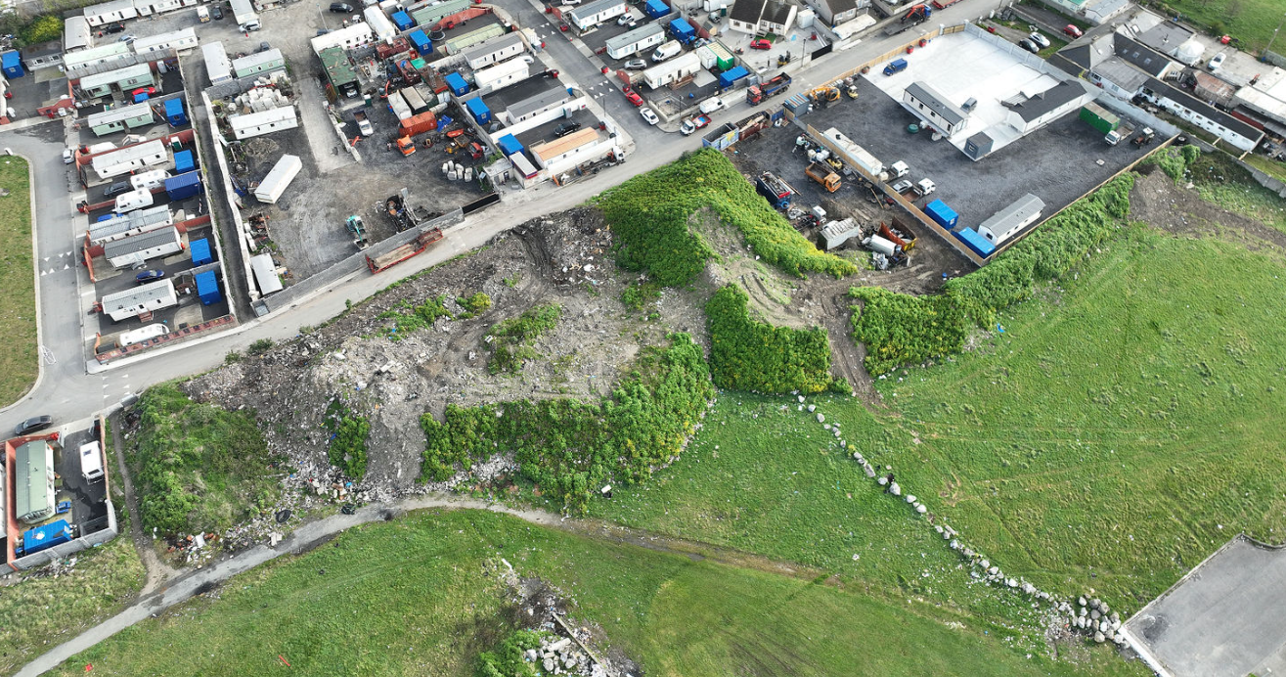
Figure 1-Existing view of illegal dump
E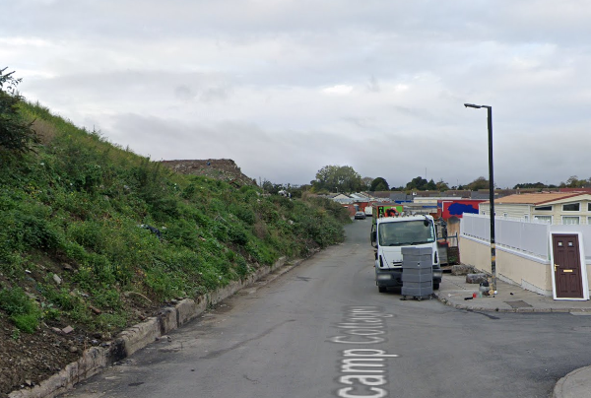
Figure 2 -Existing view looking west at Belcamp Cottages

What changes will this project make?

We will remove the illegal waste and:
- Level off the ground so that the mound is gone
- Build a new wall along the edge of the park and add a footpath along the edge of the road
- Add a new entrance so that people can walk into the park from Belcamp Cottages
- Plant new trees in the park near the new wall

By making all of these changes we hope to make the area look and feel better for everyone who lives in the area.

What will it look like?

The wall will be 2.5m high and will be made out of concrete, the front of the wall will look like it is built from stone. The top of the wall will step in level every 5m to match the slope of the road.
The concrete footpath will be 2m wide and will have a 125mm high kerb.
The ground in the grassed area will be the same level as the roadway and new trees will be planted behind the wall.
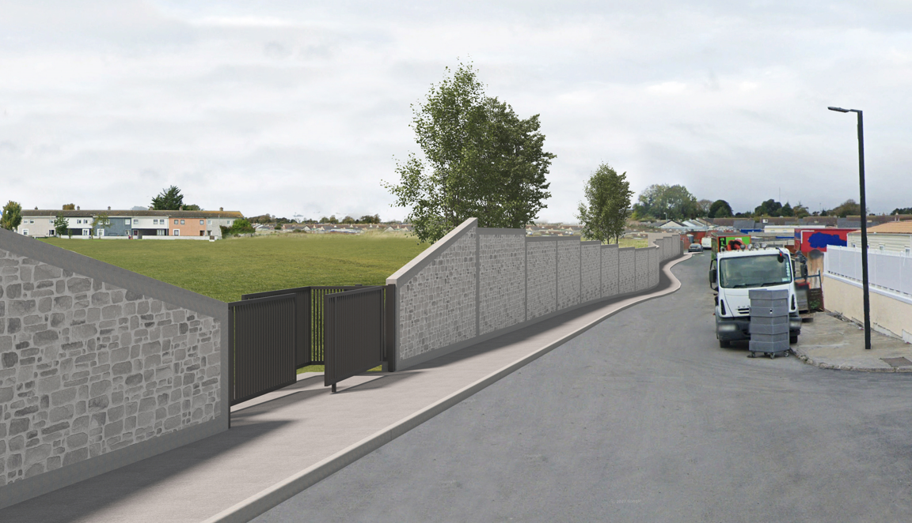
Figure 3-Proposed view looking west along Belcamp Cottages
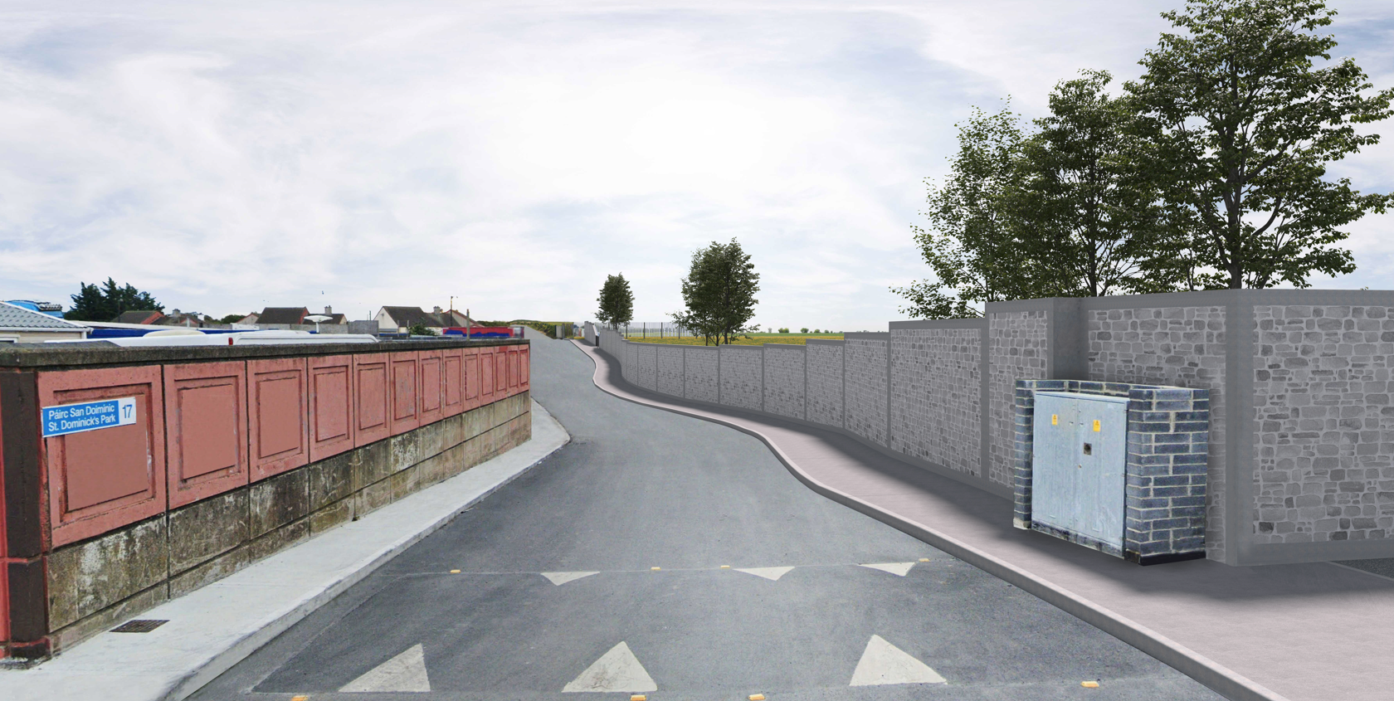
Figure 4-Proposed view looking east along Belcamp Cottages
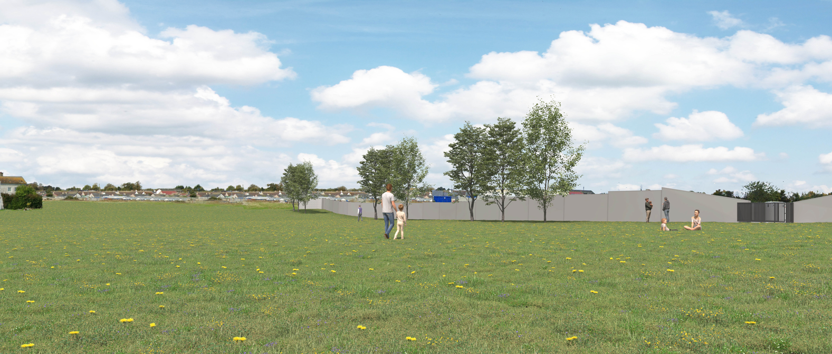
Figure 5-Proposed view from Belcamp Park

What happens next?

Dublin City Council need to get planning permission to build this project.
Everyone can look at the plans and send us comments for six weeks after the date we start the planning application. All the comments are then put into a report and the Dublin City Councillors vote on whether this project should go ahead or not.

How do I comment on this project?

There are a few different ways to get more information or comment on this project:
- You can visit the public counter the Ground Floor of Block 4 of Dublin City Council’s Civic Offices, Wood Quay, Dublin 8
- You can look at all the plans, and make a comment, on-line at Dublin City Council - Citizen Space

