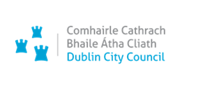 Seirbhísí Cultúir, Áineasa & Eacnamaíochta,
Bloc 4, Urlár 0, Oifigí na Cathrach,
An Ché Adhmaid, Baile Átha Cliath 8

Culture, Recreation and Economic Services,
Block 4, Floor 0, Civic Offices Wood Quay Dublin 8

5th December 2023
Planning Department
Block 4, Floor 1
Dublin City Moorings, Custom House Quay, Dublin 1
Application for Part 8 Planning Permission.

Dublin City Council, Culture, Recreation and Economic Services is applying for Planning Permission under Part 8 of the Planning & Development Regulations 2001 (as amended) for Dublin City Moorings, Custom House Quay, Dublin 1.
Copies of the following documentation shall be submitted online in support of the application.
-Cover Letter.
-Newspaper Notice (Published in Irish Independent 05/12/2023).
-Site Notice.
-Schedule of Content.
-Planning Report.
-The relevant Plans/Drawings as follows:

1831-UA-DR-A-P-PP01 Site location Map
1831-UA-DR-A-P-PP02 Existing Site Layout Plan
1831-UA-DR-A-P-PP03 Existing Elevations and Sections
1831-UA-DR-A-P-PP04 Proposed Site Layout Plan
1831-UA-DR-A-P-PP05 Proposed Quayside Pontoon Canopies and Gangways Floor
Plans - Sheet 1
1831-UA-DR-A-P-PP06 Proposed Quayside Pontoon Canopies and Gangways Floor
Plans - Sheet 2
1831-UA-DR-A-P-PP07 Proposed Extended Boardwalk Floor Plans
1831-UA-DR-A-P-PP08 Proposed Canopy no.1 Elevations and Sections
1831-UA-DR-A-P-PP09 Proposed Canopy no.2 Elevations and Sections
1831-UA-DR-A-P-PP10 Conservation Drawing
- Landscape drawings (by CSR)
- Architectural Heritage Impact Assessment (by Howley Hayes Cooney Architecture).
- Screening Report for Appropriate Assessment (by Ruth Minogue Environmental Consultancy).
- Environmental Impact Assessment Screening Report (by Ruth Minogue Environmental Consultancy).
- Outline Construction Management Plan (by RPS)
- Flood Risk Assessment Report (by RPS)

In accordance with the Revised Procedures for Processing Developments by Dublin City Council, we hereby forward our application to the Registry Section and would be obliged if you could forward this to the Planner for their Report.

Should you have any queries or require any additional information, please email donncha.odulaing@dublincity.ie

Yours Sincerely
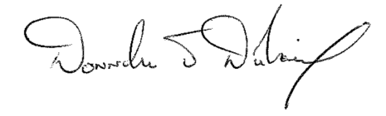
-----------------------------
Dublin City Council, Culture, Recreation and Economic Services

