Proposed amendment to the North Lotts and Grand Canal Dock SDZ Planning Scheme in relation to revised bridge location across the River Liffey

Table of Contents

- Introduction
- Background
- The North Lotts and Grand Canal Dock SDZ
- Previous ABP decision
- Recent changes in planning and development context
- Current position

- Proposed amendment to the scheme

- Rationale for amendment
- Section 170A of the Planning and Development Acts 2000-2015

- Consultation Details
- Strategic Environmental Assessment Screening
- Appropriate Assessment Screening
- Conclusions

Appendix 1 Associated amendments to the Planning Scheme
Appendix 2 Letter from NTA setting out concerns in relation to the Forbes street bridge location.
Appendix 3A Location Report (Oct 2017)
Appendix 3B Forbes Street and Blood Stoney Road Bridge Location Review (Dec 18)
Appendix 3C ‘Traffic Modelling Report’ Summer 2019
Appendix 3D Programme and Cost Implications
Appendix 4 Building Heights Review Document as submitted to An Bord Pleanala (2019)
- Introduction
This application is for an amendment to the North Lotts & Grand Canal SDZ Planning Scheme approved in 2014 and is made by Dublin City Council as the Development Agency for the North Lotts and Grand Canal Dock SDZ under Section 170A of the Planning and Development Acts 2000 to 2015. The proposed amendment, if approved, will allow for the relocation of a pedestrian/cycle bridge from the Forbes Street location shown in the adopted Planning Scheme, to a new location nearby to the east, linking Blood Stoney Road and New Wapping Street.

This is the second application to the Board for an amendment to the scheme to relocate the proposed pedestrian/cycle bridge from Forbes Street to Blood Stoney Road. This proposal formed part of a previous application by Dublin City Council for amendments to include the relocation of two planned bridges over the river Liffey, decision ref 29N.ZE.0006 refers. The previous proposal to relocate the Forbes Street Bridge to Blood Stoney Road was refused by the Board. While Dublin City Council is cognisant of the reasons for the refusal, it is submitted that the amendment proposed in the current application is necessary having regard to a changing context.

The requirement for this current application to amend the approved SDZ arises from changes in circumstances which no longer make the position of the bridge at Forbes Street feasible. Since the previous application, the National Transport Authority has confirmed that the DART Underground Project is under review and its future alignment would be constrained by a bridge at Forbes Street. Furthermore, the continued development of east Docklands and its resultant growing resident and employee population give rise to a demand for improved transport infrastructure to serve this area. A new bridge located further eastwards at Blood Stoney Road would better address this need.

This report sets out the supporting rationale for the proposed amendment. It begins by setting out the background and context to the scheme and then proceeds to outline the changing circumstances that generate the need for the amendment. The concerns raised by An Bord Pleanala in the assessment of the previous amendment application are addressed in detail. Supporting documentation in the form of a letter from the NTA and a report reviewing the SDZ bridge locations is referred to in the report and included as appendices. Also enclosed are screening assessments in relation to Appropriate Assessment and Strategic Environmental Assessment processes.

The Board is requested to give consideration to this report and supporting documentation when assessing this current amendment application. Dublin City Council considers a favourable decision is necessary for the continued proper planning and sustainable development of the SDZ and wider Docklands area.

- Background

The North Lotts and Grand Canal Dock SDZ

The North Lotts and Grand Canal Dock SDZ (hereafter referred to as NLGCD SDZ) Planning Scheme was approved by An Bord Pleanala in 2014. Implementation has been swift, and the majority of SDZ lands have now been developed in accordance with the scheme, bringing increased footfall to the area and increased demand for sustainable transport options.

In relation to the content of the 2014 SDZ scheme, the chapter on movement (chapter 4) sets out the mobility strategy for the SDZ area. This is based on encouraging sustainable modes as the predominant form of movement for residents, workers and visitors to the area. The pedestrian/cycle bridges are key in encouraging active travel by providing new links for pedestrians and cyclists across the Liffey and improving connectivity between north and south Dockland areas. The bridges also link Luas, DART, Dublin Bus and Inter City bus routes thereby facilitating and encouraging greater integration of the public transport network and interchange between modes.

In relation to new bridges, the scheme illustrates two pedestrian bridges over the Liffey; a western bridge at Forbes Street, and one further east /downriver at Castleforbes Road. Please refer to orange-coloured dashed arrows on the map below (extract from Fig 33 of the SDZ scheme, page 172).

The above bridge proposals have been superseded by the decision below, which in effect, permits a new pedestrian and cycle bridge parallel ( and west to) Tom Clarke Bridge.

Previous ABP decision
Dublin City Council, as Development Agency, previously applied to an Board Pleanala to amend the planning scheme ..
- ..by omitting two separate pedestrian/cycle bridges at Forbes Street and Castleforbes Road, and
- ..by replacing them with bridges at
  - New Wapping Street/Blood Stoney Road, and…
  - Immediately west of (and parallel to) the existing Tom Clarke Bridge.

In effect, this would result in the eastward relocation of two bridges eastwards. Decision ref 29N.ZE.0006 (dated 5th November 2018) relates.
In summary, the Board’s decision:
- Approved the amendment for a new pedestrian/cycle bridge immediately west of Tom Clarke Bridge
- Did not approve the amendment for the relocation of Forbes Street Bridge to Blood Stoney Road , and
- Decided that the Castleforbes Street Bridge should not be removed from the planning scheme as this crossing would “in itself satisfy important desire lines for pedestrians and cyclists in the vicinity and the wider area,” (p4 of ABP order)

In relation to item B above, the Board provided reasons for the decision not to permit the relocation of Forbes Street Bridge to Blood Stoney Road. In summary, these reasons were that the Forbes street location remains appropriate because it is on a clear desire line between the Grand Canal Square and Spencer Dock. It would also serve a future Dart underground commuter rail station at North Wall Quay. The decision further states that this location has greater potential to alleviate pedestrian and cycling congestion on the Samuel Beckett Bridge compared with the Blood Stoney Road. The Board added, that notwithstanding the technical and cost arguments put forward to support the relocation, the Forbes street location would better serve the interests of the area in the long term.

Recent changes in the broad planning and development context
Progress in delivering development on foot of the NLGCD SDZ has been swift, with the majority of City Blocks now built out and some of the remaining sites under construction. The full indicative capacity for residential uses as set out in the planning scheme was 2600 units, and permissions to date allow in excess of 2200 units (representing approx. 85% of the indicative capacity). The indicative commercial capacity of 305,000-366,000 sq. m as set out in the scheme, has been exceeded. As these developments are occupied, there is a correlated increase in demand for sustainable transport options.

On foot of Ministerial Guidelines on Building Heights (December 2018), Dublin City Council has recently submitted a proposed amendment to the Board, seeking revised building heights at some locations throughout the scheme. This is a requirement under SPPR3 of the guidelines. The amendment is currently being considered by the Board, and if approved will bring a further increase in anticipated pedestrian and cycling activity to the area.

Nearby, and to the southeast of the NLGCD SDZ, the Poolbeg West Planning Scheme has recently been approved by the Board, and this will, in due course bring increased demand for transport and related infrastructure, as the area will have an eventual population in excess of 8000 people. A planned public transport bridge over the river Dodder at its entry to the River Liffey is anticipated for delivery in 2021, and this bridge is required at the stage where one third of the housing in Poolbeg West is delivered. This new bridge will in itself draw increased numbers of pedestrians and cyclists to the NLGCD area, many of these accessing the Quays from Poolbeg via the proposed Dodder Bridge.
The full build out of both SDZs requires the timely delivery of key transport infrastructure to increase the sustainable mobility options for the areas. The provision of the Dodder Bridge and the pedestrian/cyclist bridges across the Liffey will not only improve pedestrian and cycle networks, they will also improve public transport supply and provide greater opportunities for interchange between all modes.

Current position
The current position is that proposed pedestrian/cycle bridges accord with the original scheme as amended by the Boards 2018 decision, at the following locations;
- Forbes Street (which is not now feasible due to conflict with the proposed
Dart Underground development)
- Castleforbes Road, and
- Beside/parallel to the Tom Clarke Bridge.
Dublin City Council, as Development Agency, intends to progress design work on the new bridge adjacent to the Tom Clarke Bridge, whilst a bridge at Castleforbes Road will remain a longer term objective taking into account developing circumstances, as it is not seen as an immediate requirement.
Whilst accepting the Boards Decision, Dublin City Council now wishes to reapply to amend the planning scheme to relocate the planned bridge at Forbes Street to Blood Stoney Road. It is submitted that changed circumstances have arisen which significantly alter the context and provide a more robust evidence-base to support the proposal.
DCC respectfully requests the Board to give consideration to these changed circumstances and to the reviewed/updated evidence base.

- The proposed amendment to the Planning Scheme

As outlined above, the North Lotts and Grand Canal Dock SDZ Planning Scheme contains an objective to provide a pedestrian/cycle bridge at Forbes Street. This is represented in figure 35 of the scheme by the dotted orange-coloured arrow on the left.
Figure 35 of the original Planning scheme.

The proposed amendment now seeks to omit this, replacing it with a bridge at New Wapping Street/Blood Stoney Road.
For clarity, the new location is illustrated in pink below (pink dashed arrow). Note that the bridge would be designed to open, to allow boats/vessels to pass through, and would be proximate to the new Central Bank Building on the North Quays.

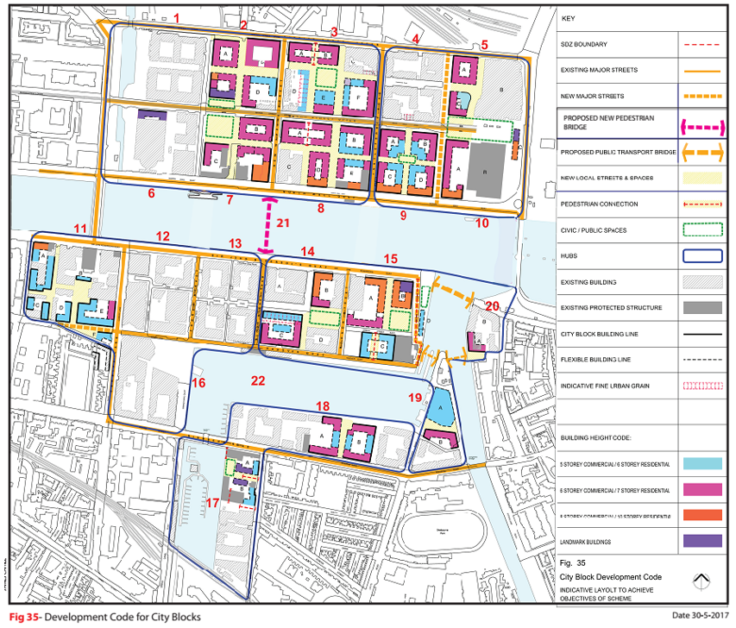
The above, when taken with the previously approved amendments to bridges under recent decision ref 29N.ZE.0006, would result in an amended figure 35 within the planning scheme, and this is shown below

Proposed amended SDZ scheme Fig. 35.

As stated earlier, current priority is, subject to a favourable decision, to progress the bridges at Blood Stoney Road and beside the Tom Clarke Bridge, with progress on the Castleforbes Street Bridge being phased for a later stage following further analysis and subject to funding.

- Rationale for amendment
As stated above, significant changes in circumstances have occurred that require the submission of this current amendment application. These changes relate to a review of the DART Underground project and the shift of development and population growth eastwards in the Docklands area. The above changes are outlined in more detail below. In tandem with the provision of a strong rationale for the amendment, the City Council wishes to alleviate the concerns of An Bord Pleanala by addressing the reasons for refusal for the previous amendment application.

Refusal reasons
In summary, and as set out in the Boards ‘reasons and considerations’, the reasons for refusing this aspect of the previous amendment application were as follows :
- Forbes Street is on a clear and direct pedestrian desire line between Grand Canal Square and Spencer Dock, with potential to connect to the future DART underground station.
- It has greater potential than the Blood Stoney Road location to alleviate pedestrian cyclist congestion on the Samuel Beckett Bridge.
- Notwithstanding the technical and cost arguments put forward, the Forbes Street location would better serve the interests and amenities of the area.
In addressing each of the above hereunder, some additional information of relevance is also included.

First Area of concern raised by the Board:
Forbes Street is on a clear and direct pedestrian desire line between Grand Canal Square and Spencer Dock, with potential to connect to the future DART underground station.

Development Agency Response
In the above regard, Appendix 7 of the Planning Scheme (2014) sets out the proposed DART Underground reservation strip and secondly the zone of influence (extract from Fig. J, page 277 and K, p 278 below). The reservation strip allows for the construction of the DART Underground station at Spencer Dock. The position of the Forbes Street Bridge traverses this reservation strip and is within the illustrated zone of influence.

Since the previous application to the Board, the NTA has confirmed that the position with regard to the Dart Underground project has changed. The alignment of DART Underground is under review which means that desire lines for access to stations may change. Furthermore, the provision of a bridge at Forbes Street would place unacceptable design and cost constraints on the routing of DART Underground. A letter from the NTA (see Appendix 2) provides clarity in relation to the above and in particular confirms the change in circumstances that require this amendment application. In further support of the rationale for changing the bridge location a review of bridge locations in the SDZ was commissioned by Dublin City Council, a summary of which is also presented below.

NTA Position
In the above regard, the NTA has provided the Council with an up-to-date position in relation to DART Underground and Forbes Street Bridge. The attached letter (see Appendix 2) from the Deputy Chief Executive of the NTA and dated 16th May 2019 refers to the reasons and considerations provided in the Boards previous decision, and gives recent context relating the DART expansion programme and the National Development Plan. It goes on to provide a series of reservations in relation to the recent rejection of the Forbes Street Bridge location.
In summary, there will be a full reappraisal of the DART Underground Project in line with a Government Decision in 2015, including a full review of station locations. The NTAs position is that a bridge at Forbes Street would represent a significant extra constraint on the design of the tunnel, and may even necessitate the removal of the pedestrian bridge if it clashes with the tunnel, which would be a waste of scarce resources. In any event, support piles would add significantly to the previous cost estimate for the tunnel, and it may be cheaper to relocate a future Forbes Street Bridge than to address in situ requirements. This would be clearly unproductive, and a waste of scarce Exchequer funds.
The letter concludes that a bridge should not proceed at Forbes Street as it carries too high a risk to the possible development of the future tunnel project.

Content of Bridge Location Review Document
Dublin City Council commissioned a review of the bridge locations within the SDZ area in 2018 prior to receipt of the NTA letter above. The appointed consultants, RPS COWI, examined the feasibility of providing a bridge at the Forbes Street location, and contains details of the impact of the DART Underground tunnel on the bridge with regard to costs and risks associated. This report, titled ‘Forbes Street/Blood Stoney Bridge Location Review’ is provided in full in Appendix 3B.
The report concluded that it is impossible to proceed with a bridge at Forbes Street without compromising the future development of DART underground to some degree or without incurring very significant technical, financial and programme risks. Issues highlighted in the report include (in summary);
- The preliminary design of the Forbes St Bridge identified significant technical and procedural challenges relating to constructing a bridge over the proposed DART Underground tunnel. The NTA subsequently requested that the design of the bridge be suspended to avoid restricting the future development of the DART Underground project.
- The 2014 North Lotts and Grand Canal SDZ planning scheme did not explicitly consider the interaction between the proposed bridge at Forbes St and the planned DART Underground tunnel.
- The most significant risk for the Forbes St bridge programme would be getting the necessary agreement from key stakeholders, and this could delay the design programme.
- Whilst a preferred alignment and pier locations had been set for the Forbes St bridge these were only viable based on the understanding that high level commitments had been reached between the Tunnel promoters and Dublin City Council. With the route now up for review it is not possible to achieve agreement from Iarnrod Eireann for the bridge design.
- There is a risk that ground movements caused by the tunnels’ future construction would cause detrimental differential settlements of the bridge foundations so these would have to be significantly over designed resulting in increased construction costs. The fact that it is an opening bridge adds further complications, with moving bridges being particularly sensitive due to their tight tolerances. Monitoring would be required during tunnel construction and beyond.
- A bridge at the Forbes St locations complicates the tunnel design, increasing design and construction costs for the DART Underground project.
The report advises against proceeding with a bridge at Forbes Street until the status of the DART Underground is known, and the Blood Stoney location provides the best alternative. This is because it can satisfy the demand for river crossings in the area, is much more cost efficient and avoids the risk of long delays.
While the Forbes St Bridge location provides a more direct route between Grand Canal Dock and Spencer Dock, the eastern docklands area has seen hugely increased activity since the implementation of much of the NLGCD SDZ scheme so desire lines have been gradually shifting eastwards. Blood Stoney Bridge also provides a more evenly spaced crossing point between the Samuel Beckett Bridge and the Tom Clarke Bridge, providing a vital connection point for the central NLGCD SDZ area.

The pedestrian study carried out by Arups in 2015 predicted pedestrian usage figures of 1600 at AM peak for the Blood Stoney Bridge by 2025 (compared to 1760 for the Forbes St bridge; a 9% difference. DCC have since worked with the NTA to carry out further traffic modelling for the area (see report in Appendix 3C), the modelled data was calibrated against actual count data at the existing dockland bridges and found that by 2035 (the NTA ‘Do-strategy’ year) while there had been an increase in all pedestrian numbers, the ‘origin-destination’ activity had significantly increased in the eastern areas of the docklands zone.

The 2035 AM peak southbound pedestrian usage figures for the Blood Stoney Bridge option were found to be 3,586 compared to 3,630 for Forbes St Bridge; only a 2% difference. This high level usage confirms the demand for a crossing point at the Blood Stoney location. The 2035 peak usage figures for bridges the NLGCD SDZ area, with the Blood Stoney Bridge in place, are shown in Figure 2 below:

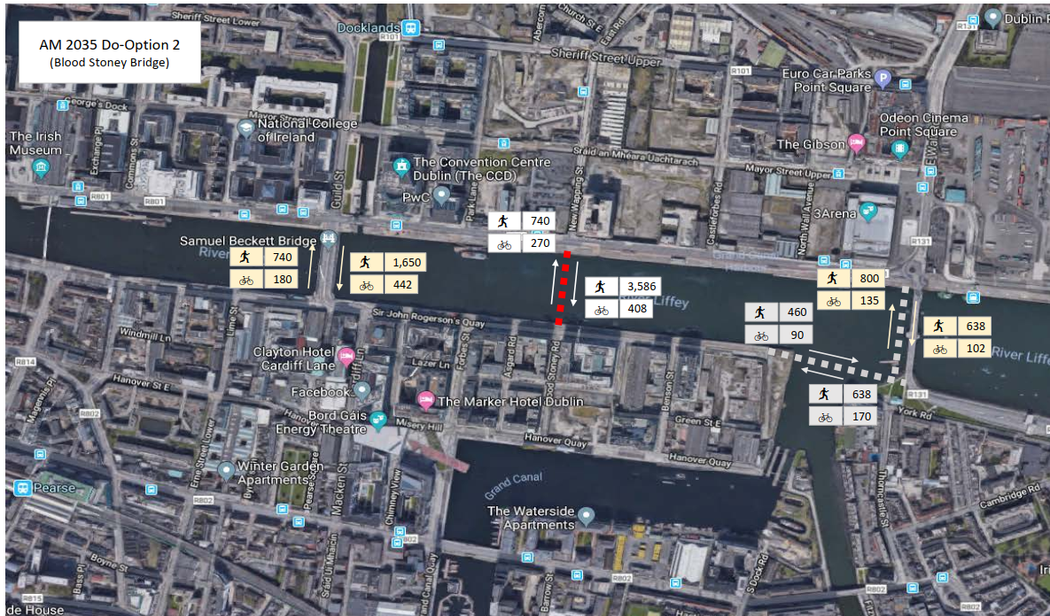
Figure 2

Notwithstanding any reappraisal of the Dart Underground station location, the Blood Stoney Bridge is well positioned for ease of access to a possible future DART Underground Station at Block 2 as set out in NLGCD SDZ. The proposed station would be 300m from the northern end of Blood Stoney Bridge, compared with 200m from the northern end of a bridge at Forbes St. This would ensure a comparable level of convenience, representing only approximately an additional 80 seconds walk.
In summary, the relevant advantages of the proposed Blood Stoney Road location are as follows:

- It removes any interaction with the DART Underground project, hence removing all future risk from both the bridge and DART schemes, allowing both schemes to be progressed independently.
- The location removes any risk of interference with the existing Diving Bell and Bord Gais above Ground Installation adjacent to the Forbes St location.
- It is away from main vehicular routes, hence allowing soft and hard traffic to be separated and optimise the bridge approaches for cyclists and pedestrians. The location also removes the requirement to relocate the MV Cill Airne restaurant and berthing facilities which are located directly on the previously proposed alignment for Forbes Street Bridge.
- It would provide a direct linear link to adjacent streets (Blood Stoney Road and New Wapping Street) whereas the Forbes Street bridge connecting roads (Forbes Street and Park Lane) are not directly aligned.
- It is well positioned (compared with Forbes Street) for ease of access to a possible future DART Underground Station at City Blocks 2 and 7 as set out in the NLGCD SDZ. The proposed station would be approx. 300m from the northern end of a Bridge at Blood Stoney Road compared with 200 m from the northern end of a bridge at Forbes Street. This would ensure a comparable level of convenience ( approx. an extra 80 seconds walk)

Second Area of concern raised by the Board
Forbes Street has greater potential than the Blood Stoney Road location to alleviate pedestrian cyclist congestion on the Samuel Beckett Bridge.
Development Agency Response
While the Forbes St Bridge would have an increased influence on the Samuel Beckett Bridge usage the construction of the Blood Stoney Bridge would still significantly reduce demand on the Samuel Beckett Bridge, eliminating the congestion problem, allowing it to operate at a very comfortable level.
The American Highway Capacity Manual (HCM) concept of Level of Service (LOS) for pedestrian traffic is widely used as a qualitative measure to describe operational conditions of footpaths and walkways, based on measurement of bi-directional pedestrian flow rates and available footpath widths:
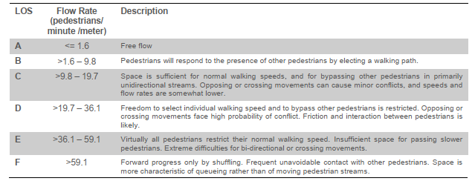
LOS C is generally considered acceptable and a minimum for design purposes.
An analysis was carried out of the existing LOS (Included in the Traffic Modelling Report in Appendix 3C) for the Samuel Beckett Bridge based on 2019 count data. Using the observed preference for 66% of users to travel on the eastern footpath, it was established that the current LOS for the eastern footpath is 24.6 or Level D. Looking forward to 2035 this worsens to 35.6 which is almost a level E.
By adding in the Blood Stoney Bridge the LOS for Samuel Beckett Bridge in 2035 has reduced to a comfortable 17.1 or Level C. It can also be assumed that the current preference by users for the eastern footpath of Samuel Beckett Bridge shows the desire for access to the eastern area of the docklands and the addition of a new crossing point to the east would shift the usage patterns for the footpaths on Samuel Beckett Bridge back towards a 50/50 split which would provide an even better LOS of 13.3 (low C).
Blood Stoney Bridge is therefore well placed to alleviate pedestrian and cyclist congestion on the Samuel Beckett Bridge, reducing it to very comfortable level.
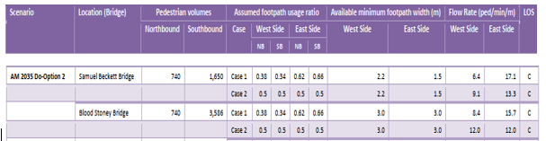

The proposed bridge location is underpinned by the eastward shift in the desire lines for pedestrian and cyclists due to the development of the North Docks area, with notable recently completed buildings including the new Central Bank of Ireland Headquarters on New Wapping Street.

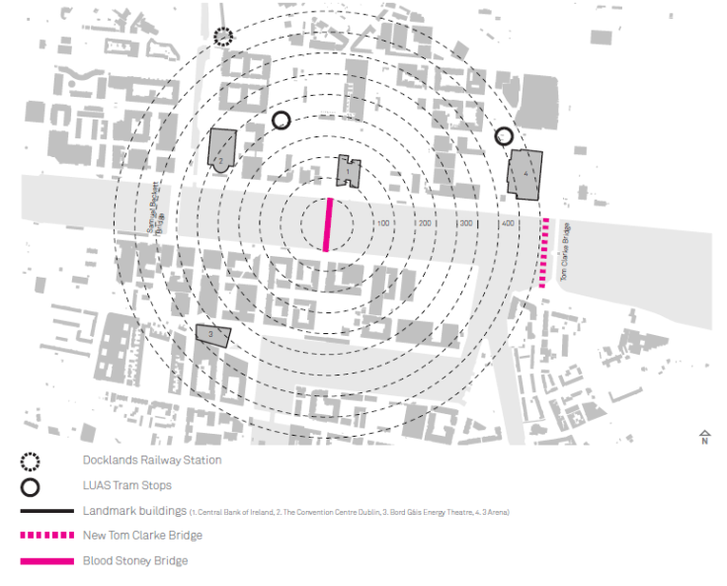

Fig 1.-Blood Stoney Bridge Location

A more detailed analysis of all the factors considered in the selection of the Blood Stoney Rd location is carried out in the Blood Stoney Bridge Location Report, provided in Appendix 3A.

By not relocating the bridge to the Blood Stoney Road location it will be at least 2029 before a decision will be made on whether a bridge could be provided at Forbes St. This delay would mean that the Samuel Beckett Bridge would be operating at an unsafe and uncomfortable level of congestion for another ten years and further expansion in the docklands area would be compromised as the additional crossing point was identified as critical in the NLGCD SDZ plan.

Dublin City Council is rolling out a number of new cycle routes for the area in the coming years as part of the corporate policy to encourage a modal shift to more sustainable modes of transport. Cycling infrastructure in the area is currently sub-standard with the Samuel Beckett Bridge cycle route a particular area for concern due to its arrangement presenting many opportunities for conflict. With NLGCD SDZ activity levels increasing year on year and no safe cycle crossing route available there is a risk that cycling levels will drop off in the area.

Third Area of concern raised by the Board;
Notwithstanding the technical and cost arguments put forward, the Forbes Street location would better serve the interests and amenities of the area.

Development Agency Response
It is considered that the circumstances stated previously are significant and a long term view must be balanced against the needs of the area at present and into the short and medium term.
Having regard to eastward shift in development and a resultant growing resident, worker and visitor population, there is a strong argument that a more eastern location for the bridge will better serve the interests and amenities of the SDZ area. In this context, the Board is reminded of the strong support among landowners and other stakeholders for the relocation of the bridge eastwards to the Blood Stoney Road location as expressed during the public consultation for the previous amendment application. The Blood Stoney Road location will provide a crucial connection between the eastern north and south docklands thereby making services and amenities, including public transport services, more readily accessible to populations both sides of the Liffey. It is considered that the location of the bridge at the Blood Stoney Road location will enable the SDZ area to continue to develop in a proper and sustainable manner.
In relation to amenities, the proposed bridge would be designed to be attractive and would not obstruct key views. It itself it would provide a new amenity similar to that which would be provided at Forbes Street and would allow for clear vistas along not only the quays but also through Blood Stoney Road and New Wapping Street.
The Blood Stoney Road location is further away from Samuel Beckett Bridge, allowing the new bridge to create its own architectural identity without detracting from the iconic existing bridge. Also, the Forbes St Bridge location would result in the existing MV Cill Airne Restaurant boat having to be relocated and would also possibly interfere with the historic Diving Bell and its new interpretive experience on the south quay. In contrast the campshires at the Blood Stoney Bridge location are currently free of any obstruction and providing more opportunity to improve the public realm for this area. See Figure 3 below.

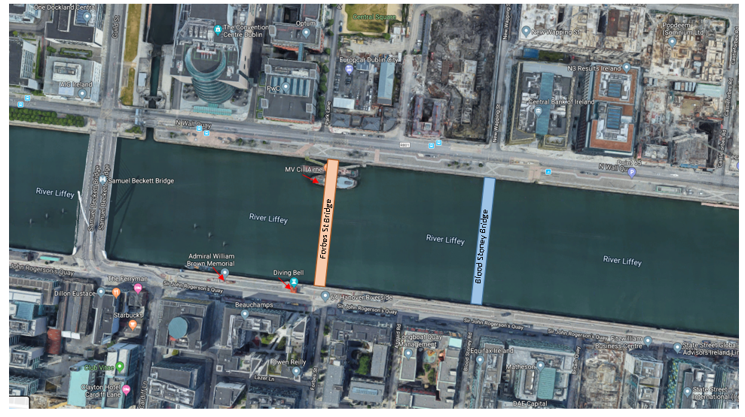
Figure 3
Cost and programme implications
Notwithstanding the rationale put forward above for the relocation of the bridge, the cost implications of providing the bridge at Forbes Street are such that they may render the construction of the bridge non feasible. The financial costs associated with construction of the bridge at Forbes Street are considered to be significantly greater than those for bridge development at Blood Stoney Road.

In this regard, DCC commissioned a technical report to investigate the feasibility of constructing a new bridge at Forbes St; in particular, to examine the impact of the future DART Underground tunnel on cost and programme and compare this to the Blood Stoney option. The full ‘Forbes Street/Blood Stoney Bridge Location Review’ is included in Appendix 3B.
The report concluded that, without clarity on the future tunnel route, it would be impossible to proceed with a bridge at the Forbes St location without compromising the future development of the DART Underground project and without incurring very significant technical and financial and programming risks.

The report carried out a risk analysis for programme, cost and technical issues and presented a number of different scenarios that would result from proceeding with the Forbes St Bridge, ranging from best to worst case.

It should be noted that this report was produced prior to the NTA setting out their position on the proposed bridge and so does not take account of the fact that the NTA have now definitively stated that any bridge at Forbes St could not proceed until after the DART Underground route has been confirmed, meaning the ‘worst case’ scenario or programme is now the most likely.

The report information was used to estimate the future cost and programmes implications for the Blood Stoney Bridge and Forbes St Bridge options, which are included in Appendix 3D and can be summarised as follows:

 | Blood Stoney Bridge | Forbes St Bridge
 |  | Best case | Probable | Worst Case
 | Future Costs | Future Costs | Future Costs | Future Costs
Estimated cost | €15,767,678.00 | €18,558,763.00 | €23,338,763.00 | €24,978,763.00
Estimate Cost to DART Underground Project |  |  | €2,000,000.00 | €25,000,000.00
Total | €15,767,678.00 | €18,558,763.00 | €25,338,763.00 | €49,978,763.00

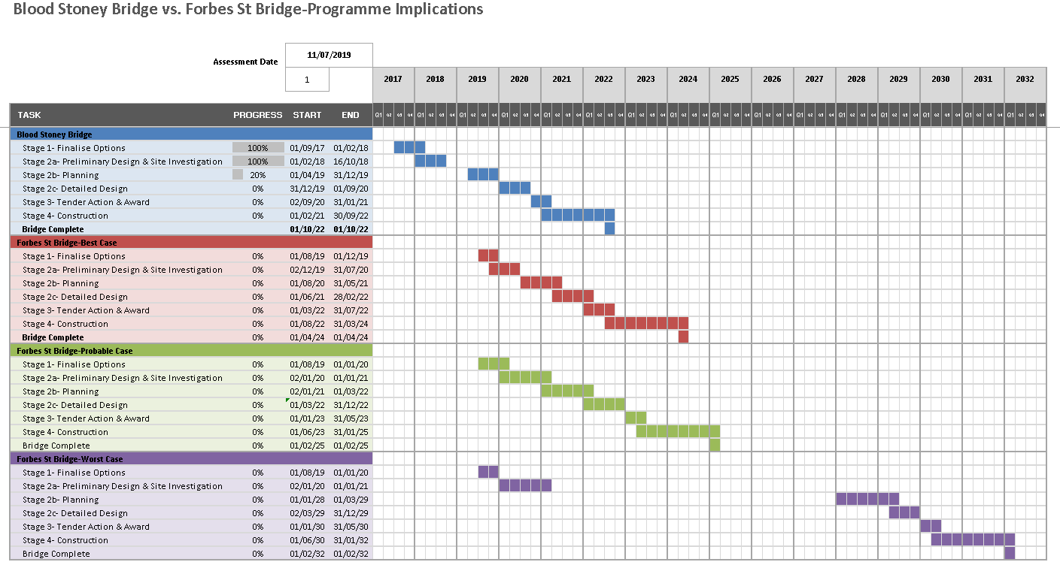

Other reasons supporting the Blood Stoney Location: Approach gradients, Visual impact and Architecture, and traffic reasons.
In addition to the above, the following are other considerations that support the relocation of the bridge:

- The existing quay levels at the Blood Stoney location are ~250mm higher than at Forbes St meaning the approach gradients to the bridge can be less to achieve the flood design requirements of the OPW
- The location is further away from Samuel Beckett Bridge, and hence can create its own architectural identity.
- Blood Stoney location provides an improved spacing of bridges between Samuel Beckett Bridge and Tom Clarke Bridge, aligning better with the existing rhythm of bridge spacing along the river.
- Submissions received in response to the public consultation for the amendment to the SDZ in the previous application to the Board were positive and generally supported the revised location. Positive responses were received from NAMA, NTMA, Eastern & Midlands Regional Assembly, Dept. of Housing Planning & Local Govt. and local businesses.
- It is away from main vehicular routes, allowing hard and soft traffic to be segregated, optimising the approach for cyclists and pedestrians, with options for further public realm improvement in this area.

- Section 170A of the Planning and Development Act 2000 as amended
Section 170A of the Planning and Development Act 2000 (as amended) sets out procedure for making an amendment to a Planning Scheme.
Subsection (1) requires the Planning Authority to make an application to the Board to request an amendment to the planning scheme.
Subsection (2) states that where an application is made, the Board shall make a decision as to whether the making of the amendment would constitute the making of a material change to the planning scheme.

To assist the Board, the proposed amendments to the Planning Scheme are considered below with reference to the criteria outlined in section 170A(3)(b), where the criterion in italics is commented on in each case (i) to (v) as follows;

- would not constitute a change in the overall objectives of the planning scheme concerned,

It is considered that the proposed amendment would not constitute a change in overall objectives of the Planning Scheme. Whilst it would result in a redistribution of pedestrians and cyclists this would not alter the main objectives for the area.

Objective MV3 of the Planning Scheme (p71) states: ‘To promote additional cycle and pedestrian bridges across the canals and rivers in the SDZ to form part of strategic cycling and walking routes’. The relocation of the bridge to Blood Stoney Road will help progress the above Objective.

- would not relate to already developed land in the planning scheme,

Whilst the amendment would alter the pattern of access for pedestrians and cyclists from that originally planned in the Planning Scheme, there would be no direct impact on land being developed or to be developed under the scheme.

- would not significantly increase or decrease the overall floor area or density of proposed development,

The proposed amendment would have no impact on overall floor area or density of proposed development in the vicinity. Such development is guided by the content of the Planning Scheme including city-block design parameters.

- would not adversely affect or diminish the amenity of the area that is the subject of the proposed amendment,

The omission of planned bridge at Forbes Street would not adversely impact on amenity as the area would remain as at present, with open views of the river being uninterrupted. In relation to the proposed new location, design work to date ensures that the bridge design will be appropriate to the context, affording views of the river and existing bridges and minimising visual intrusion. Compared with the Forbes Street location, the revised location will provide a similar level of convenience and amenity for pedestrians and cyclists.

Note that a previously required criterion (number ‘v’), which related to considerations of an infrastructural, commercial or economic nature, was deleted by Courts Act 2016

- Consultation Details
On request of the Board, during the previous application, the proposed amendment to move the bridge to the Blood Stoney location was subject to a six week public consultation from 6th February to 5th March 2018. A total of 13 submissions were received from both businesses and Government/Statutory bodies who were all in support of the proposed changed location, indicating that the Blood Stoney Bridge was a more favourable position and would optimise north-south permeability for pedestrians/cyclists in the area. The full report on submissions was submitted as part of application ZE 29N.ZE006.
The proposed amendment was also presented, and positively received, at the Dublin City Council Transportation Strategic Policy Committee (SPC) meeting, held on 30th January 2019.
In addition to elected members, members of the SPC include selected representatives of public bodies, special interest and business groups.
As mentioned previously, the NTA has been consulted and relevant correspondence is set out in Appendix 2.

- Strategic Environmental Assessment Screening
The adopted planning scheme for North Lotts and Grand Canal Dock full was subject to full process in relation to Strategic Environmental Assessment. The SEA Statement was published in Nov 2013, and is available at... http://www.dublincity.ie/sites/default/files/content//Planning/OtherDevelopmentPlans/LocalAreaPlans/Documents/SEA%20Statement%2012th%20November%202013.pdf
The adopted Planning Scheme included planned pedestrian bridges at Forbes Street and Castleforbes Road .Subsequent to this, the Dublin City Development Plan 2016-2022, which covers an area inclusive of the SDZ area, was the subject of a full and comprehensive SEA process.

The Planning Authority is satisfied that the proposed amendment to the SDZ Planning Scheme will result in development that will be sustainable and environmentally sound. The Planning Authority is also satisfied that, owing to the nature of the proposed amendment and the scope of the original SEA procedures already completed for the adopted scheme, the need for SEA does not arise in relation to the amendment proposed.

- Appropriate Assessment Screening
The adopted planning scheme for North Lotts and Grand Canal Dock was subject to full process in relation to Appropriate Assessment. A link to the full Natura Impact Statement is provided here;
http://www.dublincity.ie/main-menu-services-planning-urban-development-plans-local-area-plans/north-lotts-grand-canal-dock
The Planning Authority is of the opinion that there would not be any significant impacts on the integrity of Natura 2000 sites. Owing to the nature of the proposed amendment and the scope of the original AA procedures already completed for the adopted scheme, the need for AA does not arise in relation to the amendment proposed.

- Conclusion
As outlined above, the North Lotts and Grand Canal Dock SDZ Planning Scheme contains (inter alia) an objective to provide a pedestrian/cycle bridge at Forbes Street. An amendment is hereby sought under relevant legislation to relocate this bridge to Blood Stoney Road.

The amendment is required due to significant changes in circumstances, firstly with regard to the review of the alignment of DART Underground and secondly due to the growth of east Docklands which generates the need for a more eastern north-south connection across the Liffey.

One of the main reasons for the Board’s previous refusal for the relocation of the bridge relates to Forbes Street being considered a more appropriate location in the context of the previous DART Underground alignment. The DART Underground project including its exact alignment is now under review bringing into question whether Forbes Street remains an appropriate location. In addition, an independent review of the SDZ bridge locations commissioned by Dublin City Council confirms that the provision of a bridge at the Forbes Street location will place unacceptable practical and financial constraints on the DART Underground project. This position is confirmed by the NTA. Having regard to the above and in the interests of safeguarding the future strategic transport network, the City Council is obliged to apply to amend the bridge location.

With regard to the Board’s other reasons for refusal, the new bridge location will still effectively connect the North Lotts and Grand Canal areas and will facilitate a desire line to the proposed DART Underground station at Block 2. It will also help to relieve congestion on the Samuel Beckett Bridge and can be constructed much sooner than the Forbes Street bridge which must await the review of DART Underground, assuming the construction of the Forbes Street Bridge were practically and financially feasible.

While the relocation of the bridge is necessary for the reasons stated, it is considered that the new location will, in effect, better serve the SDZ area which is rapidly expanding eastwards. The provision of a bridge at the revised location will ensure timely delivery without compromising the overall objective for quality connections across the River Liffey within the SDZ. This relocation also removes any constraints from the DART Underground project and allows the two schemes to be progressed independently.

Having regard to the content of this report, the Planning Authority considers that this proposal is consistent with the proper planning and sustainable development of the area, and will support active travel and sustainable transport in the developing network.

John O’Hara
City Planning Officer
Dublin City Council

Appendix 1; associated amendments to the Planning Scheme

The North Lotts and Grand Canal Dock SDZ Planning Scheme contains a number of references which will need to be amended to accommodate the change. These proposed amendments, which include text and graphics, are set out in detail below.

Graphics

Figure number | Page no. of document | Amendment to be made  Please note; map key also to be changed, where relevant.
Fig 30A, | 167 | Amend illustrated bridge locations as required; Omit Forbes Street Bridge and insert Blood Stoney bridge (& previously approved bridge at Tom Clarke Bridge – approved by ABP)
Fig 31, | 168 | As above
Fig 33 | 172 | As above.
Fig 34 | 176 | As above
Fig 35 | 178 | As above

Also; amend graphics relating to individual city blocks on the following pages 181, 182, 184, 186, 187, 189, 190, 192, 194, 196, 198, 200,202, 204, 206, 208, 215, and 216.
Also amend three graphics in Appendix 6, shadow analyses, p272-274 inclusive.

Text changes; Proposed text changes to the Planning Scheme are set out below. Please note that;

Deletions are in red text and struck through
Additions are in green text

Page 66. Section 4.4.4.1, start 2nd para, and “The two proposed pedestrian/cyclist bridges across the Liffey are crucial to improving”…. etc.

Page 127. Section 4.10 4.1.4; Omit final sentence in 2nd para, i.e. “ A bridge link is also proposed …Spencer Dock Square”.

P 127, third column, 3 lines down, delete text , the creation of a new pedestrian bridge connection linking Spencer Dock with Grand Canal Square...

Page 191. Last sentence in second bullet point to be amended “Also provides links to new pedestrian bridge across to Forbes Street Blood Stoney Road”

Page 193. New bullet point to be added to be added to end of section 3 (public realm) as follows;
New pedestrian/cycle bridge across the River Liffey connecting New Wapping Street to Blood Stoney Road.

…………………….

