Blood Stoney Bridge vs. Forbes St Bridge
- Current Status
Blood Stoney Bridge
Preliminary design and site investigation works (Stage 2a) are complete and the planning stage (Stage 2b) has commenced.
Forbes St Bridge
Preferred option has been selected by Dublin City Council but would need to get agreement from 3rd parties (NTA & TII) that this is the optimum solution prior to commencing preliminary design.

- Future Cost Implications

Stage |  | Blood Stoney Bridge | Forbes St Bridge
 |  |  | Best case | Probable | Worst Case
 |  | Future Costs | Future Costs | Future Costs | Future Costs
1 | Finalise Options | Complete | €50,000.00 | €50,000.00 | €50,000.00
2a | Preliminary Design & Site Investigation | Complete | €491,085.00 | €491,085.00 | €561,085.00
2b | Planning Stage | €131,066.00 | €131,066.00 | €131,066.00 | €131,066.00
2c | Detailed Design | €168,933.00 | €168,933.00 | €198,933.00 | €268,933.00
3 | Tender Action & Award | €27,094.00 | €27,094.00 | €27,094.00 | €27,094.00
4 | Construction Stage | €15,403,310.00 | €17,653,310 | €22,403,310 | €23,903,310.00
5 | Handover of Works | €37,275.00 | €37,275.00 | €37,275.00 | €37,275.00
Estimate cost |  | €15,767,678.00 | €18,558,763.00 | €23,338,763.00 | €24,978,763.00
Estimate Cost to DART Underground Project |  |  |  | €2,000,000.00 | €25,000,000.00
 |  | €15,767,678.00 | €18,558,763.00 | €25,338,763.00 | €49,978,763.00
Table 1- Estimate Future Cost

- Future Programme Implications

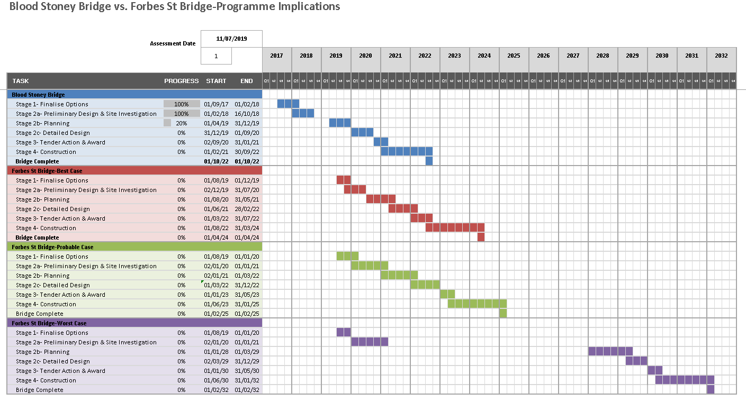
- Assumptions for future risks/costs of Forbes St Bridge Option
Costs for Forbes St bridge are based on the tendered design fees and estimated construction costs for the Blood Stoney Bridge plus the following additional costs/risks for each scenario, based on the risk analysis set out in Table 2.1 of ‘Forbes St/Blood Stoney Rd Bridge Location Review’:
Best Case Outcome | Probable Outcome | Worst Case Outcome
- Additional consultant fees of €50,000 to finalise option design  - Re-do preliminary design & Site Investigation Works for new location  - Site Investigation works cost increase by €50,000 due to inflation  - Additional consultant fees of €30,000 for getting design agreement from 3rd parties, w.r.t. future proofing for DART Underground, at preliminary stage  - Additional foundation costs of €750,000 to future proof design for DART Underground  - Additional construction costs of €1.5m for curved bridge and additional length compared to Blood Stoney Bridge  - Programme follows that set out for BSB with no delays | - Additional consultant fees of €50,000 to finalise option design  - Re-do preliminary design & Site Investigation Works for new location  - Site Investigation works cost increase by €50,000 due to inflation  - Additional consultant fees of €60,000 to get agreeable design with 3rd parties (TII, NTA) w.r.t. future proofing for DART Underground. Additional design costs (€60,000) split between preliminary & detailed design.  - €1 million additional foundation & future monitoring costs (included in construction costs)  - Additional construction costs of €2m for curved bridge and additional length compared to Blood Stoney Bridge  - The process to achieve design approval/agreement from NTA/TII and APB takes additional 5 years resulting in delay in project delivery and €4 million additional construction/consultancy costs due to inflation | - Additional consultant fees of €50,000 to finalise option design  - Re-do preliminary design & Site Investigation Works for new location  - Site Investigation works cost increase by €50,000 due to inflation  - Additional consultant fees of €200,000 to get agreeable design with 3rd parties (TII, NTA) w.r.t. future proofing for DART Underground. Additional design costs (€200,000) split between preliminary & detailed design.  - €1.5 million additional foundation & future monitoring costs (included in construction costs)  - Additional construction costs of €2m for curved bridge and additional length compared to Blood Stoney Bridge  - No approval/agreement from NTA/TII until DART Underground plan is finalised delays project ~10 years resulting in €5 million additional costs due to inflation  - Suppression of development of Docklands Area due to lack of bridge. Over-crowding of Samuel Beckett Bridge results in the off road cycle lane being removed.
Table 2- Risk to bridge project

- Assumptions for risks/costs to DART Underground Project
Best Case Outcome | Probable Outcome | Worst Case Outcome
- No Impact on DART Underground | - Increase in monitoring, design & construction costs by ~€2 million due to increased complexity resulting from proximity to bridge foundations | - Significant cost increases of ~€5million for additional monitoring, design & construction costs due to proximity to bridge foundations  - Bridge damaged during future DART Underground works resulting in €20 million damage to bridge
Table 3- Risk to DART Underground project

Note:
- Design costs are as per consultant’s tender submission with estimated additional fees as set out in Table 2 above. Preliminary Design fee = €161,085.00, Detailed Design Fee = €168,933.00.
- Some preliminary design work was carried out for the Forbes St Bridge location in 2015/2016 but due to changes in team members and inflation costs it is assumed that the full preliminary design fee would be charged by the consultant if design restarted at this location.
- Site Investigation costs for Forbes St Bridge are estimated at €300,000. The investigation works for Blood Stoney Bridge cost €250,000 but construction costs are increasing and extra boreholes may be required due to the profile of the Forbes St Bridge
- Planning Stage programme excludes ABP decision/review period. The detailed design will begin during the review period.
- Additional fees for statutory approvals, DCC salaries and other reports have been omitted.
- Design fees/ Site Investigation fees paid to date have been excluded.
- Estimated construction cost of Blood Stoney bridge is €15,080,000.0,0 as estimated by Turner & Townsend in detailed project appraisal report, and includes 15% for contingencies.
- Construction stage costs also include consultant’s fees for supervision (€323,310.00).
- All costs are exclusive of VAT.

- Summary
By reverting to the Forbes St bridge location the provision of new bridge is delayed by minimum 16 months with an estimate minimum additional cost of €2,791,085.00 excl. VAT. In a worst case scenario, the provision of a new bridge is delayed by 10 years with possible future additional costs of €34,302,085.00.
Also, as the Blood Stoney Bridge location is more centrally located between the Samuel Beckett Bridge and the Tom Clarke bridge, the need for a third bridge at Castleforbes St has been negated.

