Conservation Section, Planning & Development Department
Civic Offices, Wood Quay, Dublin 8
An Rannóg Caomhantais, An Roinn Pleanála agus Forbairt Maoine
Oifigí na Cathrach, An Ché Adhmaid, Baile Átha Cliath 8
T. 01 222 3927 F. 01 222 2830

8th of June 2021

To the Chairperson and Members of the North Central Area Committee

Initiation of the Statutory Process for the Proposed Addition of the Northern Gateway, Casino, Marino, Dublin 3, as an Amendment to the Record of Protected Structures in accordance with Section 54 and 55 of the Planning and Development Act, 2000 (as amended).

The initiation of the statutory addition/amendment process was noted by the North Central Area Committee of Dublin City Council at its monthly meeting held on 21st of June 2021

PHOTOGRAPH OF STRUCTURE

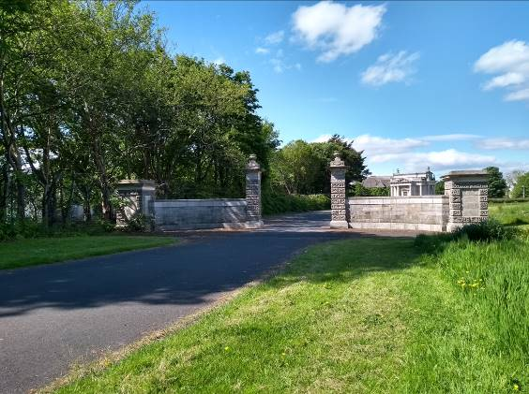

Introduction
It is proposed to initiate procedures under Section 54 and Section 55 of the Planning & Development Act 2000 (as amended) to add ‘the Northern Gateway, Casino, Marino, Dublin 3’ to Dublin City Council’s Record of Protected Structures.

Request for Addition
- Dublin City Council Conservation Section.

Summary of Reasons for Seeking Addition
- The addition of the Northern Gateway was a recommendation of the Marino Casino Architectural Conservation Area (ACA) (2009, 14 & 16).

Methodology for Assessing Early Buildings
In November 2019, the Planning & Property Development SPC agreed a methodology to expedite the proposed additions/deletions to the RPS in a systematic manner, based on the Architectural Heritage Protection Guidelines 2011 and NIAH/Ministerial Recommendations under Section 53(1) of the Planning and Development Act, 2000 (as amended). The methodology agreed to prioritise industrial, twentieth century, early buildings and underrepresented typologies. On foot of this the Conservation Section carried out a screening process and identified the gateway as an early structure.

Site Location & Zoning Map
There is a mix of zonings in the area in question:
- Green hatching: Marino Architectural Conservation Area
- Red hatching: Conservation Area
- Green: Zoning Objective - Z9: To preserve, provide and improve recreational amenity and open space and green networks.
- The Casino Marino is a protected structure (RPS Ref 4858) and a National Monument (Nat Mon No. 332) in state care. Its location on the zoning map is marked by a red asterix and castle symbol.

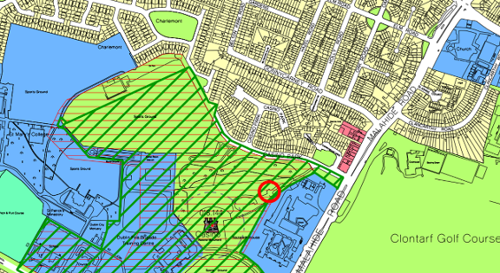
Fig.1: Site location and zoning map for the Northern Gateway. The location of the Northern Gateway is circled in red.

Recent Planning History
No recent planning history.

Recent Planning Enforcement History
No recent planning history.

Site Access
A site inspection was carried out by the Dublin City Council’s Conservation Section on the 3rd of June 2021. The land is in public ownership and is open to the public so there were no limitations to access.

Summary Description
The gateway is located in a parkland setting associated with the Casino, Marino. The gateway is no longer in its original position. It is now located a short distance to the northeast of the Casino, Marino on the entrance avenue to the carpark. The Marino, Casino, Architectural Conservation Area describes the Northern Gateway as a simple neo-classical structure which probably marked the northern entrance to the demesne. It is likely to be the work of Chambers as the Doric friezes with bucrania matches exactly the detail to be found in the frieze of the Casino. This now stands within the current Casino site, where it marks the entrance to the car park. It consists of a pair of tall elegant piers topped with urns on a swag-enriched plinth, which sit on ornamental cappings with Doric enrichments and bucrania identical to those of the outer piers of the Griffin Gateway (now located at entrance to Marino Institute of Education, just off Griffith Avenue). From these, long ashlar-faced walls curve outwards, forming a carriage-turn, and terminating in squat, wide-based piers. While both of these gates are no longer in their original positions their survival is nonetheless extremely important to an understanding of the site as they attest to the grandeur and scale of the former demesne (Dublin City Council, 2009, 16).

Historical Background
The Northern Gateway was located in the Marino Demesne. It formed the northern most entrance to what is now the Malahide Road at the present entrance to Casino Park. It is shown at this location on the 1st edition OS Map (see Figure 2) and also the later 1935 OS Map, along with the original gate-lodge (now demolished). The gateway was removed and relocated to its present position in the later 20th century.

The former Marino House (demolished to make way for the 1920’s Marino housing development) and the main neo-classical entrance (the Griffin gateway now located at the entrance to Marino Institute of Education on Griffith Avenue) lay to the south close to the sea. The more interesting part of his designed landscape containing: the Casino; an artificial lake; an extensive walled garden and various other ornamental garden structures, was situated to the north-east of the demesne, where the views were at their most impressive (ibid., 6).This part of the estate could be accessed through the Northern Gates which were located on the Malahide Road.

The demesne was one of the most important designed landscapes ever to have been created in Ireland.... on what was then a coastal site a short distance to the north of the city of Dublin (ibid., 6). James Caulfield, the First Earl of Charlemont (1728-1799), was responsible for the demesne. He was a learned, well-travelled and patriotic man, who made a major contribution to the cultural and intellectual life of Dublin, through his architectural patronage and his role as founder of the Royal Irish Academy (ibid., 6).

The Casino, now located a short distance to the SW of the Northern Gateway, is the most impressive example of Charlemont’s architectural patronage. The Casino was conceived as the central jewel of what was an impressive designed landscape in the natural style – was built over a period of some sixteen years, in the form of a neo-classical garden temple, to the designs of Sir William Chambers, a preeminent architect of the day. The Casino is considered by many to be amongst Chambers’ best work and is today acknowledged as being a building of international architectural importance and national cultural significance (ibid., 9). Its significance is further highlighted by the Casino’s status as both a protected structure and a National Monument.

While Marino House and most of its former demesne have long since vanished, the Casino has survived by virtue of its architectural qualities. It stands as one of the few reminders of the former beauty of the demesne and the highly significant contribution it has made to Irish and European culture. The other architectural fragments of significance that survive from the former demesne are the walled garden and two neo-classical gateways (ibid., 12). The Griffin Gateway (RPS 8716) on Griffith Avenue and the Northern Gateway at the Casino, Marino.

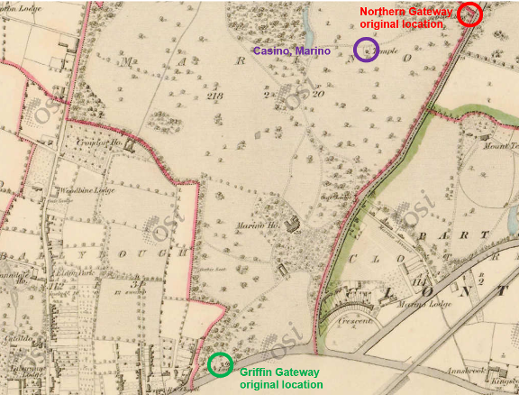
Fig.2: First Edition OS Map showing Marino Demesne still intact with the Casino Marino circled in purple; the main south-western entrance – the Griffin gateway in green (now located at entrance to Marino Institute of Education on Griffith Avenue) and the Northern Gateway in red (now located a short distance to the northeast of the Casino).

References
Dublin City Council (2009) Marino, Casino, Architectural Conservation Area. Adopted by Dublin City Council 11/05/09.

NIAH Significance/Rating
The National Inventory of Architectural Heritage (NIAH) has been completed for this area however Ministerial Recommendations have not yet been issued. The Casino Marino was recorded by the NIAH and the Northern Gateway was included in that entry (Reg No. 50130270, see Appendix 2).

The NIAH uses eight categories of special interest (architectural, historical, archaeological, artistic, cultural, scientific, technical & social) and identifies five categories of rating in seeking to rank buildings. The NIAH rating values are International, National, Regional, Local and Record Only (I, N, R, L, O). Structures which are considered of International, National, and Regional significance are deemed worthy of inclusion on the RPS.

The NIAH record provided in Appendix 2 of this report has assigned the Casino, Marino has been assigned an International rating by the NIAH. These are structures or sites of sufficient architectural heritage importance to be considered in an international context. These are exceptional structures that can be compared to and contrasted with the finest architectural heritage in other countries.

Assessed on its own, the Northern Gateway is considered to be of National significance. These are structures or sites that make a significant contribution to the architectural heritage of Ireland. This rating corresponds to the National rating assigned to the Griffin Gateway on Griffith Avenue by the NIAH (Reg. No. 50130262).

Assessment of Special Interest under the Planning & Development Act 2000
The Northern Gateway is considered by the Conservation Section of Dublin City Council to be of special interest under the following headings:
- Architectural: The gateway is likely to be the work of Chambers as the Doric friezes with Bucrania matches the friezes found on the Casino. The gateway is also similar to the Griffin gateway which originally marked the main entrance to the former Marino Demesne. It is an exemplar of good quality architectural design and considered to be the work of a known and distinguished architect, Sir William Chambers.
- Historic interest: While the gate is no longer in its original position, its survival, like that of the Griffin gateway, is important to an understanding of the site as they both attest to the grandeur and scale of the former Marino demesne that was established by James Caulfield, 1st Earl of Charlemont and designed by William Chambers. The Architectural Conservation Area (ACA) Report ‘Marino Casino’ states that: the Marino Demesne was one of the most important designed landscapes ever to have been created in Ireland. It was laid out by James Caulfield, First Earl of Charlemont (1728-1799), during the second half of the eighteenth-century on what was then a coastal site a short distance to the north of the city of Dublin. Charlemont was a learned, well-travelled and patriotic man, who made a major contribution to the cultural and intellectual life of Dublin.

Conclusion
Dublin City Council Conservation Section has carried out an assessment of the Northern Gateway at the Casino, Marino. The section has considered the reasons for seeking addition and concludes that the structure merits inclusion on the Record of Protected Structures

It is an important surviving element of the former Marino demesne landscape, therefore it is proposed to add the Northern Gateway to the Record of Protected Structures.

The Casino, Marino is already listed in the Record of Protected Structures, therefore it is proposed to protect the Northern Gateway by way of clarification to the existing entry for the Casino.

The extent of the proposed Protected Structure status and curtilage is outlined in Fig.3 of this document (below).

It is now proposed to initiate the statutory process for the proposed addition of this structure to the Record of Protected Structures. This includes undertaking a statutory public consultation process in accordance with Section 55 of the Act. Following the statutory consultation process, a further report will be prepared taking any submissions and observations received into consideration, with a recommendation to the City Council to proceed or not with the proposed addition, or with a recommendation including amendments to the proposed addition.

Recommendation
It is recommended that the statutory process to initiate for the proposed addition of the Northern Gateway, as an amendment to the Record of Protected Structures, in accordance with Section 54 and 55 of the Planning and Development Act, 2000 (as amended), be noted.

It is recommended that the current entry on the RPS, Ref 4858, Malahide Road, Dublin 3 - The Casino, Marino be amended to now read Malahide Road, Dublin 3 - The Casino, Marino, including Northern Gateway on Dublin City Council’s Record of Protected Structures, under Section 55 of the Planning & Development Act 2000.

The initiation of the statutory addition/amendment process was noted by the North Central Area Committee of Dublin City Council at its monthly meeting held on 21st of June 2021

The current entry reads
RPS | Address | Description
4858 | Malahide Road, Dublin 3 | The Casino, Marino

The current entry should be amended to read as follows:
RPS | Address | Description
4858 | Malahide Road, Dublin 3 | The Casino, Marino including Northern Gateway

 09/06/2021
_______________ _________________
Deirdre Scully Date
Deputy City Planner
Extent of Protected Structure Status

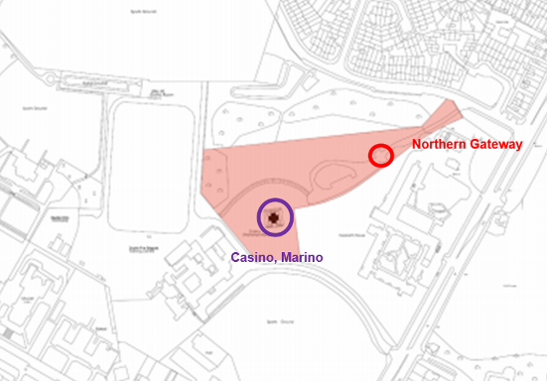
Fig.3: The current extent of the Marino Casino site highlighted in pink. This corresponds to the curtilage of the present site. The location of the existing Protected Structure (Marino Casino) is shown in purple and the (Northern Gateway) is shown in red.

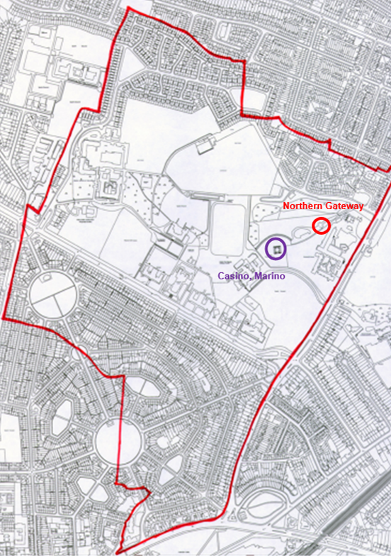
Fig.4: The original extent of the Marino Casino Demesne overlain on the 2006 OS map. The location of the Casino is circled in purple and the Northern Gateway is circled in red to the northeast of the Casino.
Appendix 1: Short Photographic Record
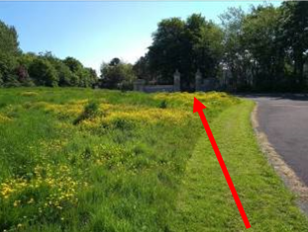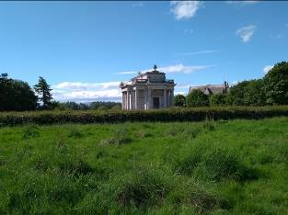
Views of limestone and granite Northern Gateway (left) located a short distance to the northeast of the Casino, Marino (right)

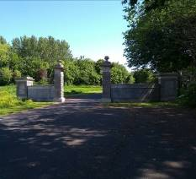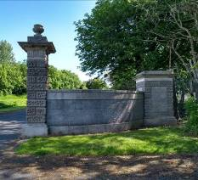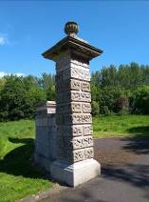
View of southwest side of Neoclassical Northern Gateway, with curving ashlar wall with tall elegant gate-pier and curving ashlar wall terminated by a squat, wide pier. Gate piers display vermiculated rustication.

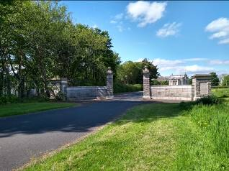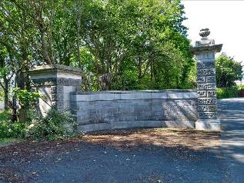
Views of northeast side of entrance gateway.
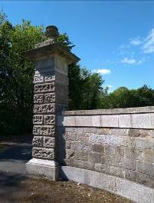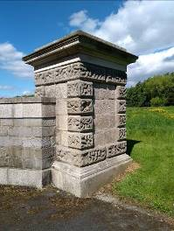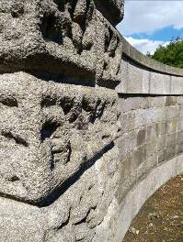
Detail of tall elegant gate piers to left topped with urns on a swag-enriched plinth, which sit on ornamental cappings with Doric enrichments and bucrania identical to those of the outer piers of the Griffin Gateway. The different materials used - limestone and granite clearly visible.

Appendix 2: NIAH Record for the Casino, Malahide Road, Dublin 3. Northern Gateway is mentioned in description (see text in bold below).
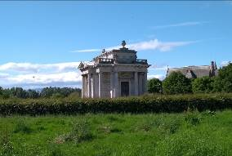
  Reg. No. | 50130270
  Date | 1755 - 1780
  Previous Name
  Townland
  County | Dublin City
  Coordinates
  Categories of Special Interest | Architectural, Artistic, Historical, Social, Technical
  Rating | International
  Original Use | Garden temple
  In Use As | Museum/gallery
Description: Freestanding neo-Classical three-bay two-storey Greek cross-plan pleasure house over basement, built 1758-76. Shallow pitched copper-sheeted roof with parapet walls and balustrades having two chimneystacks disguised as Grecian urns, and concealed gutters with drip-chain downpipes hidden inside four hollow columns. Rusticated Portland Stone walls with ornamented stringcourse and corner pilasters surrounded by projecting Doric portico of columns and entablature having frieze of triglyphs and bucrania with projecting bracketed cornice; swag frieze to north and south, with statuary to north and pediments to east and west. Square-headed window openings with raised classical surrounds, having brackets and pulvinated friezes, containing multiple-pane timber sliding sash windows; secondary square-headed window openings with rusticated surrounds and keystones, containing six-over-six pane timber sliding sash windows. Square-headed doorway with raised classical surround having ornamented pediment and frieze, containing fielded timber door with inset double-leaf section opening onto limestone terrace with steps vaulting over basement to north and south, having reclining lions to corners and balustrades to basements. Grass margins to front of building in remains of landscape park, with gate screen surviving to north having piers of vermiculated rustication. Interior has sixteen rooms, including reception rooms, bedrooms, kitchen and servants' quarters.
Appraisal: A well-proportioned neo-Classical pleasure house, designed for James Caulfield, 1st Earl of Charlemont, by William Chambers in 1759. It is considered one of the most accomplished examples of neoclassicism in Ireland and a fine example of Chambers designing on a small scale. It was inspired by the sights of Charlemont's Grand Tour between the ages of eighteen and twenty-seven, on which travels he developed a great interest in classical architecture. The lands and demesne house at Marino were presented to Charlemont by his stepfather, Thomas Adderley, and Charlemont proceeded to re-landscape the demesne with Mathew Peters in an Italianate style. He contracted William Chambers to design him a garden villa or casino as part of this landscape, with parties and entertainment in mind. The building was completed in the 1770s and is now the only surviving building of the grand Marino Estate. The building retains a wealth of ornamental detail and its classical features create a strong air of stately elegance and order. It also has various interesting technical features that help utilize the compact space of the design, notably the chimneys disguised as urns on the parapet. Simon Vierpyl supervised the works. The National Monuments Act of 1930 was 'specially worded to allow for the essential preservation of the Casino' and the State carried out repairs from about 1933 onwards, while the building remained in the ownership of the Christian Brothers, with large-scale restoration from 1974, when the State acquired the building. Unfortunately, all paintings, sculpture, fireplaces and furnishings were sold or lost without trace in the nineteenth century, making restoration of the interior a very difficult task. Nevertheless, the Casino has been stated to display 'such a wealth if subtlety, craftsmanship and innovation, in an architectural idiom so perfectly in tune with contemporary taste, that it ranks among only a handful of buildings of international significance in Ireland' and its design is 'extraordinarily well-proportioned, balanced and inventive, and is often compared to two other gems of pavilions in Europe - the third Earl of Burlington's villa at Chiswick and Marie Antoinette's Petit Trianon...at Versailles...However, the Casino is much smaller, and for that reason arguably a greater architectural achievement'. To achieve his masterpiece, Charlemont spent more than £20,000 and never recovered financially.

