Conservation Section, Planning & Development Department
Civic Offices, Wood Quay, Dublin 8
An Rannóg Caomhantais, An Roinn Pleanála agus Forbairt Maoine
Oifigí na Cathrach, An Ché Adhmaid, Baile Átha Cliath 8
T. 01 222 3927 F. 01 222 2830

8th of June 2021

To the Chairperson and Members of the North Central Area Committee

Initiation of the Statutory Process for the Proposed Addition of two surviving sections of former demesne wall, St. Vincent’s GAA Club, Malahide Road, Marino, Dublin 3, to the Record of Protected Structures in accordance with Section 54 and 55 of the Planning and Development Act, 2000 (as amended).

The initiation of the statutory addition process was noted by the North Central Area Committee of Dublin City Council at its monthly meeting held on 21st of June 2021.

PHOTOGRAPH OF STRUCTURE

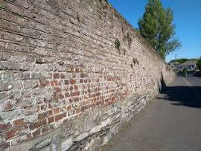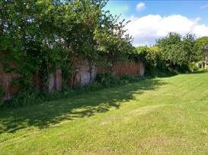

Introduction
It is proposed to initiate procedures under Section 54 and Section 55 of the Planning & Development Act 2000 (as amended) to add ‘two surviving sections of former demesne wall, St. Vincent’s GAA Club, Malahide Road, Marino, Dublin 3’ to Dublin City Council’s Record of Protected Structures.

Request for Addition
- Dublin City Council Conservation Section.

Summary of Reasons for Seeking Addition
- The addition of the former historic demesne wall was a recommendation of the 2009 Marino Casino Architectural Conservation Area (ACA): It is an objective of the ACA to protect and conserve any surviving fragments of the former walled garden (2009, 20).

Methodology for Assessing Early Buildings
In November 2019, the Planning & Property Development SPC agreed a methodology to expedite the proposed additions/deletions to the RPS in a systematic manner, based on the Architectural Heritage Protection Guidelines 2011 and NIAH/Ministerial Recommendations under Section 53(1) of the Planning and Development Act, 2000 (as amended). The methodology agreed to prioritise industrial, twentieth century, early buildings and underrepresented typologies. On foot of this the Conservation Section carried out a screening process and identified the walls at St. Vincent’s GAA Club as early structures.

Site Location & Zoning Map
There is a mix of zonings in the area in question:
Green hatching: Marino Casino Architectural Conservation Area
Red hatching: Conservation Area
Yellow: Zoning Objective - Z1: To protect, provide and improve residential amenities.
Green: Zoning Objective - Z9: To preserve, provide and improve recreational amenity and open space and green networks.
Blue: Zoning Objective - Z15: To provide for institutional, educational, recreational, community, green infrastructure, and health uses.
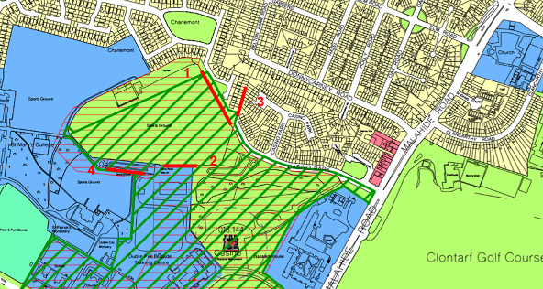
Fig.1: Site location and zoning map for historic boundary walls. The four sections of surviving historic boundary wall are highlighted in solid red line on the zoning map above.

Recent Planning History
Planning Ref | Description | Decision
4652/18 | Dublin City Council St. Vincent's GAA Club intend to apply for planning permission for external works to existing club-house. External works to include new balcony at first floor level along with new double doors from lounge / bar area onto new balcony, along with all associated site works. All at St. Vincent's GAA Club, Malahide Road, Dublin 3. | Grant permission  20-Feb-2019
4573/19 | RETENTION: planning permission for works to existing facilities. Works to include; retention of 2m high fencing around perimeter of juvenile pitch adjacent to club house & re-laying of this sand-based pitch with an all-weather pitch on the same alignment, along with all associated site works. | Application withdrawn  22-Oct-2020
2662/20 | RETENTION of an existing 18.5 metre high telecommunications support structure carrying telecommunications equipment and floodlights, together with existing equipment container and associated equipment within a fenced compound as previously granted under local authority reference 3067/09. The development will continue to form part of meteor Mobile Communications Ltd existing and future telecommunications and broadband network. | Grant retention permission  14-Jul-2020
3234/20 | The development will consist of replacing the existing 18.5 metre floodlight with a new 18.5 metre high telecommunications support structure carrying telecommunications equipment and floodlights, and ground level equipment cabinet and fencing. | Grant permission  16-Oct-2020
2630/21 | Proposed single-storey detached prefabricated building located to the west of the clubhouse to be used for after school age childcare facility with perimeter fencing, service connections, and associated site development works. | A decision has not yet been made on this application

Recent Planning Enforcement History
Ref | Date Opened | Reason | Date Closed | Reason
E1105/18 | 05-Dec-2018 | Unauthorised works | This case remains open

Site Access
A site inspection was carried out by the Dublin City Council Conservation Section on the 3rd of June 2021. Access was provided to the walls in the grounds of St. Vincent’s GAA Club. Access to the section of wall in the grounds of the Marino Institute of Education was not obtained.

Summary Description
The Marino, Casino, Architectural Conservation Area describes the former historic demesne wall as follows: The walled garden was the first project undertaken by Lord Charlemont at Marino. It is located at the north-eastern corner of the demesne within thirty acres of land to which Lord Charlemont had held secure title. Enclosed within walls rising to twelve feet in height, the shape of the garden is described as an irregular pentagon. The boundary walls were constructed of rubble limestone, with brick facings to those walls that enjoyed a sunnier aspect. Today, the St. Vincent’s GAA club occupies most of the area within the former walled garden, with the exception of the eastern corner on which housing has been constructed. Referring to the three sections of wall on and immediately adjacent to the GAA lands (Walls 1, 2 & 3) the ACA document states: Only two short sections and one long section of wall survive in a good state of preservation but a poor state of repair. The long section runs north to south at the eastern side of the walled garden and the smaller sections of wall occur along the southern boundary and consist of rubble limestone on the exterior, and brick-coated with recent cement render on the inside faces (Dublin City Council, 2009, 16).

The 2009 document describes four intact sections of walls (see Fig 1: zoning map above and Fig. 2 below for locations of walls). These four sections of wall were assessed.

- Wall 1: The site inspection confirmed that the most intact section of wall was a long section of wall located to the north-eastern side of the GAA grounds. This first section of wall running northwest-southeast is the most visible and despite some inappropriate repairs survives largely intact. This wall has been subject to a number of patch repairs with concrete blocks and has been repointed with a modern cement based mortar in places. The wall is calp limestone with brick facing having a calp limestone base. The historic bricks are quite weathered but are relatively intact apart from a small number of areas of damage. The original lime mortar joint is visible in a number of locations with a penny struck finish.
- Wall 2: A further second section survives to the south and forms the boundary between the GAA grounds and lands belonging to Dublin City Council. This is the next longest and most intact section to survive. It is obscured in places by vegetation but survives relatively intact. The face of the wall visible from the GAA pitch is weathered brick. The original lime mortar joint is visible in places.
- Wall 3: A further third section is located to the north of this adjacent to the entrance gate to the GAA grounds and forms part of the boundary to 109 Casino Park. From a study of google earth it appears to continue further north and forms the rear garden boundary between Casino Park (6 houses) and Charlemont (8 houses). This wall appears to be brick on its western side and calp limestone on its eastern side. It is difficult to assess the condition and nature of this wall as it is located within the back gardens of private houses. From a study of aerial maps, a number of modern sheds are constructed against this historic boundary.
- Wall 4: The last and fourth section of historic demesne wall is located to the south between the graveyard of the Marino Institute of Education and lands belonging to that organisation. Only the north side is visible and is pebble-dashed with a hard cement mortar. From a study of aerial images, the south side of the wall appears to be largely un-rendered and appears to be historic in nature, however this section of wall was not accessible and therefore not inspected.

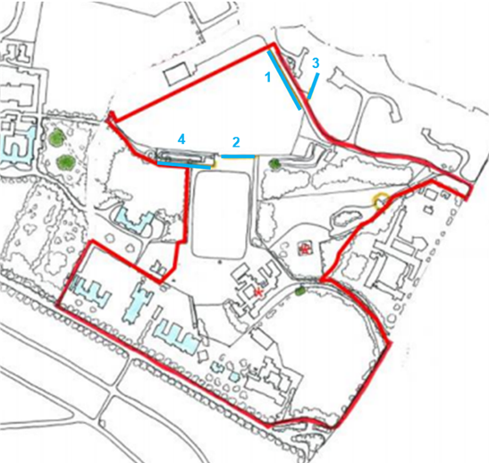
Fig.2: Map showing boundary of the Casino, Marino ACA in red. The location of the surviving four sections of former demesne wall are shown in blue.

Historical Background
The walled garden was located in the north-eastern corner of the Marino Demesne. The demesne was one of the most important designed landscapes ever to have been created in Ireland.... on what was then a coastal site a short distance to the north of the city of Dublin (Dublin City Council, 2009, 6). James Caulfield, the First Earl of Charlemont (1728-1799), was responsible for the demesne. He was a learned, well-travelled and patriotic man, who made a major contribution to the cultural and intellectual life of Dublin, through his architectural patronage and his role as founder of the Royal Irish Academy (ibid., 6). According to a 2003 OPW report, the walled garden largely survived until 1990, when large sections were demolished to make way for the GAA pitches.

The former Marino House (now demolished to make way for the 1920’s Marino housing development) and the main neo-classical entrance gates (the Griffin gateway now located at the entrance to Marino Institute of Education on Griffith Avenue) lay to the south close to the sea. The more interesting part of his designed landscape containing: the Casino; an artificial lake; an extensive walled garden and various other ornamental garden structures, was situated to the north-east of the demesne, where the views were at their most impressive (ibid., 6).

The Casino located a short distance to the SW of the northern gateway is the most impressive example of Charlemont’s architectural patronage. The Casino was conceived as the central jewel of what was an impressive designed landscape in the natural style – it was built over a period of some sixteen years, in the form of a neo-classical garden temple, to the designs of Sir William Chambers, a pre-eminent Architect of the day. The Casino is considered by many to be amongst Chambers’ best work and is today acknowledged as being a building of international architectural importance and national cultural significance (ibid., 9). Its significance is further highlighted by the Casino’s status as both a protected structure and a National Monument.

While Marino House and most of its former demesne have long since vanished, the Casino has survived by virtue of its architectural qualities. It stands as one of the few reminders of the former beauty of the demesne and the highly significant contribution it has made to Irish and European culture. The other architectural fragments of significance that survive from the former demesne are the walled garden and two neo-classical gateways (Griffin Gateway protected 13/5/2013 and the Northern Gateway which is also proposed for addition) (ibid., 12). Only four sections of the former demesne wall survive today which are shown on the maps below (Fig 3 & Fig. 4).

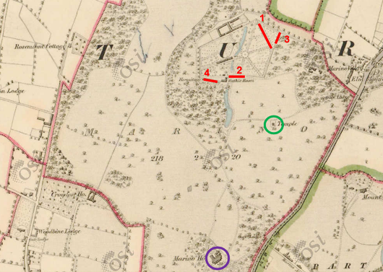
Fig.3: 1837 OS Map showing part of Marino Demesne lands. Marino House circled in purple (now demolished); the Casino circled in green; the approximate location of surviving sections of walled garden walls highlighted in red.

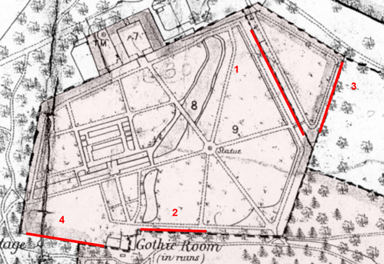
Fig.4: Ordnance Survey 1867 2nd Ed., showing the area of the walled garden. The approximate location of the longest surviving sections of former Demesne boundary wall are shown in red.

References
Dublin City Council (2009) Marino, Casino, Architectural Conservation Area. Adopted by Dublin City Council 11/05/09.
Office of Public Works (2003) Report and Historic Assessment of the Casino Marino and Lord Charlemont’s Demesne. Unpublished OPW report by Elizabeth Morgan, Senior Landscape Architect.

NIAH Significance/Rating
The National Inventory of Architectural Heritage (NIAH) has been completed for this area however Ministerial Recommendations have not yet been issued. The NIAH uses eight categories of special interest (architectural, historical, archaeological, artistic, cultural, scientific, technical & social) and identifies five categories of rating in seeking to rank buildings. The NIAH rating values are International, National, Regional, Local and Record Only (I, N, R, L, O). Structures which are considered of International, National, and Regional significance are deemed worthy of inclusion on the RPS.

Using the NIAH system of rating, the two most intact and visible sections of walls (No 1 & 2) are considered to be of Regional significance. Regionally significant structures are considered to make a significant contribution to the architectural heritage within their region or area. They also stand in comparison with similar structures or sites in other regions or areas within Ireland.

Assessment of Special Interest under the Planning & Development Act 2000
Two sections of the historic demesne wall are considered by the Conservation Section of Dublin City Council to be of special interest under the following headings:
- Architectural: The surviving long sections of former historic demesne wall make a positive contribution to their surrounding setting. Their texture, use of materials and height provide an attractive setting and sense of enclosure to St. Vincent’s GAA Club (which occupies the site of the former walled garden) and the surrounding area.
- Historic interest: While the wall is not fully intact, its survival like other elements of the former estate is important to an understanding of the site. The subject surviving sections attest to the grandeur and scale of the former Marino demesne designed by William Chambers. The Architectural Conservation Area (ACA) Report ‘Marino Casino’ states that: the Marino Demesne was one of the most important designed landscapes ever to have been created in Ireland. It was laid out by James Caulfield, First Earl of Charlemont (1728-1799), during the second half of the eighteenth-century on what was then a coastal site a short distance to the north of the city of Dublin. Charlemont was a learned, well-travelled and patriotic man, who made a major contribution to the cultural and intellectual life of Dublin.

Conclusion
Dublin City Council Conservation Section has carried out an assessment of the surviving historic demesne walls at St. Vincent’s GAA Club, Marino, Dublin 3. The section has considered the reasons for seeking addition and concludes that two of the surviving four sections of the former historic demesne wall merit inclusion on the Record of Protected Structures.

It is proposed to add the two most intact and visible sections of wall to the Record of Protected Structures (Wall no. 1 & 2). Wall 3 is not considered to meet the criteria as only a short section is visible to the public, the rest is located in the back gardens of modest houses in the Casino Park and Charlemont estates. There are sheds built up against it and it is difficult to ascertain the condition and intactness of the wall. Wall 4 is located in lands belonging to the Marino Institute of Education. The north face of this wall was visible from the GAA club and it is rendered with a hard cement based pebbledash. The southern face of the wall was not accessible. Based on the information available it is not considered to meet the criteria for addition. The opportunity should be taken to reassess Wall 4 should access be facilitated at a later date.

The extent of the proposed Protected Structure status and curtilage is outlined in Fig.5 of this document (below).

It is now proposed to initiate the statutory process for the proposed addition of this structure to the Record of Protected Structures. This includes undertaking a statutory public consultation process in accordance with Section 55 of the Act. Following the statutory consultation process, a further report will be prepared taking any submissions and observations received into consideration, with a recommendation to the City Council to proceed or not with the proposed addition, or with a recommendation including amendments to the proposed addition.

Recommendation
It is recommended that the statutory process to initiate for the proposed addition of two of the most intact sections of wall at Saint Vincent’s GAA Club, to the Record of Protected Structures, in accordance with Section 54 and 55 of the Planning and Development Act, 2000 (as amended), be noted.

The initiation of the statutory addition process was noted by the North Central Area Committee of Dublin City Council at its monthly meeting held on 21st of June 2021.

Recommendation
Address | Description (to appear on RPS)
Saint Vincent’s GAA Club, Pairc Naomh Uinsionn, Malahide Road, Dublin 3 | Two surviving sections of historic brick and calp boundary wall. Remains of walled garden associated with the former Marino Demesne.

 09/06/2021
_______________ _________________
Deirdre Scully Date
Deputy City Planner
Extent of Protected Structure Status

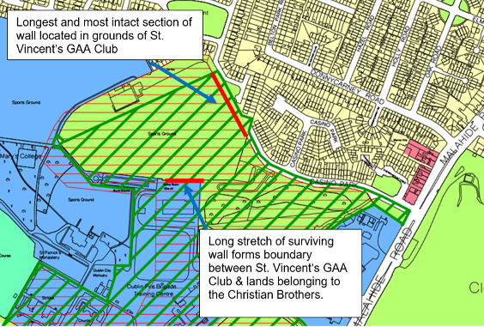
Long stretch of surviving wall forms boundary between GAA Club & lands belonging to Dublin City Council.
Fig.5: St. Vincent’s GAA Club. The extent of Protected Sturcture status and curtilage is outlined in red. The curtilage is limited to the walls themselves.

Aerial Map

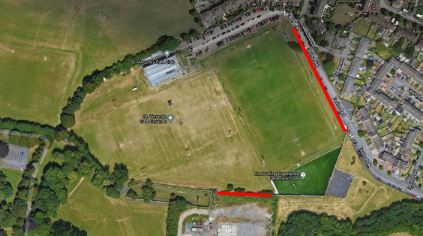
Fig.6: Aerial Photograph showing location of walls to be added to RPS.

Appendix 1: Photographic Record (Note it is proposed to add Wall 1 and Wall 2 to the RPS)

Wall 1: Views of northeast section of wall running alongside entrance lane to club. This section is the longest surviving section.

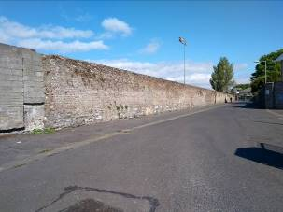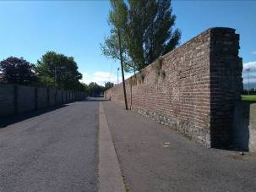
View of north side of wall running alongside entrance lane to club

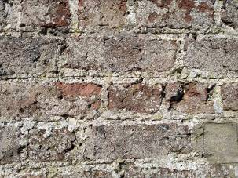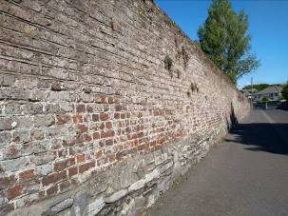
Note surviving penny struck lime mortar joint.

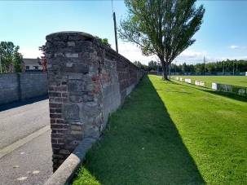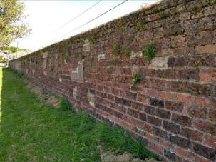
View of south side of wall
Wall 2: Views of surviving section of wall to south of St. Vincent’s Club.

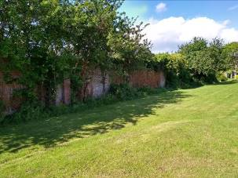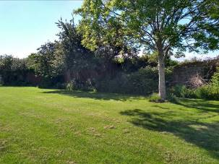
Views of brick wall to south end of GAA club. The wall is heavily overgrown in places.

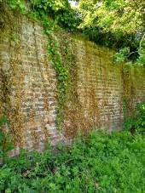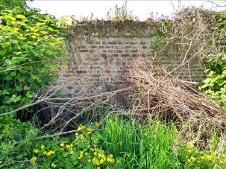
Weathered brick wall with original mortar joints visible.

Wall 3: Views of section of wall to north of entranceway to St. Vincent’s Club. Forms boundary between Charlemont and Casino Park modern housing estates

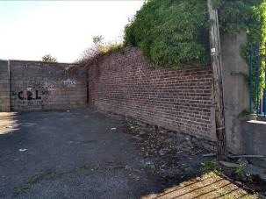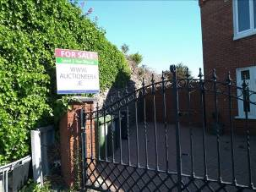
Former walled garden wall. Brick on western side and calp limestone on eastern side.

Wall 4: Views of surviving short section of wall to south of St. Vincent’s Club. The north side of the wall are pebble dashed. According to the 2009 ACA report, this section of wall is of similar composition to the other upstanding sections. This wall forms the boundary between a graveyard and the Marino Institute of Education. This wall was not accessible.

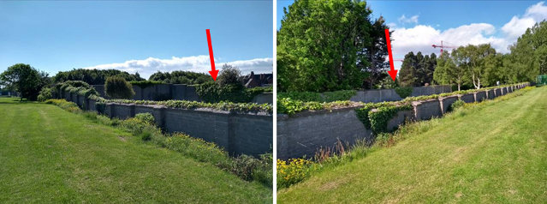
Wall has a modern render of pebble dash. No historic fabric was visible.

