Draft Dublin City Biodiversity Action Plan (2021-2025)
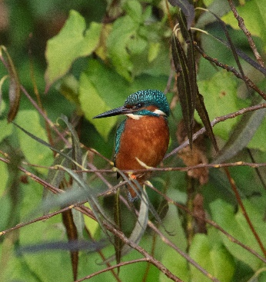
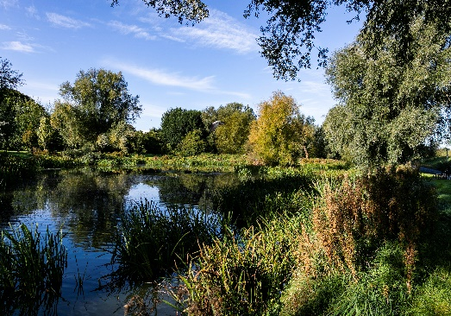
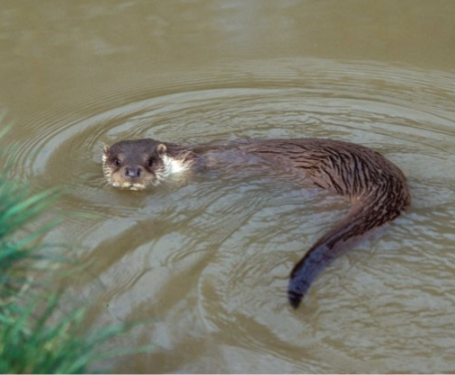

Arts, Culture & Recreation Strategic Policy Committee (SPC)

May 2021

Maryann Harris, Senior Executive Parks and Landscape Officer (Biodiversity)
Lorraine Bull, Biodiversity Officer

Dublin City is rich in biodiversity of global importance, especially in Dublin Bay, which includes the most designated site on the island of Ireland – the North Bull Island National Nature Reserve. Dublin Bay is a UNESCO Biosphere Reserve for sustainable development to manage for the coexistence of nature and people. Biodiversity is defined under the Convention on Biological Diversity (1992), as the ‘variability among living organisms from all sources’, and includes ‘diversity within species, between species, and of ecosystems’. Ireland ratified this Convention and therefore is obliged to act to conserve biodiversity and prepare a national policy framework - the National Biodiversity Action Plan (2017-2021). This requires that local authorities review and update their Biodiversity Action Plans. The Draft Dublin City Biodiversity Action Plan (2021-2025) is the third such plan produced by Dublin City Council and is based on six themes that have been co-created in partnership with various organisations working for biodiversity. These contain 18 objectives to be implemented through targeted actions with measurable outcomes. It is based where we want to be in five years in terms of addressing the crisis of biodiversity loss.

What has changed over the period 2015-2020?

Since the last BAP was launched, the extent of the biodiversity crisis has been recognised and declared locally, nationally and globally:
- 2017 – Ireland’s National Biodiversity Action Plan states national policy of no net loss of biodiversity on projects and plans.
- 9th May 2019 - Dáil Éireann declares a Biodiversity Crisis. Ireland is second country to do so.
- Sep 2019 - IUCN proposes to achieve no net loss of biodiversity by 2030, and through recovery and restoration, achieve a net gain by 2050.
- 14th Oct 2019 - Dublin City Council declares a Biodiversity Crisis.
- Dec 2019 - European Commission launches the Green Deal for major investment in biodiversity.
- September 2020 - The fifth Global Biodiversity Outlook report published by the United Nations Convention on Biological Diversity (CBD) warns starkly that the world has so far failed to halt the destruction of wildlife and life-sustaining ecosystems.
- 20th May 2020 - launch of the EU Biodiversity Strategy to 2030, which provides targets for all member states within the European Union to address the biodiversity crisis. The strategy links the recovery of biodiversity to recovery from economic recession, health threats and climate disasters. “We need nature in our lives” is a central message. Investing in nature protection and restoration will also be critical for Europe’s (and Dublin’s) economic recovery from the COVID-19 crisis.

What has been achieved (2015-2020)?

The current Biodiversity Action Plan contained 4 Themes and 29 Actions. 27 of these actions were completed, which resulted in 36 specific Conservation, Research and Management projects and 28 Education and Outreach initiatives, with additional outreach through press, radio, and social media.
(see Appendix 1 for full list). Dublin City Council is a key partner on the Dublin Bay UNESCO Biosphere Reserve Partnership, the Dublin Mountains Partnership, and strengthened and developed new partnerships with regional offices, agencies, and third level educational institutes to achieve the objectives of the Dublin City Biodiversity Action Plan (2015-2020).

Developing the Draft Dublin City Biodiversity Action Plan (2021-2025)

Figure 1: The review process for the Draft Dublin City Biodiversity Action Plan (2021-2025)

Parks, Biodiversity and Landscape Services reviewed the outcomes and recommendations from the previous City Biodiversity Action Plans and current legislation and policies. In December 2020, DCC conducted a public questionnaire survey via Your Dublin Your Voice. The aim of the survey was to gauge people’s awareness of biodiversity and seek their views on actions that are needed in Dublin City to conserve biodiversity. The survey attracted over 1,000 respondents.

- 74% of respondents to the Your Dublin Your Voice December 2020 survey felt that biodiversity had become more important to them over the past 5 years to their quality of life.
- 74% of respondents to the Your Dublin Your Voice survey would like to see Dublin City Council carry out more habitat restoration projects.
- 50% would like to see the creation of new areas for wildlife.
- One-third have participated in practical activities to help the environment, such as beach clean-ups and volunteering with Tidy Towns or local resident group biodiversity projects.

A Biodiversity Forum of over 40 representatives met in February-April 2021 to further develop what themes, objectives and actions should go into the Draft Plan. The Forum comprises partnering agencies, environmental NGOs, and educational institutions. Through workshops, they reviewed: the current BAP - what worked well and why, gaps; key areas for biodiversity conservation over the next 5 years; measurable targets.

What is new in the Draft Dublin City Biodiversity Action Plan (2021-2025)

The Draft Plan is based on the following six themes that focus the outcomes for biodiversity conservation required across the city (Table 2, below). Within these themes, there are 18 objectives for biodiversity management and conservation along with a series of targeted actions with measurable outcomes to achieve these objectives. Each theme links to the Strategic Objectives of the National Biodiversity Action Plan (2017-2021) while considering the urban context of biodiversity within Dublin. There is a new focus on restoration of biodiversity to respond to the public survey and reflect EU policy. A specific theme centres on Dublin as a Green Capital City to link biodiversity to quality of life, health and economic competitiveness.

Next Steps

Table 1: Timetable for completion of Draft Dublin City Biodiversity Action Plan

May 2021: | Draft Dublin City Biodiversity Action Plan (2021-2025) brought to the Arts, Culture, Leisure and Recreation SPC
May 2021: | Public consultation from National Biodiversity Week for 4 weeks
Jul- Aug 2021: | Review public submissions and finalise BAP
Sep 2021: | Presentation to the Arts, Culture, Leisure and Recreation SPC for adoption
Oct 2021: | Launch of Dublin City Biodiversity Action Plan, 2021-2025
Table 2: Themes and Objectives of the Draft Dublin City Biodiversity Action Plan (2021-2025)

Theme 1 - Maintaining Nature in the City
1 | Ensure effective implementation of the Dublin City Biodiversity Action Plan
2 | Protect designated sites for nature conservation in accordance with the Conservation Management objectives for Natura 2000 sites and proposed Natural Heritage Areas in Dublin City
3 | Identify and protect sites that have conservation value for biodiversity using evidence-based research
4 | Monitor and conserve legally-protected species within Dublin City, particularly those listed in the annexes of the EU Birds and Habitats Directive using evidence-based research
5 | Prepare and plan for the impacts of climate change on biodiversity
6 | Implement measures for species with that have a local biodiversity value or impact local biodiversity
7 | Prepare and disseminate information on guidance for development and site management for biodiversity conservation
Theme 2 - Restoring Nature in the City
8 | Devise and implement habitat restoration initiatives across Dublin City
9 | To use nature-based solutions to restore biodiversity and ecosystem services
10 | Strengthen measures to control Invasive Alien Species, improve biosecurity and ecological status of catchments
11 | Ensure that measures for biodiversity and nature-based solutions are incorporated into new building projects, retrofit and maintenance works
Theme 3 - Building for Biodiversity
12 | Promote net biodiversity gain and ensure there is no net loss of biodiversity through strategies, planning, mitigation measures, appropriate offsetting and/or investment in Blue-Green infrastructure
13 | Pilot initiatives for the creation of habitats using artificial habitat methods
14 | Minimise and reverse soil sealing in the Dublin City Council administrative area
Theme 4 - Dublin as a Green Capital City
15 | Implement measures for Dublin city to be a leader on biodiversity as a Green Capital City
Theme 5 - Understanding Biodiversity in the City
16 | Increase understanding and appreciation of biodiversity and its importance across Dublin City
17 | Empower citizens to connect with, and take action for, biodiversity at a local and city-wide level
Theme 6 - Partnering for Biodiversity
18 | Strengthen collaboration for the conservation of biodiversity at a regional, national, and global level

Appendix 1

Tables 1-3 below, detail the outcomes from the actions completed during the Dublin City Biodiversity Action Plan (2015-2020), which resulted in 36 specific Conservation, Research and Management projects and 28 Education and Outreach initiatives along with outreach through press, radio, and social media, as well as partnering with other local authorities, the Dublin Bay UNESCO Biosphere Reserve Partnership, the Dublin Mountains Partnership, regional offices, agencies, and third level educational institutes.

Table 1. Conservation, Research and Management projects from the City BAP, 2015-2020

1 | Pesticide reduction strategy implemented, resulting in the elimination of glyphosate from parks management and DCC roads, 2018-2020
2 | Brent Goose Research Project on how the birds use Dublin Bay with Exeter University, 2017-2021
3 | Annual surveys for Marsh Fritillary Butterfly on North Bull Island with NBDC
4 | Assessment of the effects of Kitesurfing and other activities on the water birds using Dollymount Strand
5 | Assessment of the effects of recreational and other activities on the water birds using the Bull Island saltmarsh
6 | Flora & Vegetation Surveys of North Bull Island, 2020
7 | Managing the impact of dogs and dog walkers on biodiversity at North Bull Island, 2017
8 | North Bull Island Dog Tracking Project, with the Herpetological Society of Ireland, 2018
9 | Hare survey on North Bull Island, 2016
10 | North Bull Island Management Plan updated, 2018-2020
11 | North Bull Island Nature Reserve Rebranding, 2018-2021
12 | Orchid survey of North Bull Island, Irishtown Nature Park & St. Anne’s Park, 2015
13 | Special Conservation Interests of SPAs: Monitored by Birdwatch Ireland as part of the Irish Wetland Birds Survey
14 | Pilot Study on the Disturbance of Grey and Harbour Seals on North Bull Island with Irish Whale and Dolphin Group, 2018
15 | Ground-Nesting Bird surveys on North Bull Island with BirdWatch, 2019 & 2020
16 | Assessment of the abundance, distribution and breeding status of riparian birds along the River Dodder, as part of the Dublin City Urban Birds project, 2015
17 | Dublin City pilot wetland projects commenced in Bushy and Belcamp Parks with the Herpetological Society of Ireland, 2020
18 | Dublin Bay Seal Census with Irish Seal Sanctuary, 2018
19 | Dublin City Habitat map updated, 2020
20 | Dublin City Otter Survey, 2020
21 | Dublin City Tree Mapping Project, 2020
22 | Dublin City Urban Woodland and Hedgerow Survey updated, 2020
23 | Ectocarpus Study with NUI Galway, 2020
24 | Eelgrass (Zostera) study at Sandymount with Coastwatch Ireland, 2019
25 | Flora & Vegetation Surveys of 50 City Parks, 2017-2019
26 | Green infrastructure projects with DCC Engineers on the rivers Dodder and Mayne
27 | Hedgehog, pygmy shrew, and badger surveys in 10 city parks, 2020
28 | Herpetological surveys in parks with the Herpetological Society of Ireland, 2015 & 2019
29 | RAMSAR Wetland Contribution
30 | South Dublin Bay Management Plan commenced 2020
31 | Supported Dublin Bat Group surveys with equipment
32 | Surveys of the Canals with Waterways Ireland Partnership
33 | Trout population genetic study for Dublin Rivers, in conjunction with Inland Fisheries Ireland and Queens University Belfast, 2015
34 | Wildfowl Monitoring, 2019-2020 and review of the Wildfowl Monitoring Programme, 2007-2020
35 | Santry River Regeneration project, with surveys of wintering and breeding birds conducted by BirdWatch Ireland, 2019-2020
36 | Bat survey of Brickfields Park, Drimnagh, 2020
*The one action outstanding is the publication of ‘The Flora of North Bull Island’ was delayed by Covid..

Table 2. Education, Outreach and Citizen Science initiatives from the City BAP, 2015-2020

1 | Hosted the EuroMAB conference in April 2019
2 | A ‘Short Guide to Three Dublin City Woodlands’ educational guide to the woodlands of Bushy Park, St. Anne’s Park and Tolka Valley Park produced, 2020
3 | An Urgent Enquiry arts project in conjunction with the City Arts Office
4 | Annual biodiversity seminar with Environmental NGOs and Third level educational institutes
5 | Biodiversity outreach villages at Battle for the Bay and St. Anne’s Rose Festival
6 | Brent Goose Ambassador Schools Progrsamme and Urban Birds projects outreach
7 | Daubenton Bat Surveys with Bat Conservation Ireland and the Dublin Bat Group
8 | Developed and published interpretation material
9 | Dodder Networking Summit
10 | Education, training and support for students and teachers through the National Discover Primary Science Centre at North Bull Island, which has facilitated numerous research projects, including genetic populations of lizards; urban fox populations in south Dublin; ecosystem service mapping for Dublin.
11 | Established the North Bull Island conservation volunteer programme
12 | Explore the Shore launch hosted on North Bull Island and beach events held
13 | Heritage in Schools Training Days hosted
14 | Invasive Species Training provided to staff
15 | Marine surveys conducted with Coastwatch and members of the public
16 | National Biodiversity Data Centre workshops supported
17 | National Heritage Week events hosted, including trips to North Bull Island, bat and river walks, and wildlife found in cemeteries
18 | Nature First Saturdays & Wildlife Wednesdays
19 | Nature in the Park schools’ resource produced with ECOUNESCO
20 | Otter citizen science surveys with the Irish Wildlife Trust
21 | OWLS Biodiversity Awareness Programme
22 | Promotion and education of the Dublin Bay UNESCO Biosphere Reserve at events and workshops
23 | Promotion of biodiversity themes and events on key national events, including UN International Biodiversity Day and National Biodiversity Week, World Wetlands Day, National Heritage Week, National Tree Week, National Dawn Chorus, National Coastwatch Survey, Bealtaine and National Science Week.
24 | RTÉ Dawn Chorus events annually and publicity with RTÉ
25 | Support for students of all ages on information for biodiversity projects and third level internships
26 | Training webinars for teachers on using resources and teaching about biodiversity
27 | Volunteering activities with Conservation Volunteers Ireland
28 | World Wetlands Day exhibitions and field trips with BirdWatch Ireland, Coastwatch, Explore Your Shore, and the Herpetological Society of Ireland

Table 3. Partnering and collaboration from the City BAP, 2015-2020

1 | Key partner in the Dublin Bay UNESCO Biosphere Partnership, working to promote the conservation, research, and education of the Biosphere
2 | Worked in partnership with Fingal, Dun Laoghaire Rathdown and South Dublin County Councils on cross border biodiversity initiatives.
3 | Partner in the Dublin Mountains Partnership (DMP), contributing to the DMP strategic plan, Dublin Mountains Makeover project, and management of the mountains area
4 | Collaboration with agencies, including National Parks and Wildlife Service, Heritage Council, Waterways Ireland, Irish Rail, National Biodiversity Data Centre
5 | Partner with Third level educational institutes to conduct biodiversity research, including TCD, UCD, NUI Galway, DCU and Queen’s University Belfast
6 | Collaboration with other Dublin City Council and departments, including the Water Framework Office on Green Infrastructure, Climate Action Office, Climate Action Regional Office, and City Arts Office.

Action 1.1.5 National Biodiversity Action Plan (2017-2021).
IUCN proposals on the Post-2020 Global Biodiversity Framework in response to CBD Notification 2019-075 September 2019

