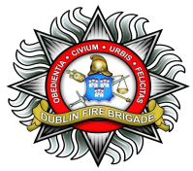   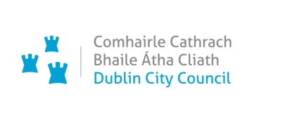

**EXTERNAL EMERGENCY PLAN for**

**TOP Dublin Terminal**

An Garda Síochána, the Health Service Executive and the relevant Local Authority (in this case – Dublin City Council) are each required by the Chemicals Act (Control of Major Accident Hazards involving Dangerous Substances) Regulations 2015 (S. I. No. 209 of 2015) to prepare a plan (External Emergency Plan) to deal with effects off-site and to assist, where relevant, with the emergency response on site in the event of a major accident at sites designated as ‘Upper-Tier Seveso Sites’ under the above-mentioned Regulations. The above is such a site. This public consultation is taking place in accordance with Section 16 (6) of S. I. no. 209 of 2015.

**Public Consultation Feedback Form**

Your views are very important and we would like to hear what you have to say about the Draft External Emergency Plan for TOP Dublin Terminal, Tolka Quay Road, Dublin Port, Dublin 1. Your comments will be considered and will inform the development of the final plan.

You can make general comments or comment on specific issues. When commenting on a specific section of the plan, it would help us if you would tell us the reference number of the section on which you are commenting.

**The closing date for submissions is 5.00pm on Friday 2nd March, 2018, as specified in the Public Notices on the Health Service Executive and Dublin City Council’s websites and on the Garda Síochána Facebook Account with regard to the consultation with the public on this Plan.**

**You can email, fax or post a completed form to us at the addresses given at the end of this form.**

**About you**

|  |  |
| --- | --- |
| **Name:** |  |
| **Contact details:** |  |
| **Date:** |  |
| **Are you commenting on behalf of your organisation or in a personal capacity?** | **Organisation** □ **Personal** □ |
| **Organisation Name:**  **(Please include if making this submission on behalf of your organisation)** |  |

**General feedback questions**

* **Question:** Are there any general comments you would like to make on the Plan?

*Please comment*

|  |
| --- |
|  |

**Feedback on Specific Sections**

**Question: What are your views on the content of the specific sections in the draft Plan**?

Please include section number (and page number) here:

|  |
| --- |
| *Comment/ Suggestion on content of Section* |

**Please copy and use one page per section to facilitate collation of comments**

**Thank you for taking the time to give us your views on the**

**TOP Dublin Terminal, Tolka Quay Road, Dublin Port, Dublin 1.**

**External Emergency Plan.**

*Please return your form to us either by email or post.*

You can download a blank feedback form at [www.dublincity.ie](http://www.dublincity.ie)

and *email the completed form to* [mem@dublincity.ie](mailto:mem@dublincity.ie)

*or post it to:*

Emergency Management Officer,

Dublin Fire Brigade Headquarters

165-169 Townsend Street

Dublin 2

If you have queries on this plan, you can contact the Emergency Management Office at [mem@dublincity.ie](mailto:mem@dublincity.ie)

**Please return your form to us before 5.00pm on Friday 2nd March, 2018, which is the latest date for submissions specified in the Public Notices with regard to the consultation with the public on this Plan.**

We will review and consider carefully all submissions received during the consultation process. Your comments will inform the development of the final plan.