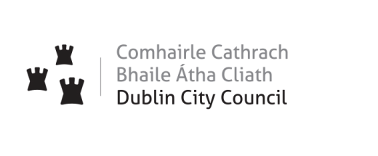Dublin City Council
Local Property Tax 2023 – Public Consultation Phase
Survey

- Do you live in the Dublin City Council Area?
Yes
No

- Which of the following best describes you? (select all that apply to you)

Tenant
Home owner
Living at home
Business in Dublin City Council area
Charitable Organisation in Dublin City Council area
Non-Resident
Other – please specify _________________________

- Are you required to pay Local Property Tax to Dublin City Council?
Yes
No

- Are you aware that Local Property Tax payments are used to fund some of the essential services Dublin City Council provides to its citizens, such as roads, water services, housing, litter collection and parks?

Yes, I am aware
No, I was not aware of this

- Are you aware that City Councillors can increase or decrease the basic rate of Local Property Tax by up to 15% for Dublin City Council’s Revenue Budget 2023?
- - Yes
- - No

- If you are aware, how did you hear about this?

- Public advertisement
- TV / Radio
- Newspapers
- By elected representative
- By public debate
- From friends and family
- Other (please specify)

- Would you like the Elected members to retain the current reduction of -15% on the base rate for the year 2023?

- Yes

- No

You have selected No in the previous question and therefore wish to increase the rate. Please indicate the range of preferred increase (please select your preferred option)

Option 1
- Percentage increase towards the basic rate

i) Between 1% and 5%
ii) Between 6% and 10%
- Between 11% and 15%
- Increase to the Base Rate

Option 2
- Percentage increase above the basic rate

i) Between 1% and 5%
ii) Between 6% and 10%
- Between 11% and 15%

- If the elected members were to vary the rate by a lesser amount that the current reduction and additional income became due to the City Council, what area would you like to spend it on?
  - Housing Maintenance
  - Footpaths & Carriageways
  - Planning Enforcement
  - Street Cleaning
  - Libraries
  - Parks
  - Events
  - Cycling
  - Other (please specify)

You can submit your views/opinions by completing the Online Survey at https://consultation.dublincity.ie/
The public consultation phase will take place from Tuesday 9th August to Thursday 8th September.

