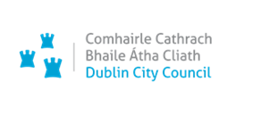 An Roinn Comhshaoil agus Iompair,
Bloc 2, Urlár 6, Oifigí na Cathrach,
An Ché Adhmaid, Baile Átha Cliath 8

Environment and Transportation Department,
Block 2, Floor 6, Civic Offices Wood Quay Dublin 8

01rd April 2022
Planning Department
Block 4, Floor 1
Barrow Street
Application for Part 8 Planning Permission.

Dublin City Council, Environment & Transportation Department is applying for Planning Permission under Part 8 of the Planning & Development Regulations 2001 (as amended) for Barrow Street. The previous invalid planning application number applicable to this Scheme is DSDZ3583/22. We also submit a copy of the letter received from Dublin City Council Planning Department dated 28-03-2022 advising of the invalid application.

Copies of the following documentation shall be submitted online in support of the application.
-Cover Letter.
-Newspaper Notice (Published in Irish Independent 01/04/2022).
-Site Notice.
-Schedule of Content.
-Planning Report.
-Schedule of Content for Drawings.
-Relevant Plans/Drawings as follows:
BAR-GPB-ZZ-ZZ-DR-L-0011-P Site location Map
BAR-GPB-ZZ-ZZ-DR-L-0012-P Site Layout Plan-Sheet 1
BAR-GPB-ZZ-ZZ-DR-L-0013-P Site Layout Plan-Sheet 2
BAR-GPB-ZZ-00-DR-L-1101-P Hardscape Plan-Sheet 1
BAR-GPB-ZZ-00-DR-L-1102-P Hardscape Plan-Sheet 2
BAR-GPB-ZZ-00-DR-L-1103-P Hardscape Plan-Sheet 3
BAR-GPB-ZZ-00-DR-L-1104-P Hardscape Plan-Sheet 4
BAR-GPB-ZZ-00-DR-L-1105-P Hardscape Plan-Sheet 5
BAR-GPB-ZZ-00-DR-L-1106-P Hardscape Plan-Sheet 6
BAR-GPB-ZZ-00-DR-L-1107-P Hardscape Plan-Sheet 7

In accordance with the Revised Procedures for Processing Developments by Dublin City Council, we hereby forward our application to the Registry Section and would be obliged if you could forward this to the Planner for their Report.

Should you have any queries or require any additional information, please contact Derek Dixon at (01) 222 8601 or email derek.dixon@dublincity.ie

Yours Sincerely
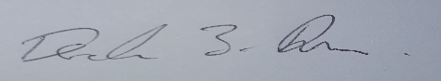
-----------------------------
Derek Dixon,
Senior Engineer, Environment & Transportation Department.

