Summary Report
on the Non Statutory Public Consultation
for the Proposed Liffey Cycle Route

November 2019
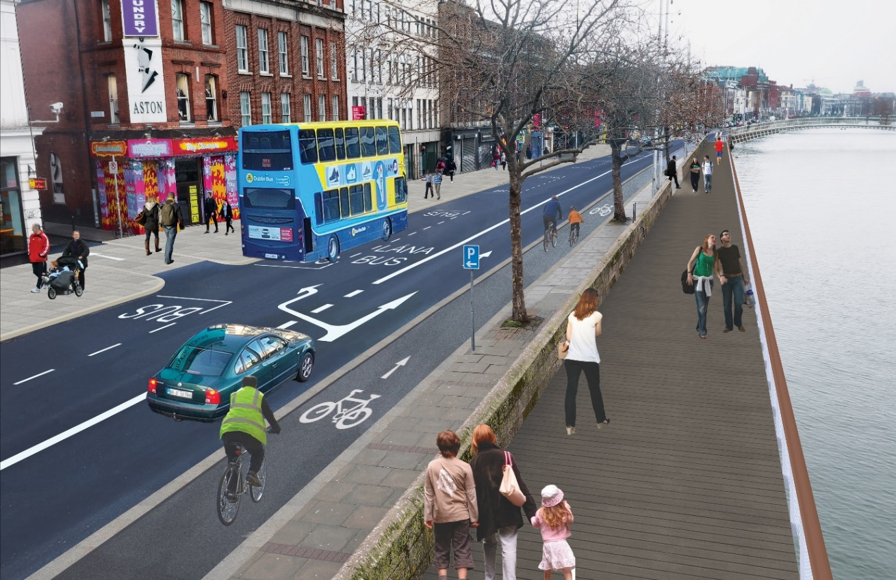

Contents
1 Introduction 4
1.1 Scheme Benefits 4
2 Non Statutory Public Consultation 5
3 Themes/Concerns arising as part of the Non Statutory Public Consultation 6
3.1 Pedestrian Themes 6
3.1.1 Boardwalks 6
3.1.2 Footpaths Widths 7
3.1.3 Pedestrian Crossings 7
3.1.4 Pedestrian-Cyclist Conflict 7
3.1.5 Kerb Depths 8
3.1.6 Possible Plazas suggested along the route 8
3.1.7 Future Pedestrian Projects to be considered 8
3.2 Cycle Track Design Themes 9
3.2.1 Cycle Route Width 9
3.2.2 Cycle Route Segregation- Junction Design 9
3.2.3 Cycle Route Segregation-Minor Side Roads 10
3.2.4 Cycle Route Segregation- Right/left turn facilities for Cyclists 10
3.2.5 Cycle Route Transition 11
3.2.6 Cyclist Signals 11
3.2.7 Cycle Parking 11
3.2.8 Cycle Route Connectivity 11
3.3 Cycle Track Design Observations Drawing by Drawing 12
3.3.1 Map 1 Parkgate Street 12
3.3.2 Map 2 Parkgate Street-Heuston Station & Wolfe Tone Quay/Victoria Quay 13
3.3.3 Map 3 Wolfe Tone Quay- Sarsfield Quay & Victoria Quay 14
3.3.4 Map 4 Sarsfield Quay-Arran Quay & Victoria Quay-Ushers Quay 16
3.3.5 Map 5 Mellowes Bridge –Father Mathew Bridge 17
3.3.6 Map 6 Father Mathew Bridge-O Donovan Rossa Bridge 18
3.3.7 Map 7 O Donovan Rossa Bridge-Grattan Bridge 20
3.3.8 Map 8 Grattan Bridge- Ha’penny Bridge 21
3.3.9 Map 9 Ha’penny Bridge- O Connell Bridge 22
3.3.10 Map 10 O Connell Bridge – Butt Bridge 23
3.3.11 Map 11 Butt Bridge- Matt Talbot Memorial Bridge 23
3.4 Public Transport Themes 24
3.4.1 Bus Stops 24
3.4.2 Public Transport Proposals 24
3.5 Greening of the Quays 25
3.6 Loading 25
3.7 General Proposals 25
4 Specific Body Submissions 26
4.1.1 Car Parks-Lowstrand Properties Ltd 26
4.1.2 Dublin Town 26
4.1.3 Public Participation Network 27
4.1.4 St James Hospital 29
4.1.5 Dublin Cycling Campaign 29
4.1.6 Cycling Without Ages 30
4.1.7 An Taisce 30
4.1.8 Dublin Bus 31
4.1.9 Dublin Chamber 32
4.1.10 Fighting Blindness 33
4.1.11 National Council for the Blind Ireland (NCBI) 34
4.1.12 Transport Infrastructure Ireland 36
4.1.13 C+W O Brien Architects 37
4.1.14 I BIKE Dublin 37
4.1.15 Phoenix Farrell Limited 37
4.1.16 IrishCycle.com 37
5 Conclusions 39
6 Appendices 40

Introduction
The Liffey Cycle Route is a Primary Route in the Greater Dublin Area Cycle Network Plan published by the National Transport Authority (NTA) in December 2013, and as such is a key objective of the NTA and Dublin City Council (DCC). It is one of a number of routes being developed by DCC as part of its overall 470km of safer cycling routes suitable for cyclists of all ages and abilities.

The scheme will deliver pedestrian improvements, a high quality cycle route that will meet the requirements of cyclists of varied experience and will provide an optimal balance of provision between the various road users along the route. The design will have particular regard to any engineering, architectural and environmental constraints along the route.

In 2017 DCC and the NTA agreed that the NTA would undertake a review of all design options considered to date and identify any new design options.
In March 2019 the NTA presented an Emerging Preferred Design to DCC.

This Emerging Preferred Design includes the following
- The existing road layout will be reconfigured to provide a one-way segregated cycle track on the north and south quays, located on the building side from the Phoenix Park to O Donovan Rossa Bridge where it then crosses to the river side of the road to Matt Talbot Memorial Bridge,
- Provision of boardwalks at various locations,
- Upgrade of junctions to provide pedestrian and cyclist improvements,
- Public realm improvements and
- Improvements to existing traffic signal operational infrastructure.

Scheme Benefits

- Safety improvements for walking, cycling and public transport
- Increased capacity at bus stops.
- Accommodating modal shift- Since 2012 cyclist numbers have doubled on the quays while bus numbers are up by 14%. Car numbers are down 50% on the North Quays and down 33% on the South Quays
- Car park assess will continue to be maintained.

Non Statutory Public Consultation
A Non Statutory Public Consultation was carried out from May 2nd – June 6th 2019. 425 submissions were received, and are outlined in the Table 1.0 below.

Category | Number
Emails | 80
Written Submissions | 2
Online submissions | 310
Comments Box Submissions | 33
Total | 425
Table 1.0

This report outlines the themes arising from submissions made by members of the public and specific bodies during the Non-Statutory Public Consultation process for the Liffey Cycle Route, and all submissions received during this process are presented in the Appendix
It should be noted that any views, thoughts and opinions presented in this report are those submitted during the Non-Statutory Public Consultation, and are not Dublin City Councils.
Dublin City Council has not addressed any of the comments raised at this time.
The submissions included a variety of response themes including:
- Strong support for the proposals Many submissions were very supportive of the provision of a segregated cycle track along the Liffey, and for the creation of a more pedestrian friendly space; the reduction in private motorised traffic along the quays and the associated environmental benefits. The facilitation of more active modes of travel was welcomed.
- Support for the scheme, but with suggestions. Many submissions support the scheme but also highlight concerns with some aspects of the design along the scheme. A reoccurring suggestion was to remove private cars from the Quays rather than trees. The design of the cycle track through junctions where left turning car movements remain in place was also questioned. The width of the cycle track was also a dominant theme with many submissions claiming that 2.0m does not cater for the future cyclist growth that such a scheme will bring.
- Opposing the scheme in its current form. Some submissions were against the plan in part due to the inclusion of perceived dangerous designs mainly relating to island bus stops, depth of dividing kerbs and in some cases the lack of 100% cyclist segregation through junctions. Some submissions opposed the scheme due to maintaining private car access at the expense of trees

Themes/Concerns arising as part of the Non Statutory Public Consultation
This section presents a summary of the reoccurring themes raised during the consultation process, however as this is a summary report it is not possible that all individual comments/observations have been included in this section of the report, the appendix of this report documents all the submissions received. It should be noted that any future Design Consultant appointed by Dublin City Council for the Liffey Cycle Route will be required to consider all comments received when progressing the scheme.

Pedestrian Themes
This section will present the reoccurring themes relating to pedestrians.

Boardwalks
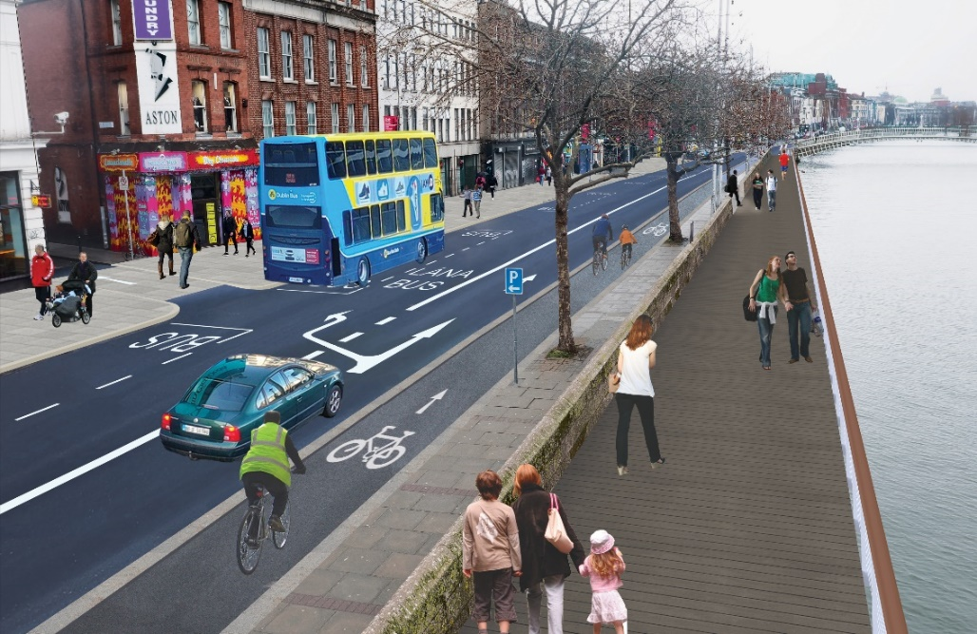
Aston Quay Proposals
While the boardwalks were generally welcomed there were some concerns regarding the following.
- Anti-social behaviour on both the existing boardwalks and any future boardwalks. Additional security suggestions included, CCTV cameras and bright lighting.
- Materials selected on any new boardwalks should be durable and anti-slip.
- Extent of boardwalks proposed was questioned especially at Frank Sherwin Bridge as most pedestrians use the Luas Bridge. It was suggested that the amount of boardwalks could be reduced if private cars were removed from the Quays
- Concerns over the consequences of having boardwalks at different levels on either side of the Liffey, the cross section will not be symmetrical.
- Concerns about having boardwalks on the Southside where they will be in the shadow of the buildings for the majority of available sunlight.
- The cost of the proposed boardwalks and the requirement to build them from the river will delay the project.
- The addition of boardwalks and altering historic bridges may delay the project.

Footpaths Widths
- Proposals to widen the footpaths along the route are welcomed especially at Bachelors Walk and Aston Quay.
- Concern was expressed over the removal of the riverside footpath and narrowing of footpaths for pedestrians in places along the route. Footpaths were thought to be dangerous where they are too narrow.
Proposed Bachelors Walk Cross Section

Pedestrian Crossings
- Wrap around pedestrian crossings should be included at all major junctions, specific areas mentioned included Fr Matthew Bridge, Bridgefoot Street, Frank Sherwin Bridge and Phoenix Park Entrance.
- Concern over the apparent removal of some existing pedestrian crossings along the route.
- Traffic signals should prioritise pedestrian and cyclist movements along the route.
- There is an opportunity to include zebra crossings on the 30kph quays.
- Remove the right turn from Bachelors Walk to O’ Connell Bridge, as the right turning vehicles often block the pedestrian crossings.

Pedestrian-Cyclist Conflict
- Concern amongst visually and mobility impaired pedestrians regarding the inclusion of shared space areas for pedestrians and cyclists in the design at Frank Sherwin Bridge.
- Concern was expressed regarding the inclusion of a cycle track just outside the Hueston Station exit where there is large footfall of pedestrians.
Proposal at Heuston Station

Kerb Depths
- The depth of the kerb between the footpath and proposed cycle track along the route was highlighted as being inadequate for visually and mobility impaired persons, with a request to increase the proposed height of 50mm to 60mm.

Typical Cycle track Cross Section

Possible Plazas suggested along the route
- Plaza outside Hueston Station
- Plaza outside Aisling Hotel
- Plaza outside Custom House-Reroute Traffic behind Custom House.

Future Pedestrian Projects to be considered
- Liffey Street pedestrianisation.
- Comments that one of the reasons College Green Plaza was refused permission was due to concerns over footpath capacity along the quays when buses were rerouted. The Liffey Cycle Route design needs to take account of this.

Cycle Track Design Themes
Overall the proposed cycle route along the Liffey was welcomed with some concerns expressed over the design itself. This section will present the reoccurring themes relating to cyclists.

Cycle Route Width
- A prevailing concern throughout the submissions related to the proposed width of the cycle track, it was suggested that 2 metres and less in places will barely cater for current cyclist numbers on the Quays let alone any increase in numbers that such a scheme will most likely attract, a wider cycle lane should be provided now to avoid revisiting the design after construction.
- It was said that the current design width does not match the requirements of the National Cycle Manual.
- The growing number of e-scooters appearing in Dublin Streets will increase the demand for space on the cycle route.
- Passing slower cyclists may be difficult along the route.
Proposed Cross Sections

Cycle Route Segregation- Junction Design
- Vehicles crossing the cycle track is a major cause for concern amongst cyclists. The current proposed junction design where the cycle track comes onto the road and is placed in between a left turning lane and a straight ahead lane was mentioned regularly as being unsatisfactory-(Church St Junction, Blackhall Place Junction and Winetavern Street). This design reduces the level of segregation of the scheme and is unsuitable for a child to use, therefore below European design.
Junction Design at Arran Quay/Church Street

- Use Dutch style separation at junctions-protected intersections.
- Consider primary school children as a primary user when designing such infrastructure. If we get it right for them, then it will work for everyone.

Cycle Route Segregation-Minor Side Roads
- It was suggested that cycle tracks should not go on road through smaller junctions but maintain priority through them on raised entry treatments, smaller junctions should have their radius reduced with the cycle track crossing on a raised track. This raised concerns that the proposed route is not segregated enough over its full length, advisory cycle lanes along the route should be minimised. Kerbs are needed throughout the scheme.
Minor Junction at Temple Street West

Cycle Route Segregation- Right/left turn facilities for Cyclists
- Concerns were expressed regularly regarding the difficulty for cyclists making right turns across the Liffey Bridges when the cycle track is on the building side and for left turns when the cycle track is on the river side.
O Connell Bridge – Rosie Hackett Bridge

Cycle Route Transition
- The transfer of cyclists from building to river side and vice versa was highlighted as an area that requires careful design, some submissions stated it was a bad idea on the North Quays as they didn’t believe cyclists would wait to cross the road when they can just continue on in the bus lane especially if they are approaching a red cyclist light and the general traffic light is green. Changing sides detracts from consistency and thus quality of the entire route.
Proposed Crossover for cyclists on North Quays

- Cycle track should stay on the river side for the entire length of the scheme, a continuous route along the water would have the additional advantage of removing potential conflicts with alighting bus passengers.

Cyclist Signals
- Requests were made for cyclist activators or advance green lights for cyclists to be included in the design. Cyclists should get a 5 sec head start on motorized vehicles at junctions.
- Traffic Signals should prioritise pedestrian and cyclist movements along the route.
- Adequate green time for cyclists to cross junctions as cycle lane only facilitates single file cycling.

Cycle Parking
- Addition of adequate cycle parking is required along the scheme.
- Provide an access to the Dublin Bikes station on Ormond Quay.

Cycle Route Connectivity
- The Liffey Cycle route will connect the Liffey Route to the Bus Connects routes.
- Potential for connectivity with the O' Devaney Garden redevelopment and TUD Grangegorman should be considered.

Cycle Track Design Observations Drawing by Drawing
This section will outline some of the observations made in the submissions relating to the cycle track design drawing by drawing where applicable.

Map 1 Parkgate Street

- Loading facilities are required for the garage on Parkgate Street in order to stop the cycle track getting blocked.
- Loss of private parking in front of businesses on Parkgate Street.
- Current Issue with Gardaí parking on cycle track outside Criminal Courts may continue.

Map 2 Parkgate Street-Heuston Station & Wolfe Tone Quay/Victoria Quay

- Signage is required on Frank Sherwin bridge to highlight the cycle lanes are the “wrong way around”
- The switch from river side to building side can happen much easier at Frank Sherwin Bridge where numerous other traffic movements have to be accommodated
- Cyclists on Victoria Quay turning right across the Frank Sherwin Bridge may not use the cyclist crossing but will instead weave across the lanes.
- Concern over the design of the junction at St James Gate. Advance stop line for cyclists required ahead of the left turners stop line.
- Junctions such as Temple Street West should be provided with Entry treatments and the large radii should be reduced.
- How will the complex arrangement of cycle tracks around Heuston affect the green time for cyclists?
- Extend Dublin Bikes and cycle parking at Heuston.

Map 3 Wolfe Tone Quay- Sarsfield Quay & Victoria Quay

- A two way cycle track was requested on Wolfe Tone Quay utilising Croppies Acres.

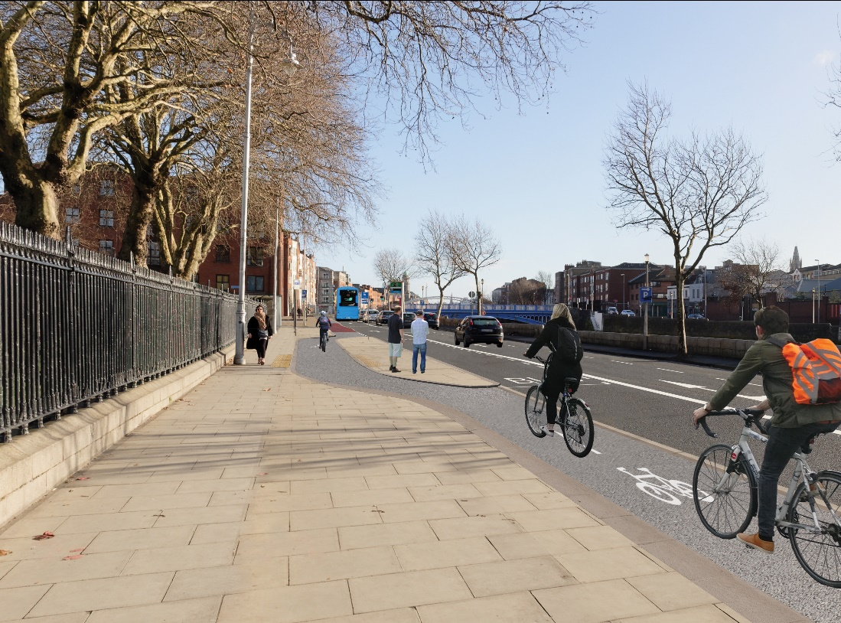
Wolfe Tone Quay Proposals

- Junction design at Liffey St West needs further analysis, if a bus is pulled over, car driver visibility will be impaired and there isn't a lot of space for a car turning left to pull in in front of the bus, drivers may accelerate to make this turn and thereby risk the safety of cyclist in the unprotected cycle lane.

Liffey Street West Junction

- It was mentioned that cycle tracks should not go on road through smaller junctions, smaller junctions should have their radius reduced and raised entrances provided with the cycle track crossing on the raised entrance.

Map 4 Sarsfield Quay-Arran Quay & Victoria Quay-Ushers Quay

- Opportunity to introduce contraflow cycling on one way streets which would increase permeability of the street network.- Arran Street, Watling street.
- Ellis Quay Cycle track is too narrow at 1.5m. Reduce riverside footpath and increase cycle track.
Ellis Quay Section

- Remove second lane of traffic on Wolfe Tone Quay to facilitate pedestrians/cyclists.

Map 5 Mellowes Bridge –Father Mathew Bridge

- It was questioned if the contra flow on Queens Street is an error, how does north to south cyclists proceed? Is the Bus Connects proposal different for this junction?
- On Arran Quay the filtering of left turning traffic into the leftmost lane enables cars to block busses and to force cyclists and vehicles to interact. A better approach would be to have a cycle track in the leftmost lane with a bus lane outside it. Traffic can then have a short left turning lane from the centre with a filter to stop busses and bicycles.

- Cycle facilities required on Father Matthew Bridge.
- Additional cycle parking required.

Map 6 Father Mathew Bridge-O Donovan Rossa Bridge

- The lack of cycling provision on some bridges was questioned, for example 4 traffic lanes remain on Father Matthew Bridge while no provision is made for cyclists.
- The 90 degrees angle of the crossing point from building side to river side is a sharp, dangerous manoeuvre, it will lead to cyclists bunching up waiting to cross and then using the bus lane if allowed to especially if they arrive at cyclist signal as it turns red.

Proposed Crossover for Cyclists on North Quays

- Cyclists need a green light to access the Liffey Cycle route from O Donovan Rossa Bridge
- A two way cycle track is required on O Donovan Rossa Bridge and up Winetavern St to Christchurch. A traffic lane should be removed to facilitate this.
- The removal of the slip lane for traffic is welcomed but a cyclist slip lane from Merchants Quay to Bridge Street should be provided to facilitate left turners.
- Why has the pedestrian Island on Bridge Street been maintained?

Proposed removal of Slip Lane towards Bridge Street

- Right turning cyclists need to be accommodated.

Map 7 O Donovan Rossa Bridge-Grattan Bridge

- Provide the cycle track on the west side of Grattan Bridge to avoid cyclists having to cross two traffic lanes to access the cycle route.

Grattan Bridge
- How is Parliament Street accessed from the westbound cycle track?
- Can cyclist facilities be added to Capel Street and a traffic lane removed?

Map 8 Grattan Bridge- Ha’penny Bridge

- It was claimed that the cycle track reduces available space for pedestrians at Ha’Penny Bridge.

Ha’Penny Bridge Capel Street Junction

- A contra flow cycle lane was requested for Capel Street?

Map 9 Ha’penny Bridge- O Connell Bridge

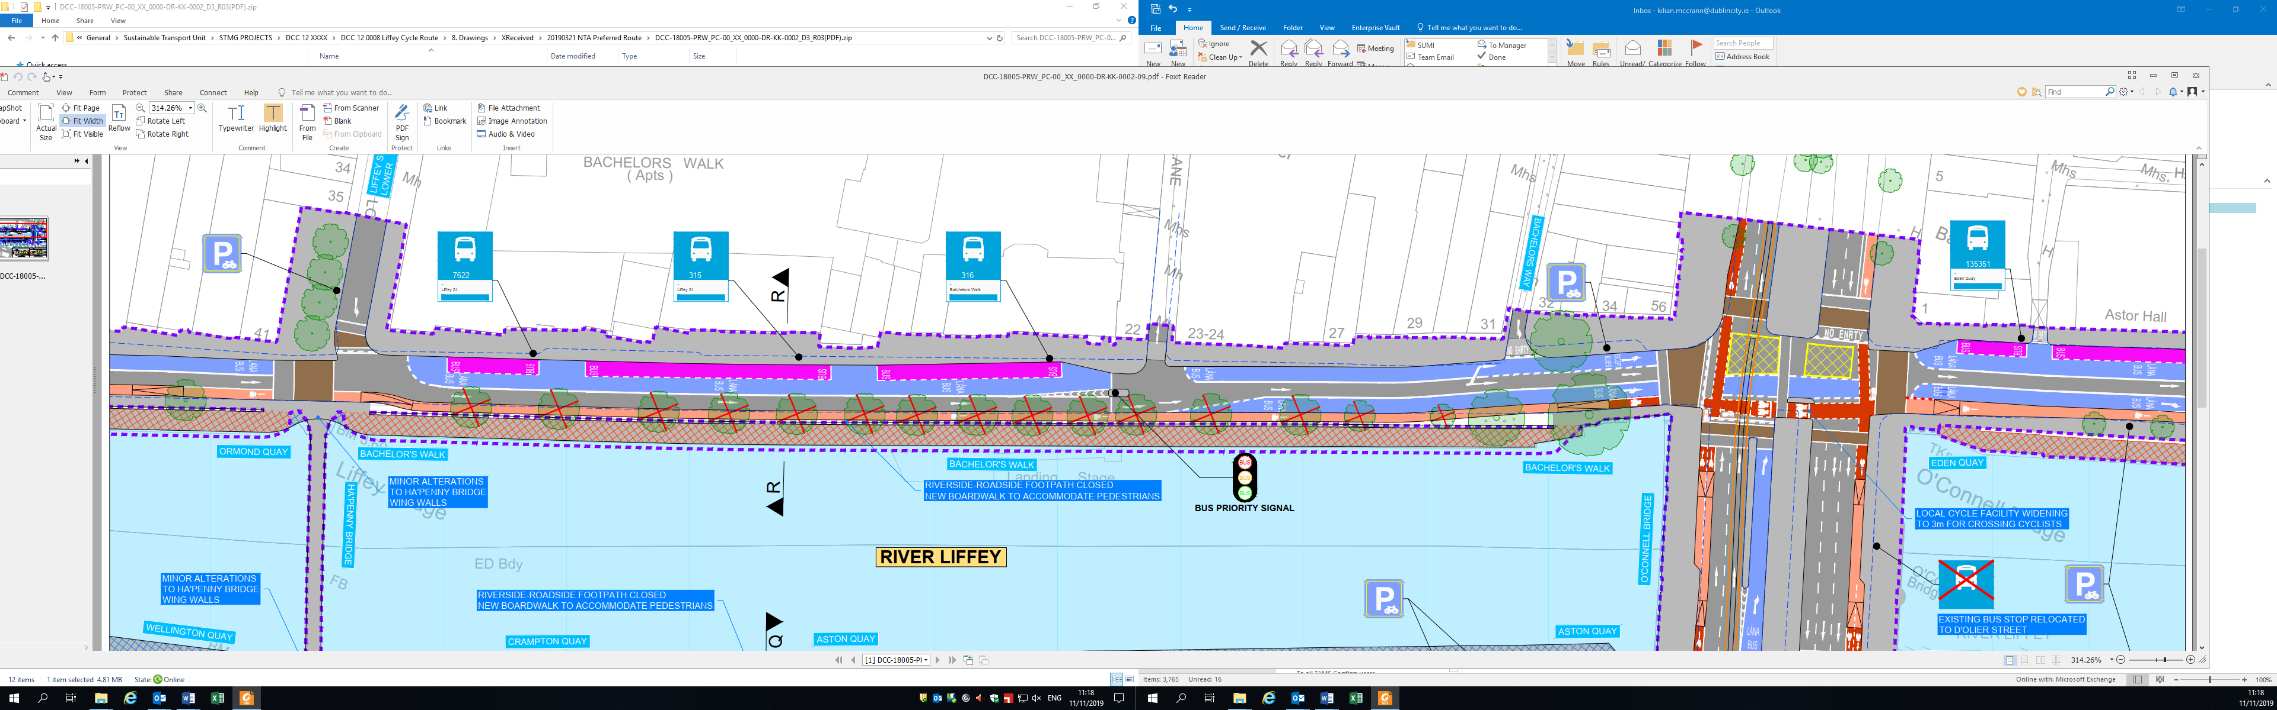

- Cyclists may use the right turn bus lane on O Connell Bridge to access Eden Quay.
- How will left turning cyclists access O Connell Street/Dolier Street.

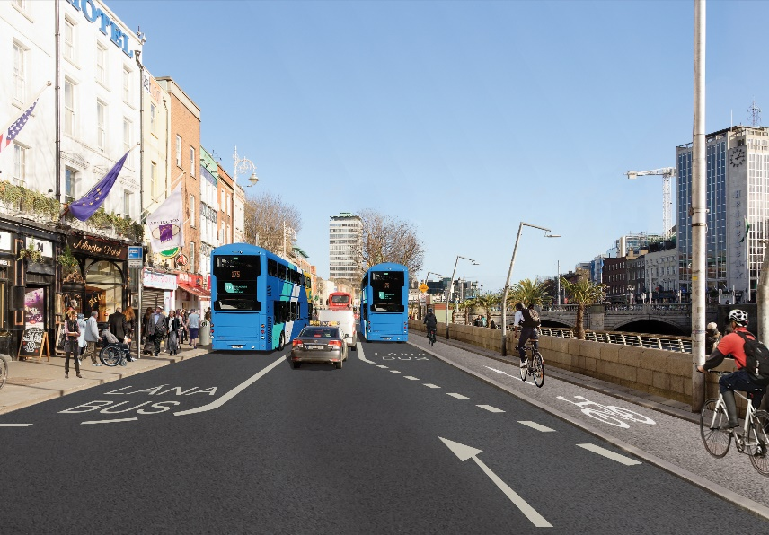
O Connell Bridge Bachelors Walk

Map 10 O Connell Bridge – Butt Bridge

- The proposals to restrict through traffic on Eden Quay needs to be revisited.
- Provide a left turn box on Burgh Quay for cyclists to access D’olier Street and all left turns off the river side cycle path to stop straight ahead cyclists getting blocked.

Map 11 Butt Bridge- Matt Talbot Memorial Bridge
- The link between Tara St station and the Liffey Cycle route needs to be further developed. How do cyclists access the cycle track?
- Is Custom House Quay cycle track two way?
- City Quay junction needs to be redesigned to avoid discommoding cyclists as is currently the case in this design. The route needs to be more direct.

Public Transport Themes
This section will present the reoccurring themes relating to public transport.

Bus Stops
- While a lot of submissions welcomed the addition of island bus stops there is concern amongst disability groups regarding their inclusion in the scheme. The concern lies with the requirement for pedestrians including the visually and mobility impaired to cross the cycle track to access the bus stop. Visually and mobility impaired pedestrians are highly reliant on the bus network with it being the only means of transport for many, they feel that the placing of a cycle lane between the footpath and the bus stop introduces an additional risk.
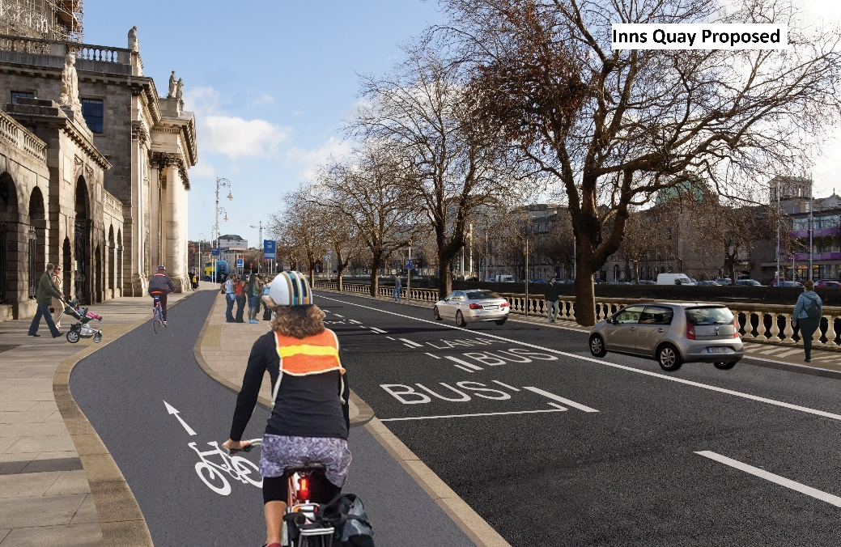
Proposed Island bus stop at the Four Courts
- A continuous cycle route along the river would have the additional advantage of removing potential conflicts with bus passengers.
- There is opposition to the placement of bus stops at historic buildings such as the Four Courts and the Custom House.
- Move the bus stop at Ushers Quay to in front of the Petrol Station and remove one of the access points to the Petrol Station.

Public Transport Proposals
- Remove private cars to create more space for buses and cycling
- Proposal to provide a two-way bus corridor on the south quays which would free up space on the North Quays.
- Introduce a congestion charge for cars with proceeds going towards public transport.
- Smart Technologies/cameras required to keep bus lanes clear.

Greening of the Quays
Many submissions suggested the current proposal does not go far enough from an environmental aspect, that the scheme is an opportunity to green the quays to provide linear parks like other European cities (Paris) have done, removing trees to facilitate private cars was objected to. It was felt that the scheme could help Ireland meet climate change targets and improve air quality and lower noise levels for all in the area. The recent support for the Green Party indicates a willingness to tackle climate change.
Further trees,greenery and public spaces need to be added to the design, it was noted that the Liffey route is not just a transport route, it is a public amenity in the city centre that is being underutilised. The proposals will greatly improve the current appearance of the Quays as a place to be.

Loading
• Loading/parking on the proposed cycle track will occur if no vertical protection is in place. Bollards are required between cycle track and carriageway. Loading bays need to be provided.
• Encourage loading at off peak times.
• Encourage deliveries via smaller vehicles-cargo bikes.

General Proposals

- Speed Limits-Request to lower speed limit along the full route.

- Park and ride facilities Investment required with bike share schemes.

- Paving, street furniture and signage all need to be carefully designed and integrated.

- Central median from Phoenix Park to the Quays on Parkgate Street to give a visual connection between both.

- Drawing legend needs to include all features.

Specific Body Submissions

This section summarises the submissions on the Liffey Cycle Route from specific bodies. The full submissions are located in the appendix of this document

Car Parks-Lowstrand Properties Ltd

- The removal of on street parking increases the importance of off street parking.
- The options assessment should be expanded to include the impact on existing multi-storey car parks.
- Uncertainty exists for car parks as Dublin City Council expands, the areas where private traffic is restricted in favour of public transport.
- If the restriction of vehicular traffic continues then Dublin City Council should compensate car park owners for loss of parking revenue or acquire their interests.
- Car park signage needs to be improved following various city centre traffic management changes.
- Long term policies in relation to access to the off street car parks in the city centre need to be adapted

Dublin Town

- Supportive of a Liffey Cycle route
- Infrastructure does need to be improved to match the growing demand for cycling within the city centre and to tackle congestion and climate change targets.
- Supportive of the addition of boardwalks along the route.
- Supportive of the cycle track on the river side closer to the city centre areas and thus avoiding the higher demand bus stops which will require additional capacity if other changes like the College Green Plaza proceed.
- Supportive of the arrangement proposed to access Jervis Street.
- Secure bike parking is required along the route.
- Traffic signal alterations will be required on adjoining roads along the route
- The construction phase should be planned so as to minimise impact on movement in the city especially at the busy Christmas period.

Public Participation Network

- Supportive in general of the plan to improve cycling and walking services and realises that if the plan works that it will benefit all members of society.
- Pedestrian should be placed at the top of the hierarchy when designing.
- Planners should take into account any public realm works proposed for the area.

Footpath Design
- A footpath should be wide enough for 2 wheelchair users to pass approximately 2.2 metres minimum width and wider where poles are present
- Footpaths should be of one material only, preferably a non-slip surface with a grainy feel so that guide dogs can use them easily.
- Where a footpath meets the road or edge then a kerb needs to be there that is 100mm at least higher than the road surface and also it should be designed in such a way that a person with a cane or a guide dog can notice this can be done with either raised edging or else by using a different contrasting colour at the edge.
- Where a bus stop is placed the path should have tactile paving inserted across the width of the footpath to indicate the position of the stop and also should be placed at the edge of the footpath. The bus stop pole should also be at the top edge of the bus stop and no other pole should be placed within the tactile area including real time poles.
- At all crossing point’s tactile paving should be used and the path should also slope gently to allow wheelchair users and prams to cross the road safely. Directional tactile paving should be used to show the direction of the crossing especially where the crossing is wide.
- Where information poles or signage is placed on footpaths then these need to be placed at a height greater than 2.5 meters from the ground to prevent head injuries to individuals with visual impairments.
- If access hatches must be installed on footpaths then these need to be flush with the paths and easily identified. They should be made of a non-slip or tripping material as well.
- Where Bus shelters are provided they need to be as close to the edge of the path as possible and also they should not hinder the passing behind them of wheelchair and buggy users. Tactile paving should also be used to warn of their presence and their design should not allow too many obstructions or protrusions onto the footpath.
- In no circumstances should a footpath be designed where the space is shared by other road users including cyclists.

Cycle Lane Design
- Cycle lanes should be wide enough for a fast cyclist to overtake a slow cyclist without impeaching on either the footpath or the roadway.
- Cycle lanes should be clearly marked for direction of traffic and should only be directional or against the flow of traffic if there is space for a cycle lane on one side of the road only
- At a traffic light a cycle lane should stop behind the pedestrian crossing but ahead of the vehicular stop line
- The edge of a cycle track should be visible and if possible segregated from both traffic and pedestrians.
- Cycle lanes should operate at the same time as the bus lane and should be enforced for parking infringements as rigorously as the bus lanes.
- Where a cycle lane intersects at a bus stop location the best option is to have the cycle lane continue straight if no bus is at the stop otherwise the bus lane should be marked so that if a bus is stopped the cyclist can safely go around the bus in a marked pyramid shaped cycle lane at each stop.
- Where the cycle track is raised off the road with a slight raise to the footpath, these stops are an issue for the blind and wheelchair users as they are not level from the path to the bus as there is a step down so wheelchair users cannot access either the bus from the path or the path from the bus, the designer should consider raising the cycle track to the height of the footpath at these locations so ensuring firstly safe access for bus users and secondly a means to slow cyclists down at bus stops

Stops and Crossings
- Comments that in some of the designs current straight crossings are been replaced by long crossing times and awkward routes.
- Crossings need in general to be straight and wide enough to allow wheelchairs and prams to pass safely.
- If the crossing is at a major junction than the lead up to the crossing should be railed to prevent early crossings or access by children and then the crossing itself should be clutter free and well lit up.
- The edging of all crossings should have tactile kerbing.
- The crossing section should be a different colour to the road and it should have a clearly marked edge point.
- In high volume areas the footpath at the crossing should be able to safely accommodate the people using it.

St James Hospital

St James hospital supports the enhancement of cycling infrastructure in the city which encourages active means of commuting which in turn will support the aims and objectives of their campus Mobility Management Plan. With growing staff numbers the Liffey Cycle Route will serve to provide a safe convenient and efficient means of accessing the city centre while also
- Reducing the reliance on the private car
- Increase cycling mode share
- Improve air quality
- Promotes “active travel” important from a healthcare perspective

Dublin Cycling Campaign

Dublin Cycling Campaign stated it is delighted to see progress on the Liffey Cycle Route, and welcomes the proposals for cycling infrastructure, pedestrian improvements and bus
facilities.
Bus Stop Bypasses and Locations
Note the relocation of many of the bus stops along the proposed routes is an opportunity to optimise the stops and the feature of these being full bus stop bypasses for bicycles, removes conflict between buses and cyclists. By locating the new cycle track on the riverside of the roadway for much of its length this conflict is avoided totally.
Pedestrian Facilities
Welcomes the inclusion of extra boardwalks along certain sections of the river to facilitate pedestrian movement, will greatly enhance the river for all.
Commends the number of new additional pedestrian crossing areas.
Notes that some sections of riverside path for pedestrians are removed on a number of quays. This breaks a major desire line, particularly for visitors to the City
It is not clear that pedestrian needs have been fully taken into account in the
design.
Segregated Cycle Path
The facility of having a nearly fully segregated cycle track along the spine of
the Liffey is a major positive, which will encourage more users. However concern is raised that the width of the cycle track throughout the one way route sections is at best only sufficient for present cycling levels in the City. Where possible, and there are a number of locations, the one way route width should be increased in line with the best recommendations of the National Cycle Manual.
Cycling Right Turns and Road Crossings
At a number of junctions it is not clear how a cyclist will make a right turn, usually to
cross a bridge. The design also needs to clearly indicate if all marked crossing
points are Toucan crossings, or simply pedestrian crossings.
Cycling Facilities on Bridge Crossings
Notes the inconsistency of the provision of cycling facilities on bridges. The reasoning for this needs to be made clear. In reality cyclists will still continue to use those without facilities, but should receive some level of protection.
Traffic Signal Activators
Requests that all junctions will include cycling activators for traffic lights, to ensure that cyclists are recognised.
Tree Retention and Planting
Welcomes that many of the existing trees along the Liffey Corridor are retained with the exception of those on Bachelor’s Walk and part of Eden Quay. A proposed planting regime will also help to enhance any final scheme.

Cycling Without Ages
Cycling without Age requests Dublin City Council to consider the future of Dublin city as a sustainable and liveable space for its citizens and visitors. The car has been given priority over all other forms of transport for the past 50 years. A consequence is that people are pushed to the edges to live elsewhere, to shop elsewhere, to have to commute long distances, to see the city as an obstacle to their living.
Cycling without ages requests
- That city centre access be reduced, parking and ease of use for private car owners be restricted.
- Creation of cycling and bus corridors,
- That trees be left alone as they help to clear the air and make Dublin look beautiful.
- A reduction in cars as ess cars will reduce pollution, noise, stress, and danger to citizens.

An Taisce

Overall, Green-Schools is supportive of the Liffey Cycle Route project and the long-term investment in segregated cycling and walking infrastructure.The investment in cycling and pedestrian infrastructure along the quays via the Liffey Cycle Route supports the ongoing work of Green-Schools Travel. The hope would be that the Liffey Cycle Route would change the perception and reality of cycling as being unsafe. Segregated cycling infrastructure gives the streets back to the children and parents by creating a non-intimidating, functional space. The streets will also be a more pleasant place to be with less noise and air pollution with a higher standard of air quality. Not only will the Liffey Cycle Route infrastructure support parents and children on the school run, but also on the parent’s and wider community’s commute. It is a brilliant investment in safety, sustainable transport, and congestion reduction within the city centre.
Some specific points highlighted by An Taisce along the route are:

Bridges
- The Rory O’Moore Bridge, Watling Street and Father Mathew Bridge are missing dedicated cycle lanes or tracks.
- The James Joyce Bridge, the cycle proposal shows only maintaining the status quo cycle lane.
- Consideration of the safety of cyclists turning right on to the bridge also needs to be made.
- Proposal there is no provision for cyclists to turn right on to the quays safely.
- The Rosie Hackett Bridge, as it stands now and in the proposal should be afforded the safety of designated turning road markings or lanes.

Parking
- More cycle parking should be provided throughout the scheme

Environment.
- The removal of trees along Bachelors Walk should be re-assessed as they provide a refuge for city wildlife; absorb Carbon Dioxide; supports better air quality, retain water in the soil; provide natural, softer elements to the built-up quays; allow for picturesque outlooks for tourists and locals alike

Dublin Bus

Dublin Bus welcome the published proposals on the Liffey Cycle Route and are fully supportive of the measures proposed and of the principles behind them. The ongoing change to travel patterns, and modal shift to cycle and public transport seen in Dublin has been a long time goal, and is set to continue. Supporting sustainable modes will both ease congestion and reduce emissions in the city, and the proposals go a long way towards helping rebalance infrastructure provision to allow that shift to take place.
Specifically welcomed are the segregation of cycling and traffic which allows safer interaction between bus and cyclists; and the arrangement of island bus stops which again segregate cyclist and pedestrian traffic. This is particularly important when considering those with impaired mobility and offers a level of confidence in using public transport.
The increased bus priority measures along the Quays will assist in greater journey time reliability which in turn will help encourage modal shift.
Dublin Bus proposes that some design items should be reviewed primarily in relation to traffic merges, lane widths, and turning arrangements, briefly as follows:
- 3m Bus lane widths are minimal allowing very little flexibility in the path of the bus.
- Map 4: Bus lane is caught between two converging movements at Liffey Street West: cycle lane onto road level from behind a stop, and left turning car traffic. Staggering these slightly will alleviate any potential conflict here.
- Map 6 & 7: Cycle transition between buildings and quay wall – detail of operation will be key but the principle is fine.
- Map 7: What provision will be in place for buses to access Grattan Bridge from Ormond Quay in the event of heavy traffic?
- Map 9 & 10: The arrangements for buses leaving Bachelors Walk to go straight on to Eden Quay while crossing a lane of general traffic needs clarification. Will signal phasing deal with this?
- Map 10: New stops at Burgh Quay (plus other locations) give welcome expansion to public transport provision in this area.
- Map 11: Do the lane positions and markings on the Tara St /Burgh Quay junction allow a bus to take the turn without getting caught in queueing traffic? A similar query for buses moving from Butt Bridge to Eden Quay. The segregated cycle provision changes the road position of the bus on approach to these turns – yellow box extensions may be required. Overall signalling arrangements to be detailed.

Dublin Chamber

Dublin Chamber is supportive of the overall objective of the Liffey Cycle Route, which is to develop a route which provides a safe and continuous segregated cycle route in both directions between the Phoenix Park / Heuston Station and the Tom Clarke East Link Bridge. Dublin Chamber believes that the option presented is the best option that has been put forward so far. The proposal represents a good outcome for all road users and should result in enhanced bus prioritisation, a significantly improved environment for cyclists and pedestrians, and, crucially, maintenance of access for private vehicles. This remains essential in light of the significant improvements that are required to Dublin’s public transport system.

Currently, many people are discouraged from cycling along the Quays as they do not feel safe. It is an area of the city in which cyclists are forced to mix with the other vehicles travelling along the quays, including buses, vans, cars, taxis and other large vehicles. This is a situation that requires urgent attention. It was concerning to note that, according to the most recent Canal Cordon figures, the number of people cycling into the city each morning stalled in 2018, following almost a decade of consistent year-on-year growth.

Dublin Chamber believes that the proposal represents a fair compromise for all of the city’s users and will ensure the delivery of a safe and high-quality cycle route. The Chamber’s main concerns with previous incarnations of the Liffey Cycle Route related to: the removal of private car access from large sections of the North Quays; the need for access to all existing car parks; a lack of capacity at bus stops; and an apparent unwillingness to consider more ambitious alterations along the route including the modification of bridges and changes to the quay walls including the creation of more Boardwalk-type spaces for pedestrians. Dublin Chamber are satisfied that the Recommended Option has recognised each of these aspects.

Interconnectivity
Dublin Chamber would like to see more detail around how cycle lanes on streets in and around the Quays will link into the proposed Liffey Cycle Route. There is very little detail in the plan, for example, regarding cycle lanes on the various Liffey bridges along the route. Cycle lanes along many of the bridges are currently inadequate, particularly between Heuston Station and O’Connell Bridge. Dublin’s cycle network needs to be closely and cleverly integrated with the public transport network. This will make it easy and attractive for people to switch between modes and to increasingly consider cycling as an option for at least part of their journey, if not all of it.

Trees
Dublin Chamber notes commentary around the possible need to remove trees along the route, particularly along the western sections between Heuston Station and O’Connell Bridge. While it would be unfortunate if some trees required removal, Dublin’s overall transition to becoming a green and environmentally sustainable city should take priority. It should be noted that some trees along the north quays have now grown to the point of impacting upon access for pedestrians. Pedestrian movement along some sections of the riverside footpaths on the North Quays is already very restricted due to the eruptions of roots in the already narrow footpaths, which are now impassable for those with pushchairs, wheelchairs, and the infirm. However, Dublin Chamber suggests that Dublin City Council should seek to make up for the loss of trees by undertaking more appropriate forms of tree-planting in the city centre.

Delivery Timeframe
Dublin Chamber is disappointed by the slow progress in improving Dublin’s cycle network, and is concerned about the timeframe for delivery of the Liffey Cycle Route, given that this route has already been in planning for 6 years. It is a source of frustration for the business community in Dublin that so little of the Greater Dublin Area Cycle Network Plan, launched in 2013, has come to fruition. Failure to prioritise delivery of necessary cycleway infrastructure within the M50 will seriously hamper Dublin’s transition to being a more sustainable, environmentally friendly, and congestion-free city. With this in mind, Dublin Chamber hope that the recommended route can be approved and taken through the planning process with urgency, and that construction work can begin as soon as possible.

Fighting Blindness

Fighting Blindness raised concerns about the impact of the proposed Liffey Cycle Route on people with sight loss.
Fighting Blindness are in favour of segregated cycle lanes as this is safer than having people cycling on the foot path. For some people with sight loss it is very difficult to hear oncoming cyclists as they do not make a lot of noise. For this reason Fighting Blindness are worried about the proposals to have some bus stops situated in islands between cycle lanes and roads with no safe way for a person with sight loss to cross the cycle lane.
Because the cycle lanes are segregated, cyclists will be moving at speed and the positioning of the bus stops and the need to swerve around them will make it more likely that people with disabilities will be seriously injured.
Fighting Blindness have learnt from the UK that shared spaces cause people with disabilities and older people to avoid the areas where these are in place. This will mean people with sight loss may be afraid to use these bus stops. In a lot of cases it is not possible for a person with sight loss to cross a cycle lane without a signalled crossing or sighted assistance. This will massively reduce the ability of people with sight loss to navigate the city independently.
It is very important that when a person with sight loss is walking around the city, they are walking on footpaths and not roads and cycle lanes. Every piece of cycle lane included in this plan must be clearly separated from pedestrians to avoid accidents where a person with sight loss steps out in front of a bike or car because they do not realise they are walking in a cycle lane. The kerb needs to be a minimum of 60 millimetres, but ideally 100 millimetres. This is so white cane users and guide dogs can easily identify the kerb. A shorter kerb is a serious trip hazard. Mountable kerbs, or kerbs with a slant so bikes can mount the footpath, are also dangerous and should not be included in this plan. For safety, flat facing kerbs need to be maintained.

Crossing points need to have clear signals and tactile paving and cyclists should stop when pedestrians are crossing a road or cycle path. It is in no way acceptable to force a person with sight loss to cross a cycle lane in an unsafe way. This will cause accidents.

Fighting Blindness concerns relate to a failure to follow the user priority set out in the Design Manual for Urban Roads and Streets. The manual clearly states that pedestrians should be considered first. For this to include people with sight loss, it is necessary to make sure that every bus stop has a safe way for people to walk once they get off a bus. It is also necessary for cycle lanes to be truly separated from the footpath and for crossing points to be clearly signalled and enforced. It is also necessary for kerbs to be kept at a safe height.

National Council for the Blind Ireland (NCBI)
NCBI notes the priority rating of Road Users as follows:
- The most vulnerable members of society: people with disabilities and elderly people.
- Pedestrians generally.
- Cyclists.
- Public Transport.
- All other road users.

People with impaired vision do not have the option of cycling or driving. To get around the city they must walk or use public transport. Cyclists, on the other hand, are also pedestrians and public transport users, at times, and many are also drivers. Providing good facilities for pedestrians benefits everyone.
In order to walk in the city safely and independently, people with impaired vision need:
- smooth surfaces underfoot;
- reasonably wide pavements;
- change of level (kerb) between pedestrian area and area for cyclists and vehicles of minimum 60 mm in height;
- accessible road crossings – that is, pedestrian lights with audible signals, with tactile paving to lead them to the crossing, and to replace kerbs which are dished at crossing points (to facilitate people using wheels).

Key concerns for NCBI, on the overall plan:
With regard to cyclists:
- Cyclists on pavements are a major problem for people with impaired vision. Therefore NCBI welcomes any initiative which encourages cyclists to keep off the pavements, which this scheme should do, by giving them a safe space for themselves.
- Bicycles parked in places and ways which cause obstructions and painful collisions, even falls, are also a problem. NCBI therefore hope that this plan will include the provision of sufficient cycle parking bays, of a design which will be safe for people with impaired vision, who happen to come into contact with them, but preferably located on the road, not the footpath.
- If it is necessary to put cycle parking racks on footpaths, for example on a build-out, they should be surrounded by a change of colour and texture
- It is proposed, in this plan, to have cyclists sharing crossings with pedestrians, at one of the crossing points. (On the west side of Frank Sherwin Bridge)This is not acceptable to NCBI, because people with impaired vision are under enough stress, crossing roads, without having people cycling alongside, in front of and behind them, while they do so. If it is not possible to provide safe facilities for cyclists at a particular crossing point, then cyclists should be obliged to dismount, before using the pedestrian crossing. Again, this is a minor inconvenience for a cyclist, but makes all the difference for people with impaired vision. If their perception is that it’s not safe to go out walking in the city, they are likely to give up doing so. Their physical, mental and emotional health then suffers, as they become housebound, physically unfit, and socially isolated. It’s a small ask, for cyclists to get off and walk across a pedestrian crossing, considering the potential ill-effects on people with impaired vision, if they do not.

With regard to bus stops.
- It is unsafe for people with impaired vision to cross cycle lanes, even at light controlled crossings, unless the crossing is one at which cyclists must stop or risk being hit by vehicles. The reality is that cyclists do not stop for pedestrians, they just weave around them. That may be acceptable for many people, but can be terrifying for someone with impaired vision, especially if they have been hit by a cyclist before. The provision of a cycle track which runs between a bus stop and the pavement – making the bus stop into an island - is not acceptable, for this reason.

- NCBI suggests that cyclists have three choices:

- they can overtake buses on the outside, while they stop for passengers;
- if they consider this too dangerous, they can wait behind buses, just as cars must;
- They can (and do) mount the pavement to overtake bus queues on the inside. This is unsafe for pedestrians and should be discouraged, rather than making it a legal option for them, by installing a track for them to do this.
Pedestrians using buses have no choice in the matter – they have to get from the footpath onto and off buses. They should be able to do so safely and without anxiety. Cyclists’ convenience should not take precedence over pedestrians’ safety. (See Priority Rating of Road Users, above.)
If this objection is over-ruled, and cyclists’ convenience is given priority over the safety of elderly and disabled pedestrians, then can DCC at least assure us that the size of these islands - on which people must gather to get on and off buses - is adequate for the number of people who will be forced to use them?
There may not be enough physical space available, on an island bus stop such as those proposed in this plan, for all the people who will need to use it.
When a large crowd of people are jostling to get on and off buses, those on the edges of the available space are likely to stumble off, onto the cycle track.
- NCBI questions if measurements have been taken, to establish how many bus-loads of passengers boarding and disembarking could fit onto each island, at any one time?
- What if several buses arrive together? Traffic problems can and do disrupt timetables.

Bus Connects
NCBI recommends very good communication between the designers of this cycle route, and the designers of Bus Connects.

College Green pedestrianisation
NCBI questions if the designers have considered the pedestrianisation of College Green within this plan and how increased bus stop and pedestrian volumes will be accommodated.

Other concerns:
These plans include the provision of more boardwalks along the riverside, in order to provide enough space – for instance where tree roots have lifted the paving surface, and there is no flat surface to walk on, and very little room to pass pedestrians coming in the opposite direction.
NCBI is concerned that it may not be possible to provide boardwalks in some places – for instance, in the location of the photograph below, in Docklands. Note the very narrow footpath. It seems unlikely that a boardwalk could be provided along this section of the docks.
The idea of having the new boardwalks on the same level as the footpaths beside them is welcome. This may help to prevent the new boardwalks becoming areas where ordinary people are reluctant to go, for fear of being accosted or mugged.
NCBI has been assured that the material of the new boardwalks will be carefully selected to meet the requirements for slip-resistance, and that the surface of the existing boardwalks will be improved to match.

Transport Infrastructure Ireland

TII recommends that Dublin City Council consider the following matters in the progression of the Liffey Cycle route
- Loading required for car transporters at existing garage on Parkgate St in order to avoid impacting the LUAS tracks
- Pedestrian crossing location across Parkgate St from Hueston to the Ashling Hotel need to be rethought to cater for pedestrian desire lines. There is a possibility of pedestrians crossing adjacent to the LUAS at a non-signalised crossing location which may impact on LUAS operations
- The previously recommended pedestrian crossing west of the LUAS tracks on the Hueston access road should be included in the scheme.
- Clarification is required as to how north bound cyclists turn right from O Connell Bridge.
- Clarification is required as to how southbound cyclists turn right from Rosie Hackett Bridge onto Burgh Quay
- Clarification is required as to how cyclists who wish to turn left from the South Quays onto Hawkins Street are catered for.
- Consultation should continue in regard to monitoring potential impacts on the Dublin Port Tunnel

C+W O Brien Architects
Over all the proposals are a huge improvement with lots of great ideas, the use of bus stops bypasses is excellent and a very welcome move.
At junctions, designs need to take into account the reality of what cycling is like: clear priorities need to be incorporated by the use of raised surfaces; cycle traffic lights; placement of stop lines in positions which are several metres in front of those for other traffic lanes.
It would be nice to see the superfluous general traffic lanes removed. Despite walking, cycling and public transport being the priority, private motoring is still granted a disproportionate amount of the road space in many cases. By reducing this to one lane in many locations (e.g. Victoria Quay), footpaths and cycle tracks can be widened and kept far away from the road by distance. It also presents opportunities to introduce more flora, which should be important, given that Ireland is on the verge of ecological collapse.

I BIKE Dublin
Over all the proposals are a huge improvement with lots of great ideas, the use of bus stops bypasses is excellent and a very welcome move.
At junctions, designs need to take into account the reality of what cycling is like: clear priorities need to be incorporated by the use of raised surfaces; cycle traffic lights; placement of stop lines in positions which are several metres in front of those for other traffic lanes.
It would be nice to see the superfluous general traffic lanes removed. Despite walking, cycling and public transport being the priority, private motoring is still granted a disproportionate amount of the road space in many cases. By reducing this to one lane in many locations (e.g. Victoria Quay), footpaths and cycle tracks can be widened and kept far away from the road by distance. It also presents opportunities to introduce more flora, which should be important, given that Ireland is on the verge of ecological collapse.

Phoenix Farrell Limited
A very good and practical suggestion, as an occasionally traveller in from Castleknock on a bike it is noted that as buses pull in to stops there is no room for bikes, they are forced to either stop, overtake on the right, or mount the footpath. The suggested change is an obvious fix to that and would be welcomed. It is good to see practical improvements to make healthy commutes easier.

IrishCycle.com

Given all that we know about liveable cities, the health effects of inactivity, climate breakdown, biodiversity collapse, air pollution, and the cost of congestion, it’s time for our capital city to be bold, be brave.
Rather than chopping down trees and squeezing in people walking and cycling Dublin should #GreenTheQuays — add trees and greenery, add public space, and give sustainable transport priority by removing cars at least from the central quays.
Despite spending millions on new boardwalks and cutting down trees, the cycle route designs released by the National Transport Authority and Dublin City Council are not safe and far from the standards of Cycling For All.
- The ‘politics of space‘— maintaining too much space for cars in a location where public transport use far outstrips car use and, in current poor conditions, bicycles outnumber cars at rush hour.
- New boardwalks will cost €7.6 million — because of an unwillingness to remove cars from the quays boardwalks are needed to make space.
- The new Boardwalks will likely add €7.6 million or more to the cost of the project and add complications due to working over the river, digging or drilling into quay walls and historical impacts.
- Overly focused on transport — the quays are not just a transport corridor. It’s the centre of our capital city and includes some of the highest density housing in the country.
- Cutting down trees — the plans include cutting down rows of trees on some of the widest quays because the city council and the NTA puts a larger value on having bus and car traffic lanes. Trees will be removed on Bachelor’s Walk where there will be two bus lanes and a car lane and also Eden Quay where there will be four bus lanes and a car lane. Public transport is important at this locations, so, the obvious answer is to remove cars.
- Removal key space from pedestrians — while the project includes larger footpaths at some points, it also includes narrowing other footpaths including at crossings.
- Removal and not including pedestrian crossings — because the planners of the project are overly concerned with traffic flow they have removed pedestrian crossings and not followed best practice and guidance on including pedestrian crossings at a number of locations.
- Junction designs proven to be deadly to cyclists — the Liffey Cycle Route was supposed to be a fully segregated cycle path from the Phoenix Park to the Point Village but after years of chopping and changing people cycling will now be left exposed at junctions and many crossings will be shared with pedestrians.
- Narrow cycle paths — despite spending millions on new boardwalks and cutting down trees, the cycle paths are too narrow for existing never mind an increased amount of people cycling.
Dublin City Council and the NTA should be providing for cycling for all and follow the elements of CyclingForAll.ie.

Conclusions

This report outlines the themes arising from submissions made by members of the public and specific bodies during the Non-Statutory Public Consultation process for the Liffey Cycle Route and all submissions received during this process are presented in the Appendix
It should be noted that any views, thoughts and opinions presented in this report are those submitted during the Non-Statutory Public Consultation, and are not Dublin City Councils.
Dublin City Council has not addressed any of the comments raised at this time.
Dublin City Council wishes to thank everyone who made a submission to this Consultation process, it is clear from the Non-Statutory Public Consultation that there is strong support for the proposed Liffey Cycle Route scheme. However it is noted that there are elements of the scheme that will need to be considered in further detail when progressing the design of the project. The Non Statutory Public Consultation has helped Dublin City Council identify the areas of public concern and potential design improvement requirements.
Dublin City Council is currently carrying out extensive internal stakeholder engagement and gathering necessary information which will define the scope of the Liffey Cycle Route as a project. It is envisaged that a design consultant will be appointed in Quarter 1-2020 to bring the current Emerging Preferred Design forward to Preliminary Design and Detailed Design. Further Public Consultation is envisaged when the correct statutory approval route is established.
The appointed design consultant for the Liffey Cycle Route will be required to analyse all submissions received as part of this consultation process and take them into account as the design progresses.

Appendices

